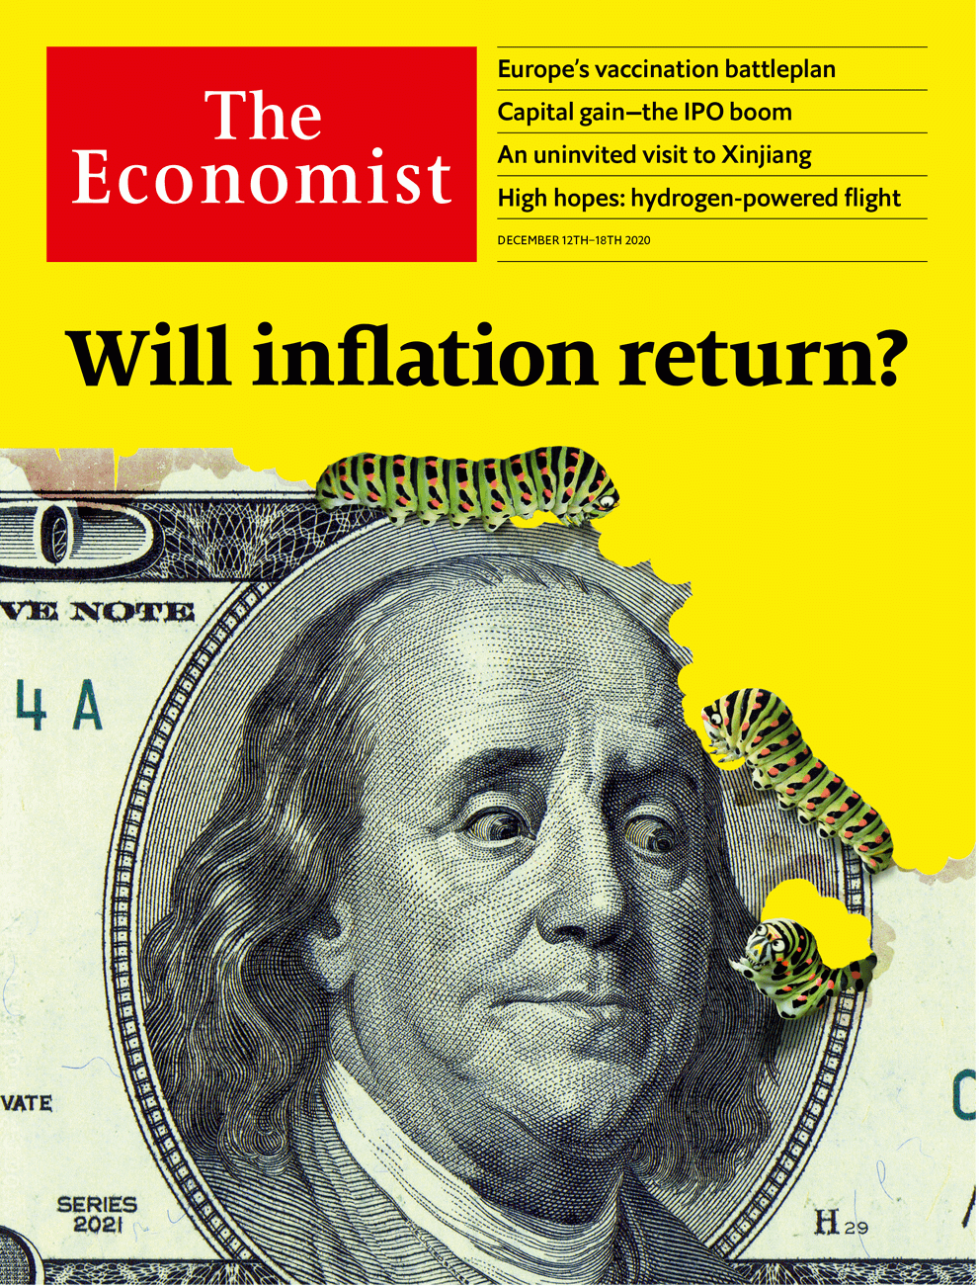

# Table of Contents

The world this week

Politics this week

Business this week

KAL’s cartoon

Leaders

The world economy: Will inflation return?

Brexit trade negotiations: Last tango in Brussels

The IPO boom: Capital idea

Transgender medicine: First, do no harm

The music industry: Knock-knock-knockin’ on Jody’s door

Letters

On race data, Galicia, epidemiology, Bosnia, companies, Jonathan Sacks, China: Letters to the editor

Briefing

Inflation: Prognostication and prophecy

Asia

Covid-19 in Japan: 3C epiphany

Suicide in South Korea: Deepening despair

Nature conservation in Thailand: Unshellfish love

Policing in the Philippines: Beatings v shootings

Banyan: Cosplaying nice

Rohingya refugees in Bangladesh: Club Mud

China

Exporting Xi Jinping thought: How the party trains foreign politicians

Club culture: A different beat

Chaguan: China doubles down in Xinjiang

United States

Black Lives Matter: The George Floyd effect

African-American businesses: Capital punishment

The never-ending election: Final countdown

The urinal is political: Where have all the toilets gone?

Anti-Semitism accusations: Here today, zone tomorrow

The Fort Hood report: A look under the Hood

Economic policy: Picking a package

Lexington: When America and China went to war

The Americas

Nicaragua: Seeing off a strongman

Cuba: Udder delight

Bello: Natural and political disasters

Middle East & Africa

Mining’s toxic legacy: Lead astray

Ghana’s election: Skirt and blouse

The boycott of Qatar: Bridging the Gulf

The Yazidis: Divided, oppressed and abandoned

Football: The most racist club in Israel...

Europe

Covid vaccines: Coming soon

Germany and covid-19: In vino, virus

France and Islamism: The republic strikes back

Italy: Unchained Meloni

Romania’s election: Diluting the cleanser

Charlemagne: Republic of cranks

Britain

Brexit: Fade to grey

Regulating technology: Injection of confidence

Culture wars (1): Roads must fall

Culture wars (2): New school rules

Covid-19: Out of sight

The environment: Chasing rainbows?

The Shetland Islands: Carrion call

International

Trans rights: Boys and girls

Business

Corporate balance-sheets: A year of raising furiously

Big tech and antitrust: Battle commences

Bartleby: Fair play

Information technology: Hitting the reset button

Commercial arbitration: The case of the disappearing cases

Self-driving cars: Spinning off

Schumpeter: Dirigiste? Moi?

Finance & economics

Productivity trends: Reasons to be cheerful

Buttonwood: C’mon feel the noise

Oil production: Opening the taps

Mexico’s unbanked: Bringing Mexicans to account

Climate finance: Counting the carbs

Free exchange: A question of illumination

Science & technology

Hydrogen-powered flight: If at first you don’t succeed...

Sonic warfare: A megamegaphone

The fiery end of SN8: SpaceX's latest launch

Gene therapy: Eyeball to eyeball

Bees versus hornets: The uses of dung

Books & arts

American extremism: Fear and loathing

Intellectual history: Pleasure principles

Johnson: Eiffel power

Contemporary art: The room where it happens

Economic & financial indicators

Economic data, markets and commodities

Graphic detail

Economic research: Starving for knowledge

Obituary

Chuck Yeager: Mechanic to hero



Friday, December 11, 2020

### #加迪迪QQ1562739651问外刊/脱口秀/新闻群#

|  |  |
| --- | --- |
| The world this week | 3 |
| Leaders | 5 |
| Letters | 1 |
| Briefing | 1 |
| Asia | 6 |
| China | 3 |
| United States | 8 |
| The Americas | 3 |
| Middle East & Africa | 5 |
| Europe | 6 |
| Britain | 7 |
| International | 1 |
| Business | 7 |
| Finance & economics | 6 |
| Science & technology | 5 |
| Books & arts | 4 |
| Economic & financial indicators | 1 |
| Graphic detail | 1 |
| Obituary | 1 |

|  |  |  |
| --- | --- | --- |
|  | Sections | Leaders |

The world this week

Politics this week

.

Business this week

.

KAL’s cartoon

.

|  |  |  |
| --- | --- | --- |
|  | Sections | Leaders |

|  |  |  |  |
| --- | --- | --- | --- |
|  | Articles | Sections | Next |

# Politics this week

Dec 10th 2020 |

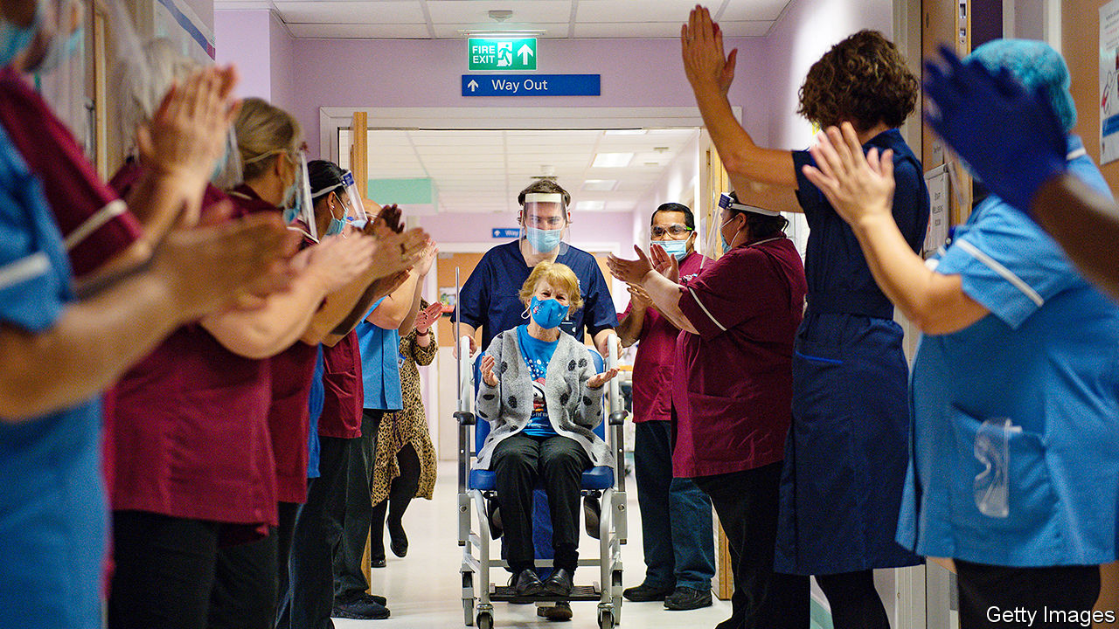

Britain began the world’s first vaccination programme for covid-19 using a fully tested vaccine. Thousands of people, mostly the very elderly and frontline health workers, received the Pfizer/BioNTech jab in hospitals. Family doctors will also administer the injections, as will care homes by Christmas. Canada became the second country to approve the Pfizer vaccine and will start distribution soon. In America regulators were on the verge of approving it.

General Lloyd Austin was tapped by Joe Biden to be his defence secretary. If confirmed, General Austin, who has led America’s command in Afghanistan and Iraq, will be the first black person to hold the job. He will also be a former military man in a position that by tradition goes to a civilian. Donald Trump’s first defence secretary, James Mattis, also came from the armed forces.

The House of Representatives passed a defence bill, with 140 Republican votes, that would, among other things, remove the names of Confederate generals that adorn some military bases. Mr Trump says he will reject the bill, but it has been approved by a two-thirds majority, enough support to override a presidential veto. It now goes to the Senate.

The House also passed a bill that would decriminalise marijuana and overturn the sentences of those who have been convicted of non-violent cannabis crimes. Its purpose is to redress the racial disparities in marijuana convictions (black people are more likely to be jailed for possession). It is unlikely to pass the Senate.

The Supreme Court made its first foray into the jumble of lawsuits from Republicans still trying to overturn the election result. In a one-line response with no dissents, it refused to hear a case from Pennsylvania. Joe Biden’s victory will be officially confirmed on December 14th, when the electoral college meets to cast its vote. See [article](https://www.economist.com/node/21796062).

As Brexit trade talks went down to the wire, the British government announced an “agreement in principle” with the European Union over border controls between Ireland and Northern Ireland. Britain also agreed to scotch legislation that would allow it to break international law. Boris Johnson, the prime minister, went to Brussels for a dinner with Ursula von der Leyen, the president of the European Commission, but their meeting left a bad taste in the mouth for those hoping for a breakthrough. See article.

France published details of a proposed new law designed to combat the spread of radical Islam. The law, which will go to parliament next year, was prompted by the beheading of a French schoolteacher for showing children cartoons of the Prophet Muhammad. See [article](https://www.economist.com/node/21796073).

Venezuela’s dictatorial regime, led by Nicolás Maduro, reclaimed control of the legislature, the one branch of government it did not command. The ruling PSUV and its allies won more than two-thirds of the votes in a legislative election that was boycotted by most of the opposition. The PSUV’s victory means that the opposition’s leader, Juan Guaidó, recognised as Venezuela’s interim president by more than 50 countries, will lose his role as head of the assembly.

Tabaré Vázquez, who was twice Uruguay’s president, died. A doctor turned left-wing politician, Mr Vázquez’s victory in 2004 ended more than 160 years of rule by the National and Colorado parties. His second term ended in March this year.

Opposition candidates made gains in a parliamentary election in Kuwait, raising fears that they will stand in the way of efforts to tackle a fiscal crisis caused by low oil prices and the outbreak of covid-19. None of the 29 female candidates who ran won a seat.

Ethiopian federal troops fired at UN workers who were assessing roads to provide aid in Tigray, a war-torn region. Fighting erupted in November between the central government and Tigrayan forces, after Tigray held what the government called an illegal election. The government has shut internet and telephone access to the region. Thousands have died and perhaps 1m have fled their homes.

Five people were killed in election-related violence in Ghana. Both presidential and parliamentary races were close. Results showed that Nana Akufo-Addo won a second term as president, narrowly beating his predecessor, John Mahama, who said the election was flawed. See [article](https://www.economist.com/node/21796103).

Opposition leaders in India complained that the government was preventing them from joining farmers protesting against recent agricultural reforms, which would curb price supports for crops. The protesters rejected an offer to revise the reforms.

Gibran Rakabuming Raka, the eldest son of Indonesia’s president, Joko Widodo, was elected mayor of the city of Surakarta, the job that launched his father’s career.

Rarely can a mountain stretch its advantage over its rivals, but this week Everest did just that. Nepal and China, the two countries that the “goddess mother of the world” straddles, agreed that the correct height is 8,848.86 metres above sea level, 86cm above the previous height, established in 1954 by a survey in India. China did its own estimate in 2005 and had insisted that Everest was four metres shorter.

## Coronavirus briefs

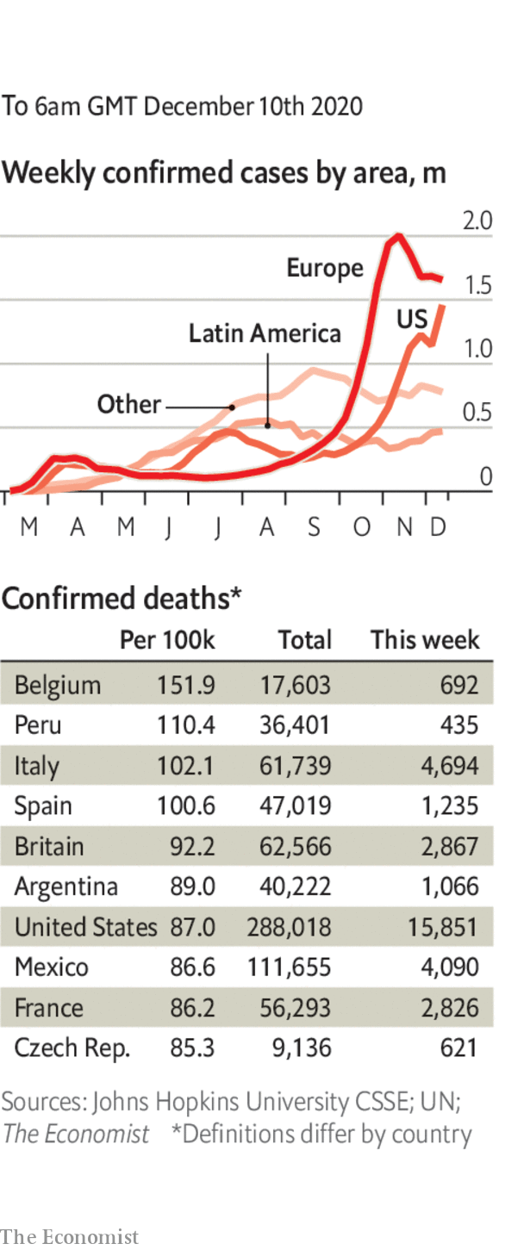

America reported more than 3,000 deaths in a single day for the first time. Hospitalisations also hit a new record.

Most of California’s residents were told to stay at home, as tighter restrictions were introduced in counties where the virus is surging.

Officials in France said it was now unlikely that a national lockdown will end on December 15th. In Germany, Angela Merkel said her country should go into a hard lockdown before Christmas.

Daily infections in India continued to fall, dropping below 27,000 for the first time in five months.

A “cruise to nowhere” in waters off Singapore, which allowed passengers to experience the fun of a cruise ship without disembarking, had to return to port when someone tested positive on board (he subsequently tested negative in a re-test).

This article was downloaded by calibre from <https://www.economist.com/the-world-this-week/2020/12/10/politics-this-week>

|  |  |  |  |
| --- | --- | --- | --- |
|  | Articles | Sections | Next |

|  |  |  |  |
| --- | --- | --- | --- |
| Previous | Articles | Sections | Next |

# Business this week

Dec 10th 2020 |

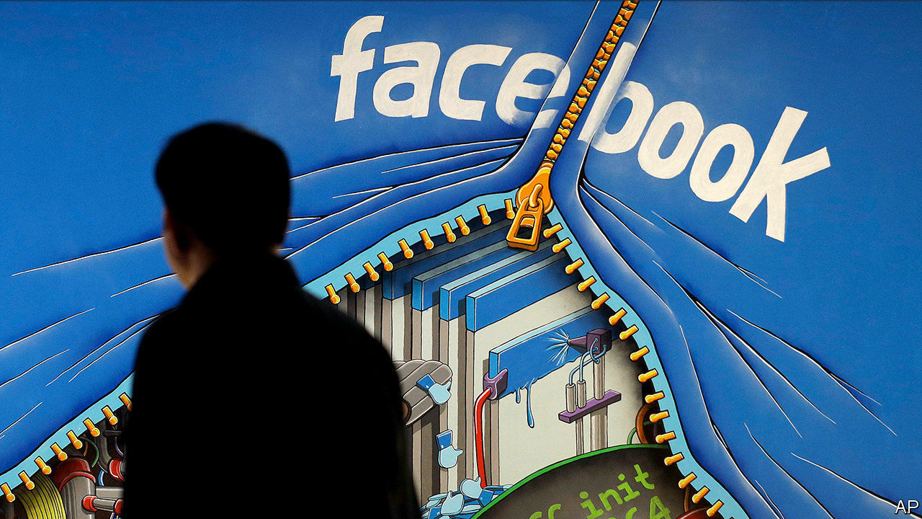

America’s competition regulator filed an antitrust lawsuit against Facebook, alleging that it bought WhatsApp and Instagram, two social-media rivals, to suppress competition. Separately, a coalition of 46 American states, led by New York, launched a similar lawsuit against the company. Facebook argues that the legal actions are an attempt to revise history, as the takeovers were scrutinised and approved by regulators at the time. See article.

Uber decided to sell its autonomous-vehicles subsidiary to Aurora, a startup that counts Amazon among its backers. Uber spent billions on self-driving cars, which it can no longer afford as the pandemic eats into its ride-hailing business (it is also selling its flying-car division, Uber Elevate, to a separate startup). The project unnerved investors in 2018 when one of its cars killed a woman in Arizona, the first fatal collision involving an autonomous car and a pedestrian. Uber is not getting out of the business entirely. It will take a stake in Aurora and may eventually integrate the technology with its platform. See [article](https://www.economist.com/node/21796085).

## Back in the sky

The first commercial flight of a Boeing 737 MAX took place, 20 months after the fleet was grounded worldwide following two fatal crashes. Gol airline flew passengers from São Paulo to Porto Alegre after its pilots completed training to fly the revamped jet, which has been certified as safe in Brazil and the United States. Meanwhile, Boeing delivered its first 737 MAX aircraft since the ban was lifted, to United Airlines, which will test the plane before entering it into service.

Huge investor appetite for the stockmarket debut of DoorDash, America’s leading meal-delivery app, pushed its share price up by 86% on the first day of trading, valuing it at $60bn. DoorDash raised $3.4bn from its IPO. Facing similar demand for its IPO, Airbnb priced its shares above the target range it had set out to investors, as it prepared to float on the Nasdaq exchange. See [article](https://www.economist.com/node/21796072).

JD Health’s IPO was also a success. The health-care division of JD.com, one of China’s big e-commerce companies, raised $3.5bn in Hong Kong, in the biggest flotation of shares on the city’s stockmarket this year. See [article](https://www.economist.com/node/21796117).

China’s exports grew by 21% in dollar terms in November over the same month last year, the fastest pace since February 2018. Much of that came from exports to the United States, which rose by half, despite the stiff tariffs imposed by the Trump administration in the countries’ trade war.

Meanwhile, China’s official consumer price index fell by 0.5% in November from a year earlier, the country’s first month of deflation since October 2009. A drop in food prices, notably in pork, as pig stocks improved after a bout of swine fever, lay behind the fall.

In Japan the government began a fresh round of stimulus following earlier packages in April and May, and said it thinks the latest measures will boost GDP by 3.6%. As well as fighting covid-19, the money will be spent on green and digital technologies.

Société Générale became the latest big bank to recognise the pandemic’s effect on changing customer behaviour, as it set out a restructuring plan with a “fully digital banking model” at its heart. The French bank is merging its two retail-bank networks, which will result in around 600 branch closures.

Ivan Glasenberg decided to retire as chief executive of Glencore, a job he has held for almost 20 years. Under his leadership Glencore became a global powerhouse in commodities, expanding from trading into mining. Mr Glasenberg’s replacement when he steps down next year will be Gary Nagle, who runs Glencore’s coal business. He has been tasked with a new company plan to cut its emissions by 40% over the next 15 years.

The World Economic Forum changed the location of its annual meeting next year to Singapore. The event, already postponed from January to May, is normally held in Davos, Switzerland, but the WEF thinks the risk from covid-19 is too high in Europe.

In what is thought to be the most lucrative deal for a single artist’s publishing rights, Bob Dylan sold the copyright for more than 600 songs to Universal Music. The price was not revealed, but the troubadour and winner of a Nobel prize in literature is said to have wrung $300m from Universal, certainly no simple twist of fate. See [article](https://www.economist.com/node/21796070).

## A publishing sensation

Seventy years after it was first published, IKEA said it was “turning the page” and will no longer print a catalogue. IKEA used to distribute 200m copies of its book in 32 languages, but it has been surpassed by digital browsing. Catalogues in general are heading for the checkout. Argos, a British retailer, will stop printing its in January. A family staple at Christmas, the Argos catalogue was once Europe’s most widely printed publication, vying with the Bible for the title of most-read book in Britain.

This article was downloaded by calibre from <https://www.economist.com/the-world-this-week/2020/12/10/business-this-week>

|  |  |  |  |
| --- | --- | --- | --- |
| Previous | Articles | Sections | Next |

|  |  |  |  |
| --- | --- | --- | --- |
| Previous | Articles | Sections | Next |

# KAL’s cartoon

Dec 12th 2020 |

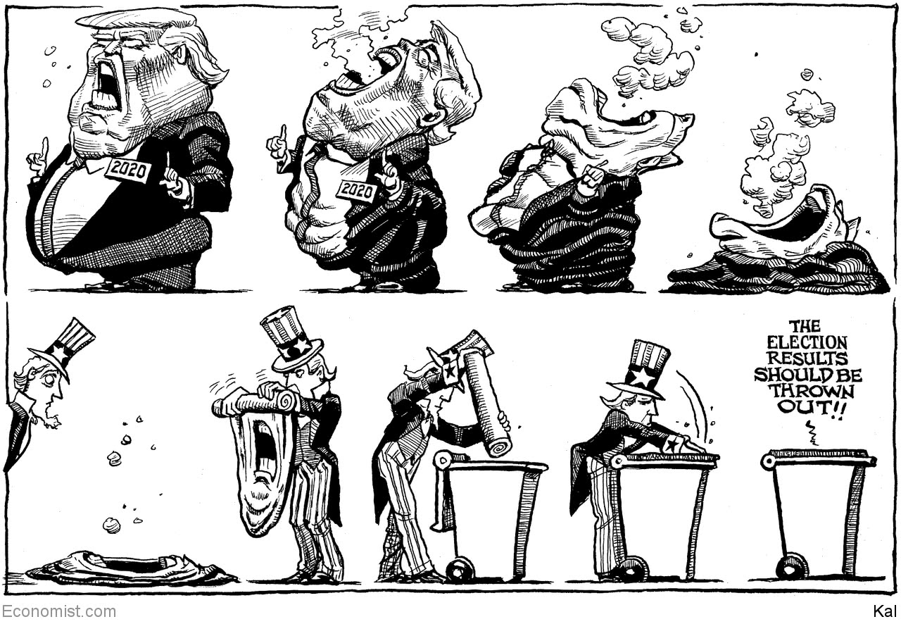

This article was downloaded by calibre from <https://www.economist.com/the-world-this-week/2020/12/12/kals-cartoon>

|  |  |  |  |
| --- | --- | --- | --- |
| Previous | Articles | Sections | Next |

|  |  |  |
| --- | --- | --- |
| The world this week | Sections | Letters |

Leaders

The world economy: Will inflation return?

.

Brexit trade negotiations: Last tango in Brussels

.

The IPO boom: Capital idea

.

Transgender medicine: First, do no harm

.

The music industry: Knock-knock-knockin’ on Jody’s door

.

|  |  |  |
| --- | --- | --- |
| The world this week | Sections | Letters |

|  |  |  |  |
| --- | --- | --- | --- |
|  | Articles | Sections | Next |

#### The world economy

# After the pandemic, will inflation return?

Low inflation underpins today’s economic policy. It is not guaranteed to last

Dec 12th 2020 |

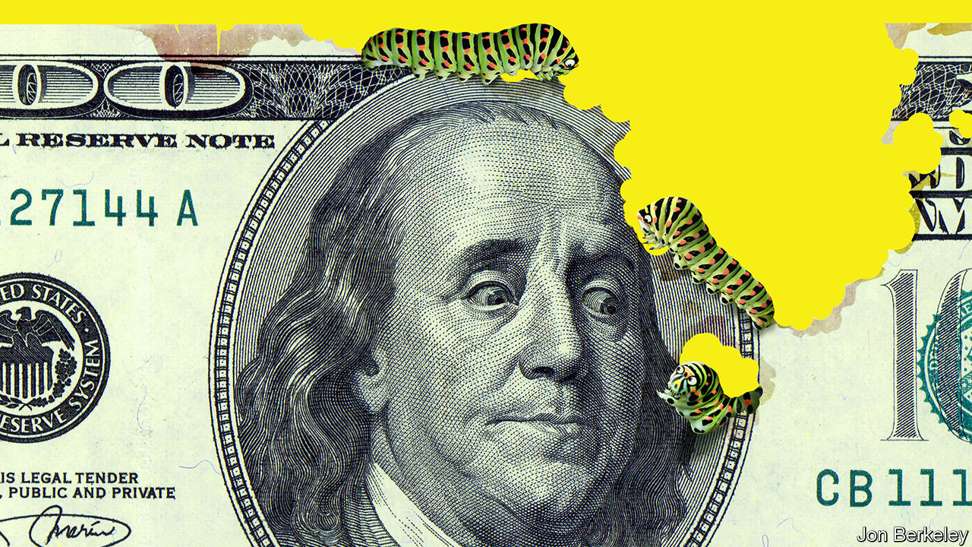

ECONOMISTS LOVE to disagree, but almost all of them will tell you that inflation is dead. The premise of low inflation is baked into economic policies and financial markets. It is why central banks can cut interest rates to around zero and buy up mountains of government bonds. It explains how governments have been able to go on an epic spending and borrowing binge in order to save the economy from the ravages of the pandemic—and why rich-world public debt of 125% of GDP barely raises an eyebrow. The search for yield has propelled the S&P 500 index of shares to new highs even as the number of Americans in hospital with covid-19 has surpassed 100,000. The only way to justify such a blistering-hot stockmarket is if you expect a strong but inflationless economic rebound in 2021 and beyond.

Yet as we explain this week (see article), an increasingly vocal band of dissenters thinks that the world could emerge from the pandemic into an era of higher inflation. Their arguments are hardly overwhelming, but neither are they empty. Even a small probability of having to deal with a surge in inflation is worrying, because the stock of debt is so large and central-bank balance-sheets are swollen. Rather than ignore the risk, governments should take action now to insure themselves against it.

In the decades since Margaret Thatcher warned of a vicious cycle of prices and wages that threatened to “destroy” society, the rich world has come to take low inflation for granted. Before the pandemic even an ultra-tight jobs market could not jolt prices upwards, and now armies of people are unemployed. Many economists think the West, and especially the euro zone, is heading the way of Japan, which fell into deflation in the 1990s and has since struggled to lift price rises far above zero.

Predicting the end of this trend is a kind of apostasy. After the financial crisis some hawks warned that bond buying by central banks (known as quantitative easing, or QE) would reignite inflation. They ended up looking silly.

Today the inflationistas’ arguments are stronger. One risk is of a temporary burst of inflation next year. In contrast to the period after the financial crisis, broad measures of the rich-world money supply have shot up in 2020, because banks have been lending freely. Stuck at home, people have been unable to spend all their money and their bank-balances have swelled. But once they are vaccinated and liberated from the tyranny of Zoom, exuberant consumers may go on a spending spree that outpaces the ability of firms to restore and expand their capacity, causing prices to rise. The global economy already shows signs of suffering from bottlenecks. The price of copper, for example, is 25% higher than at the start of 2020.

The world should be able to manage such a temporary burst of inflation. But the second inflationista argument is that more persistent price pressures will also emerge, as structural disinflationary forces go into reverse. In the West and in Asia many societies are ageing, creating shortages of workers. For years globalisation lowered inflation by creating a more efficient market for goods and labour. Now globalisation is in retreat.

Their third argument is that politicians and officials are complacent. The Federal Reserve says it wants inflation to overshoot its 2% target to make up for lost ground; the European Central Bank, which announced more stimulus on December 10th, may yet follow suit. Weighed down by the need to pay for an ageing population and health care, politicians will increasingly favour big budget deficits.

Might these arguments prove correct? A temporary rebound in inflation next year is perfectly possible. At first it would be welcome—a sign economies were recovering from the pandemic. It would inflate away a modest amount of debt. Policymakers might even breathe a sigh of relief, especially in Japan and the euro zone, where prices are falling (though rapid changes in the pattern of consumer spending may have muddied the statistics).

The odds of a more sustained period of inflation remain low. But if central banks had to raise interest rates to stop price rises getting out of hand, the consequences would be serious. Markets would tumble and indebted firms would falter. More important, the full cost of the state’s vastly expanded balance-sheet—both governments’ debt and the central banks’ liabilities—would become alarmingly apparent. To understand why requires peering, for a moment, into how they are organised.

For all the talk about “locking in” today’s low long-term interest rates, governments’ dirty secret is that they have been doing the opposite, issuing short-term debt in a bet that short-term interest rates will remain low. The average maturity of American Treasuries, for example, has fallen from 70 months to 63. Central banks have been making a similar wager. Because the reserves they create to buy bonds carry a floating interest rate, they are comparable to short-term borrowing. In November Britain’s fiscal watchdog warned that a combination of new issuance and QE had left the state’s debt-service costs twice as sensitive to short-term rates as they were at the start of the year, and nearly three times as much as in 2012.

So while the probability of an inflation scare may have risen only slightly, its consequences would be worse. Countries need to insure themselves against this tail risk by reorganising their liabilities. Governments should fund fiscal stimulus by issuing long-term debt. Most central banks should start an orderly reversal of QE and instead loosen monetary policy by taking short-term interest rates negative. Finance ministries should incorporate risks taken by the central bank into their budgeting (and the euro zone should find a better tool than QE for mutualising the debts of its member states). Shortening the maturity of the state’s balance-sheet—as in 2020—must only ever be a last resort, and should not become the main tool of economic policy.

## In praise of mothballs

The chances are the inflationistas are wrong. Even the arch-monetarist Milton Friedman, who inspired Thatcher, admitted late in his life that the short-term link between the money supply and inflation had broken down. But the covid-19 pandemic has shown the value of preparing for rare but devastating events. The return of inflation should be no exception. ■

Editor’s note: Some of our covid-19 coverage is free for readers of The Economist Today, our daily [newsletter](https://my.economist.com/user#newsletter). For more stories and our pandemic tracker, see our [hub](https://www.economist.com/news/2020/03/11/the-economists-coverage-of-the-coronavirus)

This article was downloaded by calibre from <https://www.economist.com/leaders/2020/12/12/after-the-pandemic-will-inflation-return>

|  |  |  |  |
| --- | --- | --- | --- |
|  | Articles | Sections | Next |

|  |  |  |  |
| --- | --- | --- | --- |
| Previous | Articles | Sections | Next |

#### Last tango in Brussels

# A thin, last-minute Brexit trade deal is better than no deal at all

It would at least provide a base on which later agreements could be built

Dec 12th 2020 |

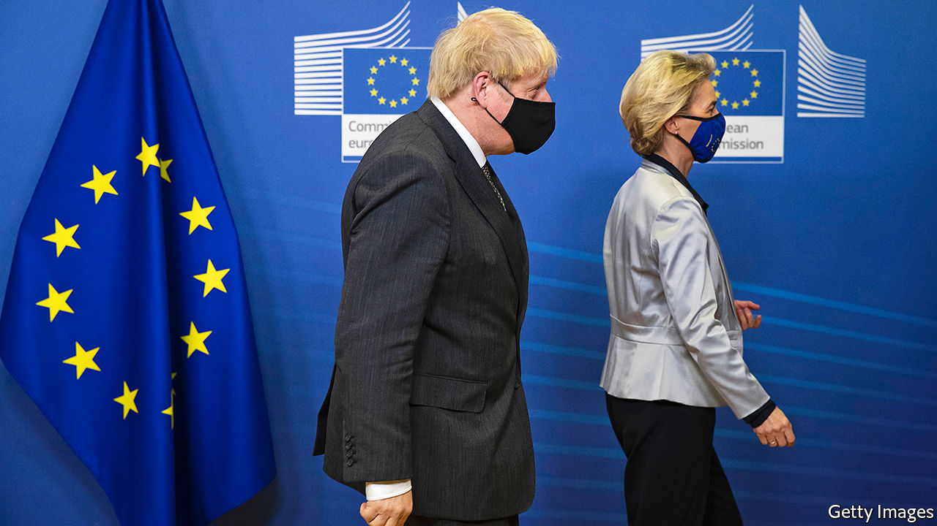

WITH THE Brexit trade talks deadlocked—again—Boris Johnson flew to Brussels on December 9th to meet Ursula von der Leyen. By having a fish dinner with the European Commission’s president, the prime minister hoped to replicate the last-minute deal that he struck in the Brexit withdrawal treaty in the autumn of 2019 after he went for a walk in Cheshire with his Irish counterpart, Leo Varadkar. This time it seems not to have worked. As we went to press, the two had agreed that negotiations should continue until Sunday, but the dinner failed appreciably to narrow any of the big gaps remaining.

Contrary to many reports, the most intractable of these is not over access to British fishing waters. For both sides, fisheries are politically important but economically insignificant, which should make a compromise feasible. The biggest difficulty concerns the so-called level playing field. This is the label for the European Union’s longstanding worry that post-Brexit Britain may undercut the social, labour, environmental and state-subsidy rules that underpin its single market. The EU’s wish to be allowed to retaliate promptly if this happens runs slap against Mr Johnson’s claim that Brexit must mean unfettered sovereignty and an absolute right to diverge from regulations that are set in Brussels. If no compromise proves possible on the level playing field, the outcome is likely to be that there will be no trade deal in place when the transition period comes to an end on December 31st.

The deal or no-deal argument skates over an important fact: that even agreement would represent a hard Brexit. Avoiding tariffs and quotas on goods is certainly desirable, but it still entails leaving the single market that Margaret Thatcher did so much to create. The deal does nothing for services, which make up 80% of the economy. The EU is withholding decisions to grant Britain the necessary equivalence for its financial regulation or to rule its data protection adequate so as to permit data transfers. Being out of the customs union implies not just more bureaucracy and customs controls but also checks on rules of origin for exports. A trade deal that erects rather than pulls down barriers is an unusual beast. Industries ranging from broadcasting to chemicals (see article) will suffer from being under a different regulatory regime and losing hitherto frictionless trade.

Then there is Northern Ireland. Under the withdrawal treaty, the province will stay in the single market and customs union in order to avert the risk of a hard border with the Irish Republic. But this necessitates checks on goods crossing the Irish Sea. It is welcome that, after reaching agreement with the EU this week on how these checks should be done, the government has abandoned its earlier plans unilaterally (and illegally) to rewrite the Northern Irish provisions of the withdrawal treaty. But treating the province, which voted to remain in the EU, differently from Great Britain inevitably raises questions about the future of the United Kingdom. Equally, the demand for a second independence referendum is rising in Scotland, which also voted to remain.

Yet even a thin deal would be better than no deal at all. The economic differences between the two count for something. Modelling by the independent Office of Budget Responsibility finds that a deal would make GDP some 4% lower than it otherwise would be: no deal would add a further 2 percentage point cut on top. Then there are the politics. Whereas a deal would create a base on which Britain could build other agreements with its largest and most important neighbour, the acrimonious blame game that would follow a failure in the talks would poison relations for years. Not reaching a deal would complicate co-operation on such matters as domestic security, intelligence-sharing and foreign policy. And it would stand as a globally reputation-shredding failure of statecraft by both sides. As he returns home from his Brussels dinner, Mr Johnson should reflect on what a poor outcome that would be.■

This article was downloaded by calibre from <https://www.economist.com/leaders/2020/12/12/a-thin-last-minute-brexit-trade-deal-is-better-than-no-deal-at-all>

|  |  |  |  |
| --- | --- | --- | --- |
| Previous | Articles | Sections | Next |

|  |  |  |  |
| --- | --- | --- | --- |
| Previous | Articles | Sections | Next |

#### Public markets

# Will the IPO bonanza last?

From Airbnb to Tesla, 2020 will be a bumper year for capital-raising

Dec 12th 2020 |

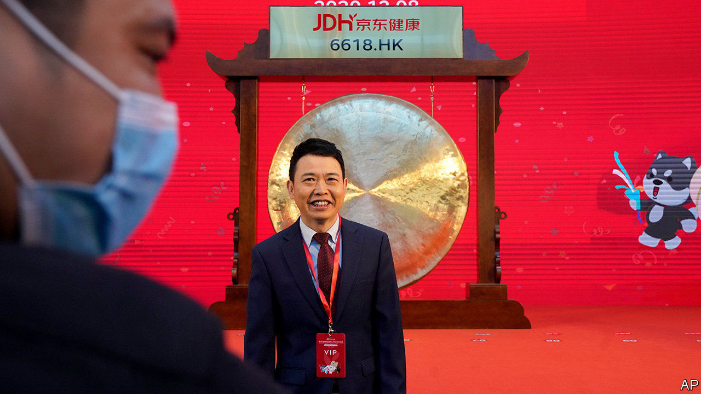

FOR OVER a decade many people in finance have worried about the decline of the public company. Big firms were shrinking their capital bases by buying back shares. And fast-growing firms, including several hundred tech “unicorns”—startups worth over $1bn—chose to remain in private hands rather than bother with an initial public offering (IPO). The result was riskier corporate balance-sheets and the exclusion of ordinary investors from the ownership of the economy’s most exciting firms.

This year has seen a reversal of this trend with an equity-raising bonanza (see article). In the past few days Tesla has said it will sell $5bn of new shares, while DoorDash, a food-delivery company, raised $3.4bn in an IPO. In Hong Kong shares of JD Health, a digital-medicine star, rose by over 50% on their first day of trading after its $3.5bn IPO. As we went to press Airbnb, one of the largest unicorns, was listing at a valuation of over $40bn. Worldwide, some $800bn of equity has been raised in 2020 by non-financial firms, the highest sum on record. In America in the last quarter the proceeds should roughly match the amount of shares that companies have bought back.

Equity is more expensive than borrowing, but has attractions. It is permanent capital that does not need to be repaid. And because it does not come with interest payments it is flexible, making firms more resilient. It is back in fashion for several reasons. Some firms need to repair the damage from the pandemic, for example Rolls-Royce, an aircraft-engine maker, and Carnival Cruises. The tech boom means unicorns can go public at sky-high valuations. Frothy share prices allow the founders of firms that are already listed to raise capital without diluting their own stake by as much—something Tesla’s Elon Musk has spotted.

There are other factors, too. More Chinese firms are coming of age. This year Nongfu Spring, China’s answer to Evian, floated, making its founder the country’s richest man. Investors are experimenting with legal structures that they think are more efficient than IPOs, including SPACs (special purpose acquisition companies). Finally, because covid-19 has led many firms to cut their buybacks there is less equity being retired than normal.

Investors are euphoric but they face several risks. One is that prices are too high. Another is that it is not yet clear whether overall corporate indebtedness will fall, partly because the damage from lockdowns is still mounting. For non-financial companies in America’s S&P 500 index, net debt (debt less cash), dropped only slightly in the third quarter of this year, and remains above its level in 2019. Some firms are still burning cash and perhaps a fifth of S&P 500 firms are overborrowed. As the pandemic abates, firms may reinstate buybacks and dividends.

The last danger stems from a cohort of firms having too much cash. In the 1970s Michael Jensen, a scholar, argued that debt forced discipline on managers. His ideas were taken too far by Wall Street’s junk-bond salesmen, but the risk of executives wasting cash on deals or vanity projects is real. The five biggest tech firms have over $550bn sitting around. They might try big takeovers—think of Apple buying Netflix. Meanwhile, some newly listed firms have oodles of cash, but give outside investors only limited voting power, making managers unaccountable.

Governments should welcome the equity boom. For years libertarians have argued that the only way to revive IPOs is by watering down corporate-governance rules. They have been proved wrong. Many politicians long to ban buybacks, which they accuse of all sorts of evils (in fact they are similar to dividends but more flexible, which came in handy this year). If politicians really want to sustain healthy equity markets, they should instead reform tax codes, which almost everywhere favour debt by making interest costs tax-deductible. Removing the tax break for debt and putting equity on a level playing field should be the priority. It has the added advantage that the proceeds should help governments repay their own colossal debts.■

This article was downloaded by calibre from <https://www.economist.com/leaders/2020/12/12/will-the-ipo-bonanza-last>

|  |  |  |  |
| --- | --- | --- | --- |
| Previous | Articles | Sections | Next |

|  |  |  |  |
| --- | --- | --- | --- |
| Previous | Articles | Sections | Next |

#### First, do no harm

# Other countries should learn from a transgender verdict in England

The high court ruled that children cannot give informed consent to treatment that may render them sterile

Dec 12th 2020 |



WHAT SHOULD you do if a 12-year-old girl says: “I am a boy”? If the answer were simple or obvious, the question would not be so explosively controversial. A good place to start, if you are a parent, is to affirm that you love the child. It should go without saying, too, that no child should be bound by gender stereotypes. Boys can wear dresses; girls can play with cars, or become plumbers. The question gets much harder, however, when children say they hate their body and want a different one. Gender dysphoria (a feeling of alienation from one’s natal sex) is real, and the proportion of children and adolescents diagnosed with it in rich countries is rising for reasons that are poorly understood (see [article](https://www.economist.com/international/2020/12/12/an-english-ruling-on-trans-identifying-teens-could-have-global-repercussions)). One school of thought, which has spread rapidly, is that you should agree with youngsters who identify as transgender, and offer them medical interventions, if they ask for them, to help their bodies match what they regard as their true selves.

England’s high court last week highlighted some of the problems that can flow from such thinking. The case concerned Keira Bell, who says she was rushed into life-changing medical treatment when she was 16, which she now regrets. The process began with drugs that delay puberty. These are typically described as reversible and a way to “buy time”. But at the Tavistock clinic, where Ms Bell was treated, most patients who took puberty blockers went on also to take cross-sex hormones (oestrogen for males who want to grow breasts; testosterone for females who want to develop male sexual characteristics). Many then proceeded to surgery.

Some of the effects of this are irreversible. Skipping puberty causes sterility. Ms Bell’s breasts, which were removed when she was 20, will not grow back. Those who undergo gender-reassignment treatment may never be able to have children of their own, or experience an orgasm; and the evidence of long-term benefits is extremely sketchy. The English court said it was highly unlikely that someone of 15 could understand all this well enough to give informed consent to taking puberty blockers, which it called an experimental treatment. It suggested that in the case of 16- or 17-year-olds, it might be wise for doctors to seek a court’s permission before prescribing such drugs. Once they reach adulthood, young people in England and Wales are free to seek whatever hormones or surgery they choose.

Many trans activists denounced the ruling as a travesty, or even a denial of the right of trans people to exist. Their passion is understandable. Trans people have often been appallingly treated, and it is right that societies should pass laws to protect them from discrimination, and from bullying in schools. But given the available evidence, the ruling is a reasonable attempt to set out guidelines in an area where there are as yet no good solutions. Other countries should learn from it.

Some children and adolescents who express gender dysphoria will never be happy with their natal sex. But studies suggest that 61-98% of children with gender-related distress, if allowed to go through puberty without medical intervention, will be reconciled to it. Many will realise that they are simply gay. Alas, there is as yet no way to predict these outcomes. So the possible harm of delaying transition for those who might benefit from it must be weighed against harm to the health and the emotional lives of a larger number of people. The latter harm appears worse, so the English court was right to err on the side of preventing it.

It was also right to criticise the Tavistock for several failures. The clinic could not say how many of those referred for puberty blockers had autism, which is common among those who express gender dysphoria. It did not have good data on how many move on to cross-sex hormones. Nor did it properly lay out for patients the alternatives to medical intervention.

Perhaps clinics in other rich countries do a better job of caring for the children and adolescents that attend them. But since they are often subject to less scrutiny, it would be unwise to assume so. The number of transgender clinics has shot up in several countries. In America it has risen from one to more than 50 since 2007—there are no national statistics on how many patients seek treatment. And some activists are urging rules which, though no doubt well-meaning, would make it harder to strike the right balance when treating gender dysphoric children.

Some Australian and American states have banned “conversion therapy” in relation to sexual orientation or gender identity; Canada is considering doing likewise. This conflates two issues which are not the same. It is wrong to try to talk gay people into being straight. But the same principles applied to gender identity could criminalise counselling that raises the distinct possibility that a particular trans-identifying child or adolescent might one day desist. So such laws are a bad idea. Youngsters who are trying to grapple with gender dysphoria need honest, caring therapy that sets out all the long-term options. Health services must do a better job of providing it. And before embracing invasive procedures such as those undergone by Ms Bell, the medical profession needs to gather evidence to establish the balance of benefits and harm they bring. ■

This article was downloaded by calibre from <https://www.economist.com/leaders/2020/12/12/other-countries-should-learn-from-a-transgender-verdict-in-england>

|  |  |  |  |
| --- | --- | --- | --- |
| Previous | Articles | Sections | Next |

|  |  |  |  |
| --- | --- | --- | --- |
| Previous | Articles | Sections | Next |

#### Knock-knock-knockin’ on Jody’s door

# A song for Dylan’s deal with Universal

Selling your catalogue makes sound commercial sense. But it may not always fit the brand

Dec 12th 2020 |

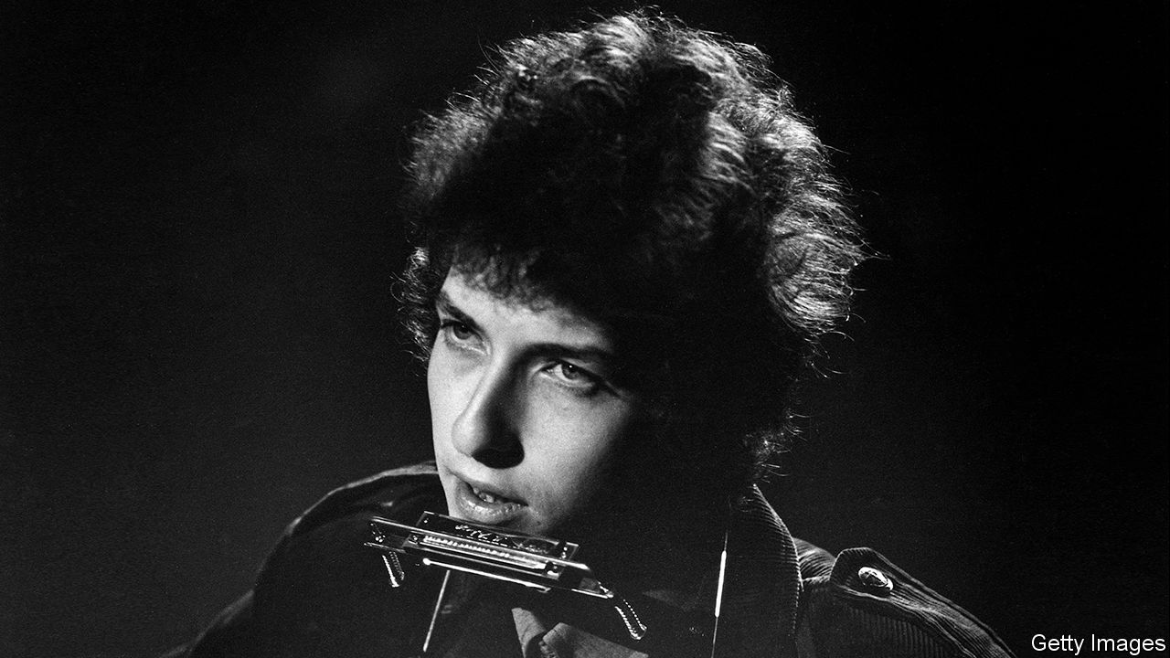

THIS WEEK Bob Dylan sold his song catalogue to Universal Music Publishing Group. Mr Dylan, like other musicians, has not been able to tour during the pandemic. Cashing in now will spare him the bureaucracy of future tax payments. Universal’s chief executive, Jody Gerson, has not disclosed how much the group paid. Mr Dylan has put his thoughts about the deal into ballad-form. It came into our hands thanks to a Mr Tambourine Man.

Hey! Ms Universal, Ma’am, play my songs for me  
In the clouded covid mourning I’ll sell ’em all to you  
My weariness amazes me, I’m branded on my feet  
I have no one to sing to  
And the ancient empty street’s dead set for streaming

We live in a commercial world  
Love don’t have any place  
Life is in mirrors, death disappears  
Up the steps into the nearest bank

Papa’s bank book wasn’t big enough  
And I was standin’ on the side of the road  
Lord knows I’ve paid some dues gettin’ through  
Tangled up in red tape

I never said nothing, there was nothing I wrote  
I went with the woman  
In the long black stretch-limo

Oh, Bob said to Jody G, “Name me a sum”  
Jody says, “Man, you must be puttin’ me on”  
Bob say, “No.” Jody say, “What?”  
Bob say, “You must pay what I want Jody  
But next time they play my songs you’re in the mon  
Ey.” Jody says, “When you want this payin’ done?”  
Bob says, “In structured payments in the next three tax years.”

How many roads must a man walk down  
Before you call him a financier?  
Yes, ’n’ how many deaths will it take till he knows  
That the live-performance industry is in severe recession?  
Yes, ’n’ how many years can some people exist  
Before they capitalise their ongoing revenues?  
The answer, my friend, is contained on p96 of the offer document

I ain’t gonna work on no one’s farm no more  
No, I ain’t gonna work on no one’s farm no more  
Well, I tried my best  
To find the highest price  
And Universal wants me  
To sell it to them  
So I ain’t gonna work on no one’s farm no more

Ring them opening bells at the NYSESo the people will know  
Oh it’s rush hour now  
Ring them closing bells for the chosen few  
who will judge when the dividend is due  
Bring them Nobels for the child that cries  
When innocence dies

You say you’re lookin’ for someone  
Who’s never venal but always strong  
To protect you and defend you  
From the greed you think is wrong  
Someone to turn their back on Mammon’s law  
But it ain’t me, babe  
No, no, no, it ain’t me, babe  
It ain’t me you’re lookin’ for, babe

How does it feel  
How does it feel  
Like a complete tycoon  
Like a rolling stone?

Hey! Ms Universal, Ma’am, play my songs for me  
In the clouded covid mourning I’ll sell ’em all to you

©Universal Music Publishing Group■

This article was downloaded by calibre from <https://www.economist.com/leaders/2020/12/12/a-song-for-dylans-deal-with-universal>

|  |  |  |  |
| --- | --- | --- | --- |
| Previous | Articles | Sections | Next |

|  |  |  |
| --- | --- | --- |
| Leaders | Sections | Briefing |

Letters

On race data, Galicia, epidemiology, Bosnia, companies, Jonathan Sacks, China: Letters to the editor

.

|  |  |  |
| --- | --- | --- |
| Leaders | Sections | Briefing |

|  |  |  |  |
| --- | --- | --- | --- |
|  | Articles | Sections | Next |

#### On race data, Galicia, epidemiology, Bosnia, companies, Jonathan Sacks, China

# Letters to the editor

A selection of correspondence

Dec 12th 2020 |

Letters are welcome via e-mail to letters@economist.com

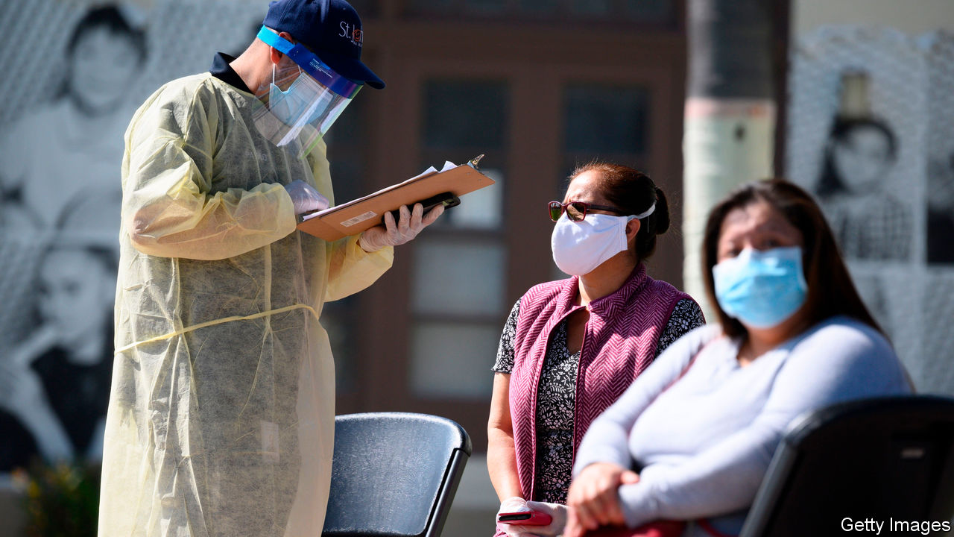

## WEIRD science

You reported that a lack of data on race hampers efforts to tackle inequalities, and exhorted governments to ensure that they start to gather this vital information (“[Wanted: more data](https://www.economist.com/leaders/2020/11/21/a-lack-of-data-on-race-hampers-efforts-to-tackle-inequalities)”, November 21st). This message also needs to be heard by researchers. The over- or under-sampling of ethnic and social groups in research is skewing our understanding of human behaviour and disease. As of 2018, individuals included in the vital studies defining the genetic causes of diseases were 78% European, 10% Asian, 2% African, 1% Hispanic, and less than 1% for all other ethnic groups. A report in Science suggested that Western bias in human genetic studies is “both scientifically damaging and unfair”. In the field of psychology, the problem is so great—96% of data comes from 12% of the world’s citizens—that the over-sampled privileged population has its own acronym, WEIRD (Western, Educated, Industrialised, Rich and Democratic). This WEIRD population has been shown across a number of traits to be poorly representative of the wider population.

Missing data matter. This increases inequalities, especially when missing from inputs to algorithmic decision-making systems and artificial intelligence, technologies that have an impact on society.

PROFESSOR ANDREW MORRISCAROLINE CAKE  
PROFESSOR ALASTAIR DENNISTON  
Health Data Research UKLondon

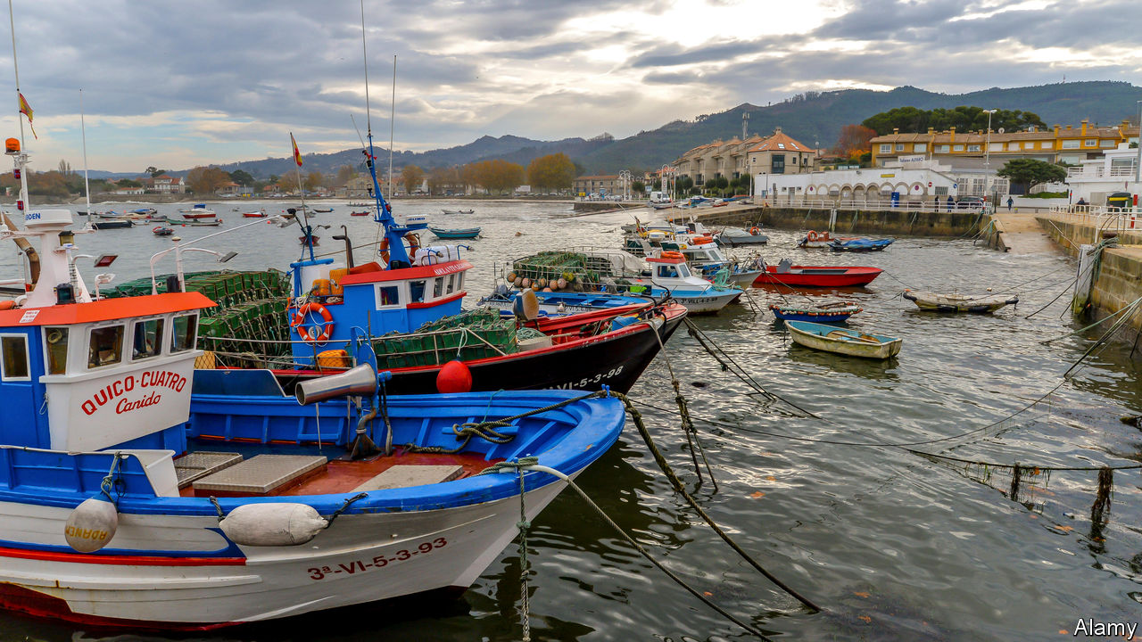

## Borders melt away

One important thing to note about the Spanish region of Galicia is that things began to improve when Spain joined the European Union and the border with Portugal disappeared (“[Us Gallegos](https://www.economist.com/europe/2020/11/07/galicia-shows-how-devolution-can-work)”, November 7th). The combined Spanish and Portuguese area in the north-west of the Iberian peninsula has 12.5m people. Money from Europe helped build a motorway between Vigo and Porto. Thanks to the EU, we are now more open to international trade than most Spanish regions, and our economy is growing fast. In Galicia, at least on the economic front, our relationship with Portugal is as important as it is with Madrid. Our languages are similar, which helps us communicate with 300m Portuguese speakers around the world.

ENRIQUE SáEZA Coruña, Spain

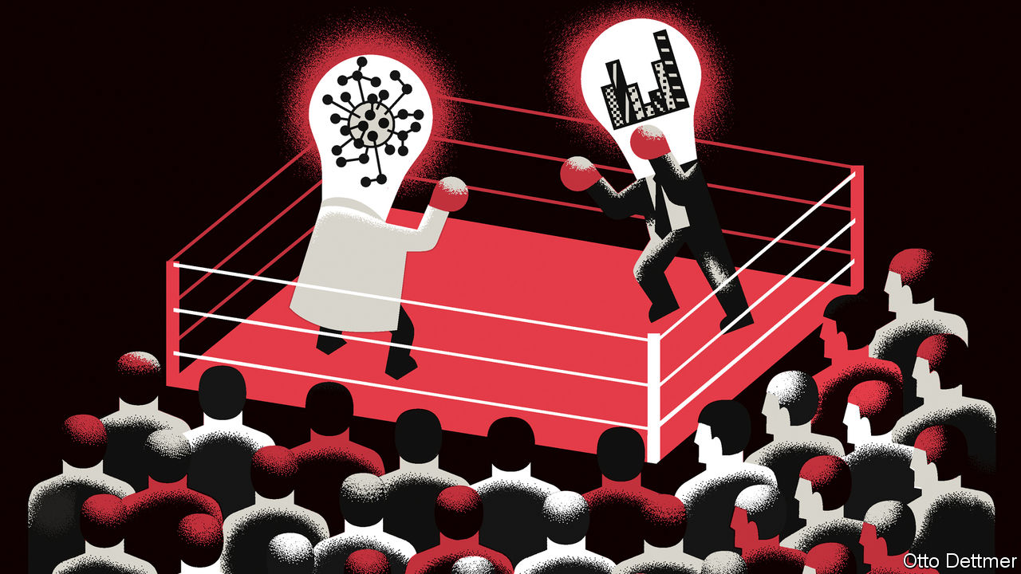

## The economics of a disease

Although epidemiologists may have sometimes failed to see how social behaviour influences the spread of a disease ([Free exchange](https://www.economist.com/finance-and-economics/2020/11/14/why-relations-between-economists-and-epidemiologists-have-been-testy), November 14th), economists have often been slow to recognise how the social changes generated by the threat of a disease affects the economy. This is the second time this century that economists have failed miserably to anticipate how an epidemic can be as much an economic crisis as it is a public-health one, and to anticipate how deep it would be once it did emerge.

You said, rightly, that economics shows very little interest in crossing disciplines. More worrying is the insistence of economists to rely on a limited set of methods that, although rigorous, prevent us from investigating catastrophic risks. George Akerlof recently criticised the “hard” methods that are preferred in economics.

ILAN NOYChair in the economics of disasters and climate change  
Victoria University of Wellington  
Wellington, New Zealand

Your column claimed that economists like me and epidemiologists “got off on the wrong foot” during the pandemic. The views you attributed to “economists” are those of a small but loud minority. Most economists I know value the work of epidemiologists and try to learn from them as much as possible. They do not “intensely criticise” epidemiologists’ models or their use. Instead they have benefited greatly from them and been very much aware of how difficult it is to forecast an epidemic in the face of limited and fast-changing data availability and quality. They also try to collaborate with, and get feedback from, epidemiologists and public-health researchers.

BENJAMIN MOLLProfessor of economics  
London School of Economics

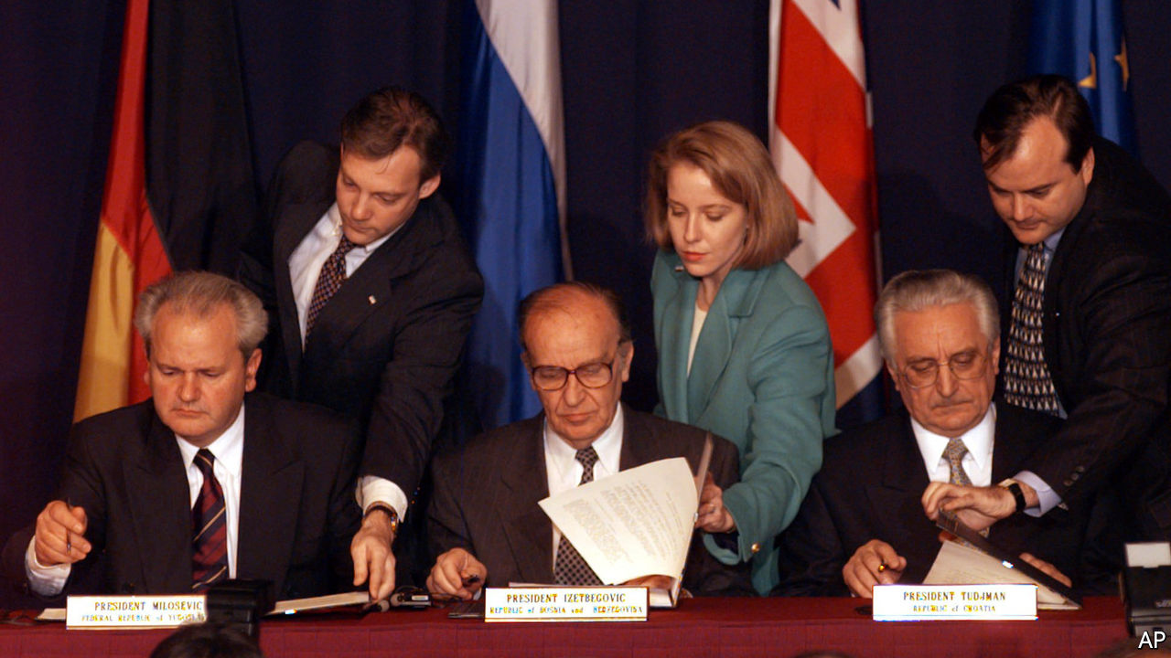

## After the Dayton peace deal

“[Dayton at 25](https://www.economist.com/europe/2020/11/21/after-a-quarter-of-a-century-of-peace-bosnia-remains-wretched)” (November 21st) depicted Bosnia correctly in several aspects. When I started visiting the country 12 years ago, I was surprised to still see divisions among its people. The war heroes on monuments in one place would be considered war criminals just a few kilometres away. Car plates bear no indication of the region of registration, probably to prevent trouble. Yet some of the problems you pointed out are not necessarily attributable to the current state structure: mass emigration, poverty and bad public services can be found in several ethnically homogenous countries. As regards Milorad Dodik, he may well talk “of independence and integration with Serbia”, but he will not follow this up with action. Any new armed confrontation is close to impossible. Over time, the present differences will soften. In the future, Dayton at 50 might be a rare example of a successful case in state building.

OLEKSANDR OVCHYNNYKOVStrasbourg



## The corporate jungle

Writing about the change in leadership at McDonald’s, [Schumpeter](https://www.economist.com/business/2020/11/14/takeaways-from-mcdonalds-remarkable-comeback) mused on new bosses who are “overeager to tear up the legacy of their disgraced predecessors” (November 14th). This is what I call the Simba Syndrome. Many new executives follow the model of the lion pride, formed by a dominant male, several lionesses and their cubs. When a new male takes over by chasing off or killing the previous king he then kills off the previous male’s cubs. This also happens in companies, where projects and sometimes people linked with the previous boss are “killed off” by the successor upon taking over.

DANIEL WEIHSHaifa, Israel

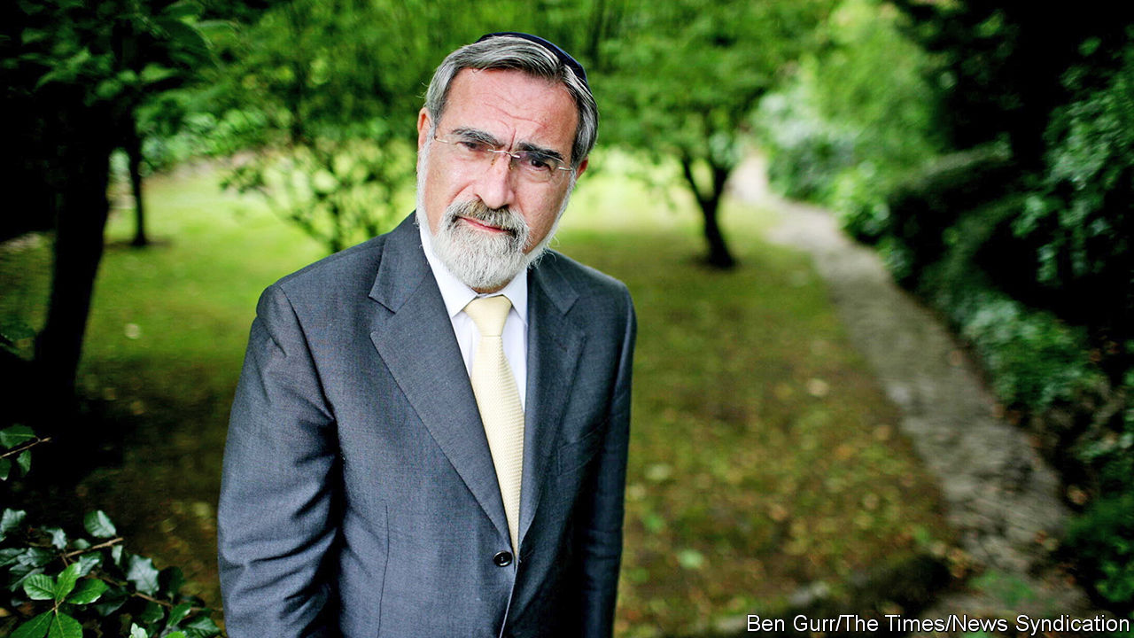

## What Abraham said

Your lovely obituary of Rabbi Lord Sacks (November 21st) mentioned that “Abraham, ordered to sacrifice his son Isaac, had said three times to God, ‘Hineni’, ‘Here I am.’” In fact, Abraham says Hineni to God only once in that episode, once more to God’s messenger (or “angel”), and once to Isaac himself. The story is about Abraham’s fidelity and availability to God, surely; but by embedding the same word in Abraham’s response to his son, the story itself presents the tension between our obligations to the divine and our obligations to our fellow humans. It does not try to obscure those tensions, but confronts the reader frankly with them.

I met Rabbi Sacks only once, and very briefly. But from that encounter, I suspect that he would be delighted that the obituary’s small slip gives us an opportunity to contemplate some of the fundamental dynamics he had dedicated his life to communicating.

CHARLES MATHEWESProfessor of religious studies  
University of Virginia  
Charlottesville, Virginia

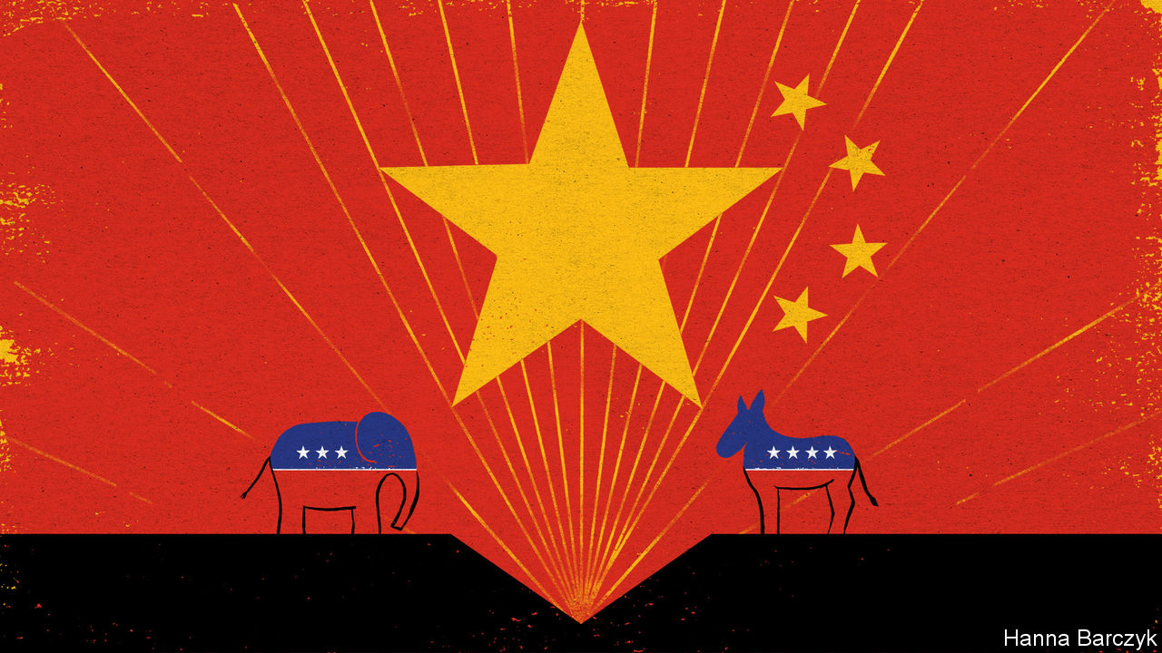

## So there

Chinese officials’ views of America and its democracy may be filled with “disdain” ([Chaguan](https://www.economist.com/china/2020/11/07/no-american-election-will-change-chinas-mind), November 7th) but there is something we can do that China’s citizens cannot. We can change our president. And we did.

ROY GIRASABeaverton, Oregon

This article was downloaded by calibre from <https://www.economist.com/letters/2020/12/12/letters-to-the-editor>

|  |  |  |  |
| --- | --- | --- | --- |
|  | Articles | Sections | Next |

|  |  |  |
| --- | --- | --- |
| Letters | Sections | Asia |

Briefing

Inflation: Prognostication and prophecy

.

|  |  |  |
| --- | --- | --- |
| Letters | Sections | Asia |

|  |  |  |  |
| --- | --- | --- | --- |
|  | Articles | Sections | Next |

#### Tail risks

# A surge in inflation looks unlikely

But it is still worth keeping an eye on

Dec 12th 2020 |

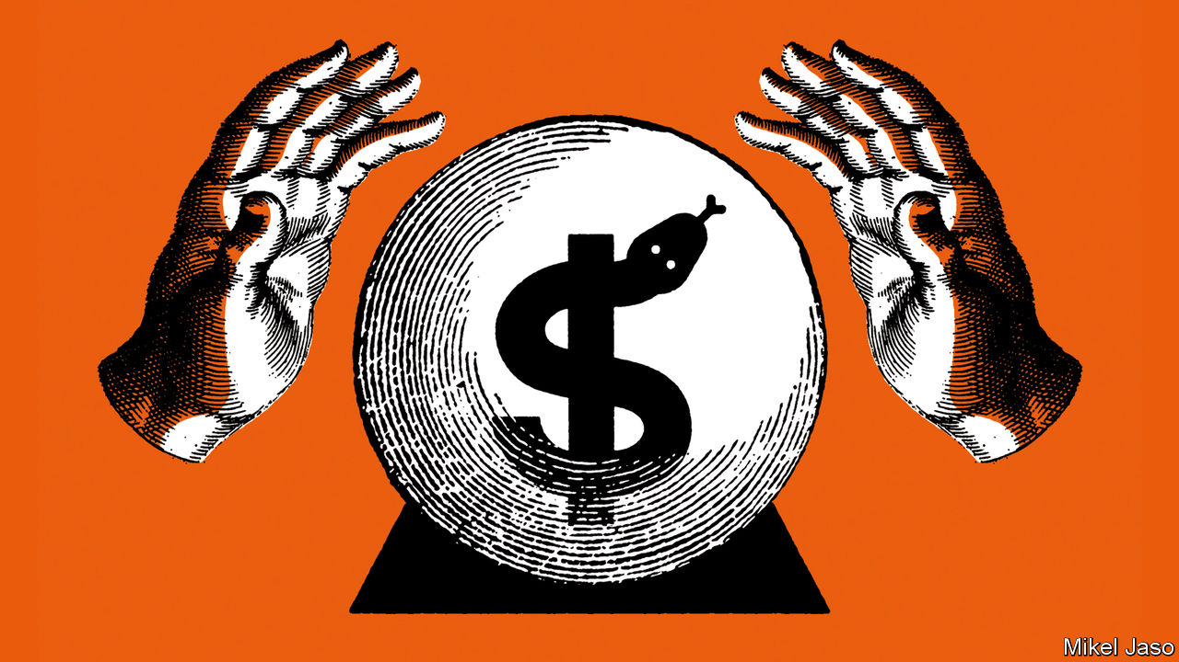

IN 1975 Adam Fergusson, a journalist on the Times, published a book called “When Money Dies”. A history of hyperinflation in Germany in the early 1920s, it was written with an eye to what was going on in the then-present day. Inflation in Britain was not at the prices-soaring-day-by-day levels seen in the Weimar Republic. But in 1975 it reached an unprecedented 24%—grim enough for Fergusson’s warning that the experience of inflation was “totally absorbing, demanding complete attention while it lasts” to hit home.

Rapid, continuous increases in prices arbitrarily take wealth away from savers and devalue people’s wages. It is not just the purchasing power of a unit of currency that is eroded; it is the trust in a reliable future on which contracts and capitalism depend. From the early 1970s to the 1980s more than 50% of Americans said “inflation or the high cost of living” was the single biggest problem facing the country.

But by the 1990s the beast seemed to be vanquished. Average rates dropped; so did the number of “inflation surprises” in which the rate spikes (see chart 1). When “The West Wing”, a television show, gave its fictional president a “secret plan to fight inflation” in 1999 it was as a joke, not a plot point. True to Mr Fergusson’s belief that the experience of living with inflation is “forgotten or ignorable when it has gone”, his book fell out of print.

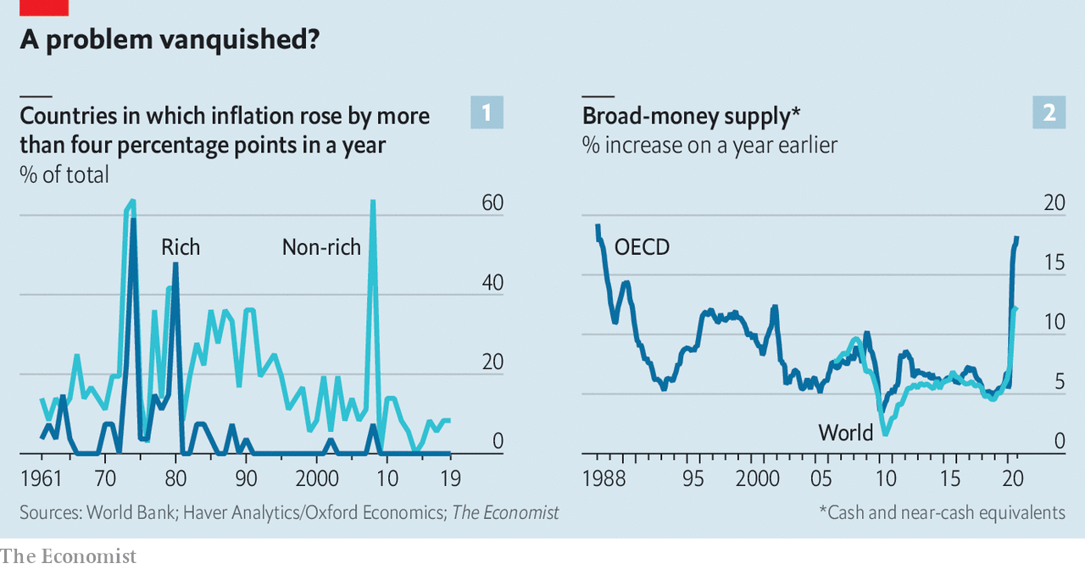

It was republished to acclaim at the end of the 2000s, when post-financial-crisis stimulus packages increased government debt prodigiously, and “quantitative easing”, the process by which trillions of new dollars would be created, started to hit its stride. Many worried that the stage seemed set for prices to surge in a way which had not been seen for a generation.

They did not. Over the 1970s rich-world inflation averaged 10% a year. In the 2010s the rate stayed stubbornly below 2% a year. That is one of the reasons that the small but vocal band of economists and investors that is once again worried about excessive price rises is by and large being ignored. The agenda for a big conference on central banking to be held in February has copious space for financial instability, climate change and inequality but barely any for inflation—despite taking place in Germany, a country which, since Weimar, has all but fetishised sound money.

Indeed a modest rise in inflation, rather than giving central bankers the vapours, would have them sighing with relief. In recent years, and most dramatically during the worst of the crisis this spring, the threat of demand-sapping deflation loomed large, especially in the euro area and Japan. Some want central banks to aim for inflation higher than the 2% target that most of them use, and America’s Federal Reserve has already said that it wants to overshoot its 2% target in the recovery to make up for recent shortfalls. Recent experience suggests that may be hard: interest rates close to zero have left monetary policy hard-put to push inflation back up even to 2%.

## Look behind you

But if it is easy to ignore the prophets of doom, it may not be wise. If 2020 has a lesson, it is that problems which many in the world had broadly stopped worrying about can rear up with sudden and terrible force. And those sounding the alarm today are right to point out that the circumstances of the covid pandemic do not offer a simple re-run of 2009’s false alarm.

Some of today’s inflationistas predict a possibly high but transitory spike in prices as consumer spending bounces back from the pandemic. On December 3rd Bill Dudley, who was until 2018 a vice-chairman of the Fed’s interest-rate-setting committee, warned Bloomberg readers that sharp price increases might be necessary “to balance demand with the available supply, which the pandemic has undoubtedly diminished.” The next day David Andolfatto, an economist at the St Louis Fed, warned Americans to “prepare themselves for a temporary burst of inflation.”

Others warn of more persistent inflationary pressure. Economists at Morgan Stanley, a bank, predict “a fundamental shift in inflation dynamics” in America, with inflation rising to the Fed’s 2% target by the second half of 2021 and going on to overshoot it. After a typical recession such a rebound takes three years or more. The most pessimistic group warns that complacent or distracted central bankers will allow such pressures to go unchecked, leading to a decade of stubbornly high inflation comparable to the 1970s.

Three main factors are deemed to be at play: the after-effects of the stimulus measures taken by governments to cope with the pandemic; demographic shifts; and changes in policymakers’ attitudes towards the economy.

Take the stimulus packages first. Monetarism, which was the dominant economic ideology over the period in the 1980s during which inflation was squeezed out of rich-world economies, sees the root cause of inflation as an excessive supply of money. On that basis the fact that nearly a fifth of all the dollars in existence have been created this year clearly looks perturbing. Central-bank balance sheets in America, Britain, Japan and the euro zone have risen by more than 20% of their combined GDP since the crisis began, mostly to buy government debt. This new money is paying for enormous stimulus programmes, including wage subsidies, furlough schemes and expanded welfare benefits that put money in pockets and purses.

This money creation differs from the burst seen after the financial crisis—the burst which, despite warnings, triggered no surge in inflation. That earlier burst began during a prolonged credit crunch. This meant that the new money created by central banks was making up for money that was not being created by bank lending.

This time it is not just “base money”— physical cash and electronic reserves the quantity of which is under central-bank control—which has soared. Measures of “broad money”, which includes households’ bank balances, have, too. Lending to the private sector has risen sharply as firms have borrowed cash to continue operations. After 2009 the broad-money supply rose slowly; today it is spiking (see chart 2).

The private sector will thus find itself flush with cash as vaccinated economies reopen. Households and firms may remain cautious, sitting on their accumulated savings. But amid the joy of reopening they may instead go on a spending spree, making up for all the time not spent in theatres, restaurants and bars during 2020. That would result in a lot of money chasing goods and services that might not be in ample supply, resulting in a period of inflation that would tail off as the purchasing power of the money involved fell, bringing things back towards the status quo.

## From the Black Death on

Researchers from the Bank of England who looked at 800 years of (admittedly patchy) records have concluded that inflation does typically rise in the year after a pandemic begins. A recent paper by Robert Barro of Harvard University and colleagues finds that the influenza pandemic of 1918-20 “increased inflation rates at least temporarily”. By the time the effects of the covid-19 pandemic are fully on the wane more firms will have joined the ranks of those which have already gone under and many of the survivors will be struggling to run at full tilt. Thus people’s willingness to spend could easily rebound faster than their opportunities to do so. There is already some evidence of bottlenecks where supply is falling behind demand. The price of shipping an object from one country to another has jumped in recent weeks, while the price of iron ore has risen by more than 60% since the beginning of the year.

This is the risk of which Mr Dudley warns. In the aggregate, though, investors seem unconvinced. The inflation expectations which can be derived from prices in financial markets have recently picked up a little thanks to the good news on vaccines and the prospects for a rebound in the world economy. But they still suggest that investors think next year’s inflation is more likely to be below the 2% central banks target than above it (see chart 3). Lars Christensen, a Danish economist, points out that this means there is a “clash” between the two best-known economic theories associated with the Chicago school. Milton Friedman said sustained growth in the money supply leads to inflation; Eugene Fama argued that market prices fully reflect all available information. “If you believe that we are going to have inflation now...the efficient-markets hypothesis would have to be wrong,” Mr Christensen argues.

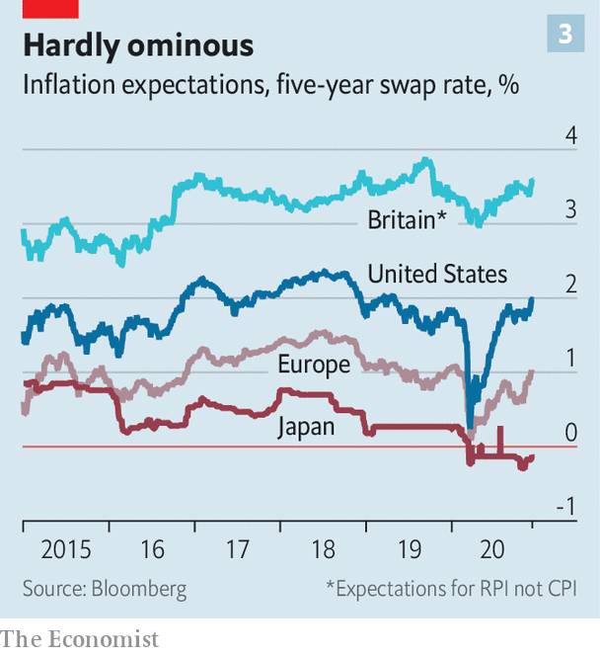

Most economists side with the markets and Mr Fama. In general they no longer think about inflation as 1980s monetarists did (indeed even Friedman, late in life, admitted that modern central banking might have severed the link between the money supply and prices). Following the “New Keynesian” framework of the 1990s they believe that the underlying driver of inflation is a combination of the public’s expectations of price rises, which are self-fulfilling, and the health of the labour market. Both currently point to low inflation.

Neither survey data nor the financial markets suggest that the public expects dramatic price rises. And most forecasts suggest it will take some time for employment to find its pre-pandemic level, even in the economies which bounce back most quickly. Goldman Sachs, a bank which has been especially bullish about the prospects for the American economy, does not expect the unemployment rate to fall below 4% until 2024. And America’s economy is expected to recover faster than most. Relatively high unemployment—in the jargon, an “output gap”—will give firms little incentive to increase people’s wages, and thus little need to raise prices. A “projected large output gap should push global core inflation 0.5% percentage points below its pre-crisis levels next year”, argue economists at JPMorgan Chase, another bank.

So even if there is a spending boom, there will be plenty of economic slack around to accommodate it. Some economists bridge the two views, predicting that the economy will get back to speed in fits and starts, some perhaps inflationary. But for most, high joblessness and contained inflation expectations make forecasting continued low inflation a no-brainer.

What, though, if the New Keynesian view is missing key parts of the story? In “The Great Demographic Reversal”, published last summer, Charles Goodhart, a former member of the Bank of England’s monetary-policy committee, and Manoj Pradhan of Talking Heads Macro, a research firm, provide an alternative view of the past decades’ low inflation. It was not, they say, the result of a correct diagnosis of the problem leading, in the hands of independent central bankers, to appropriate monetary policy. Rather, it was driven by global demography.

In recent decades the integration of China, Europe’s formerly communist east and other emerging markets into the global trading system provided the world economy with millions of new workers. As bosses found it ever easier to get their labour done in Guangdong or Bratislava the bargaining power of rich-country workers fell, and price rises to cover increased wages became a thing of the past. This fits the finding that much more of the low inflation seen in recent decades has come from stable or falling prices for goods that can have their site of production shifted than has come from services which have to be delivered in situ.

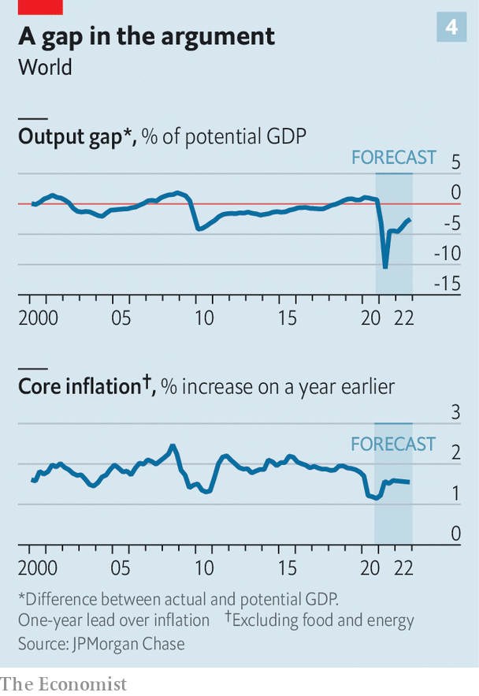

Things are now about to change, the authors claim. As populations in the rich world and China age, the number of dependents per worker will soar, creating a labour shortage in care industries. True, Africa and India have plenty of youngsters. But rich-world politics may further increase the barriers to their migration. Workers in the rich world will thus acquire more bargaining power; wages will rise and prices will rise accordingly. As well as reigniting inflation, these demographic forces will make Western countries more equal, Mr Goodhart and Mr Pradhan argue: another seemingly inexorable trend reversed.

It might seem that the recent experience of Japan, the rich country that has aged the most, puts paid to this idea. Inflation there has long been lower than anywhere else, despite Herculean efforts on the part of the Bank of Japan. Mr Goodhart and Mr Pradhan counter this argument by saying that a “global escape valve” stopped inflationary pressures in Japan from achieving much. Rather than stagnate, investment moved overseas as Japanese manufacturing firms took advantage of plentiful global labour. Cheap imports kept goods inflation down and the offshoring of manufacturing jobs reduced workers’ bargaining power.

In fact, though, wage growth in Japan’s manufacturing industries has been comparatively strong. What is more, the authors concede that Japan’s ageing population has not had quite the effect on the dependency ratio that might be expected—because many more elderly people are now working. The same phenomenon could yet contain inflation elsewhere.



The third argument for fearing a return of inflation is political. It rests on the idea that governments and central banks are becoming more tolerant of inflation, and that they will become even more so as the extent of the pressure on government budgets becomes apparent.

Back in the 1970s presidents and prime ministers were happy to strong-arm central bankers into doing what they wanted. Inflation was tamed only after Paul Volcker proved the Fed’s commitment and independence by pushing America into recession to slow price rises. A new paper by Jonathon Hazell of Princeton University and colleagues argues that post-Volcker “shifts in beliefs about the long-run monetary regime” have proved more important than any other factor in conquering inflation. Their actions in recent decades have built up a firm expectation that central banks will respond to the prospect of inflation rising above its target with higher interest rates, regardless of what politicians and the public might want.

It is possible that these norms are weakening. In recent years there have already been greater attacks on the independence of central banks, such as President Donald Trump’s exhortations that interest rates should stay low. And during the pandemic the relationship between central banks and finance ministries has grown unusually close. After it ends, politicians will face the problem of the debts left behind. Where those debts are long-term, inflation would be a handy way to reduce their real value, easing the strain on budgets. Politicians may be more willing to entertain such an option for the reason identified by Mr Fergusson—that, after a long period of low inflation, people forget how awful it can be. A third of the people currently living in the rich world had not been born when average inflation last exceeded 5%.

## Doubting the future

The Fed’s commitment to deliberately allow inflation to exceed 2% during the recovery is Exhibit A for this belief. Christine Lagarde, the president of the European Central Bank (ECB), emphasises her mandate is to “support the general economic policies” of the EU, as well as ensure stable prices. Central bankers everywhere now admit, if only under their breath, that as well as maintaining price stability they are also trying to keep governments’ long-term-borrowing costs low in order to facilitate fiscal stimulus. Should inflationary pressure start to rise while they are doing so, will they abandon that effort? Central banks which put up borrowing rates under the current circumstances would undoubtedly face opposition from the finance ministries that would pay the increased costs and suffer in subsequent elections. Inflationistas think that the politicians would win, as in many cases they constitutionally should. Central bankers’ independence is granted by elected politicians.

But this political argument, too, has its weaknesses. The ECB’s independence is protected by treaty, and even though it has become more willing to stimulate in recent years, it still exhibits a hawkish bias, tolerating inflation expectations that are well below target. Elderly people like to vote and tend to dislike inflation, argues Vitor Gaspar of the International Monetary Fund. That should limit any political pressure for higher inflation in ageing societies.

The doves and the markets currently have the better of the argument. But the case for reflation in the world economy is stronger than it was after the global financial crisis. A recovery from the pandemic that is untroubled by excessive inflation looks likely. But it is not guaranteed. ■

This article was downloaded by calibre from <https://www.economist.com/briefing/2020/12/12/a-surge-in-inflation-looks-unlikely>

|  |  |  |  |
| --- | --- | --- | --- |
|  | Articles | Sections | Next |

|  |  |  |
| --- | --- | --- |
| Briefing | Sections | China |

Asia

Covid-19 in Japan: 3C epiphany

.

Suicide in South Korea: Deepening despair

.

Nature conservation in Thailand: Unshellfish love

.

Policing in the Philippines: Beatings v shootings

.

Banyan: Cosplaying nice

.

Rohingya refugees in Bangladesh: Club Mud

.

|  |  |  |
| --- | --- | --- |
| Briefing | Sections | China |

|  |  |  |  |
| --- | --- | --- | --- |
|  | Articles | Sections | Next |

#### 3C epiphany

# The Japanese authorities understood covid-19 better than most

That has helped keep Japan’s outbreak relatively small

Dec 12th 2020 | TOKYO



WHEN THE Diamond Princess, a cruise ship suffering from an outbreak of covid-19, arrived in Japan in February, it seemed like a stroke of bad luck. A small floating petri dish threatened to turn the Japanese archipelago into a big one. In retrospect, however, the early exposure taught the authorities lessons that have helped make Japan’s epidemic the mildest among the world’s big economies, despite a recent surge in infections. In total 2,487 people have died of the coronavirus in Japan, just over half the number in China and fewer people than on a single day in America several times over the past week. Japan has suffered just 18 deaths per million people, a higher rate than in China, but by far the lowest in the G7, a club of big, industrialised democracies. (Germany comes in second, at 239.) Most strikingly, Japan has achieved this success without strict lockdowns or mass testing—the main weapons in the battle against covid-19 elsewhere.

“From the beginning we did not aim at containment,” says Oshitani Hitoshi, a virologist who sits on an expert panel advising the government. That would require identifying all possible cases, which is not feasible in a country of Japan’s size when the majority of infections produce mild or no symptoms, argues Mr Oshitani: “Even if you test everyone once per week, you’ll still miss some.” Japan performs the fewest tests in the G7: an average of 270 a day for every million people, compared with 4,000 or so in America and Britain (see chart).

Instead, the government tried to apply the lessons of the Diamond Princess. After trained quarantine officers and nurses were infected aboard the ship, despite following protocols for viruses that spread through droplets, Mr Oshitani’s team concluded that the virus spread through the air. As early as March, Japanese officials began warning citizens to avoid the san-mitsu or “3Cs”: closed spaces, crowded places and close-contact settings. The phrase was blasted across traditional and social media. Surveys conducted in the spring found that a big majority were avoiding 3C settings. The publishing house Jiyukokuminsha recently declared it “buzzword of the year” for 2020.

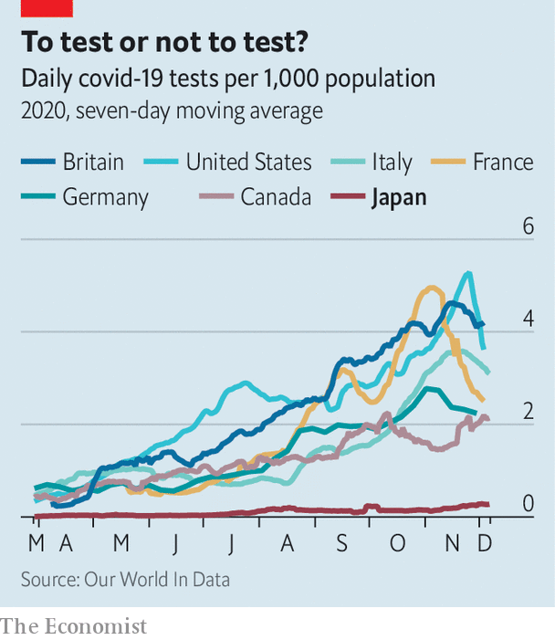

The Diamond Princess also inspired an early focus on clusters. The government set up a cluster-busting taskforce in March.

These insights allowed the authorities to make granular distinctions about risks, opting for targeted restrictions rather than swinging between the extremes of strict lockdowns and free-for-all openings. Nishimura Yasutoshi, the minister overseeing the government’s response to covid-19, carries a device that monitors carbon dioxide to measure the quality of ventilation during his meetings. (The room where he and your correspondent meet registers 506 parts per million, safely below the threshold of 1000 ppm that indicates poor air flow. The interview takes place across a large table, behind plastic shields and with face masks on.)

Researchers deployed Fugaku, the world’s fastest supercomputer, to model different situations. Crowded subways pose little risk, if windows are open and passengers wear masks, Mr Nishimura insists. Sitting diagonally, rather than directly across from each other can reduce the risk of infection by 75%. Movie theatres are safe, “even if viewers are eating popcorn and hot dogs”, Mr Nishimura says. While most cinemas in the West are closed, “Demon Slayer”, a new animeflick, has been playing to full houses in Japan, becoming the country’s second-highest grossing film ever. In addition to the 3Cs, the Japanese government warns of five more specific dangers: dinner parties with booze; drinking and eating in groups of more than four; talking without masks at close quarters; living in dormitories and other small shared spaces; and using changing or break rooms.

Of course, these insights would have been for naught if ordinary people had ignored them. But Japanese heeded the government’s advice to stay home and to quarantine if showing any symptoms of the coronavirus, even though these admonitions carried no legal force. “Sometimes we are criticised for being an overly homogeneous society, but I think it played a positive role this time,” Mr Nishimura says. And already spick-and-span Japan became even more punctilious about hygiene. While Americans argued over whether face coverings were an assault on personal freedom, Japanese lined up outside Uniqlo for the release of its new line of masks. During the first ten weeks of flu season this autumn, Japan saw just 148 cases of common influenza, or less than 1% of the five-year average for the same period (17,000).

Better yet, although the population of Japan is disproportionally elderly, and therefore potentially more vulnerable to covid-19, it is also very healthy. Only 4.2% of Japanese adults are obese, a condition known to make the disease more lethal. That is the lowest rate in the OECD and a tenth of America’s. Japan also has a good health-care system, with universal coverage and lots of well-equipped hospitals. It even had lots of already trained contact-tracers, part of an established public-health network dating back to the 1930s.

These advantages clearly have their limits. The virus has spread rapidly in recent weeks, reaching record highs in terms both of daily cases and daily deaths. The government has had to dispatch medical personnel from the Self-Defence Forces to shore up hospitals in the worst-hit spots. But at the same time it has discouraged caution with a scheme that subsidises domestic tourism and meals out, in an effort to help the economy. Although this seems to have contributed to covid-19’s recent spread, the government has only curbed it rather than scrapping it. And cold weather is now pushing people into 3C spaces, as it has been across the northern hemisphere. But in Japan, at least, the recent growth in the number of cases has started from a dramatically lower base. ■

Editor’s note: Some of our covid-19 coverage is free for readers of The Economist Today, our daily [newsletter](https://my.economist.com/user#newsletter). For more stories and our pandemic tracker, see our [hub](https://www.economist.com/news/2020/03/11/the-economists-coverage-of-the-coronavirus)

This article was downloaded by calibre from <https://www.economist.com/asia/2020/12/12/the-japanese-authorities-understood-covid-19-better-than-most>

|  |  |  |  |
| --- | --- | --- | --- |
|  | Articles | Sections | Next |

|  |  |  |  |
| --- | --- | --- | --- |
| Previous | Articles | Sections | Next |

#### Deepening despair

# Suicide is on the rise among South Korean women

The young are especially likely to kill themselves

Dec 12th 2020 | SEOUL

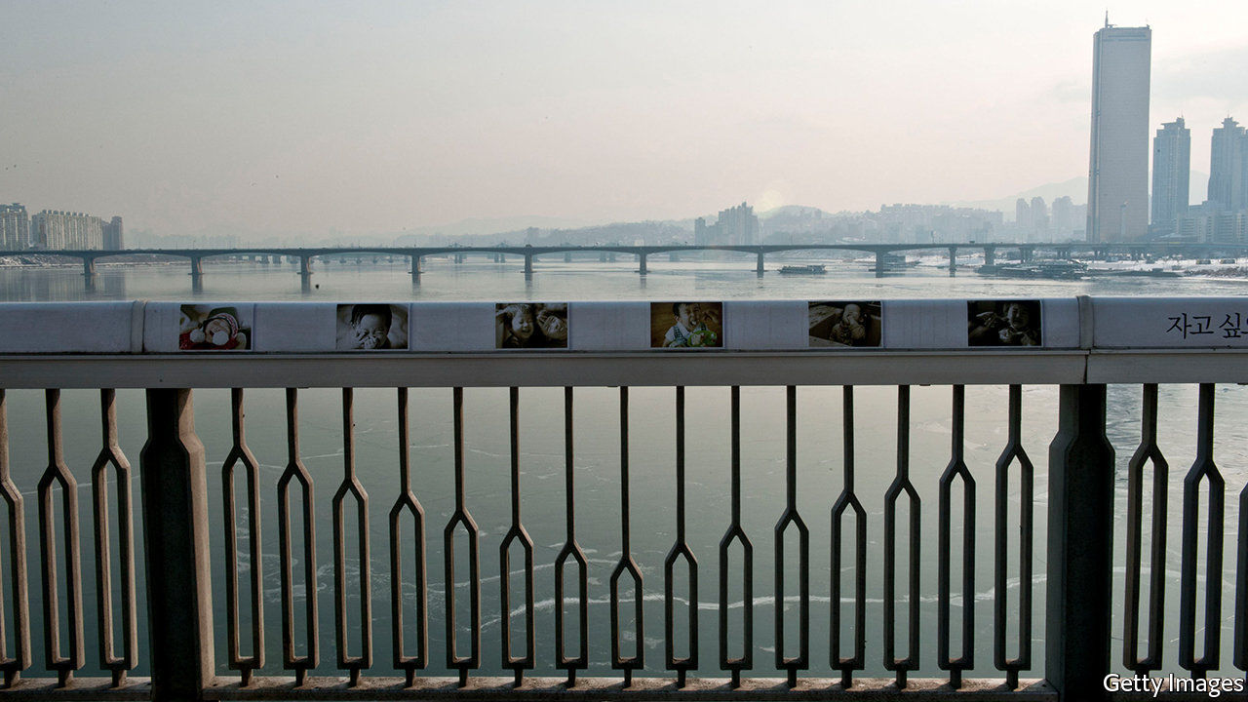

AS OF DECEMBER 10th, 564 South Koreans had died of covid-19. Roughly twice that number died by suicide every month between January and September, the latest month for which data are available. Half as many again made the attempt and were saved by the emergency services.

High as these numbers are, they are mercifully much lower than a decade ago, when the suicide rate began to decline sharply. Unfortunately, this happy trend has recently gone into reverse (see chart). The reversal is largely driven by women in their teens, 20s and 30s. Between 2018 and 2019 the number of women in their 20s dying by suicide rose by a quarter as the number of men of the same age killing themselves stayed more or less constant. Data from the first three-quarters of 2020 suggest the suicide rate among young women is rising still more. What is going on?

In most rich and middle-income countries suicide rates have been low and declining in recent years. Though South Korea had begun to follow that trend, its people are more likely to kill themselves than those of any other OECD country except Lithuania. In 2019 there were 27 deaths from suicide for every 100,000 people, almost four times the number in Britain and nearly twice as many as in America. In other respects, however, South Korea follows global patterns: men and the elderly tend to be at higher risk of suicide than women and the young—making the increase in suicide among younger women all the more puzzling.

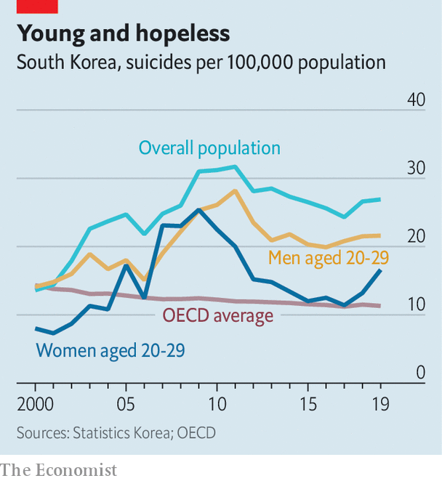

Sociologists tend to attribute the high overall rate to social and economic upheaval. They argue that rapid economic development combined with a clash between traditional social expectations and the individualism of modern life have plunged the country into the sort of confusion that Emile Durkheim, a 19th-century sociologist, called “anomie”, in which conflicting social signals drive people to despair. That sort of tension may be particularly acute for young women in contemporary South Korea, says Timothy Kang of the University of Saskatchewan in Canada. Having been brought up in the same competitive academic environment as their male peers, they then encounter discrimination in the workplace, sexist standards of beauty and pressure to marry and have children.

South Korean feminists argue that the pressure on women has been compounded in recent years by the use of the internet to propagate misogynistic views and to disseminate illicitly obtained images of women, often from spycams hidden in toilets and changing rooms. The country’s vocal women’s movement has faced an intemperate backlash from men who object to its demands. “The relentlessness of the attacks is a big problem for women,” says Shin Min-joo, an activist who has received plenty of online vitriol herself. The suicides in 2019 of two female celebrities following months of online trolling may have added to the trauma, she suggests.

Economic precariousness is another factor. Sluggish economic growth over the past few years has been harder on young women, who are more likely to be employed in the service sector and on short-term contracts. The pandemic has probably exacerbated these problems. The drop in the share of women in work this autumn compared with the year before has been three times bigger than that for men. “The economic precarity and the social isolation that it causes are major problems for young women, particularly those living on their own,” says Yun Kim Ji-yeong of Konkuk University in Seoul. In addition, women with families have borne the brunt of home-schooling kids and looking after vulnerable relatives during the pandemic. Past experience suggests that economic distress may raise the suicide rate: around the financial crisis in 2008, both young men and young women took their lives in greater numbers, with the rate among women exceeding that among men for several years.

The government is taking the problem more seriously than in the past. In a meeting on suicide prevention at the end of November, officials vowed to expand support for those at risk, particularly young women in precarious circumstances. The national suicide hotline, which has been understaffed, is recruiting more sympathetic ears. Public-information campaigns have tried to reduce the taboos around mental health in recent years, and the government has become a bit keener to combat sexism. All of this is welcome. But if rising suicide rates are indeed the result of rapid social change, a quick reprieve is unlikely. ■

This article was downloaded by calibre from <https://www.economist.com/asia/2020/12/12/suicide-is-on-the-rise-among-south-korean-women>

|  |  |  |  |
| --- | --- | --- | --- |
| Previous | Articles | Sections | Next |

|  |  |  |  |
| --- | --- | --- | --- |
| Previous | Articles | Sections | Next |

#### Unshellfish love

# The Thai authorities find shelter for homeless crustaceans

It’s part of a plan to strike a better balance between nature and tourism

Dec 12th 2020 |



AMID A SLUMP in tourism, one national park in Thailand has seen a dramatic rise in visitors. So numerous are the hermit crabs thronging the otherwise empty beaches of Koh Lanta that shells for them to live in have become a scarce commodity. The Thai government moved quickly to ease the housing shortage, launching a public appeal for empty shells that netted over 200kg. On December 5th these were distributed around the park in a ceremony marking the birthday of the late king, Bhumibol Adulyadej.

Hermit crabs rely on discarded shells to protect their soft bodies, moving to larger shells as they grow. On Koh Lanta and the surrounding, smaller islands, their rapid increase seems to be a natural phenomenon, rather than directly related to the absence of tourists. But the shortage of shells may be man-made: pretty ones have long been gathered to be sold as souvenirs. Crabs had begun to make do with potential death-traps such as plastic caps and bottles.

The shell drive was part of a government initiative to “restore the balance of nature”. “I have instructed all national parks to do whatever it takes,” says Varawut Silpa-archa, the minister for natural resources. His inspiration comes from the hiatus in tourism brought on by covid-19. A ban on international visitors (now lifted, subject to quarantine) and the closure of national parks have helped nature rebound, bringing black-tipped reef sharks back into Thai waters and endangered leatherback turtles back onto Thai beaches. In the coastal provinces of Phang Nga and Phuket, turtles have laid the largest number of eggs for 20 years.

The government has decided to try to mimic the respite forced on it by the coronavirus in future. From now on, all national parks will be required to close for part of the off-season and to limit the number of tourists through a reservation system when they are open. The temporary closure last year of Maya Bay, made famous as the eponymous strand in the film “The Beach” and subsequently overrun by tourists, set a precedent. Although such restrictions mean reduced earnings from tourism in the short term, in the longer run more pristine parks may help to keep the tourists coming—and shelling out.

For more coverage of climate change, register for The Climate Issue, our fortnightly [newsletter](https://www.economist.com/theclimateissue/), or visit our [climate-change hub](https://www.economist.com/news/2020/04/24/the-economists-coverage-of-climate-change)

This article was downloaded by calibre from <https://www.economist.com/asia/2020/12/12/the-thai-authorities-find-shelter-for-homeless-crustaceans>

|  |  |  |  |
| --- | --- | --- | --- |
| Previous | Articles | Sections | Next |

|  |  |  |  |
| --- | --- | --- | --- |
| Previous | Articles | Sections | Next |

#### Bludgeon first, open fire later

# The Philippines’ president advocates beatings over shootings

Rodrigo Duterte shows a softer side

Dec 12th 2020 | MANILA

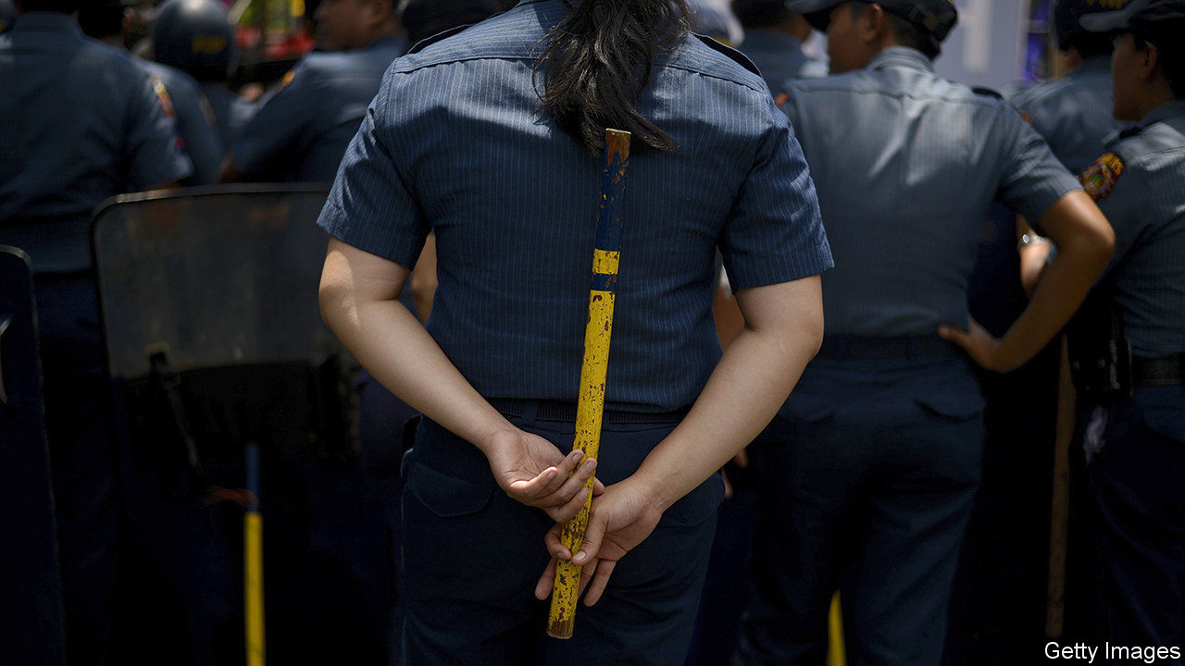

THE RATTAN sticks being issued to the Philippine National Police to keep people apart during the covid-19 epidemic are versatile, Lieutenant-General Cesar Binag explained: “They will be one metre long, and will be used for enforcement, for measuring, or for hitting those that are hard-headed.” To critics of President Rodrigo Duterte, the announcement, on December 4th, was yet another sign of the brutality of his regime. The Commission on Human Rights, a state body, remarked drily: “Violence, even in its slightest suggestion, is not the best way to address the pandemic.” Even Mr Duterte’s own spokesman, Harry Roque, had to acknowledge that it would be against the law for a police officer to whack anybody with a stick without proper cause.

The police have demonstrated a great proclivity for violence during Mr Duterte’s four-year-old war on illegal drugs. His campaign against both dealers and users has killed thousands of people. At least 5,903 of them, by the official count, have perished at the hands of the security services, guided by his exhortation to kill anybody who violently resists arrest. (Thousands more have been killed by unknown assailants.) Yet in the most recent of his frequent addresses to the nation Mr Duterte surprised his critics. Instead of ordering the police to crack heads if people failed to stay a metre apart, he gave a well-reasoned argument for the advantages of equipping the police with rattan sticks or, better still, proper batons, as a means to reduce their use of guns and thus stem bloodshed.

“When a person resists arrest and he becomes violent, the first impulse of a police without a baton is to hold his gun,” he said. “He might not draw it, but he holds his gun, ready for action. If he has a baton you just hit the hand, hit the body. It would be painful. Maybe you can subdue the person resisting arrest.” The president promised the police that he would issue them with proper batons, and told them: “Use the baton, not the gun.”

Mr Duterte often goes on television to deliver rambling monologues about what his government is doing or what he wants it to do. These talks are replete with vituperation, threats and unfunny jokes. Ministers, members of Congress, civil servants and military or police officers appear alongside him, to voice their agreement with whatever he says. It is a ritual that many ordinary Filipinos find endearing, if a little too long-winded to be entertaining. But it is not just theatre: this seems to be how policy is made in Mr Duterte’s Philippines—openly, on screen, evolving haphazardly from off-the-cuff remarks made by the president, which his subordinates must interpret as best they can.

Mr Roque is the chief interpreter of such remarks. The spokesman’s mantra is that Mr Duterte’s statements should be taken seriously, but not literally. Taking the president literally can have deadly consequences. In a televised speech on April 1st Mr Duterte urged the police and armed forces to shoot dead anyone in Manila breaking lockdown rules. Twenty days later a police officer enforcing the lockdown killed an ex-soldier who was being argumentative. The victim’s behaviour may have been due to mental illness stemming from his military service. The police officer who fired the fatal shots was later charged with murder.

This episode may help to explain Mr Duterte’s new enthusiasm for batons. And for once he put his ideas in plain words, which the police can take both seriously and literally, without fatal consequences. ■

This article was downloaded by calibre from <https://www.economist.com/asia/2020/12/12/the-philippines-president-advocates-beatings-over-shootings>

|  |  |  |  |
| --- | --- | --- | --- |
| Previous | Articles | Sections | Next |

|  |  |  |  |
| --- | --- | --- | --- |
| Previous | Articles | Sections | Next |

#### Banyan

# Thailand’s absolutist king is on his best behaviour

But protesters do not believe he is prepared to relinquish any power

Dec 12th 2020 |



THE WEEKS of stand-off between young Thai activists and the establishment they are challenging have not been short of political theatre. The protesters are calling for the resignation of the army-backed prime minister, for open elections and, above all, for an absolutist monarchy to be modernised. They raise the three-finger salute of defiance from “The Hunger Games”. Giant inflatable ducks lend their marches a carnival air—and also prove useful as protection against water cannon. And thousands of letters demanding that King Maha Vajiralongkorn accept limits to his power and wealth were delivered in replica post boxes to the very gates of the hallowed royal palace in Bangkok.

The monarchy in Thailand sits atop a cosmic hierarchy that demands order and obedience and offers beneficence. Never has it been challenged in this way before. Yet the king of four years, to whom even his most loyal supporters hesitate to attribute a great love of democracy, has betrayed no irritation and even slightly changed his ways.

A playboy resident in Germany, where he occupies a floor in an upscale Bavarian hotel with a shifting harem of “sex soldiers”, King Vajiralongkorn normally spends only brief spells in the country he rules. But recently he has stayed put in Thailand. More striking still, for the first time since his accession (and indeed the first time in decades), he has mingled with his people. The stiff and aloof king has gone walkabout, descending from his vintage Rolls-Royce to allow adoring subjects dressed in yellow (which signifies devotion to the monarchy) to touch the royal feet. In his first comments as king to the foreign press, with Queen Suthida on his arm, he expressed “love” for all Thais, protesters included. Thailand, he added, is a “land of compromise”.

The monarchy’s critics are not swallowing it. The martinet king has taken personal command of important military units and direct control over the crown’s immense property holdings and investment portfolio. He now has at his disposal over $60bn in assets—more than the sultan of Brunei and the British royal family combined. Even if he is paying more attention to appearances, the critics say, there is no sign that the king, an absolutist through and through, is thinking of giving up any of his authority.

Meanwhile, says Pavin Chachavalpongpun of Kyoto University, a “push factor” helps explain the king’s absence from Germany—the growing risks of greater parliamentary scrutiny of his presence there and whether it contravenes a ban on foreign states operating on German soil. The European press gleefully reports not only on how he churns through wives and mistresses but also on his cavortings. Paparazzi keep snapping the 68-year-old in crop tops and stick-on tattoos. A spell out of the limelight could be helpful.

For the protesters, the king’s conduct in Germany only reinforces their scorn for his attempts to burnish his image in Thailand. Not least, a mistress, Sineenat Wongvajirapakdi, whom the king summarily dismissed last year for “misbehaviour” and “disloyalty”, has been reinstated as the “untainted” royal consort. She accompanies the king and queen on their walkabouts. The king’s polygyny, his humiliation of the women vying for his capricious affection; his habit of making even the prime minister prostrate himself before his majesty: instead of connecting with members of a new generation demanding gender equality, democracy and respect for individual rights, the king’s comportment repulses them. As Netiwit “Frank” Chotiphatphaisal, a prominent activist, puts it, the walkabouts—the king in a white military uniform slathered with gold braid—are just cosplay in service of the king’s ego.

Mr Pavin points out that, for all his talk of compromise, the king, although supposedly above the political fray, only meets and greets his supporters. Meanwhile, the prime minister, Prayuth Chan-ocha, who led the coup in 2014 in which the army (ostensibly in defence of the monarchy) seized power, grows less conciliatory by the day. In particular, a draconian law against “insulting” the monarchy has been dusted off and used against more than a score of activists. Mr Prayuth’s star, admittedly, is waning with the king, not least for letting the protests wax so dramatically. But if Mr Prayuth is dismissed as a scapegoat, it will surely be because King Vajiralongkorn wants his successor to take a harder line. With the monarch digging in and young protesters convinced that change has arrived, the cosplay is becoming serious.

This article was downloaded by calibre from <https://www.economist.com/asia/2020/12/12/thailands-absolutist-king-is-on-his-best-behaviour>

|  |  |  |  |
| --- | --- | --- | --- |
| Previous | Articles | Sections | Next |

|  |  |  |  |
| --- | --- | --- | --- |
| Previous | Articles | Sections | Next |

#### Club Mud

# Bangladesh is moving Rohingyas to a remote island

The relocation will make them the “Palestinians of Asia”, an activist complains

Dec 12th 2020 | DELHI



THE FLOTILLA that sailed from the port of Chattogram (formerly known as Chittagong) in southern Bangladesh on December 4th was carrying some 1,642 refugees to a new life across the water. But their destination was no far-off promised land. It took less than four hours’ churning through the wide, muddy estuary of the Meghna River to reach Bhasan Char, an island no bigger than a large city park, and so freshly formed it barely peeps above surrounding tidal flats (see map).

It is here, improbably, that the government of Bangladesh has built a red-roofed, grid-patterned model town, intended to house Rohingyas, an ethnic minority from neighbouring Myanmar. Some 700,000 of them were chased into Bangladesh three years ago by the Burmese army and allied militias in a horrifying bout of ethnic cleansing. Bhasan Char can house about 100,000. The hosts present the new settlement, erected at a cost of $300m by the Bangladeshi navy, as a safe, sanitary and humane alternative to the teeming and squalid refugee camps that have mushroomed along the jungly border.

Yet while some of the island’s new residents say they are happy to have pukka plumbing and cement floors, to many Rohingyas the permanence and isolation of the model town promise not relief but the institutionalisation of their misery. An island exile, they fear, would mean less hope of pricking the world’s conscience, and so less hope of ever returning to their original homes in Myanmar. “After this move to Bhasan Char, I see our people slowly dying,” warns Ambia Perveen of the European Rohingya Council, an NGO. “We are becoming the Palestinians of Asia.”

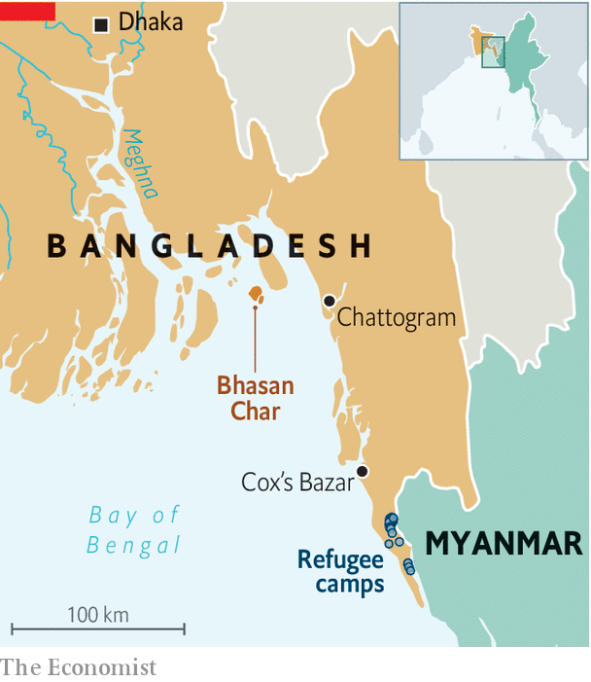

When Sheikh Hasina Wajed, the prime minister of Bangladesh, launched the relocation project in 2018, a chorus of similar objections erupted. Even as construction went ahead, diplomats and aid workers expressed doubt that large numbers of refugees would ever be settled on a remote island prone to cyclones and floods. Aside from the cost and negative publicity, they assumed, such a transfer would weaken the argument, strongly advanced by Bangladesh, that Myanmar itself must bear responsibility for the fate of the Rohingyas.

As time has passed, however, Sheikh Hasina’s government has faced growing internal pressure. Although proud that their own crowded country of 165m has aided and sheltered so many desperate refugees, ordinary Bangladeshis have gradually grown less welcoming. Stories of violent crime and disease in the border camps have spread, exacerbated by fears of covid-19 and by the smuggling from Myanmar of arms and of drugs such as yaba, a cheap form of methamphetamine that is ubiquitous in Bangladesh.

The police, who in addition fear jihadist radicalisation among refugees, have adopted an increasingly harsh line in the camps. Odhikar, a Bangladeshi human-rights group, claims that since 2017 perhaps 100 Rohingya men have been killed during alleged “gunfights” with security forces, in incidents that look more like executions. It has also built barbed-wire fences around the sprawling camps, the biggest of which houses nearly 600,000 people.

Restrictions on the refugees are multiplying. Last year the government banned them from owning SIM cards and ordered the telecom authority to block mobile-internet service in the camps. Though the networks were restored a few months ago, SIM cards are still forbidden. Rohingyas are also barred from holding bank accounts and from paid work. Learning is almost as hard as earning. Having resisted pressure from NGOs to grant Rohingyas access to education for nearly three years, the government had been on the verge of allowing some children to go school in April, when covid-19 intervened.

The move to Bhasan Char fits this pattern, and the growing authoritarianism of Sheikh Hasina, who has been in power without interruption since 2009. Troublemakers can be more easily controlled on the island, and it would be useful to reduce the density of mainland camps. It is perhaps no coincidence that CCTV cameras monitor all the streets of Bhasan Char, or that the government has just created a new body to oversee refugee affairs. The 15-person committee includes at least ten senior security officials, and no representatives of the Rohingyas.

Despite deep misgivings among aid workers, there is some sympathy for Bangladesh’s dilemma. If the relocation brings more attention to the Rohingyas’ plight, that might be a silver lining, speculates John Quinley of Fortify Rights, an advocacy group. “Bangladesh is right, calling out the international community for not pushing hard enough on Myanmar,” he says. The UN High Commissioner for Refugees, the main coordinator of international relief, tiptoes around criticism of Sheikh Hasina’s government. What it and smaller charitable outfits would most like is access to Bhasan Char. So far, Bangladesh has not allowed any regular visits, or any independent assessment of the model town. Without this, the UN cannot offer assistance.

Despite some individual reports of satisfaction with new homes on the island, which also boasts schools and medical facilities, the refugees on the mainland seem mostly sceptical. Many claim that the first to relocate to Bhasan Char were not volunteers, as claimed by the government, but were threatened by police, coerced or swayed by false promises of money. “They should call it jail island,” says Ro, a resident of a mainland camp, walking uphill for better telephone reception and a jumbled vista of plastic sheeting, tin roofs and bamboo walls. At least here the Rohingya are close to the border, and have some strength in numbers, he says. ■

This article was downloaded by calibre from <https://www.economist.com/asia/2020/12/12/bangladesh-is-moving-rohingyas-to-a-remote-island>

|  |  |  |  |
| --- | --- | --- | --- |
| Previous | Articles | Sections | Next |

|  |  |  |
| --- | --- | --- |
| Asia | Sections | United States |

China

Exporting Xi Jinping thought: How the party trains foreign politicians

.

Club culture: A different beat

.

Chaguan: China doubles down in Xinjiang

.

|  |  |  |
| --- | --- | --- |
| Asia | Sections | United States |

|  |  |  |  |
| --- | --- | --- | --- |
|  | Articles | Sections | Next |

#### Exporting Xi Jinping thought

# How China’s Communist Party trains foreign politicians

Across the world it is seeking to sway tomorrow’s leaders

Dec 10th 2020 |

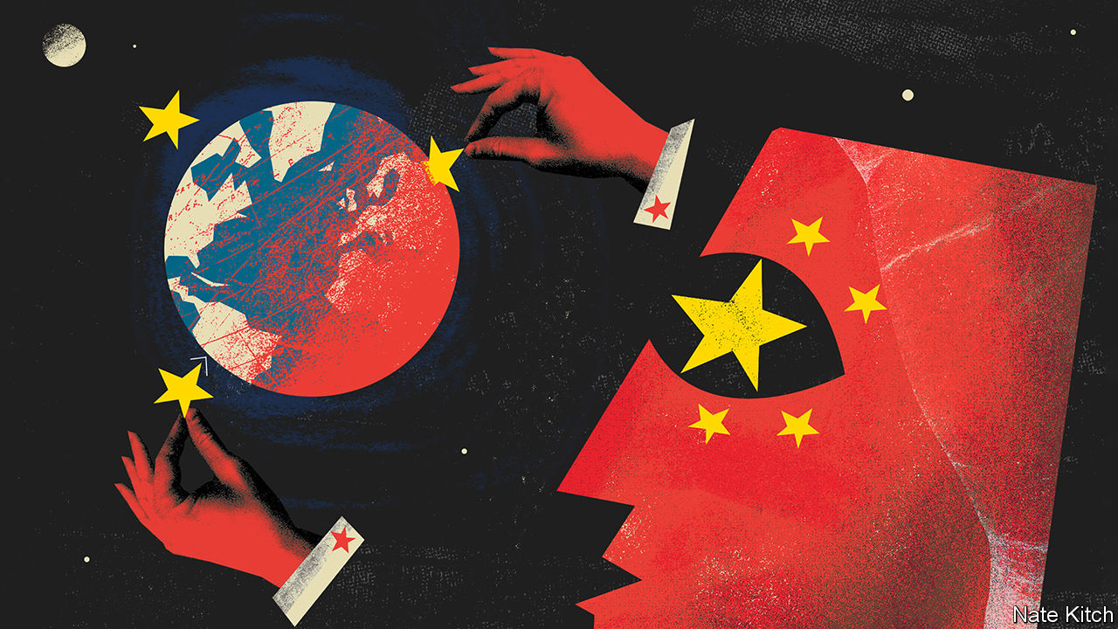

IN EARLY DECEMBER Xi Jinping, China’s leader, declared that the Communist Party had met a self-imposed deadline. Extreme poverty (defined as earning a bit more than $1 a day) has been eradicated from China. Naturally, the party is keen to tell others about its success in fighting penury. In October it hosted a mostly-virtual two-day seminar on the subject for nearly 400 people from more than 100 countries. Participants quoted by official media gushed praise for China’s progress. But the gathering was not just about uplifting the needy. It was also aimed at showing off China’s political model.

In the West, recent coverage of China’s diplomacy has been dominated by talk of how aggressive it has become. Some of its diplomats have been dubbed “wolf warriors” because of their habit of snarling at foreign critics (the label refers to the title of a jingoistic Chinese film). To non-Western audiences, by contrast, Chinese officials are speaking more softly. They preach the virtues of a form of governance that they believe is making China rich and can help other countries, too. Some welcome this message, even in multiparty democracies. At the poverty-alleviation forum, the secretary-general of Kenya’s ruling Jubilee Party, Raphael Tuju, was quoted as saying that China’s Communist Party should be an example for his own.

In 2017 Mr Xi caused a stir in the West by suggesting that China’s development model offered “a new option” for other countries, and that a “Chinese approach” could help solve humanity’s problems. Though he later insisted that his country did not plan to export a “China model”, the country’s officials have been, in effect, doing just that. Some of those engaged in this effort belong to the foreign ministry. But many, such as those who organised the recent seminar on poverty, work for a branch of the Communist Party called the International Department. Its job is to win support for China among foreign political parties.

The department is well suited to the task. Because it does not directly represent the Chinese state it has no role to play in verbal sparring. But as a party outfit it has considerable authority. It works closely with the foreign ministry and swaps personnel with it.

Late in 2017 it held a convention in Beijing joined by leaders and other members of political parties from 120 countries. Some delegates were from rich democracies such as Japan, New Zealand and America. (Both Republicans and Democrats attended.) Mr Xi gave the keynote address. Many participants signed a statement, the “Beijing Initiative”, praising the Communist Party and Mr Xi. The department has few qualms about the kind of political parties with which it interacts. “They’ll deal with right-wing parties and they’ll deal with left-wing parties and everybody in between,” says David Shambaugh of George Washington University.

Under Mr Xi one of the department’s main activities has been organising training sessions for foreign political parties, especially those from developing countries. It does not say outright that authoritarianism is good. But its mission is clearly to promote the virtues of strong centralised leadership. In November Song Tao, the department’s boss, claimed in an online briefing of party leaders from 36 sub-Saharan African countries that the party’s achievements in development proved the wisdom of five-year plans. “The Chinese system,” he said, could “serve as a reference” for his audience. He said that “only by upholding the leadership of the party” could such plans “stay on the right track”.

During the pandemic much of the department’s instruction has been conducted online, often focusing on China’s achievements in crushing covid-19 (one lesson: tough measures work). Expositions on Mr Xi’s three-part tome, “The Governance of China” have also been a common feature. In recent months such classes have been attended by officials from ruling parties in Angola, Congo-Brazzaville, Ghana, Mozambique, Panama and Venezuela.

Official websites in China often advertise these efforts. One describes a ground-breaking ceremony in 2018 for a China-funded ideological school in Tanzania. It was attended by Mr Song, the department’s boss, and by ruling-party officials from Tanzania, South Africa, Angola, Mozambique, Namibia and Zimbabwe.

In democracies such as Ghana, Kenya and South Africa the department sponsors trips to China by ruling-party members for the study of party-building and governance. In 2018 Ghana’s ruling centre-right New Patriotic Party (NPP) asked for such training in part to “deepen its ideological skills”, found Joshua Eisenman of the University of Notre Dame, an expert on the department’s activities in Africa. The former ruling party of Ghana, the National Democratic Congress (NDC), has sent dozens of its staff to China for such training. The NDC has also opened a leadership school in Ghana. It uses teaching materials devised by the Chinese Communist Party.

It is unclear what foreign party members gain from China’s training sessions. They may be no more than a means of career advancement, or of paying ritual homage to Mr Xi’s wisdom in order to curry favour—China being a valuable source of loans and investment in many developing countries. The seminars can be boozy junkets, dreary snoozefests, or both. An Egyptian veteran of them says they are hardly rigorous; she likened the experience to a “paid vacation”.

The department says it has contact with more than 600 political organisations in over 160 countries. Under Mr Xi such engagements have grown. Christine Hackenesch and Julia Bader, writing for International Studies Quarterly, found that the number of high-level party-to-party meetings increased by more than 50% between 2012 and 2017, to more than 230 annually. Martin Hala of Sinopsis, which monitors China’s activities in Central Europe, has called this akin to forming a “new Comintern”—a reference to the old Soviet-led international communist movement.

There is a critical difference, however. China is not preaching communism. Its aim, rather, is to show that a country can become richer without being democratic. That message finds attentive ears among politicians who find the checks and balances of democracy irksome. In June Kenya’s Mr Tuju (the cheerleader for China at the anti-poverty seminar in October) was challenged about his party’s affection for the Chinese Communist Party by a reader of a Nairobi newspaper. He replied that he did not see what was wrong with “learning from the most successful and the best run” party in the world. ■

This article was downloaded by calibre from <https://www.economist.com/china/2020/12/10/how-chinas-communist-party-trains-foreign-politicians>

|  |  |  |  |
| --- | --- | --- | --- |
|  | Articles | Sections | Next |

|  |  |  |  |
| --- | --- | --- | --- |
| Previous | Articles | Sections | Next |

#### A different beat

# The pandemic has changed China’s nightclubs

It has given local DJs a chance to shine

Dec 12th 2020 | BEIJING



GETTING INTO Zhao Dai, an underground nightclub in a fashionable part of Beijing, involves a little more faff than it once did. Party animals must prove that they have not travelled anywhere they might have picked up covid-19, by showing doormen a code generated by a government mobile app. Once inside, however, the smoke-filled basement is just as sweaty as usual. On a recent Saturday a hundred unmasked revellers bopped to techno tunes. No one bothered to maintain social distancing while dancing.

The pandemic posed an enormous threat to China’s fragile club scene. Nightspots in Beijing were forced to shut in January. They did not reopen properly until August. Yet many electronic-music clubs have weathered the disruption, in part because punters freed from lockdown have flocked back to them. A bouncer eyeing the crowd at Zhao Dai says it is as busy as it was before the closures. Michael Ohlsson, the American owner of Dada, another Beijing club, says his business will probably break even this year, despite being closed for much of its first half.

The pandemic has wrought changes, nonetheless. Nightspots have long felt it necessary to fly in fashionable foreign DJs to help them draw crowds. As a result Chinese performers have always had to make do with supporting slots, says Huang Hongli, a DJ who uses the stage name of Hotwill. Now they have no choice but to give locals a chance to shine. This summer Zhao Dai held an outdoor festival, attended by 3,000 people. The 40 DJs who performed there were all Chinese.

A second effect of the pandemic has been to help speed up the spread of China’s club culture beyond its traditional bases in Beijing, Shanghai and the south-western city of Chengdu. When nightclubs closed at the start of the year Mr Huang chose to leave the capital and return to Xiamen, his hometown south of Shanghai, in part because of its lower cost of living. There he helped to launch the city’s first underground nightspot, which opened in April. This year’s closures gave Mr Ohlsson more time to plan the opening of a new club in Kunming, the capital of Yunnan province.

Not everyone is happy. Ezzz, a Chinese DJ and music producer, grumbles that many of the DJs who have gained new followings during the pandemic are proficient performers but do not “understand electronic music culture”. Mr Huang looks forward to a time when a few more foreigners can enter the country; he thinks some exposure to trends from abroad is good for the local scene. As for the audience, few seem to care much who is performing, so long as they have somewhere to dance. Lea Liao, a Beijinger who attended Zhao Dai’s summer festival, says she struggled to see the stage because of all the gyrating bodies. “But I could hear the music, and that is all that matters.”

Editor’s note: Some of our covid-19 coverage is free for readers of The Economist Today, our daily [newsletter](https://my.economist.com/user#newsletter). For more stories and our pandemic tracker, see our [hub](https://www.economist.com/news/2020/03/11/the-economists-coverage-of-the-coronavirus)

This article was downloaded by calibre from <https://www.economist.com/china/2020/12/12/the-pandemic-has-changed-chinas-nightclubs>

|  |  |  |  |
| --- | --- | --- | --- |
| Previous | Articles | Sections | Next |

|  |  |  |  |
| --- | --- | --- | --- |
| Previous | Articles | Sections | Next |

#### Chaguan

# China is doubling down in Xinjiang

Our columnist visits factories accused of using forced labour

Dec 10th 2020 |

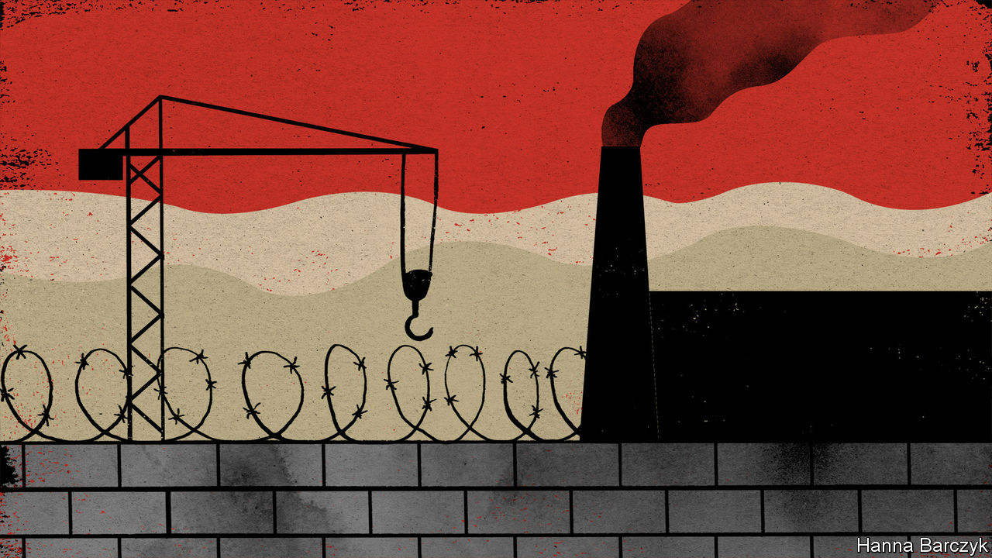

A VAST EXPANSE of sand dunes, studded with the wind-eroded ruins of lost Silk Road cities, the Taklamakan Desert is a fine place to hide a guilty secret. At first glance, shame is a plausible explanation for a mini construction-boom under way in this remote corner of Xinjiang. For outsiders are increasingly shocked by China’s rule over this north-western region, where millions of Uyghurs, an ethnic minority, endure oppressive, high-tech surveillance and the constant fear of detention for alleged Islamic extremism.

For the past few years overseas human-rights groups and scholars have used satellite images and Chinese government documents to track dozens of factories rising on the Taklamakan’s southern edge in Lop County, a poor and almost entirely Uyghur area. The factories line the newly laid streets of an industrial park sponsored by the city of Beijing, 4,000km to the east. More alarmingly, satellite images and the Xinjiang government’s own propaganda suggest that as the park rose from the desert sands, at least one political re-education camp lurked amid the factories.

Across Xinjiang over a million Uyghurs have passed through such camps in recent years. Officials eventually admitted to the camps’ existence in 2018. Pointing to terrorist attacks by Muslims from Xinjiang, they said China had set up vocational training centres to cure minds infected with religious extremism. In October 2018 China Central Television toured a camp in Hotan, an ancient oasis city. Detainees were shown in Mandarin-language classes, studying Chinese laws and learning such skills as sewing, before thanking authorities for saving them. In contrast, critics call the campaign both brutal in its methods and horrifyingly arbitrary in its application. Leaked government files record Uyghurs interned for such “suspicious” acts as growing long beards, applying for a passport or using foreign messaging services like Skype. Ex-detainees have accused camp staff of beatings and rapes.

Now this giant social-engineering project is evolving. In late 2019 officials said that all detainees have graduated from compulsory studies. On a recent weekend Chaguan visited the Hotan city camp toured by state television and found it apparently abandoned, observed only by a clutch of camels and locals digging for white jade in a dried-up riverbed. Closing highly visible sites signals shifting tactics, not a change of heart. China is merging counter-terrorism work in Xinjiang with nationwide campaigns to assimilate ethnic minorities and push the rural poor into formal employment, in the name of development and social stability. A State Council white paper from September, detailing training and job placement campaigns in Xinjiang, found 2.6m “rural surplus workers” in the region, notably Uyghurs with “outdated ideas”.

Hints of trouble abound. The white paper blames “terrorists, separatists and religious extremists” for inciting locals to “refuse to improve their vocational skills”. Global firms that audit multinational supply chains for labour abuses increasingly decline to operate in Xinjiang, blaming authorities for obstructing their work. Earlier this year the American government said that it suspects several businesses in Lop County of using forced labour, specifically firms trading in human hair. American customs officers seized tonnes of wigs and hairpieces in June, then afterwards banned all hair imports from the Lop County Hair Products Industrial Park, a zone within the Beijing Industrial Park. Chinese government spokesmen and state media dismiss talk of forced labour as a smear by Westerners bent on keeping China down.

To an optimist, such shrill denials might suggest that sanctions are biting. Xinjiang has a lot to lose: it supplies almost a fifth of the world’s cotton, among other commodities. Your columnist, who is not generally an optimist, headed to Lop County to take a look in person. Chaguan travelled with a reporter from another Western newspaper. As happens in Xinjiang, police were already waiting for the foreign journalists at Hotan, the nearest airport to Lop County. An hour later, goons blocked an access road to the industrial park, turning Chaguan’s taxi away. He and his colleague finally arrived on foot after a long desert walk around the park boundary, a metal fence topped with four strands of electrified wire.

## Defiance in the desert

American sanctions have yet to paralyse Lop County’s factories, it can be reported. On a freezing but sunny weekend morning, the entrance to the hair-products park was busy with traffic. Nearby, construction workers toiled on new buildings. The arrival of foreign reporters triggered bouts of pushing and arm-grabbing by unidentified men bent on stopping the Westerners from proceeding further, one of whom called himself “the person responsible for the park”. Trying to grab reporters’ smartphones, they demanded the deletion of pictures of their industrial zone and of what appears to be a training facility at the park’s southern end, resembling a secure boarding school, down to young adults lined up in rows on a playing field. Questions were greeted with evasions. “We don’t really have dealings with the outside world,” replied one of the men when asked about American sanctions. Initially asserting that his company only sells to domestic markets, he then claimed that it makes nothing at all and “is still being put together”.

The men staged one more physical confrontation when a hulking, prison-like complex with tall grey walls and guard towers came into view. Failing to stop the foreigners from seeing the prison, they focused on preventing photography.

Still, evidence-destruction is not a sign of a sore conscience. Bits of the park designed to be seen from the ground by locals are unapologetic. Giant rooftop characters in the training facility spell out such slogans as: “Labour is glorious” and “Serve the economy”. A poster by the main gate shows President Xi Jinping surrounded by smiling Uyghur children. China’s regime is secretive because it has no patience for debating its policies with foreigners. It is proud of its iron-fisted rule in Xinjiang, and is not about to change.■

This article was downloaded by calibre from <https://www.economist.com/china/2020/12/10/china-is-doubling-down-in-xinjiang>

|  |  |  |  |
| --- | --- | --- | --- |
| Previous | Articles | Sections | Next |

|  |  |  |
| --- | --- | --- |
| China | Sections | The Americas |

United States

Black Lives Matter: The George Floyd effect

.

African-American businesses: Capital punishment

.

The never-ending election: Final countdown

.

The urinal is political: Where have all the toilets gone?

.

Anti-Semitism accusations: Here today, zone tomorrow

.

The Fort Hood report: A look under the Hood

.

Economic policy: Picking a package

.

Lexington: When America and China went to war

.

|  |  |  |
| --- | --- | --- |
| China | Sections | The Americas |

|  |  |  |  |
| --- | --- | --- | --- |
|  | Articles | Sections | Next |

#### Black lives still matter

# Six months after mass protests began, what is the future of BLM?

Reimagining Black Lives Matter

Dec 12th 2020 | CHICAGO

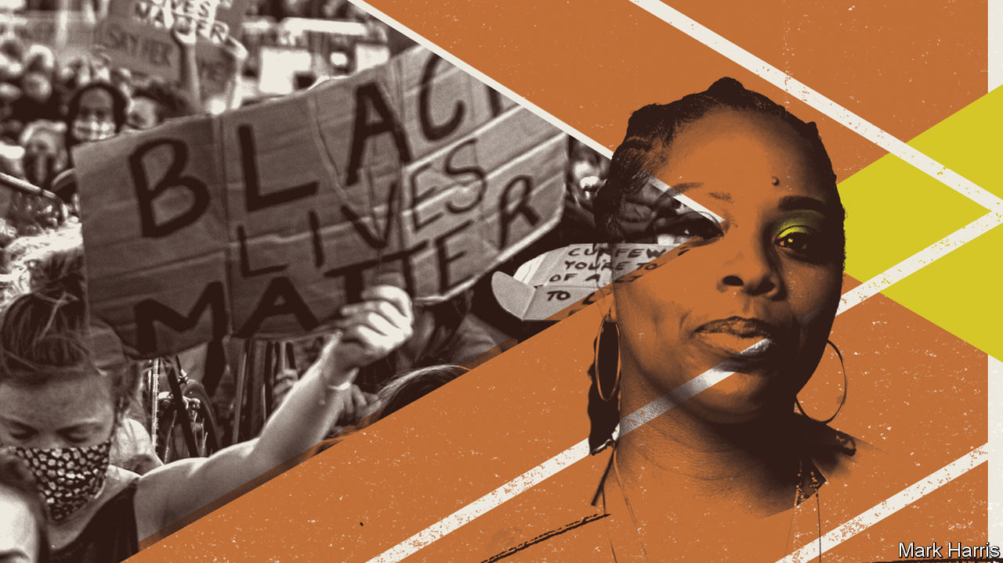

“WHEN THERE’S a chance to make change, we must be ready to take it,” says YahNé Ndgo, a singer and activist with Philadelphia’s chapter of Black Lives Matter (BLM). Events over the past six months, she says, have brought a rare chance to shape national affairs. Protests flared across America after footage spread of the death of George Floyd, an African-American who was choked for nearly nine minutes by a policeman in Minneapolis in May. By one count over 8,500 civil-rights demonstrations have taken place since.

The sight of thousands of marchers, usually young and mostly peaceful, helped to sway public attitudes in ways small and big. Kenya McKnight, who runs a group in Minneapolis educating black women about finance, says she was invigorated, feeling new “validation” for her work. Oluchi Omeoga at Black Visions Collective, a grant-giving body in the same city, is also fired up, saying America has entered “a different phase, one hundred percent”. Public support for the BLM movement, founded seven years ago, soared to an unheard-of 67% in June, according to Pew researchers. It has slipped a bit since, but remains high.

Voters, especially Democrats, responded. Joe Biden has concluded that more African-Americans must be seen in prominent jobs. His choice of Kamala Harris, who is part African-American, as his running-mate proved popular. This week he picked Lloyd Austin as defence secretary. If the retired four-star general is confirmed, he would be the first African-American to preside over the Pentagon. That matters, says the incoming president, to “make sure that our armed forces reflect and promote the full diversity of our nation”. His cabinet will be home to many non-white faces.

Does this amount to a new wave for the civil-rights movement? BLM looked bereft before the summer. Several activists say the national part of their movement had lost its way. Ms Ndgo, who is critical of national leaders, says it had become “a shambles”. Local chapters were passionate, but focused mostly on holding rallies in response to violent incidents by police. BLM boasted of its grass-roots organising and decentralised, leaderless structure. But critics say that proved messy, bureaucratic, slow-moving and ineffective.

Patrisse Cullors (pictured), one of BLM’s three co-founders, bluntly blamed her movement’s “half-drawn blueprints and road maps that led to untenable ends”, as well as its lack of funds and vision. Black people, she wrote in September, had “paid dearly” for these shortcomings. Better focus and organisation were needed.

Some of that has changed. Start with the great fire-hose of money pointed at BLM groups and sympathisers. The example of Niko Georgiades of Unicorn Riot, a non-profit, left-leaning media firm that posted early footage of protests in Minneapolis, is instructive. Thanks to online donations, within a couple of months his almost-broke outfit went from $8,000 in the bank to nearly $650,000. That’s enough to keep operating for another five years, he says joyfully. Ms McKnight saw donations flood in from people in America, Europe, Japan and Brazil. Within a month of the protests, BLM’s national network had to scramble to offer a first round of $6.5m in grants—far more than ever before—to city chapters, gay-rights groups and others.

That was just a start. Vastly larger promises and sums followed as employee and corporate donors, as well as rich individuals, joined the gift-giving. Donations to BLM-related causes since May were $10.6bn. Exact sums received will be known when the central body overseeing BLM spending publishes its finances (confusingly it relies on another entity, a “fiscal sponsor”, the Tides Foundation, to oversee its books). A leading figure talks of “incredible financial growth and capacity”, and a huge surge in “the number of folks who want to throw down with us”, meaning long-term partners.

Another change, the restructuring of BLM, could turn out to be just as significant: power is to be centralised. Ms Cullors has stood up as the boss of BLM’s Global Network Foundation, which she calls the “umbrella organisation” for the whole movement. In taking responsibility, as she says, for the “onus of our successes and failures”, she appears to be claiming leadership of the once leaderless movement.

That is because the foundation will control funds, dishing them out to officially recognised BLM city chapters through another new body called BLM Grassroots. The foundation is also moving away from doing mostly on-the-ground work. For example, it is pressing Congress to pass legislation, known as the Breathe Act, that would order a big increase in federal spending on public housing. Leaders of the foundation were hoping to meet members of Mr Biden’s transition team this week. In October a BLM political-action committee was launched, to “bring the power of our movement from the streets to the ballot box”.

That reflects new ambition, what Ms Cullors has called “a totalising and unprecedented transition” for BLM. It has long focused largely on police violence, mass incarceration and other criminal-justice woes. The idea is to confront the way African-Americans live, not only their repression and deaths.

BLM leaders plan, for example, to campaign for more funding for the Postal Service, a big employer of middle-class African-Americans. Early next year it hopes to launch a bank to push capital to black-owned firms and non-profit groups. That reflects a wish to address problems of race and economic inequality.

All that is appealing if the movement is to be more effective than just a protest outfit. But the changes have upset radicals, such as those who prefer the idea of abolishing capitalism over making banks work better, or who reject electoral politics as intrinsically ineffective. On November 30th representatives of ten city chapters, including large ones from Chicago, Denver, Philadelphia and Washington, said they rejected the recent changes as an undemocratic, secretive power-grab done without the backing of most BLM members.

One opponent, Vanessa Green, a BLM organiser in Hudson Valley, New York, says nobody was consulted about launching the political-action committee. Earlier complaints from smaller groups like hers about the centralisation of power were brushed aside in the rush to change. “You have to include every damn body,” she says. “To be ignored, it feels like a slap in the face.” She sees BLM as an offspring of the radical Black Power activism of the 1960s, but fears it is instead becoming “vanilla”, ineffective and co-opted by those who resist change.

Ms Ndgo is also upset at secrecy. She warns that Ms Cullors, if she does emerge as the main BLM leader, may be out of touch because “she is not on the streets, not grass-roots organising”. She complains that the foundation has been woefully opaque about its money.

The schism between the two camps is unlikely to end, but it is also doubtful that the disgruntled ten chapters can lure more to their camp. Nobody owns the BLM trademark. Nor can anyone say convincingly what counts as an official chapter of the movement. That means both camps are free to go on operating. Much will depend on who has more resources to help activists or mount bigger campaigns. If the money keeps flowing to the foundation that Ms Cullors runs, then her more-organised vision for BLM may emerge stronger. ■

This article was downloaded by calibre from <https://www.economist.com/united-states/2020/12/12/six-months-after-mass-protests-began-what-is-the-future-of-blm>

|  |  |  |  |
| --- | --- | --- | --- |
|  | Articles | Sections | Next |

|  |  |  |  |
| --- | --- | --- | --- |
| Previous | Articles | Sections | Next |

#### African-American businesses

# Serious help may be on the way for America’s black entrepreneurs

Will banks and Biden start to level the playing field?

Dec 12th 2020 |



BLACK ENTREPRENEURS face a mighty struggle. African-Americans make up about 13% of the country’s population but only 2% of its business-owners. Their firms earn just 0.3% of total business receipts. Minority-owned businesses are less profitable than comparable white-owned firms, and have much higher rates of failure.

The pandemic has hit these firms especially hard. Black-owned firms were nearly twice as likely to shut down (by August, over two-fifths had done so) because of covid-19 as small firms overall. Emergency aid often did not reach them, in part because the Small Business Administration (SBA) did not direct banks to prioritise lending to such firms as Congress intended.

Black entrepreneurs may now have two reasons for cheer. One is top-down. Past efforts by the federal government to boost minority enterprises, a mix of loan guarantees and quota schemes, have fallen short. A recent analysis by McKinsey, a consultancy, notes that although the SBA awarded some $2.3bn in federal contracts and backed about $210m in loans for disadvantaged businesses in 2019, these schemes were “often imperfectly implemented”.

The incoming administration is promising a big revamp. Joe Biden vows to fund such firms to retain and rehire workers. After the pandemic, he wants to expand training, small-business incubators and innovation hubs for “black and brown entrepreneurs”. He also promises to create a $30bn Small Business Opportunity Fund and to direct additional billions to minority firms.

But the playing field for black entrepreneurs is not level, argues Dana Peterson of the Conference Board, a business-research firm: access to credit is “too often determined by the colour of the skin”. Black households have just a tenth the assets of white ones. In addition, notes Katherine Klein of the Wharton School, they tend to have lower credit scores. Black female entrepreneurs receive less than 1% of all venture capital.

So even a tenfold increase in government funding would not solve the problem, argues Shelley Stewart of McKinsey, without bottom-up fixes too. That points to the second reason for cheer. In the wake of the Black Lives Matter protests, corporate titans have made big commitments to boost black businesses. JPMorgan Chase, a banking Goliath, says it will pour $30bn over five years into boosting black and Latino households and businesses. Citi, another giant bank, vows to take on “the racial wealth gap” with a $1bn pledge.

Sceptics worry this will prove mere “race-washing” and that Mr Biden’s efforts will get mired in red tape. But if they do take off, then black entrepreneurs might at last have a fighting chance. If they could achieve revenue parity with comparable white-owned businesses, McKinsey reckons, it would boost their business equity by $290bn.

Dig deeper:  
Read our [latest coverage of the presidential transition](https://www.economist.com/us-election-2020), and then sign up for Checks and Balance, our [weekly newsletter](https://www.economist.com/checksandbalance/) and [podcast](https://www.economist.com/checks-and-balance-our-weekly-podcast-on-american-politics) on American politics.

This article was downloaded by calibre from <https://www.economist.com/united-states/2020/12/12/serious-help-may-be-on-the-way-for-americas-black-entrepreneurs>

|  |  |  |  |
| --- | --- | --- | --- |
| Previous | Articles | Sections | Next |

|  |  |  |  |
| --- | --- | --- | --- |
| Previous | Articles | Sections | Next |

#### America’s never-ending election

# The final countdown to Donald Trump’s election defeat

The president’s losses have mounted in both the courts and the popular vote, but he still came surprisingly close to winning

Dec 9th 2020 |

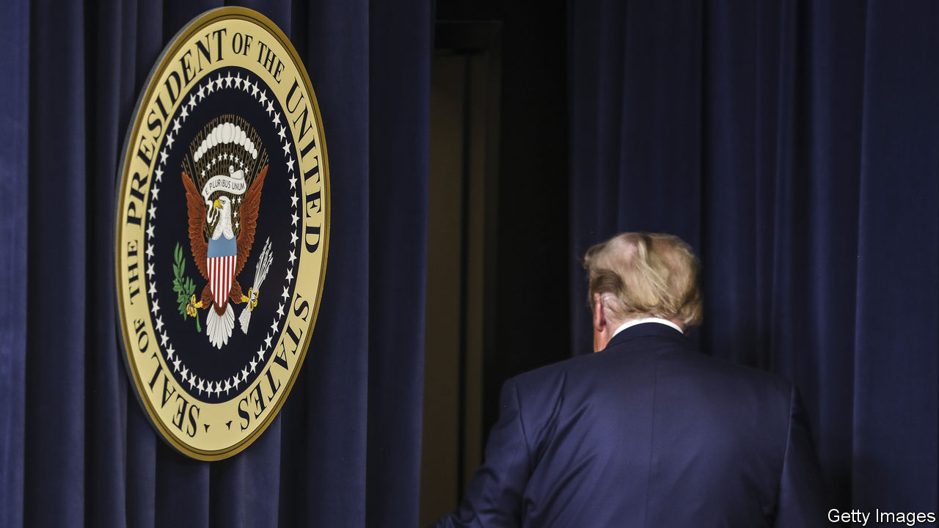

FOUR YEARS ago Democrats groused that Donald Trump had secured victory in the presidential election through razor-thin victories in three states, meaning that 77,774 voters in effect swung the election. This time, regardless of a lopsided popular vote in the Democrats’ favour, the electoral-college margin was even thinner. The final, certified results show that had just 43,560 voters, or 0.03% of the total, in three states (Arizona, Georgia and Wisconsin) changed their minds, there would have been a tie in the electoral college. The outcome would then have been decided by a still more arcane, less-majoritarian election in the House of Representatives, probably in Mr Trump’s favour—making it the third time in 20 years that Democrats would have lost the presidency despite winning the popular vote.

That nightmarish scenario for Democrats has been narrowly avoided, however. All states except Wisconsin finalised their results by December 8th. On December 14th the electoral college will meet and elect Joe Biden as the 46th president of the United States. It will do so by a pledged margin of 306 votes to 232. This is exactly the same as Mr Trump’s margin four years ago, which he described as a “landslide” back then and now decries as pure fraud.

The full picture of the election has emerged only slowly. Early on the evening of November 3rd, Mr Trump won the crucial state of Florida with unexpected ease. He looked stronger than anticipated in Georgia and North Carolina. Rather than leading by ten percentage points in the popular vote, as some polls had predicted, Mr Biden appeared to be nearly tied with the president on election night—a thin margin of 1.5 points, or just 1.9m votes. Given the electoral college’s inherent advantage for Republicans, Democrats struggled with their traumatic recollections of Mr Trump’s seemingly unimaginable defeat of Hillary Clinton in 2016.

In the end, the popular vote was not nearly as close as that (see chart). The picture changed partly because of the perennial slow vote-counting in populous Democratic strongholds such as California and New York, and also because of the unusually large numbers of (mostly Democratic-leaning) Americans who voted by post in this cycle because of the covid-19 pandemic. Mr Biden’s popular-vote margin has swelled to 4.5 points, or more than 7m Americans.

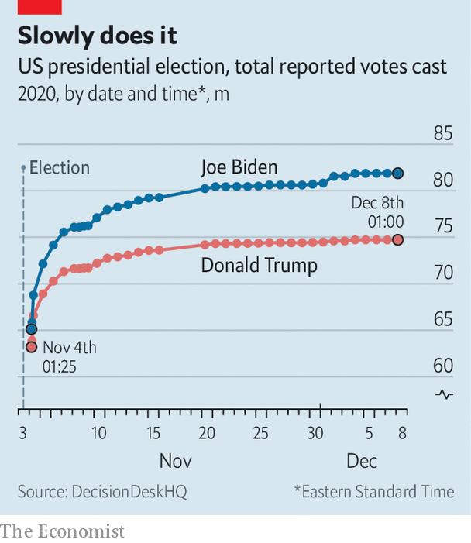

That is a good bit healthier than Hillary Clinton’s margin of 2.1 percentage points. Even so, Democrats came surprisingly close to losing the election as a result of America’s byzantine electoral-college rules, which inflate the value of small, typically Republican-leaning states and allocate votes on a winner-take-all basis.

The president is still denying defeat, refusing to concede or to go gently into that good night. His legal team has racked up an impressive record of one win and nearly 50 losses challenging election results in state and federal courts on its quixotic quest to overturn the outcome.

On December 8th Mr Trump got the especially sobering piece of news that the Supreme Court, which he had been “counting on” to look at the ballots and deliver him a second presidential term, had stamped out a wild lawsuit that sought to reverse his loss in Pennsylvania. The plaintiffs sought to toss away the state’s entire mail-in ballot, which would have disenfranchised 2.6m voters. The end came in a whimper: a one-sentence order issued merely 34 minutes after the plaintiffs, a group of eight Pennsylvania Republicans, filed their last brief. No justices noted their dissent.

As preposterous as this contention was, it attracted the support of 23 House Republicans and Senator Ted Cruz, who had offered to argue the case before the court. And the brusquely rejected case did not even take the prize for the wackiest and most anti-democratic lawsuit. That honour goes to the state of Texas, which sued four other states—Georgia, Michigan, Pennsylvania and Wisconsin—in an attempt to throw out Mr Biden’s victories on the day states were required to finalise their results. The Supreme Court will entertain this chutzpah-laden request no more than it did the other last-ditch effort. In the words of Rick Hasen, a law professor at the University of California at Irvine, the move is merely “a press release masquerading as a lawsuit”. ■

Dig deeper:  
Read our [latest coverage of the presidential transition](https://www.economist.com/us-election-2020), and then sign up for Checks and Balance, our [weekly newsletter](https://www.economist.com/checksandbalance/) and [podcast](https://www.economist.com/checks-and-balance-our-weekly-podcast-on-american-politics) on American politics.

This article was downloaded by calibre from <https://www.economist.com/united-states/2020/12/09/the-final-countdown-to-donald-trumps-election-defeat>

|  |  |  |  |
| --- | --- | --- | --- |
| Previous | Articles | Sections | Next |

|  |  |  |  |
| --- | --- | --- | --- |
| Previous | Articles | Sections | Next |

#### Public Toilets

# America is suffering from a lack of public toilets

Apart from the embarrassment of getting caught short, having nowhere to go has serious political consequences

Dec 10th 2020 |

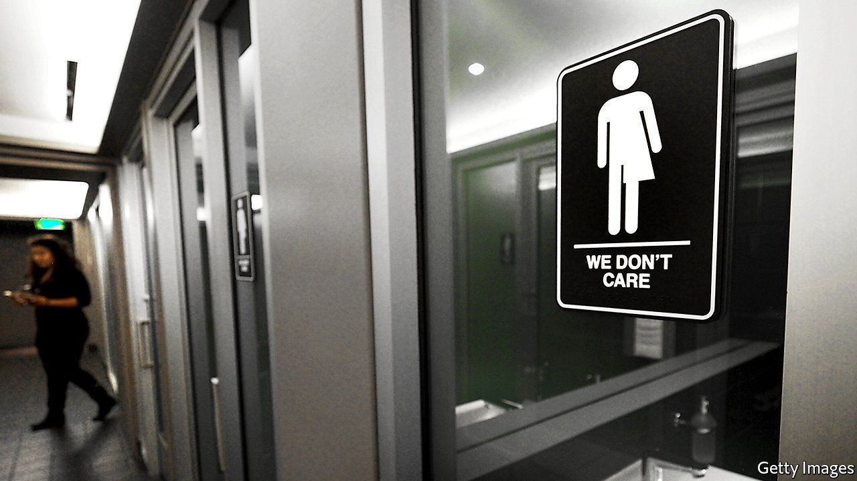

YESTERDAY’S OUTRAGE often slips away quietly. In 2016 a North Carolina law requiring transgender people to use the toilet of their birth sex upset the nation’s stomach. Companies pulled out of ventures in the state, sports leagues called off games and rock stars cancelled concerts. The law was repealed and replaced with one which prevented state and local agencies from regulating who uses which toilet in public buildings, but barred local governments from passing non-discrimination laws blocking private businesses from doing the same. On December 1st that ban expired, meaning that local governments in North Carolina can enact legislation to prevent discrimination against LGBT people.

Thus closes another chapter in the politics of the toilet. The story is a long one. In the 1950s and 60s civil-rights protesters decried “whites only” latrines. An Oakland assemblywoman, Margaret Fong Eu, took a sledgehammer to a toilet wrapped in chains outside the state capitol in 1969 to protest against pay toilets in public buildings, arguing that they placed an undue burden on women because urinals were often free. Activists poured fake urine over the steps of Harvard’s Lowell Hall in 1973 demanding “potty parity”, the equitable distribution of male and female toilets. Grip bars in bathrooms were among the demands of the disability protesters who occupied a federal building in San Francisco for 26 days in 1977.

The feminist fight against pay toilets, and a campaign by a student group, the Committee to End Pay Toilets in America, led to many states banning pay toilets in the 1970s. Vandalism and the cost of upkeep shut down many public ones. Discussions about public toilets assume they are still widely available, according to Taunya Lovell Banks, of the University of Maryland, but “free or low-cost public toilets operated by government have largely disappeared”, and access to toilets in government buildings has been reduced since the Oklahoma City Bombing and 9/11.

So those caught short must duck into a local business and awkwardly ask for relief. “Restrooms are for customers only” signs mean it often takes a penny to spend a penny, creating a barrier to the poor. Where public urination is criminalised, the homeless may have no option but to risk arrest by going in public places. In some states, this can land them on the sex-offender registry. Closures of toilets during covid-19 have only added to the problem.

The lack of accessible toilets has public-health consequences. Holding water for too long can lead to urinary-tract infections, and failure to defecate can lead to constipation and haemorrhoids. This can be difficult for workers who lack easy access to toilets, such as taxi drivers, and disproportionately affects women, who need to go more frequently. No toilets also means no soap. An outbreak of hepatitis A linked to the lack of toilets led to the death of 20 and the hospitalisation of hundreds in San Diego in 2017.

Public toilets are costly to install and maintain, and can attract undesirable behaviour. But spurred on by America’s homelessness crisis, some cities are answering the call. The right to urinate might not be up there with the right to vote, but having it guaranteed would be a relief. ■

This article was downloaded by calibre from <https://www.economist.com/united-states/2020/12/10/america-is-suffering-from-a-lack-of-public-toilets>

|  |  |  |  |
| --- | --- | --- | --- |
| Previous | Articles | Sections | Next |

|  |  |  |  |
| --- | --- | --- | --- |
| Previous | Articles | Sections | Next |

#### Religious discrimination

# Accusations of anti-Semitism return to a New York village

Zoning in on zoning

Dec 10th 2020 | AIRMONT, NEW YORK

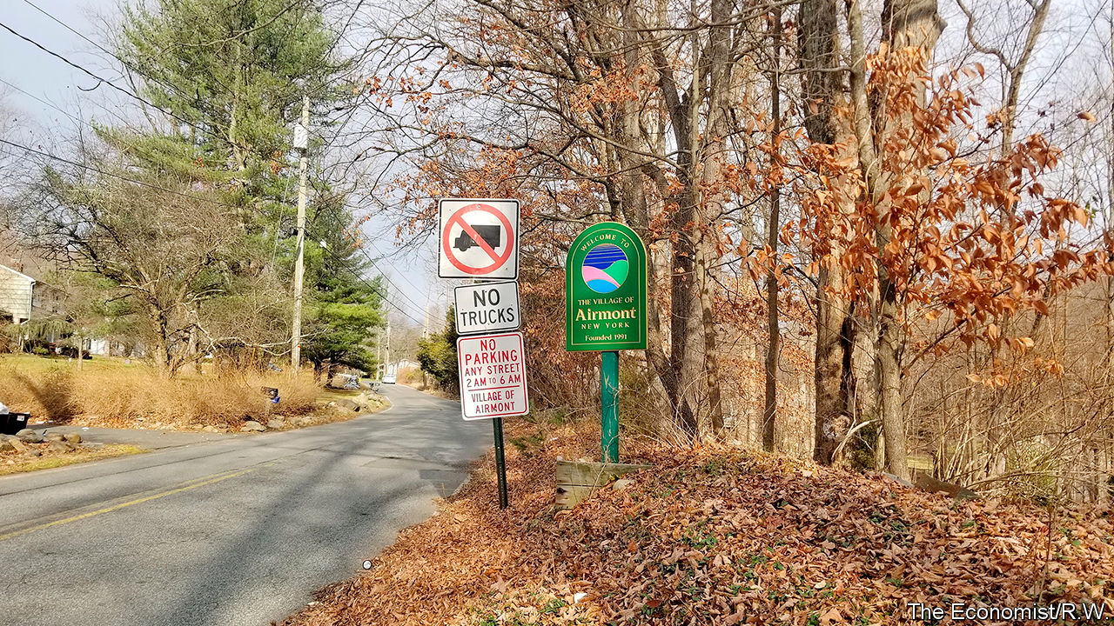

A SUKKAH IS a temporary hut built for Sukkot, a weeklong Jewish festival. It is usually covered in branches. In September 2017 the then mayor of Airmont, a village 35 miles north of New York City, ordered the fire inspector to the home of the mayor’s neighbours, an Orthodox Jewish family, to demand the family dismantle its sukkah. According to a lawsuit filed by the federal government on December 2nd, the inspector, at the mayor’s direction, threatened the family with immediate eviction unless the sukkah was taken down. The family dismantled it, despite the sukkah not violating any law.

This is one of several examples of alleged religious discrimination offered by the Department of Justice in its lawsuit against Airmont. It asserts that the village adopted discriminatory zoning codes and land-use practices that violate federal law and previous court judgments. Airmont claims the government is misinterpreting the village code. Yet this is the third time the federal government has filed a suit against the village since it was incorporated in 1991. A jury unanimously found in 1995 that the village’s first mayor, trustees and zoning board had engaged in a conspiracy to deprive Orthodox Jewish residents of their civil rights. One local said at the time: “the only reason we formed this village is to keep those Jews…out of here.”

For much of its history, Airmont has been under investigation, in litigation or under some sort of federal oversight. Its very creation, said Audrey Strauss, the acting attorney for New York’s Southern District, has its roots in animus against Orthodox Jews. Its incorporation came about because some locals wished to impose zoning restrictions to prevent the growing ultra-Orthodox Jewish population from worshipping together at home.

Since federal oversight expired in 2015, the latest lawsuit says, the village has doubled down on discriminatory land-use zoning. The government claims the village unlawfully prevented the approval of an Orthodox Jewish school’s expansion. Airmont implemented an 18-month village-wide moratorium on development, which the lawsuit claims was targeted at the Orthodox Jewish community. When the moratorium expired in 2018, the filing claims land-use laws were amended and applied arbitrarily. Jewish homeowners were prohibited from installing mikvahs, ritual baths used for religious observances.

Several rabbis jointly filed suit in a federal court in 2018. The case is pending. Their lawyer, Keisha Russell of First Liberty, a not-for-profit firm that specialises in religious-discrimination cases, said one client spent $50,000 over two years trying to get approval for a home extension.

For the past decade the ultra-Orthodox (particularly the Hasidic) population has been growing in towns in upstate New York and neighbouring New Jersey. Many of the arrivals were priced out of their old neighbourhoods in gentrified Brooklyn. The surging numbers and their demands for land have often put them at odds with locals. After battles over zoning and lawsuits, voters in nearby Monroe agreed in 2017 to allow a Jewish enclave to secede from the surrounding town to create a new town called Palm Tree. There, most wanted to replicate city life, living close together in multifamily dwellings.

But most Orthodox Jews in Airmont live in single-family homes on large lots on quiet streets. Yehuda Zorger, a community activist, for instance, left Brooklyn in 2014 for Airmont’s suburban lifestyle. He says it has reached the point where even having extended family help fix his deck might draw the wrath of code enforcement. Had he known Airmont’s history before he moved there, he says, he would have looked elsewhere for his coveted suburban lifestyle. Now, he is not going anywhere. ■

This article was downloaded by calibre from <https://www.economist.com/united-states/2020/12/10/accusations-of-anti-semitism-return-to-a-new-york-village>

|  |  |  |  |
| --- | --- | --- | --- |
| Previous | Articles | Sections | Next |

|  |  |  |  |
| --- | --- | --- | --- |
| Previous | Articles | Sections | Next |

#### The Fort Hood report

# A scathing report on sexual abuse may alter army culture

The US Army vows to change its ways in response to damning criticism on its failures at Fort Hood

Dec 10th 2020 | NEW YORK



VANESSA GUILLéN, a 20-year-old soldier, told her mother she had been sexually harassed for months by higher-ranking soldiers at her Fort Hood army base in Texas. She had refrained from reporting it out of fear of retaliation. Not satisfied with the army’s response to her disappearance in April, her family told local lawmakers and media that she had been harassed by superiors. Two months after she went missing, her dismembered body was found buried near a river 20 miles from the base. It later emerged that one of the harassing soldiers allegedly murdered her.

The hashtag #IAmVanessaGuillén, a military version of #MeToo, went viral. Service members and veterans shared their stories of sexual harassment and assault in the army. President Donald Trump vowed to help the family. In recent years Fort Hood’s reputation has suffered as a result of sexual assaults, suicides, murders and two mass shootings as well as busts for prostitution and child-sex rings. Spurred by the outcry over Guillén’s death and public awareness of violence at the base, Ryan McCarthy, the army secretary, commissioned an independent review of Fort Hood’s leadership.

The mostly civilian panel released its scathing report on December 8th. It found that Fort Hood’s commanders fostered a “permissive environment”, which allowed sexual assault, harassment and violence to go unchecked. The panel called for staffing changes and better programmes to protect soldiers. In response, the army removed or suspended 14 military leaders, including the major-general who headed Fort Hood at the time of Guillén’s disappearance.

Fort Hood has much higher rates of violent sex crimes than other posts—75% higher than the army overall. As far back as 2014 the base was identified as a high-risk installation for sexual assault. The report said Fort Hood’s commanders did little to tackle the spectrum of criminal incidents. That led to underreporting of sex crimes. Like Guillén, victims feared retaliation as well as ostracism and career damage. Queta Rodriguez, a former marine who served on the committee, called the number of unreported sex crimes at Fort Hood “shocking”. The committee discovered 93 credible accounts of sexual assault among the 507 women it interviewed. Of those, only 59 were reported. Of the 217 accounts of sexual harassment, only half were reported.

The panel found an extremely high number of suicides, but because the post’s criminal investigators were inexperienced and under-resourced, contributing causes were not always examined. Fort Hood has the highest drug-test failure rate in the army. Local police describe the base as having a “thriving drug culture”, but little seems to have been done about it. The report also criticised the inadequate procedures for missing soldiers, especially when there are suspicious circumstances. The absent soldier is often labelled a deserter. More than two dozen soldiers have gone missing or died since the start of the year, including Gregory Morales, a murdered private who the army assumed went AWOL. His body was found near Fort Hood by investigators looking for Vanessa Guillén.

The panel made 70 recommendations. Nearly half are aimed at combating sexual harassment and assault. It also recommended new procedures for missing soldiers. In response, Mr McCarthy announced that the army would take immediate action when soldiers are reported missing and formed a task force to map out a plan to tackle the problems identified in the review. Although the report focused on Fort Hood, he said, its conclusions will have army-wide implications. He predicted that the findings “will cause the army to change our culture”.

Fort Hood’s dysfunction is not unique, says Don Christensen, the air force’s former chief prosecutor who heads Protect Our Defenders, an advocacy group. Sexual harassment and retaliation cut across all services, from small air-force bases to naval ships. “It takes a crisis to move the ball forward,” he says. Joe Biden, the president-elect, has said he would take a hard line against sexual abusers in the forces.

It is rare for the army to allow an independent review. Its findings are a wake-up call not just for the army, but for Congress, too, which has a history of being hesitant in pushing for change in the armed forces. Guillén’s family hopes Congress will pass the I Am Vanessa Guillén Act, which would allow outside investigators to handle military sexual misconduct. ■

This article was downloaded by calibre from <https://www.economist.com/united-states/2020/12/10/a-scathing-report-on-sexual-abuse-may-alter-army-culture>

|  |  |  |  |
| --- | --- | --- | --- |
| Previous | Articles | Sections | Next |

|  |  |  |  |
| --- | --- | --- | --- |
| Previous | Articles | Sections | Next |

#### American economic policy

# How much economic stimulus does America actually need?

Picking the right package

Dec 12th 2020 |

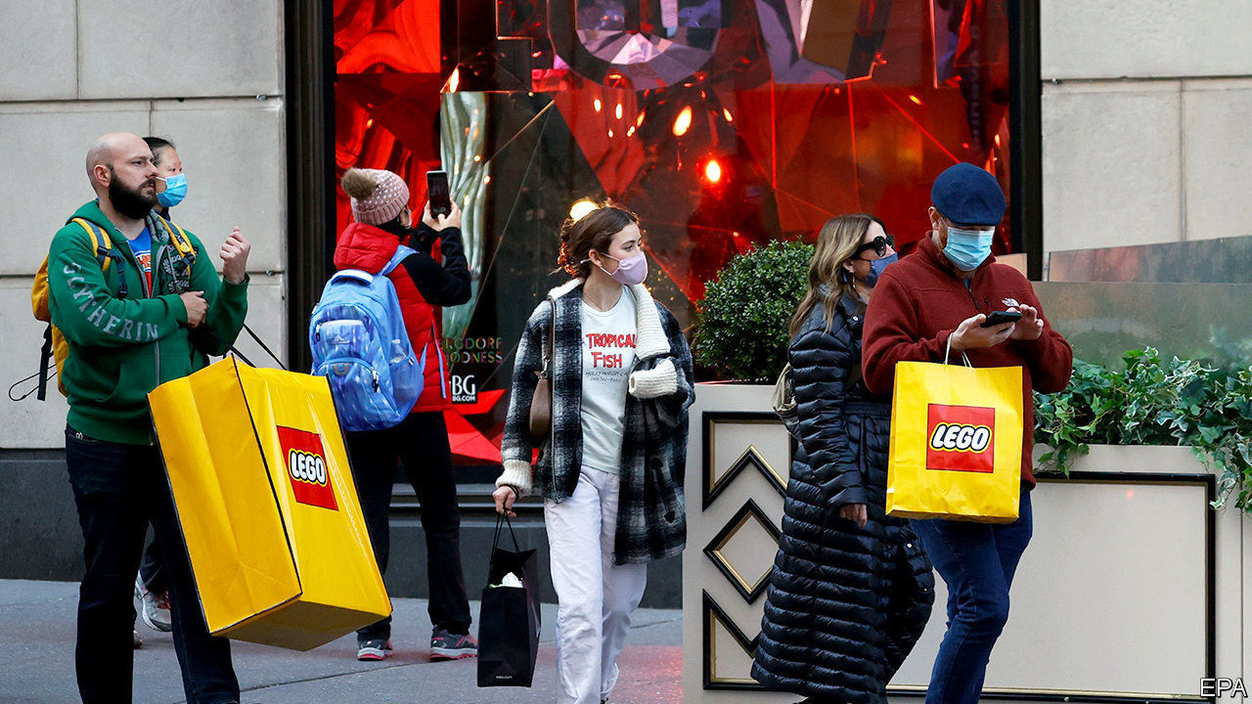

IN THE SPRING America passed economic-rescue measures worth $2.3trn this year (11% of GDP), a larger injection than in any other big, rich country. With a slowing economy, almost everyone agrees that more is required, yet for the past six months Congress has squabbled over a new bill. Democrats pushed for a deal worth over $2trn in 2021; Republicans insisted on far lower amounts. As The Economist went to press, it looked as though an agreement might be in the offing. How much extra money is needed?

To answer that question requires estimating two things: the size of the “output gap” and the “fiscal multiplier”. Both are as hard to quantify as they are to translate into plain English. The output gap measures the difference between the actual level of economic output and the amount the economy is capable of producing. Official data suggest that the gap was over 3% of GDP in the third quarter of the year, but it has almost certainly narrowed since then. Other economists estimate the gap using data on unemployment. A rule of thumb is that it is twice the difference between actual unemployment (6.7%) and full employment (with a jobless rate of perhaps 3.5%), which points to a figure of about 6% of GDP.

A stimulus package should aim to fill the output gap. But fiscal spending does not necessarily translate one-for-one into increases in GDP. Estimating this “fiscal multiplier” is also tricky. Analysis by the Committee for a Responsible Federal Budget, a public-policy organisation, suggests a multiplier of about 0.6 during the pandemic, meaning that $1 of government spending translates into 60 cents of output. Many people saved rather than spent their stimulus cheques, for instance. They might be less cautious today, however, in part because more shops and restaurants are open now.

Assume that the output gap is halfway between the GDP measure and the unemployment measure—4% or so—and that the multiplier is around one. If so, a package of $900bn-$1trn in 2021 would probably do the trick (further measures will almost certainly be needed in 2022 and beyond). But anyone pressing for a bigger or smaller stimulus can come up with their own, also plausible, estimates.

Dig deeper:  
Read our [latest coverage of the presidential transition](https://www.economist.com/us-election-2020), and then sign up for Checks and Balance, our [weekly newsletter](https://www.economist.com/checksandbalance/) and [podcast](https://www.economist.com/checks-and-balance-our-weekly-podcast-on-american-politics) on American politics.

This article was downloaded by calibre from <https://www.economist.com/united-states/2020/12/12/how-much-economic-stimulus-does-america-actually-need>

|  |  |  |  |
| --- | --- | --- | --- |
| Previous | Articles | Sections | Next |

|  |  |  |  |
| --- | --- | --- | --- |
| Previous | Articles | Sections | Next |

#### The battle of Chosin Reservoir

# Lessons from the battles between America and China, 70 years on

When America and China went to war

Dec 10th 2020 |

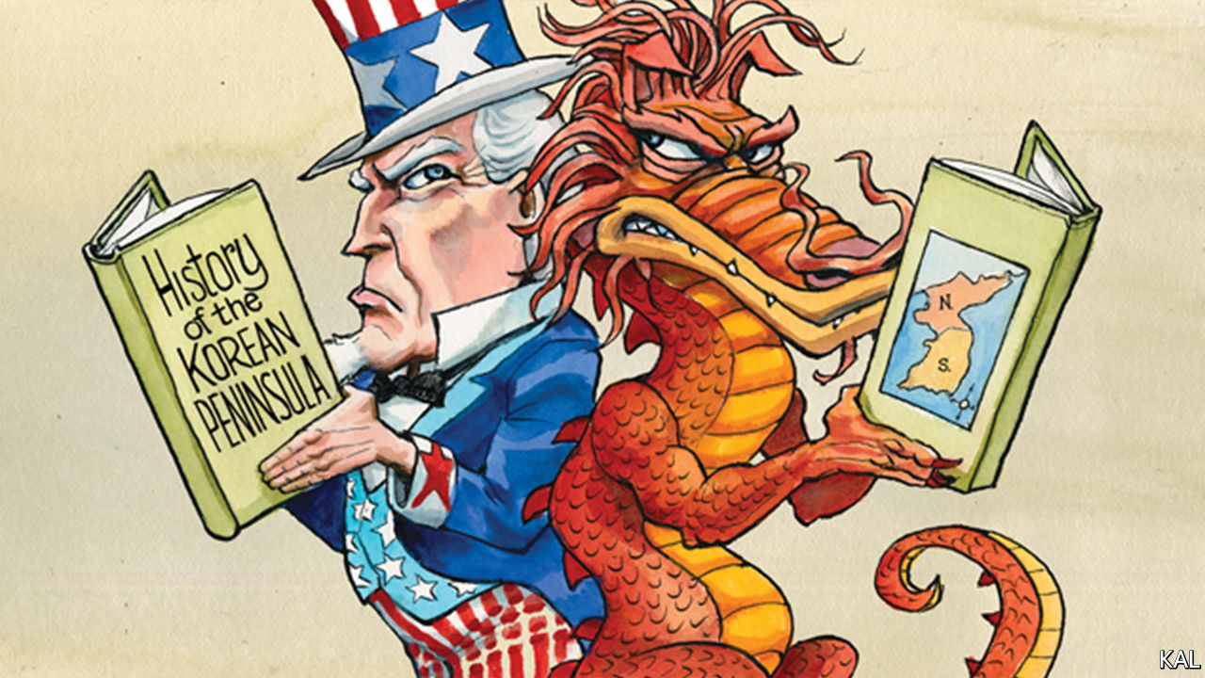

SEVENTY YEARS ago this month, Mao Zedong’s peasant army inflicted one of the worst military defeats on America in the country’s history. Over two weeks his “volunteer” fighters drove an army of 350,000 American soldiers and marines and their Korean allies the length of North Korea, from the Chinese border to hasty evacuations by land and sea. Though the Chinese suffered terrible casualties in the process and the war would continue for another three years (and technically has not ended), the American-led UN force never again threatened to reunify the peninsula.

This humiliation was made worse by the fact that General Douglas MacArthur, the force’s megalomaniacal supremo, had only weeks before assured Harry Truman that the Chinese would not cross the Yalu river. His commanders duly denied that they had. When that became incredible, they claimed the cruelly ill-equipped Chinese—wearing cotton uniforms and canvas shoes for a high-altitude war fought at minus 30°C—were not a serious foe. An American general called them “a bunch of laundrymen”.

It was classic superpower hubris, deserving of the contempt expressed by Xi Jinping at a grand 70th-anniversary event in October. Having emerged victorious from the second world war, with fewer casualties than any other major participant (America’s covid death-toll is almost equal to its second-world-war combat toll), America in 1950 had a dangerous sense of impregnability, a racially infused contempt for Asian capability and a few generals with absurdly inflated status, including MacArthur. It might seem little wonder that America, consumed by the contemporary embarrassment of its president’s effort to steal an election, is barely commemorating its first and only war with China.

That does not denote shame, however. Notwithstanding Americans’ dewy-eyed view of their forces, public knowledge of their victories and defeats is similarly thin. American schools do not teach much military history and democracies do not mobilise people through a militaristic view of the past. In the case of the Korean war, the first “limited” war of the nuclear age, before that concept was well-understood, the forgetting has merely been especially pronounced. Yet the war retains cautionary lessons for both sides.

On one level it encapsulated the superpower’s enduring ability to self-correct. This was apparent even amid the debacle—as illustrated by the battlefield recollections Lexington heard this week from Jack Luckett, a 91-year-old retired marine. He was occupying a ridge above Chosin Reservoir, close to the northernmost point of MacArthur’s advance, on the night of November 27th 1950. Awakened by explosions, he saw a column of Chinese—eight men across—advancing in the glow of the defensive flares they had triggered. “We were vastly outnumbered,” he said. “We opened fire but they kept on coming. They were blowing bugles and firing on us while pouring down both sides of the ridge.”

Mao’s intelligence chiefs had assured him that, for all their superior technology, American soldiers lacked the belly for a fight. The ensuing 17-day battle, which Mr Luckett fought through until frostbite laid him low, gave the lie to that. Surrounded by 120,000 Chinese, the 1st Marine Division broke out and made a heroic fighting retreat through the frozen mountains. The marines—and a small British contingent fighting alongside them—suffered terrible casualties; only 11 of Mr Luckett’s company of 250 survived unscathed. Yet they evacuated their wounded and equipment while inflicting a far heavier toll on the Chinese. Mr Luckett’s marine division was reckoned to have disabled seven Chinese ones.

For a military institution whose small size, relative to the US army, has fuelled a tradition of mythologising and introspection, “Frozen Chosin” ranks alongside “Iwo Jima” in importance. “It’s not an overstatement to say marines credit the marines who fought in Korea with ending the debate about whether there should be a marine corps,” says General Joseph Dunford, a former marine-corps commandant (and recently retired chairman of the joint chiefs of staff). His father celebrated his 20th birthday at Chosin reservoir on the day of the Chinese attack.

In the soul-searching that followed the American retreat, notes Max Hastings, a British historian, it is possible to see a familiar debate about the kind of superpower America should be. Deaf to the entreaties of allies, MacArthur refused to accept the limits to American power that his incompetence had helped display. He wanted to nuke the Chinese. Truman resisted and, after MacArthur sneakily appealed to his Republican backers in Congress, sacked the revered general. It may have cost him a second term. It also set a gold standard for civil-military relations that has since prevailed.

Truman’s multilateralism and restraint were also vindicated when his Republican successor, Dwight Eisenhower, maintained his conduct of the war. Better military leadership had by then stabilised the situation. America and China would both settle for their initial aims: respectively, securing South Korea, which would become one of the big successes of the late 20th century, and securing a Korean buffer against America’s presence in Asia. America lost 40,000 lives in the process; China maybe ten times as many.

## First know your enemy

That Americans are not more interested in this momentous past ultimately reflects their restless democracy, which is too consumed by contemporary dramas to dwell on history. Current appearances notwithstanding, it is the source of American strength. Yet it is important to underline two lessons from America’s war with China. In a fog of misunderstanding, each side fatally underestimated the other. And each had a flawed idea of the other’s red lines, the tripwires that turn competition into conflict. The situation today might look very different. The two countries’ interdependence and mutual awareness are on another plane. But their potential for underestimation and misunderstanding is still hauntingly present; and perhaps growing with their rivalry.■

This article was downloaded by calibre from <https://www.economist.com/united-states/2020/12/10/lessons-from-the-battles-between-america-and-china-70-years-on>

|  |  |  |  |
| --- | --- | --- | --- |
| Previous | Articles | Sections | Next |

|  |  |  |
| --- | --- | --- |
| United States | Sections | Middle East & Africa |

The Americas

Nicaragua: Seeing off a strongman

.

Cuba: Udder delight

.

Bello: Natural and political disasters

.

|  |  |  |
| --- | --- | --- |
| United States | Sections | Middle East & Africa |

|  |  |  |  |
| --- | --- | --- | --- |
|  | Articles | Sections | Next |

#### Seeing off a strongman

# How to unseat Nicaragua’s Daniel Ortega

To have any chance in next year’s presidential election, the opposition must unite now

Dec 10th 2020 | MANAGUA

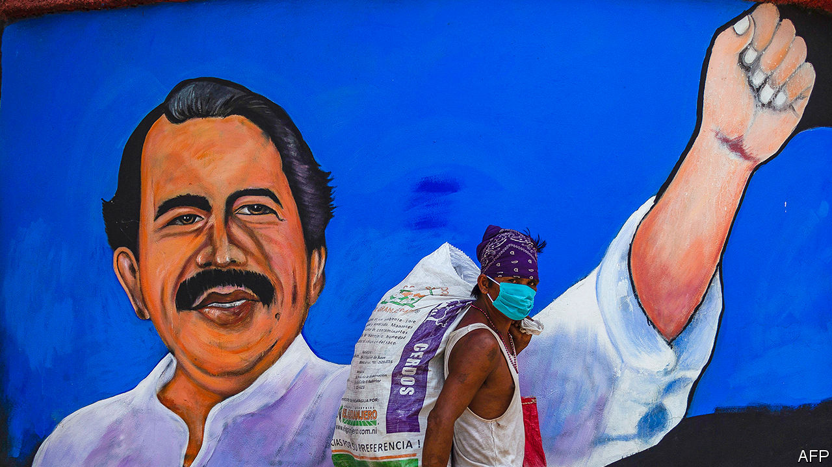

CLOAKED IN A hoodie, Camila found herself bellowing anti-government slogans along with scores of other people at a crossroads in Managua, Nicaragua’s capital, in April 2018. The protest was part of la crisis, which began in reaction to a proposal to cut pension benefits. In putting it down, the regime killed perhaps 450 people. Camila (not her real name) feared she would be spotted by government agents scanning the crowd. As repression mounted, she fled from Nicaragua. Neighbours, part of the regime’s network of local spies, later stopped by her family’s home to ask after her. Camila now studies in Europe. She will not go back, she says, until Daniel Ortega, the regime’s leader, is out of power.

Veterans of la crisis will have a chance to remove him in a presidential election scheduled for November 2021. In a fair vote Mr Ortega, who has held power without interruption since 2007, would probably lose it. But he has long stopped practising fairness. The opposition is energised and determined—but also divided. If it is to put up a respectable fight, it will have to settle its differences and find a leader soon.

John Bolton, a national security adviser under Donald Trump, branded Nicaragua’s regime and those of Cuba and Venezuela as a left-wing “troika of tyranny”. But Nicaragua is in some ways an exception. Mr Ortega’s revolutionary credentials are impeccable. His Sandinista Liberation Front overthrew the United States-backed Somoza dictatorship in 1979. He governed the country until he lost an election in 1990. But he is more an opportunist than an ideologue. During his second stint in power, even as Nicaragua took billions of dollars from Venezuela, he formed an alliance with business and wooed the Catholic church by supporting family values and anti-abortion legislation. Although the United States and the European Union imposed sanctions against officials and institutions after the crackdown in 2018, Nicaragua is not quite the pariah in the West that Venezuela is. The IMF agreed to lend it $185m to cope with the pandemic.

Mr Ortega’s friends let him rig elections and take control of courts, the electoral authority and the media. He governs with Rosario Murillo, who is both first lady and vice-president. The duo delivered political stability. Economic growth helped pay for benefits, such as tin roofs, for the poor.

But when aid from Venezuela dried up the government had to make painful reforms, including the pension cuts that sparked la crisis. The unrest hurt business confidence and tourism, causing the economy to shrink by a seventh since 2017. The number of formal jobs had fallen by a fifth, even before the pandemic struck.

When it did, the Ortega government was complacent. Before Nicaragua had confirmed cases, Ms Murillo held a rally for “love in the time of covid-19” to show solidarity with less fortunate countries. Nicaragua responded to the pandemic’s onset with the world’s laxest containment measures, according to a stringency index put together by Oxford University. The death toll, officially 162, is 6,000-7,500, according to an analysis by Confidencial, a newspaper, of extra deaths attributed to diabetes, pneumonia and heart attacks. Two hurricanes that struck in November left thousands of Nicaraguans homeless (see [article](https://www.economist.com/node/21796099)).

Mr Ortega’s popularity has plummeted. His odds of re-election depend on the coherence of the opposition, and how much he is willing and able to undermine the integrity of the vote.

The opposition that burst into life in 2018 lacked leaders and organisation. Those emerged when Mr Ortega convened a dialogue as a way to buy time. Students, businessfolk and think-tankers founded the Civic Alliance. A peasants’ movement, formed earlier in the decade, took part in the dialogue. Blue and White National Unity (UNAB), a grouping of more than 100 student and civil-society outfits, sprang up after the talks.

These groups all want to restore democracy and obtain justice for the victims of the crackdown. They are not natural partners. UNAB worries about inequality. “We see crony capitalism as part of the problem,” says UNAB’s leader, Félix Maradiaga. The Civic Alliance prioritises a quick economic rebound. Mistrust within the opposition is rife, partly because almost everyone has at some point dealt with Mr Ortega.

In January its separate elements joined to form a National Coalition. The Civic Alliance left nine months later, angry that a party in the coalition had come under the regime’s sway. (It now has new leaders.)

To have any hope in November’s election the opposition will need to unite. A candidate needs only a plurality to win. In an opinion poll in June, no opposition figure was mentioned as the probable winner by more than 13% of respondents. “We lack a messiah,” says Juan Sebastián Chamorro, the head of the Civic Alliance. The opposition has until June to register a candidate as the nominee of a party (perhaps the small independent Citizens for Liberty).

Contenders include Mr Maradiaga, Mr Chamorro and Medardo Mairena, the peasants’ leader. It is not clear how the choice will be made. In a stalemate Cristiana Chamorro, Mr Chamorro’s cousin and the daughter of Violeta Chamorro, who succeeded Mr Ortega in 1990, could become the opposition’s standard bearer. Managua’s magnates would back her.

Mr Ortega is already harassing his would-be opponents. Mr Maradiaga says he has lost three drivers in three months because the police confiscated their licences. Last year Mr Mairena was convicted of attempting to overthrow the government and sentenced to 216 years in prison, where he was tortured. He was eventually pardoned. Mr Ortega may not allow any credible candidate to challenge him.

The government has recently enacted laws that would mete out prison sentences for spreading “fake news” (as the regime defines it) and brand as “foreign agents” NGOs that get money from abroad. Under a new law, perpetrators of “hate crimes” can be jailed for life. Opposition politicians fear it will be used against them.

But Mr Ortega is reluctant to steal elections as flagrantly as his friend, Nicolás Maduro, who on December 6th arranged for Venezuela’s ruling party to wrest control of the legislature from the opposition. Without Venezuela’s largesse and oil reserves of its own, Nicaragua has turned to Western financial institutions. The IMF loan is part of nearly $1bn in credits for coping with the pandemic and hurricane damage. (At the insistence of the United States, the UN and other bodies will administer most of that money.) Brazen electoral fraud would invite tough sanctions from the incoming Biden administration. Full pariah status would further alienate the tycoons who run much of the economy.

For these reasons Mr Ortega may offer olive branches. They could include the release of the 100-odd remaining political prisoners and electoral reform. The crafty president will need to strike the right balance. Too little fairness may provoke isolation and another uprising. Too much may lead to his defeat. The opposition hopes to exploit any miscalculation.

It must overcome voters’ scepticism as well as Mr Ortega’s manoeuvring. The opposition “represent their own interest”, says Camila, the hooded protester. Unity might help correct that impression. It will be needed, even if Mr Ortega, who is 75, wins. Nicaragua will still require a robust opposition as a bridge to the eventual return of democracy.

Democracy alone may not heal Nicaragua’s wounds. When Camila contemplates returning, she wonders: “How do I live with my neighbour who came down to look for me?”■

This article was downloaded by calibre from <https://www.economist.com/the-americas/2020/12/10/how-to-unseat-nicaraguas-daniel-ortega>

|  |  |  |  |
| --- | --- | --- | --- |
|  | Articles | Sections | Next |

|  |  |  |  |
| --- | --- | --- | --- |
| Previous | Articles | Sections | Next |

#### Udder delight

# Cuba extends the shelf life of a national favourite, dulce de leche

A rare success in a decades-long quest for more and better dairy products

Dec 10th 2020 |



CUBANS LOVE dulce de leche. The confection of thickened, sweetened milk is an ingredient of popular desserts, including tarta de tres leches (three-milk cake) and alfajores. In a country where fresh milk is scarce, it is sold in the form of solid bars, a sugary way to get a bit of milk protein.

But the bars do not stand up well to Cuba’s heat and humidity. Mould and yeast spot them, often well before the sell-by date. So it was cause for excitement when Adriana Rodríguez, a student of chemical biology, reported in her master’s thesis that she had solved the spoilage problem. Her research was prompted by complaints from shoppers at stores supplied by Granlac, a state-run dairy firm, which employs her. After two years of experimenting she concluded that the admixture of potassium sorbate, a common preservative, as 0.11% of the product’s weight would increase its shelf life from a promised seven days to 30. The new recipe also made the bars harder, and therefore less prone to crumble. La Demajagua, a state-run newspaper, broke the news in November and other newspapers followed. Production of long-life dulce de leche is on its way.

This is a rare success in a long and mostly thwarted quest to satisfy Cubans’ craving for dairy foods. In a speech in 2007 Raúl Castro, then the country’s president, declared: “We must produce enough milk so that any Cuban who wishes to drink a glass of it can.” His brother, Fidel Castro, the founder of Cuba’s revolution, loved ice cream almost as much as cigars. In a foreword to a book based on interviews with Fidel, Gabriel García Márquez recounts a Sunday afternoon during which, after a large lunch, the leader gobbled 18 scoops. He also liked to quaff chocolate milkshakes at the Havana Libre hotel. In 1963 the CIA took advantage of this weakness by attempting to poison one. The plot failed because the pill to be slipped into Castro’s shake froze to the wall of the hotel’s freezer.

Undaunted, Fidel made dairy goods a symbol of the revolution. He wanted to prove that Cuba could churn ice cream as well as the Americans, and outdo the French in making Camembert. In the 1960s Coppelia, a sprawling outdoor ice-cream parlour in downtown Havana, served 50 flavours to 35,000 customers a day.

But the island’s Creole and Zebu cows were lacklustre lactators. Fidel ordered the import of Holsteins from Canada, but many perished in Cuba’s heat. Government breeders tried mating Holsteins with Zebus, hoping to create hardy milk cows. Just one of their offspring lived up to Fidel’s hopes. Ubre Blanca (“White Udder”) set Guinness world records for daily and seasonal milk production. When she was slaughtered in 1985, aged 13, Granma, the Communist Party’s newspaper, published a full-page obituary.

Dairy disaster deepened in 1990, after the former East Germany halted food shipments to the island and the Soviet Union cut back on deliveries of butter. Fidel famously chose to produce ice cream rather than butter, perhaps thinking it would bring relief to sweltering Cubans.

Things have not improved much. In October this year Marino Murillo Jorge, the economy and planning minister, said Cuba could import milk more cheaply than it could produce it. But since foreign currency is scarce, so is milk. Coppelia serves fewer flavours: vanilla, coffee, coconut and tiramisu, recalls a recent visitor. The only Cubans who can count on a daily glass of milk are those younger than seven, who get a serving through the ration-book system. For sweet-toothed adults there’s dulce de leche, soon minus the mould. ■

This article was downloaded by calibre from <https://www.economist.com/the-americas/2020/12/10/cuba-extends-the-shelf-life-of-a-national-favourite-dulce-de-leche>

|  |  |  |  |
| --- | --- | --- | --- |
| Previous | Articles | Sections | Next |

|  |  |  |  |
| --- | --- | --- | --- |
| Previous | Articles | Sections | Next |

#### Bello

# Natural and political disasters in Central America

Hurricane damage will cause problems for Joe Biden, too

Dec 12th 2020 |



IT IS A month since Central America was hit in quick succession by two hurricanes. Parts of northern Honduras are still under water: 50 bridges are down, and 120 roads and many hospitals and schools are still flooded. In all, some 200 people died and 7m were affected by the storms, most of them in Honduras and Guatemala, according to the UN. Tens of thousands of homes were destroyed, and perhaps 175,000 people are living in makeshift shelters.

The hurricanes came at a bad time, amid the pandemic and its economic slump. Whereas in Guatemala and Nicaragua they struck rural areas, in Honduras they devastated the Sula valley, the country’s economic heartland. The Honduran economy was already set to shrink by 7%, and unemployment had soared. Honduras, a country of 10m people, “is now facing the greatest catastrophe in its history”, says Gina Kawas, a consultant at the Central American Bank for Economic Integration who is based in Tegucigalpa, the capital. Total damage is equivalent to 40% of GDP.

With livelihoods destroyed, the flow of migrants to the United States is likely to increase. So think the presidents of Honduras, Juan Orlando Hernández, and Guatemala, Alejandro Giammattei. Both have cited the likelihood of increased migration when calling for North American help. “If we don’t want to see hordes of Central Americans looking to go to countries with a better quality of life, we have to create walls of prosperity in Central America,” said Mr Giammattei.

This is realistic—and an implicit threat. Honduras and Guatemala are among the worst-governed countries in Latin America. They offer a caricature of the region’s ills, of poverty, inequality, racism, corruption and the capture of the state by self-serving elites. Government spending in both countries is the lowest per person in the region, after only Haiti. Guatemala had protests in November over Mr Giammattei’s budget, which cut education spending while lavishing money on insiders. Mr Hernández faced protests in 2017, when opponents accused him of fraudulently winning a second term.

Millions of Guatemalans and Hondurans have fled violence, poverty and climate change (which has hurt farming). Rather than raising taxes on the better-off to spend on health, education, security, disaster preparedness and climate-change mitigation, the rulers of both countries have preferred to rely on remittances from the leavers, which account for 22% of GDP in Honduras and 14% in Guatemala. Governments kicked out international bodies set up to tackle corruption and organised crime in both countries. Prosecutors in New York say Mr Hernández took a bribe from a drug-trafficker (he denies this). His brother was convicted of drug-trafficking by a court in New York in 2019.

Although a relief effort is under way in Honduras, it is “patchy”, says George Redman of Oxfam, a British charity. He points out that not only was the government unprepared—just weeks before the hurricanes it appointed a reggaeton singer with no relevant experience to head its disaster-relief organisation—but that the presence of street gangs complicates aid distribution.

Donors face a dilemma. The need is huge, but so is corruption. The former director of Invest-H, a supposedly corruption-proof agency that implements foreign-financed projects, is being investigated over misuse of foreign loans during the pandemic. Central America will thus be an immediate problem for Joe Biden’s administration in the United States. Arrivals at the southern border have risen since the covid-19 recession began. The new administration “will have to balance a desire for a more humanitarian approach [to immigration] with protecting the border”, says an American official who has worked on Central America. “It’s a challenge and it’s going to come quickly,” he says.

Mr Biden has promised a $4bn plan to deal with the root causes of migration from Central America. This builds on a scheme he promoted when he was vice-president. It aims to strengthen the rule of law and democratic governance, partly by helping local anti-corruption campaigners and prosecutors, who have had some success. The need for foreign help for reconstruction should offer leverage for reform. One idea is to set up an international body to work with local public auditors to track spending. But Honduras and Guatemala need political change, rather than just protest or individual efforts. Sadly, this is not on the horizon. That is a problem for the United States, as well as for the countries themselves.

This article was downloaded by calibre from <https://www.economist.com/the-americas/2020/12/12/natural-and-political-disasters-in-central-america>

|  |  |  |  |
| --- | --- | --- | --- |
| Previous | Articles | Sections | Next |

|  |  |  |
| --- | --- | --- |
| The Americas | Sections | Europe |

Middle East & Africa

Mining’s toxic legacy: Lead astray

.

Ghana’s election: Skirt and blouse

.

The boycott of Qatar: Bridging the Gulf

.

The Yazidis: Divided, oppressed and abandoned

.

Football: The most racist club in Israel...

.

|  |  |  |
| --- | --- | --- |
| The Americas | Sections | Europe |

|  |  |  |  |
| --- | --- | --- | --- |
|  | Articles | Sections | Next |

#### Toxic legacies

# How a lead mine in Zambia has blighted a town

Children are being poisoned. A lawsuit tries to apportion blame

Dec 10th 2020 | KABWE

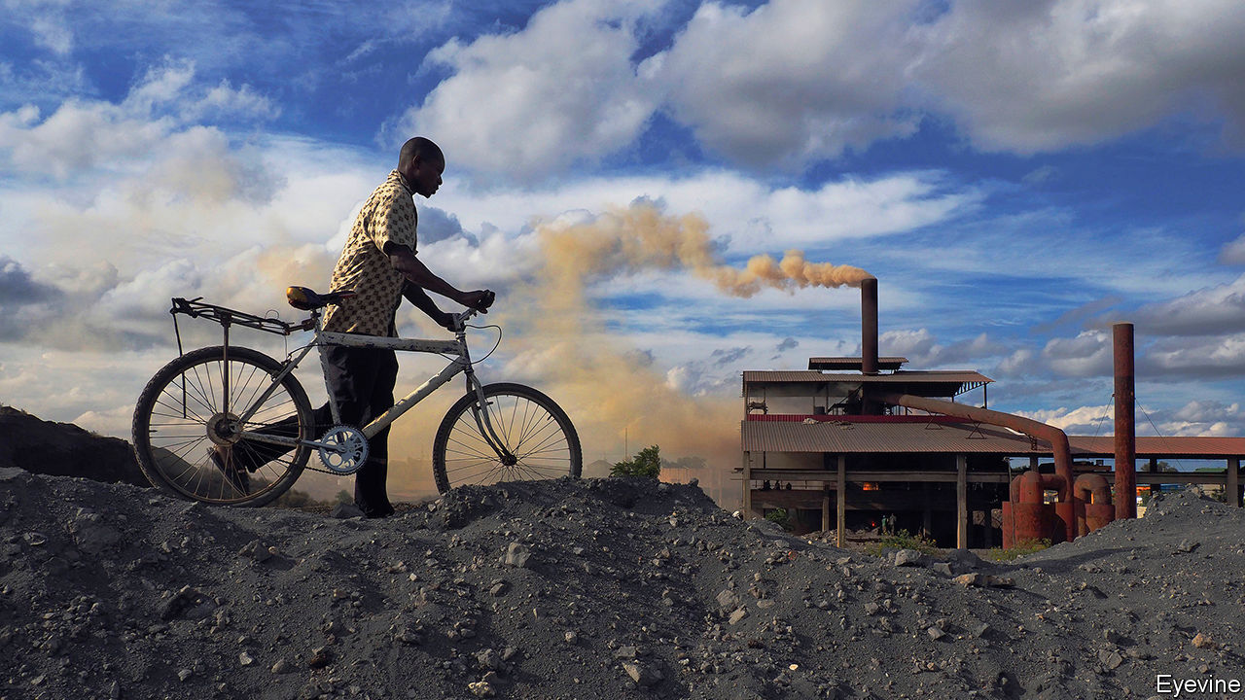

AZAEL TEMBO takes a seat in the shade of a mango tree outside his house. He kicks up the dust. “It’s affected,” he says, pointing to the plume around his feet. The 67-year-old lives in Kabwe, a town in central Zambia whose history, like that of much of the southern African country, is intertwined with mining. Kabwe sprung up around a mine founded in 1904 by the Rhodesian Broken Hill Development Company, a British colonial firm. For decades miners like Mr Tembo crushed and burnt ore to extract lead. That metal made Kabwe but it also devastated it. To this day lead particles blow across town, making their way into houses and bloodstreams.

Scientists generally consider soil hazardous if it has more than 400mg of lead per kilogram. In three townships near the old mine the soil contains six, eight and 15 times that amount, according to analysis in 2014 by Pure Earth, an environmental NGO. “Kabwe is the most toxic place I’ve ever been to,” says Richard Fuller, its president.

Prolonged exposure to lead degrades the body’s nervous and circulatory systems, damaging the brain and other organs. It is associated with higher rates of miscarriage, convulsions, comas and death. Mr Tembo believes his poor eyesight and sore limbs are from lead poisoning.

But his main concern is for his four grandchildren, in particular the two-year-old. She enjoys playing outside and is puckishly recalcitrant when told to stop putting things in her mouth. “I tell her mum to not let her eat the soil, but kids do what they will do,” he says. Children are more likely to inhale and ingest toxic dust. Their bodies are more susceptible to its potential effects, such as behavioural problems, learning disabilities and lower IQs.

Three-quarters of Kabwe’s population are estimated to have more than five micrograms of lead per decilitre in their blood, levels scientists consider elevated. Among children the average levels are much higher (see chart). “Kabwe is the most polluted place for children on the planet,” says Jack Caravanos of the NYU School of Global Public Health.

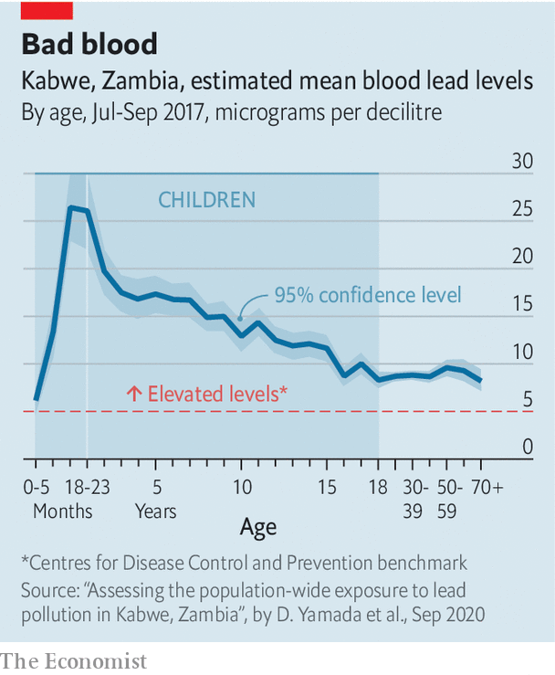

The pollution in Kabwe is a scandal. Yet responsibility for it has long been contested, and that is set to continue. In October Mbuyisa Moleele Attorneys, a South African law firm, with help from Leigh Day, a British one, announced a class-action lawsuit against a subsidiary of Anglo American on behalf of potentially more than 100,000 children and women of reproductive age in Kabwe. It is targeting Anglo because it was affiliated to the mine from the 1920s until shortly after Zambia’s mines were nationalised in 1970.

The suit claims that most of the pollution stems from the period when the mine was under the de facto control of Anglo, which allegedly did not do enough to stop the harm. Anglo rejects the claims, arguing that its involvement ended five decades ago and that, before then, it was neither the operator nor a majority shareholder in the mine and thus not responsible.

The case may take years. The lawyers for the plaintiffs must first convince a South African court to take it on. Only then may it proceed to a trial. Meanwhile children in Kabwe will keep on playing in the dust.

There have been attempts to make Kabwe less dangerous. The first concerted efforts came in the 1990s, when Zambia’s state-owned mining company conducted blood testing and provided some topsoil to cover toxic yards. But these efforts were woefully inadequate; according to Mr Fuller of Pure Earth, the government also claimed that sick residents had malaria and prescribed milk to children.

After cajoling from Mr Fuller, the World Bank included Kabwe in a broader project it funded to clean up Zambian mines. (To get Zambian officials on board, the Bank’s representative had them watch “Erin Brockovich”, a film in which Julia Roberts plays a lawyer representing victims of pollution.) The scheme, which ran from 2003-11, had some successes. It dredged a toxic canal and buried some contaminated soil. But it did not treat the main source of the dust—the former mine and dumps—and it left roads unpaved and most houses untreated. Cornelius Katiti, a local councillor at the time, reckons that just 10% of houses had topsoil replaced. An independent evaluation of the project commissioned by the World Bank found various shortcomings.

Another clean-up funded by the bank was started in December 2016. But it, too, is struggling. Some children have been tested and have received therapy to reduce blood lead levels. But since little has been done about the lead in the environment there is a risk their levels will rise again. “If this were in London, Johannesburg or a rich suburb of Lusaka it would not happen like this,” says Juliane Kippenberg of Human Rights Watch, an international NGO.

At the project office in Kabwe officials refuse to talk to your correspondent. When asked if nothing has been done to remediate the area, one worker replies: “It depends on your definition of nothing.” Later, in the capital, Lusaka, the director of the project, Gideon Ndalama, concedes that it has had a “slow start”, arguing that there is not enough money to do a full job.

More than 25 years after the mine closed, its huge waste dump—known as Black Mountain—looms. Artisanal miners cart away maize sacks filled with rocks.

In the absence of a clear plan that will end contamination in Kabwe, residents are trying to protect themselves as best they can. Local NGOs such as Environment Africa are educating people in schools and on radio shows. Families pass on warnings. “I don’t let my younger brothers play outside,” says Joy Mbuzi, a 19-year-old student, whose grandfather, a former miner, drummed into her the dangers of lead. “I’m worried about their IQs,” she says.

In his front yard Mr Tembo introduces his son, Richard. “All these years I’ve been affected,” says the 20-year-old. He struggles to focus on his college work and suffers from memory loss. He worries about his younger nieces and their difficulties at school. Given all this, hasn’t his father considered leaving Kabwe? He doesn’t have the money, says Mr Tembo. “This is our home. We’ve nowhere else to go.” ■

This article was downloaded by calibre from <https://www.economist.com/middle-east-and-africa/2020/12/10/how-a-lead-mine-in-zambia-has-blighted-a-town>

|  |  |  |  |
| --- | --- | --- | --- |
|  | Articles | Sections | Next |

|  |  |  |  |
| --- | --- | --- | --- |
| Previous | Articles | Sections | Next |

#### Skirt and blouse

# Nana Akufo-Addo wins a second presidential term in Ghana

But his party takes a hit in parliament

Dec 10th 2020 | DAKAR

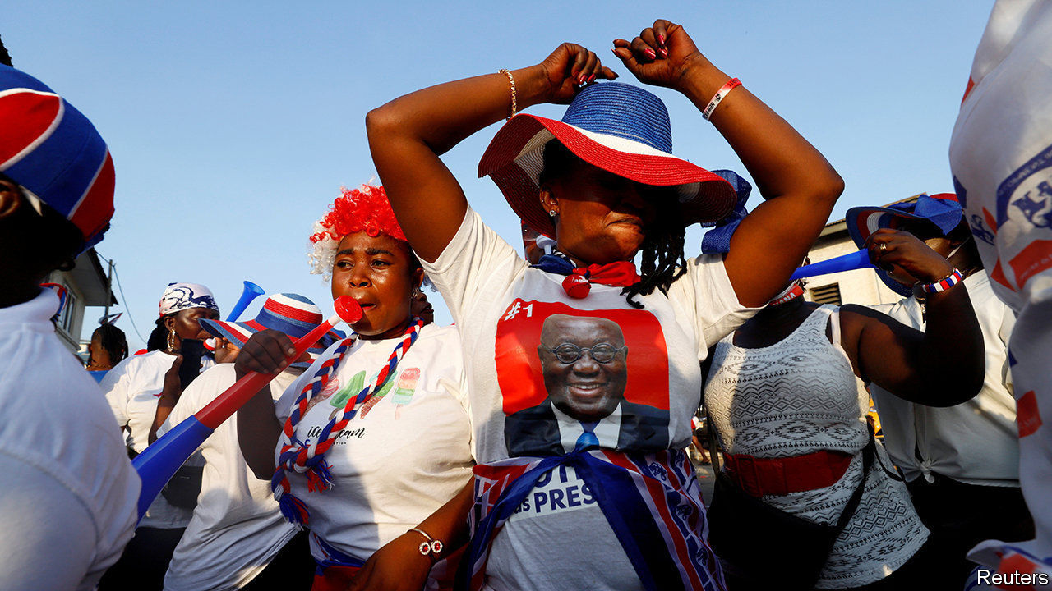

AFTER A PRAYER, the electoral commission announced that Ghana’s president, Nana Akufo-Addo, had won another four years in office in national elections held on December 7th. His supporters cheered in the streets. But his victory is far from comprehensive.

Mr Akufo-Addo’s margin shrank and his party suffered heavy losses in the parliament. About 30 seats were flipped, leaving the house split almost evenly between the two major parties. (As The Economist went to a press a handful were still in the balance.) The main opposition candidate and former president, John Mahama, was yet to concede. His party rejected the result, alleging irregularities without providing evidence of any. Few expect it to challenge the results in the streets, even if it does take them to court. Yet the moment the dust has settled, Ghana will face tough economic choices. Its public debt, already high, is climbing fast. Dealing with it may be even harder if, as remains possible, power is split between the executive president and an opposition-controlled parliament.

Mr Akufo-Addo’s win owes plenty to his government’s popular decision in 2017 to make senior high school education free. Voters also backed his handling of covid-19, which included generous handouts. Pre-election surveys showed he was trusted for his management of the economy.

Set against this, though, is the view among many voters that his government has failed at reducing corruption, says Emmanuel Gyimah-Boadi of Afrobarometer, a pan-African research group. Shortly before the election the independent special prosecutor for corruption, Martin Amidu, resigned citing political interference. Voters, especially in the capital, Accra, were unimpressed, swinging their support from the president to his opponent. The swing might have been wider still, had Mr Mahama not been tainted by corruption scandals from his time in office.

Voters seemingly punished ruling-party MPs by voting against them while still supporting the president’s bid. This was because they are seen as having failed to build things like roads or clinics in their constituencies, says Bright Simons of Imani, a local think-tank. In about 20 constituencies the opposition’s parliamentary candidate won office, even as their leader lost the presidential vote.

“Skirt-and-blouse” voting, as such splits are called in Ghana, suggests that voters are discerning in their exercise of democratic power. This may be because of experience: Ghana has held elections since 1992, with power regularly changing hands. That has made it a beacon in the region.

Yet Ghana’s democracy is not without troubles. More than 62,000 soldiers and police officers were deployed. Even so, five people were killed on election day and the day after. Political violence has been rising since 2012 and the number of Ghanaians who say they fear becoming victims of it increased by eight percentage points to 43% between 2014 and 2018.

Elections also usually add to the country’s economic woes. Those in power in Ghana almost always splurge heavily in the year before voters get to make their choice. This is often followed by an IMF bail-out; Ghana finished its 16th in 2019. Perhaps trying to tie itself to the mast, the New Patriotic Party (NPP) government introduced a rule in 2018 limiting budget deficits to 5% of GDP. But the IMF forecasts a deficit of 16.4% for 2020, the highest in sub-Saharan Africa. Covid-19 explains some of this. But the limit would have been exceeded anyway, says Henry Telli, a Ghana-based economist for the International Growth Centre of the London School of Economics.

Worse, Ghana was already at high risk of debt distress before covid-19 hit. It spends and borrows like a middle-income country, but does not collect revenue like one, says Greg Smith of M&G, an asset manager. It scrapes together tax revenue of about 14% of GDP, which is low even for similar African countries. For the next few years Ghana is likely to spend half of its revenue on interest payments. There are other troubles, too. A big new offshore oilfield, Pecan, was expected to boost growth. But this has been delayed amid lower oil prices.

Mr Akufo-Addo made bold promises on the campaign trail, from building more than a hundred hospitals to adding railway lines. If he wants parliament to pass his budgets, he may have to agree to pork-barrel side-deals with MPs. Yet if the new government cannot set a credible plan to cut spending—and stick to it— it will lose credibility with lenders. And that, says Mr Telli, could see the IMF back again. ■

This article was downloaded by calibre from <https://www.economist.com/middle-east-and-africa/2020/12/10/nana-akufo-addo-wins-a-second-presidential-term-in-ghana>

|  |  |  |  |
| --- | --- | --- | --- |
| Previous | Articles | Sections | Next |

|  |  |  |  |
| --- | --- | --- | --- |
| Previous | Articles | Sections | Next |

#### Bridging the Gulf

# The feuding Gulf states are trying to make nice

But a real end to their dispute remains far off

Dec 12th 2020 | DUBAI

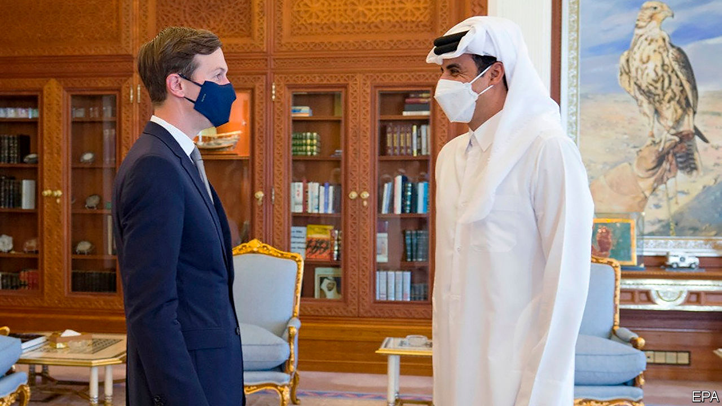

MONTHS AFTER four Arab states imposed an embargo on Qatar in 2017, a minister from the emirate made what he thought was a controversial comparison. “To be honest, we consider ourselves like Israel,” he said, referring to another small country isolated in the region. Improbably, almost three years later, this comparison seems too favourable to Qatar. Thousands of Israelis are visiting Dubai for the first time this December, while Qataris are nowhere to be found. Israel will soon have ambassadors to two of the six members of the Gulf Co-operation Council (GCC), the same number as Qatar—a GCC member.

The feud in the Gulf has long seemed intractable. But for the umpteenth time foreign officials are trying to resolve it. Jared Kushner, Donald Trump’s son-in-law and adviser (pictured, in blue mask), recently visited Saudi Arabia and Qatar to push for a deal. The Saudi foreign minister later said one was “within reach”. Qatari officials made encouraging noises too. Yet even if they promise to bury the hatchet, real reconciliation will remain out of reach.

In 2017 the “Arab quartet” behind the blockade—Bahrain, Egypt, Saudi Arabia and the United Arab Emirates (UAE)—served Qatar a list of 13 demands, among them closing Al Jazeera, the satellite broadcaster; cutting ties with Islamist groups such as the Muslim Brotherhood; and shutting a Turkish military base in Doha, Qatar’s capital. Qatar acceded to none of them and sometimes did the opposite, escalating its media war with the blockading states and deepening ties with Turkey.

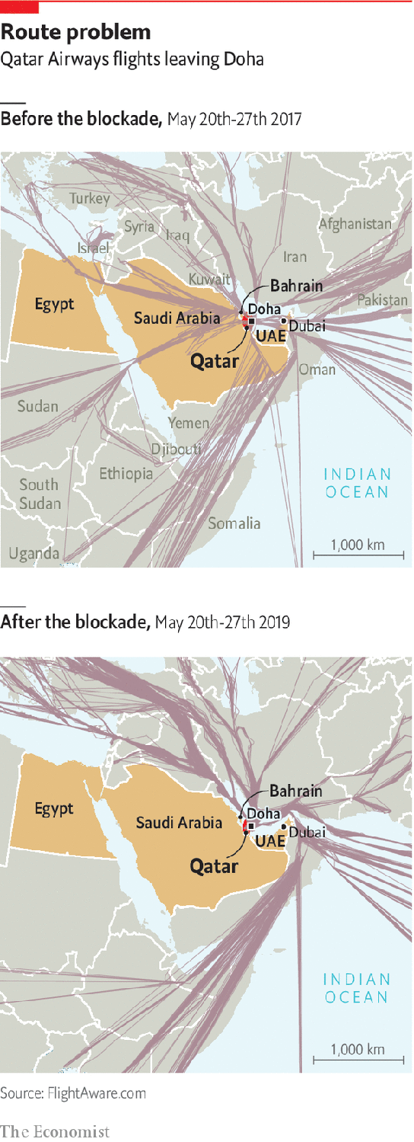

American officials want the quartet to start by reopening their air space. That would fix a self-defeating facet of the embargo. The blockading states want Qatar to cut ties with Iran, yet by forcing dozens of Qatari planes to fly new routes over Iran each day they gifted it hundreds of millions of dollars in overflight fees. Reopening the air space would be progress, but hardly a reconciliation.

Mr Kushner, who will be out of a job next month, did not offer much to accelerate a deal. Nor is it clear what Qatar would offer the quartet in return. Buoyed by the world’s third-largest proven natural-gas reserves, its economy grew in 2017 and 2018 despite the embargo. It feels no pressure to make big concessions. A small one would be to quieten Al Jazeera, where the tone of the Arabic-language channel is often a bellwether for relations between Qatar and its neighbours. Beyond that, Qatar may offer the promise of a less antagonistic relationship. In other words, not much.

That might still appease Saudi Arabia. The blockade has upset America, a close partner of both Qatar and the quartet. Steps to end the dispute would curry favour with the incoming Biden administration. Some of Saudi Arabia’s partners are less conciliatory, though. Qatar remains a bugbear for Egypt because of its support for the Muslim Brotherhood. Less enthusiastic still is the UAE, whose hostility towards political Islam puts it implacably at odds with Qatar. It has responded tepidly to the diplomacy.

Reconciliation between Saudi Arabia and Qatar would add to a growing list of disagreements between Saudi Arabia and the UAE. The Emiratis pulled out most of their troops from Yemen in 2019 and withdrew from the Saudi-led war there. They have grown nervous about Mr Trump’s belligerent policy towards Iran, which the Saudis have encouraged. Recently they have split over oil: the UAE is frustrated with Saudi-backed production caps imposed on members of the Organisation of the Petroleum Exporting Countries.

Diplomatic niceties will not end the discord between the Qatari emir (pictured, in white) and the leaders of Saudi Arabia and the UAE. And for all the talk of the “brotherly” Gulf states, the blockade has introduced a level of personal animosity in the region, particularly between Qataris and Emiratis. “People had a big shock that disturbed and tortured the social fabric of our region,” says a Qatari official. “To go back to normal, I think we need two or three generations.” Even if Qataris can soon fly over Dubai, they may not be eager to land. ■

This article was downloaded by calibre from <https://www.economist.com/middle-east-and-africa/2020/12/12/the-feuding-gulf-states-are-trying-to-make-nice>

|  |  |  |  |
| --- | --- | --- | --- |
| Previous | Articles | Sections | Next |

|  |  |  |  |
| --- | --- | --- | --- |
| Previous | Articles | Sections | Next |

#### Divided, oppressed and abandoned

# The Yazidis are still struggling to survive

Escaping Islamic State was just the beginning

Dec 10th 2020 |

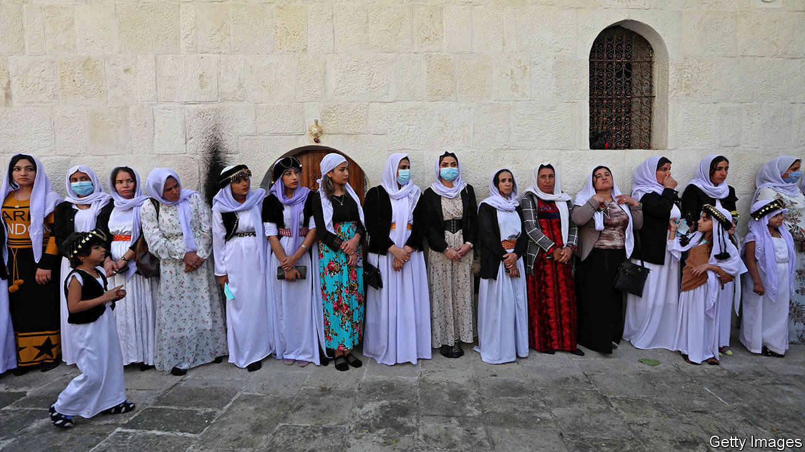

LIKE A PICTURE of purity in white robes, white shoes and a white turban, Ali Iliyas emerged from a candle-lit sanctum. He had just been inaugurated as the new Baba Sheikh, or spiritual leader of the Yazidis, on November 18th. Believers gathered at Lalish, a temple in Iraqi Kurdistan, banging drums and tootling flutes to celebrate.

But behind the scenes an unholy row is blazing between Yazidi leaders. The Asayish, or Kurdish police, had to intervene after scuffles broke out at a gathering to announce the new leader. Many Yazidi elders boycotted the temple ceremony. For the first time in its history, the esoteric Yazidi religion faces a schism.

Six years ago Western armies saved the Yazidis from Islamic State (IS). The jihadists killed 5,000 of their men and enslaved 5,000-7,000 of their women, mostly to rape. The genocide caused many Yazidis, who number perhaps 1m, to flee abroad. Inside Iraq new pressures are tearing the group apart.

Some Yazidis see themselves as part of the larger Kurdish community and have aligned themselves with the Kurdistan Democratic Party (KDP), which rules Kurdistan. But others blame the KDP for not stopping IS. They objected when Mir Hazim Tahsin Beg, a former KDP parliamentarian, was chosen as head of the Yazidis’ spiritual council last year, believing he does the party’s bidding. Nevertheless, it was Mir Hazim who chose the Baba Sheikh.

Many of the disgruntled Yazidis hail from Sinjar, home to a mountain the Yazidis consider holy (see map). Shia militias, the Iraqi army and the Kurdistan Workers’ Party (PKK), which fights for Kurdish self-rule inside Turkey, hold sway in the area—not the KDP. A number of Yazidis went to Baghdad in October to meet the prime minister and to protest against Mir Hazim. “He rules like a dictator,” says one of them. Elders within this faction are trying to set up a more representative authority.

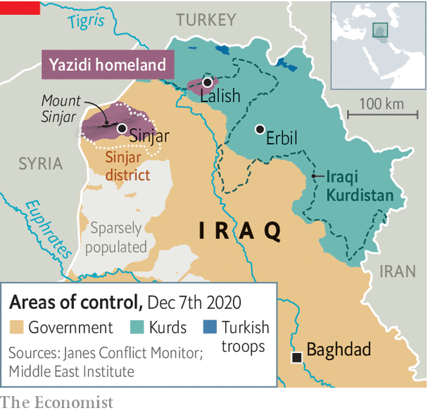

Many Muslims consider Yazidis to be devil-worshippers. The peacock etched on their buildings represents Lucifer, the angel cast from heaven—though in the Yazidi telling he is Malik Taous and has been restored to grace. In the summer Turkey, the region’s most powerful Sunni state, bombed Sinjar, claiming the Yazidis had teamed up with the PKK, which Turkey considers a terrorist group. In the Turkish-held province of Afrin in Syria, militants have driven Yazidis from their homes and defaced their shrines.

About 40% of Yazidis are thought to have fled to the West. Isolated and cut off from their homeland, many lose their religion. Yazidi elders oppose writing oral traditions down or putting them online. Meanwhile, they rigidly uphold a ban on marrying out. Some children born of Yazidi women raped by IS members are put out of the flock. Other strictures—such as the insistence on marrying inside the Yazidis’ caste system—are impractical among tiny communities abroad. Falling short, many give up altogether. It is common to see Yazidis abroad wearing blue clothes, which is taboo back home.

A little bit of liberalism could solve a lot of these problems. The opponents of Mir Hazim might be satisfied if he accepted a broader and more consultative council. Yazidi elders could ease up on those rules that are all but impossible to follow—and they could start writing things down. Many Yazidis want other countries to help rebuild Sinjar and guarantee their protection. But they are not holding their breath. They cite 74 massacres in their history—and expect to keep counting. ■

This article was downloaded by calibre from <https://www.economist.com/middle-east-and-africa/2020/12/10/the-yazidis-are-still-struggling-to-survive>

|  |  |  |  |
| --- | --- | --- | --- |
| Previous | Articles | Sections | Next |

|  |  |  |  |
| --- | --- | --- | --- |
| Previous | Articles | Sections | Next |

#### A shock result

# Beitar Jerusalem, the most racist football club in Israel...

...gets an Arab owner

Dec 10th 2020 | JERUSALEM



MATCH DAY at Teddy stadium, home of Beitar Jerusalem, can get pretty nasty. Supporters of the football club proudly sing about how it is “the most racist team” in Israel. They scream epithets, such as “terrorist”, at the Arabs who play for opposing squads. Though Arabs make up 21% of Israel’s population, Beitar Jerusalem has never itself fielded one, in keeping with fans’ claim to be “forever pure”. After the club signed two Muslim players from Chechnya in 2013, a group of fans burned down its offices. When one of the Chechens scored his first goal, many Beitar supporters walked out of the stadium. The players soon moved on.

But on December 7th the Holy Land received proof that God has a sense of irony, as Sheikh Hamad bin Khalifa al-Nahyan purchased a 50% stake in Beitar Jerusalem. Sheikh Hamad is an Arab Muslim. He is also a cousin of Muhammad bin Zayed, the crown prince and de facto ruler of the United Arab Emirates (UAE), which formally normalised diplomatic and other relations with Israel in September.

Some of Beitar Jerusalem’s fans have protested against the deal, spray-painting on the stadium’s walls that “the war has just begun”. But their collective attitude had already been changing. A documentary called “Forever Pure”, released in 2016, shone a spotlight on the club’s more despicable supporters and caused shame among the rest. Moshe Hogeg, who bought the club in 2018 and remains a co-owner, pressed fans to change their racist lyrics. Most seem elated with Sheikh Hamad’s promise to invest $100m over the next decade in the club, which hasn’t won the league since 2008.

It helps that Israel’s warmer ties with the Arab world are seen as the personal achievement of Binyamin Netanyahu, the prime minister and leader of the Likud party. Beitar Jerusalem was founded in 1936 by the youth wing of the Zionist-Revisionist movement, from which Likud descends. The club remains a bastion of working-class Mizrahi Jews, who emigrated to Israel from Arab lands. Encouraged by Mr Netanyahu, they tend to resent the old Ashkenazi elite that calls for compromise with the Palestinians. Likud bigwigs can often be seen glad-handing at Teddy stadium. Mr Netanyahu himself claims to be a lifelong supporter of Beitar Jerusalem.

That is perhaps one reason for Sheikh Hamad’s purchase: it is an investment by the ruling family of Abu Dhabi in Israel’s ruling party and its supporters. Mr Hogeg, a Jew of Moroccan and Tunisian descent, hopes it will also lead to more change. Eventually he would like to field Arab players. For now, though, he is relying on Jewish help. Before signing the deal he obtained the blessing of an Israeli ultraOrthodox rabbi. ■

This article was downloaded by calibre from <https://www.economist.com/middle-east-and-africa/2020/12/10/beitar-jerusalem-the-most-racist-football-club-in-israel>

|  |  |  |  |
| --- | --- | --- | --- |
| Previous | Articles | Sections | Next |

|  |  |  |
| --- | --- | --- |
| Middle East & Africa | Sections | Britain |

Europe

Covid vaccines: Coming soon

.

Germany and covid-19: In vino, virus

.

France and Islamism: The republic strikes back

.

Italy: Unchained Meloni

.

Romania’s election: Diluting the cleanser

.

Charlemagne: Republic of cranks

.

|  |  |  |
| --- | --- | --- |
| Middle East & Africa | Sections | Britain |

|  |  |  |  |
| --- | --- | --- | --- |
|  | Articles | Sections | Next |

#### Coming soon

# Europe prepares for its first batches of covid-19 vaccines

But supplies and uptake are both uncertain

Dec 12th 2020 | BERLIN

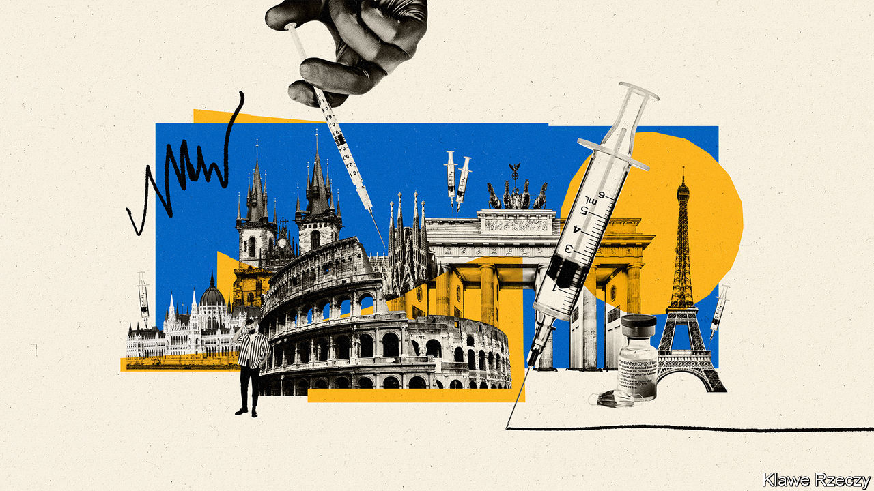

IN A TYPICAL year the Velodrom, an indoor arena in Berlin that can hold 12,000 people, hosts sports events, trade shows and concerts. This year, the biggest gig it is preparing for is a mass vaccination drive. If all goes to plan, in early January people will start streaming through its 75 booths that are being set up for dishing out doses of Germany’s first supplies of covid-19 vaccines. Two of Berlin’s disused airports and other venues are also being turned into vaccination centres. The plan is to be ready to vaccinate 20,000 Berliners a day over six weeks. This would account for 10% of the city’s residents, mainly the very old.

Germany is rushing to set up more than 430 mass vaccination sites like these. It is also organising roaming vaccination teams for care homes. In spring, vaccines will become available at doctors’ offices. Mobile teams will visit the infirm at home.

Other European countries are preparing too, though most are far behind Germany. Italy plans to set up 300 covid-19 vaccination sites, starting in hospitals, along with mobile units. The laggards are in eastern Europe, where some countries have done little more than set up task forces.

The starting shot for vaccination in the European Union will be fired on December 29th, when the European Medicines Agency (EMA), the EU’s drug regulator, is expected to decide on a covid-19 vaccine created by Pfizer and BioNTech, which has already been approved in Britain. On January 12th the EMA will make the call on a second vaccine, by the American firm Moderna. Other covid-19 vaccines that are still in clinical trials will follow. By the look of things, at some point in 2021 most European countries may be using three or more covid-19 vaccines simultaneously.

A mix of vaccines will be needed. Global supplies of any one of them will be crimped for months. Sharp elbowing for vaccines during the 2009 H1N1 (swine flu) pandemic left some European countries unable to procure any. Wary of that, the European Commission, the EU’s executive branch, earlier this year organised joint pre-purchase agreements on behalf of all 27 member states with the developers of several prospective covid-19 vaccines (see chart). These firms received hundreds of millions of euros to set up production facilities, even before their vaccines are approved. In return, they are reserving large amounts of their first vials for the EU at a set price. Approved vaccines will be distributed by the manufacturers to every EU country in proportion to its population, as batches become available.

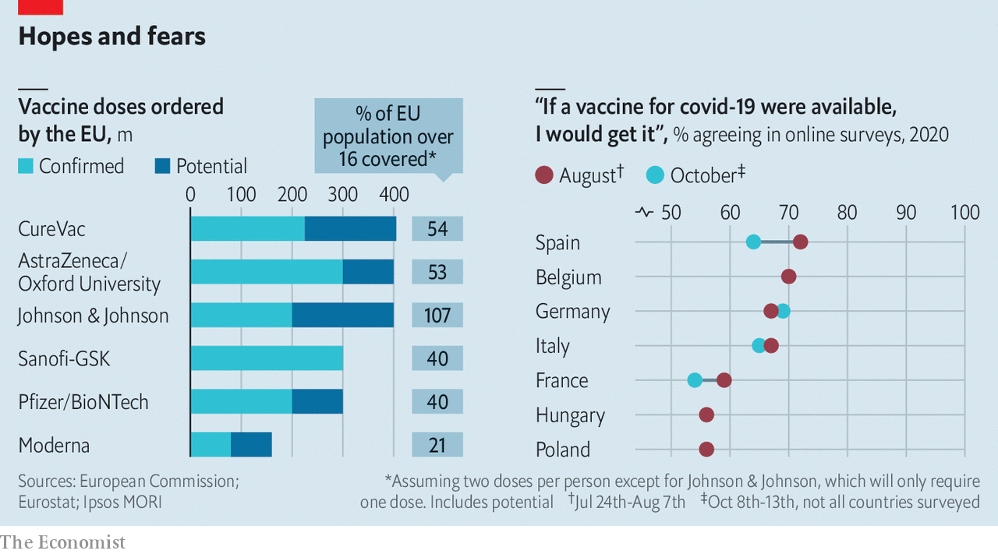

At the moment, the EU has been promised up to 300m doses of Pfizer’s vaccine and 160m doses of Moderna’s. Both require two shots per course, so this should be enough to cover 60% of all the EU’s adults. The snag is that not much of it will be ready before spring, even if there are no production hitches, which is hardly guaranteed given that the vaccines are new and production chains span several countries. In early 2021 Italy, a country of 60m, expects to get enough of the two vaccines for only 4.7m people. By some estimates, if Germany relies on its allotment of Pfizer’s vaccine alone, it will take two years to get enough for 60% of its population, the estimated threshold for “herd immunity”, the level that stops the disease from spreading.

Hence the impatience of some countries, which are looking to top up their EU allotments. Hungary is importing a Russian vaccine not vetted by the EMA. Germany is cutting its own deals with Pfizer and other vaccine-makers, joining a queue that already includes America, Britain, Japan and a global consortium buying covid-19 vaccines for poorer countries. All of this leaves European governments pinning hopes on the success of some of the other vaccines in the pipeline, and soon.

Since demand will exceed supply for some time, governments are stepping in to decide who will get priority. The answer varies by country. Bulgaria, for example, plans to start with medical workers because its hospitals are bursting with covid-19 patients, and infections among doctors and nurses are rampant.

Germany, Sweden and the Netherlands, by contrast, have weighed up the benefits of vaccinating various groups and decided to start with the elderly. German experts considered three scenarios: vaccinating those with pre-existing health conditions, the over-60s and people over 80. Their statistical models suggest that if only 500,000 people a week can be vaccinated, over a 12-week period the greatest reduction in deaths and hospitalisations will occur if all of them are over 80. The total years of life gained by vaccinating this group was also estimated to be the largest.

By April or May, Europe’s vaccination woes may swing the other way: vials of vaccine may be more plentiful but takers may be too few. Surveys asking Europeans whether they would be willing to get a covid-19 jab are returning dispiriting results (see chart 2 and [article](https://www.economist.com/node/21796040)). Ipsos MORI, a pollster, found that in some countries the share of people who say yes actually fell between August and October.

An early sign to watch will be the uptake rate among health workers, whom most European countries plan to jab early on. As things stand, many of them avoid seasonal flu shots and have doubts about the safety of the first covid-19 vaccines. Medics are as prone to believing misinformation about vaccines as anyone else. But Jacques de Haller, a former president of the Standing Committee of European Doctors, a professional association, says that some doctors avoid flu shots out of sheer arrogance, believing they are impervious to the disease.

Based on all this, some experts fear that, without strong public-messaging campaigns, the uptake of vaccines in Europe, even in countries that do well, could be as little as 40%. Mass public-communication campaigns are already being planned. One idea floated in Germany is the slogan “Sleeves up”, with photos of people cheerfully getting the jab, possibly with a single central phone number that people can call for an appointment.

But a lot more than posters and slogans will be needed. In France, where people are among the most suspicious in Europe about any vaccine, millions have watched “Hold-Up”, a slick two-hour online documentary packed with conspiracy fiction about covid-19 vaccines. It is just accurate enough to confuse viewers. As pallets of vaccine begin to arrive in European cities, a big question remains unanswered. Will people correctly see it as the best way to protect grandma, curb the pandemic and bring life back to normal? Or will they see it as a risky drug peddled by untrustworthy governments and corporations, and decide not to roll up their sleeves? If too many make the wrong or selfish choice, 2021 will be another annus horribilis. ■

Editor’s note: Some of our covid-19 coverage is free for readers of The Economist Today, our daily [newsletter](https://my.economist.com/user#newsletter). For more stories and our pandemic tracker, see our [hub](https://www.economist.com/news/2020/03/11/the-economists-coverage-of-the-coronavirus)

This article was downloaded by calibre from <https://www.economist.com/europe/2020/12/12/europe-prepares-for-its-first-batches-of-covid-19-vaccines>

|  |  |  |  |
| --- | --- | --- | --- |
|  | Articles | Sections | Next |

|  |  |  |  |
| --- | --- | --- | --- |
| Previous | Articles | Sections | Next |

#### In vino, virus

# The joys and perils of Glühwein gatherings in Germany

Covid-19 cases are rising fast

Dec 12th 2020 | BERLIN



IT IS A chilly winter evening in a courtyard in Prenzlauer Berg, a chic district in Berlin. The company is convivial, a fire pit is blazing and two cheerful barmen are serving up endless glasses of steaming Glühwein, a Christmassy concoction of spices, citrus, sugar and (usually bad) red wine. Under coronavirus restrictions the drinks are supposed to be consumed elsewhere. But here, and across Germany’s cities, that rule is honoured mainly in the breach. Warmly wrapped (but often unmasked) customers clutching their grog gather in small groups around tables or the fire. And the most magical property of Glühwein—it becomes undrinkable once it cools—ensures a steady stream of refills.

German bars and restaurants have been closed to seated custom since November 2nd. Setting up impromptu Glühwein stands is one way for their owners to replace a bit of lost income, especially as Germany’s beloved Christmas markets, where visitors usually quaff gallons of the stuff, have also been cancelled this year. There are drive-in Glühwein stands in Bavaria and Glühwein taxis in Lower Saxony. Some outlets have organised “Glühwein happenings” (although police had to break up one in Heidelberg that attracted 200 people). Andwith most other forms of public drinking off-limits, this most traditional of libations has even acquired a mild hipster edge.

Unsurprisingly, all this jollity has caught the attention of the authorities. Several cities and states have already banned open-air alcohol sales, and more seem certain to follow. “I know how much love has gone into setting up the Glühwein stands,” said Angela Merkel, the chancellor, in an emotional speech to the Bundestag on December 9th. “But this is not compatible with the agreement we have made to take food away to eat at home.”

In Germany, unlike in all other large European countries, the covid-19 caseload is growing. Every day a fresh record number of deaths is recorded. Mrs Merkel has endorsed an expert panel’s recommendation for a tougher lockdown, including extended school holidays and business and shop closures. The experts offered no specific views on Glühwein stands. But politicians are surely mulling it over.

Editor’s note: Some of our covid-19 coverage is free for readers of The Economist Today, our daily [newsletter](https://my.economist.com/user#newsletter). For more stories and our pandemic tracker, see our [hub](https://www.economist.com/news/2020/03/11/the-economists-coverage-of-the-coronavirus)

This article was downloaded by calibre from <https://www.economist.com/europe/2020/12/12/the-joys-and-perils-of-gluhwein-gatherings-in-germany>

|  |  |  |  |
| --- | --- | --- | --- |
| Previous | Articles | Sections | Next |

|  |  |  |  |
| --- | --- | --- | --- |
| Previous | Articles | Sections | Next |

#### The republic strikes back

# Emmanuel Macron unveils a controversial bill to fight Islamism

It will go to parliament next year

Dec 9th 2020 | PARIS



NEARLY TWO months after the beheading of Samuel Paty, a schoolteacher who had shown pupils caricatures of the Prophet Muhammad, the French government has unveiled a bill to clamp down on radical Islamism. This, at least, is the implicit aim of a draft law presented on December 9th. President Emmanuel Macron had promised a bill to combat “Islamist separatism”. But, to pre-empt charges of stigmatising Islam, the final version has been reframed as a text “to reinforce the principles of the republic”.

The bill, declared Jean Castex, the prime minister, is “not a text against religion, nor against the Muslim religion”. Rather, he said, it is “a law of emancipation against religious fundamentalism”, designed to reinforce such principles as laïcité (secularism) and gender equality. It was presented on the 115th anniversary of the adoption of a law that separated religion and the state, and first enshrined laïcité. This strict French version of secularism protects the right both to believe and not to believe, as well as requiring religious neutrality in public life.

The new provisions, which will go through parliament in early 2021, include tight curbs on home-schooling (though not a ban, as originally promised). Parents will need to apply for permission if they wish to teach their children at home, and to justify it. The aim is to limit the use of home-schooling as a way to escape state oversight of radical Koranic teaching. Officials say they have uncovered such classes in some neighbourhoods.

The bill will also make it easier for the government to inspect and shut places of worship or associations that get public subsidies, if they do not respect “republican principles”, such as women’s equality. A ban on state employees displaying “conspicuous” religious symbols, such as the hijab or crucifix, will be extended from the state administration to any form of sub-contracted public service, such as job centres (although, with the existing exception of schools, there is no such ban on those using public services, including universities). Those who threaten officials with violence to secure concessions on religious grounds will face criminal penalties.

Finally, doctors will be forbidden to issue “virginity certificates” in order to protect women from pre-nuptial pressure. It will also be illegal to divulge or publish information that locates or identifies individuals in a way that puts them in danger, with stiffer penalties for identifying those in positions of public authority. This measure is a direct response to the murder of Paty, whose assassin identified him on social media before travelling to the school where he taught.

The government argues that it needs stronger powers in order to break up “counter-societies”. Associations under radical Islamist influence, it says, have increasingly created parallel societies, running services from crèches to sports activities, and are waging a war for the minds of the young. Since 2017 intelligence services, magistrates and the state have worked in 15 such neighbourhoods to “destabilise” networks, closing 15 places of worship and four schools. Such “enclaves”, argues Gilles Kepel, author of a forthcoming book on the Middle East and jihadism, became a way for global jihadists to recruit fighters, provoke Islamophobia and divide Western societies. Between 2012 and 2018 over 2,000 French citizens left to take part in jihad in Syria, and more than 250 people were killed in terrorist attacks in France.

Since his election Mr Macron has come to believe that tougher rules are needed to defend French society from such influences. Indeed, Eric Dupond-Moretti, the justice minister, described the bill as a “great law of liberty”. In 2004, when France banned “conspicuous” religious symbols from state schools, recalls Patrick Weil, a French historian, the commission of inquiry that preceded the law concluded that it was necessary to protect girls from fundamentalist pressure to wear the hijab.

Not everybody, however, sees it this way. Critics say that the bill hands too much power to the state to overrule local authorities, and that it infringes the right to religious practice that laïcité is supposed to guarantee. Some also accuse the government of mistaking conservative religiosity for sinister intent, and of ignoring the structural racism behind the development of French ghettos. Mr Macron has indeed so far put less emphasis on his promise to fight racial discrimination than on the war against Islamism. In parts of the Muslim world, he is accused of being not just anti-Islamism, but against the religion itself.

In France, though, there is broad support for Mr Macron’s measures, both on the mainstream left (most of which is firmly laïc) and the right—although the far right’s Marine Le Pen considers them too tame. Some Muslim leaders have also backed them. Mohammed Moussaoui, head of the French Council of the Muslim Faith, said that the overall aim “reassures French Muslims”, since extremists are such a “marginal minority”. A recent poll showed that 79% of the French agree that “Islamism is at war with France”; 72% of Socialist voters agreed, and 90% on the centre-right. With less than 18 months before the next presidential election, Mr Macron’s tough line on Islamism may be criticised abroad, but is likely to prove popular at home. ■

This article was downloaded by calibre from <https://www.economist.com/europe/2020/12/09/emmanuel-macron-unveils-a-controversial-bill-to-fight-islamism>

|  |  |  |  |
| --- | --- | --- | --- |
| Previous | Articles | Sections | Next |

|  |  |  |  |
| --- | --- | --- | --- |
| Previous | Articles | Sections | Next |

#### Unchained Meloni

# The Brothers of Italy are on a roll

Might they team up with the Northern League to form a government of the hard right?

Dec 12th 2020 | ROME



THE SCANDALS that demolished Italy’s post-war political order in the early 1990s brought a new generation into public life. Among them was Giorgia Meloni, who at the age of 15 chose to join the youth branch of the Italian Social Movement (MSI), the direct heirs of the Fascist Party and its leader, Benito Mussolini, who ruled Italy as a dictator until 1943.

Today Ms Meloni is riding high as a leader herself. Her party, the Brothers of Italy (FdI), has been the outstanding beneficiary of the covid-19 pandemic. Since late February, when it was already on a roll, the party has climbed steadily in the opinion polls from around 12% to more than 16%. It has overtaken the anti-establishment Five Star Movement, notionally the senior partner in Giuseppe Conte’s governing coalition. The FdI is “becoming firmly established as Italy’s third party”, says Antonio Noto of Noto Sondaggi, a polling firm. Nor is it unthinkable that it may soon become the second. Some recent soundings have put Ms Meloni’s party just four points behind the centre-left Democratic Party, also in the government. Mr Conte’s coalition looks increasingly fragile. It is split by a row over divvying out money from the EU’s covid-19 recovery fund. Were it to fall, an election might produce a hard-right coalition government consisting of the FdI and Matteo Salvini’s Northern League, which still leads in the opinion polls, with around 24%.

The rise in the Brothers’ popularity has almost exactly matched the fall in support for the League. Mr Salvini’s raucous showmanship has jarred with an electorate gripped by fear of the virus and its economic consequences. At the same time even diehard nativists must question the League’s leader’s continuing emphasis on unauthorised immigration. So far this year 33,000 migrants have reached Italy, almost three times as many as in 2019 but a far cry from the 181,000 who arrived in 2017.

Ms Meloni has conveyed a more nuanced and sober message, typical of her canny stewardship of a movement that two years ago won less than 5% of the vote at the last general election. Brothers of Italy may be a slightly odd name for a party led by a woman, but it echoes the first line of the national anthem. Under Ms Meloni the FdI has remained passionately nationalistic and wedded to identity politics. Its motto is “God, family and fatherland”. Top of its 15-point programme is greatly increased support for families, to boost the birth rate so Italy no longer needs immigrant workers. It is fiercely against giving automatic citizenship to children born in Italy of immigrant parents, and would impose a naval blockade to stop further arrivals.

The FdI originated in 2012 as a splinter group, made up of lawmakers from the right of Silvio Berlusconi’s catch-all conservative alliance, the People of Freedom. It particularly objected to the TV mogul’s high-handed leadership and his tolerance of EU-imposed austerity. The Brothers’ programme calls for a “rediscussion” of all the EU’s treaties, including those underpinning the euro.

But since taking over the leadership in 2014, Ms Meloni, unlike Mr Salvini, has played down her party’s Euroscepticism. In other areas, too, she has striven to give her party a more moderate image. That got a boost in September when she was elected head of the pan-continental European Conservatives and Reformists Party. Though it includes the likes of Vox in Spain and Poland’s Law and Justice party, it also includes Britain’s Conservatives, allowing the FdI to project itself as no longer belonging to the extreme right.

Perhaps the most telling similarity between Italy’s two hard-right parties is that each is geographically challenged. The FdI’s support comes mostly from the south and centre, just as the League’s base is largely confined to the north. Together they could make a formidable combination. ■

This article was downloaded by calibre from <https://www.economist.com/europe/2020/12/12/the-brothers-of-italy-are-on-a-roll>

|  |  |  |  |
| --- | --- | --- | --- |
| Previous | Articles | Sections | Next |

|  |  |  |  |
| --- | --- | --- | --- |
| Previous | Articles | Sections | Next |

#### Diluting the cleanser

# The next Romanian government’s weak mandate for fighting corruption

The election result is unlikely to make the country any cleaner

Dec 12th 2020 | BUCHAREST

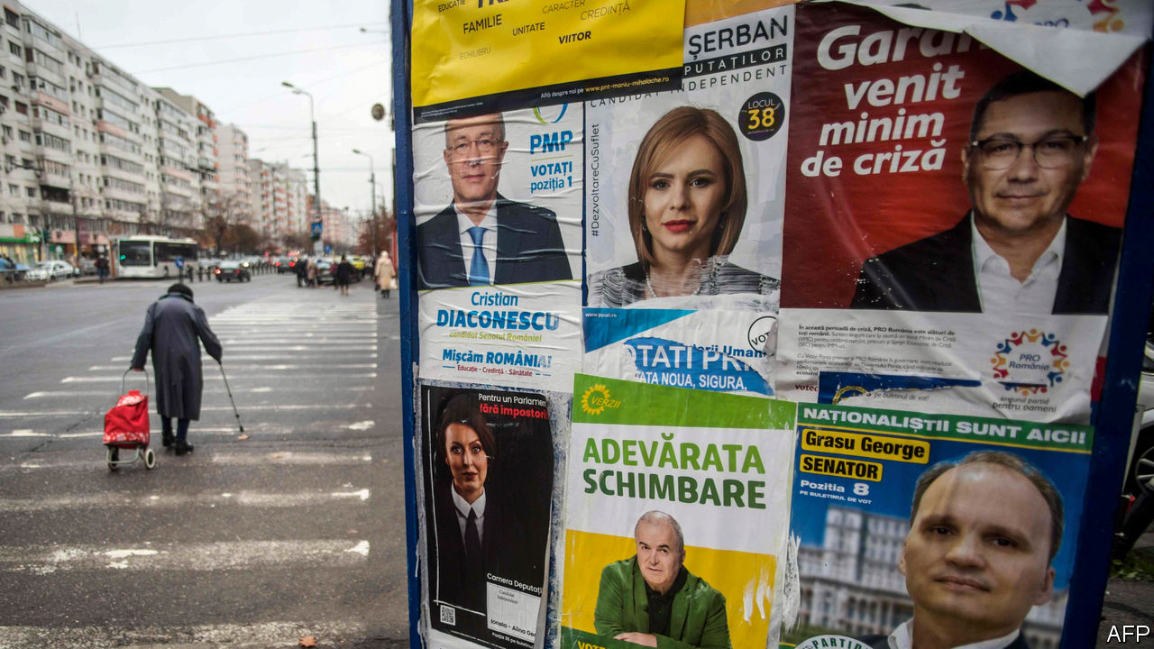

CORRUPTION IS THE biggest political issue across most of eastern Europe, and Romania is no exception. In recent years the streets of Bucharest, its capital, have filled with huge demonstrations against crooked officials and their attempts to weaken the rule of law. Yet on December 6th, when it was time to vote, the city was eerily quiet. Just 32% of eligible voters cast a ballot in the general election, the lowest turnout since the fall of the communist regime in 1989. Some blamed covid-19, others lacklustre politicians and their almost non-existent campaign. It was a sadly missed chance to elect a government with a strong mandate to tackle graft.

Many had expected the election to bring stability, after years of brief, scandal-plagued governments. Instead it offered more uncertainty. The opposition Social Democratic Party (PSD), a centre-left outfit that promises to raise welfare benefits, got an unexpectedly high 29% of the vote. The ruling centre-right National Liberal Party (PNL) got only 25% and USR-PLUS, an alliance of anti-corruption parties, won 15%—both scoring well below what pollsters had bet on. “There is no clear winner,” said Klaus Iohannis, Romania’s president.

To be sure, there was a clear loser. The National Liberals’ Ludovic Orban, the prime minister, quickly resigned. But his party looks set to stay in power. Though the PSD won, it remains discredited by a recent stint in government and lacks allies, so PNL is likely to form a coalition with USR-PLUS and one other party. Negotiations will probably be quick, says Radu Magdin, a political consultant. But any talk of a strong mandate is gone. Whoever takes over as the PNL’s new leader will, astonishingly, be the country’s seventh prime minister since 2015.

The previous election four years ago brought in a PSD-led government that spent much of its time trying to weaken various laws in order to keep its then leader, Liviu Dragnea, out of prison: he was on trial for abuse of power. Hundreds of thousands of Romanians took to the streets, worried lest the country follow the anti-democratic path blazed by Hungary and Poland. Ultimately Mr Dragnea was jailed, and his PSD was ousted in a no-confidence vote in October last year.

Many then expected the National Liberals to enjoy a period of strength. But the pandemic cost them support. The government imposed a strict lockdown that nonetheless failed to contain the virus. Romania’s health system, crippled by the emigration of staff to higher-paying jobs in western Europe, has struggled to cope. On November 14th a fire at a hospital in the city of Piatra Neamt killed 15 covid-19 patients.

The anti-corruption activists of USR-PLUS had high hopes after recent local successes. In September the candidate they backed defeated a PSD mayor of Bucharest who was often accused of cronyism. But they ran a poor campaign for parliament, and hopes that their voters would be unusually dedicated were dashed. The PSD has an advantage when turnout is low, says Veronica Anghel, a political scientist: its party machine of local officials can still get out the vote.

The biggest surprise was the Alliance for Romanian Unity (AUR), a new ultra-nationalist party. No one expected it to clear the 5% threshold to get into parliament. It took 9%. Its platform mixes religious patriotism with a call to annex neighbouring Moldova and “a hodgepodge of conspiracy theories”, says Cristian Norocel of Lund University, an expert on Europe’s far right. Many in the party were involved in a failed referendum in 2018 to outlaw gay marriage. For those hoping Romania would focus on fighting corruption and embedding European values, the election result was not auspicious. ■

This article was downloaded by calibre from <https://www.economist.com/europe/2020/12/12/the-next-romanian-governments-weak-mandate-for-fighting-corruption>

|  |  |  |  |
| --- | --- | --- | --- |
| Previous | Articles | Sections | Next |

|  |  |  |  |
| --- | --- | --- | --- |
| Previous | Articles | Sections | Next |

#### Charlemagne

# Why is Europe so riddled with vaccine scepticism?

Anti-vaxxers could hinder the struggle against covid-19

Dec 12th 2020 |

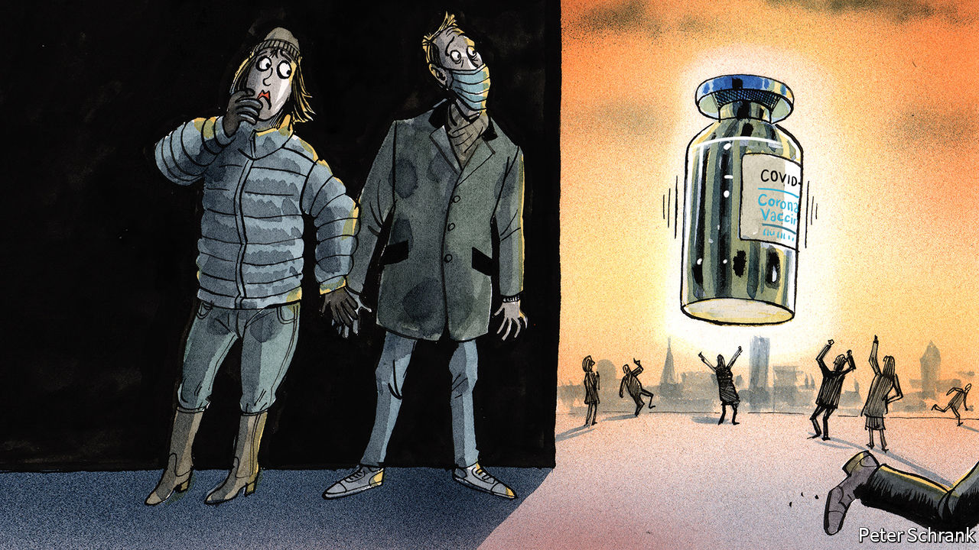

WHEN PFIZER and BioNTech unveiled their covid-19 vaccine, politicians from across Europe bustled to claim a slice of credit. German politicians reminded people that BioNTech was founded by two Germans of Turkish origin. Belgian ones were quick to note that the vaccine is manufactured in Belgium. EU officials hailed the way in which 27 countries had clubbed together to buy up enough stocks. Britain had to content itself with boasting that its regulators were the quickest to approve the drug.

Yet for a surprisingly large number of Europeans, a different emotion came before pride: paranoia. Despite scrupulous tests showing that the vaccine is safe, many people doubt it. One in three French people thinks vaccines in general are unsafe—the highest figure for any country, according to the Wellcome Trust, a British charity. A whopping 46% say they would reject a covid-19 vaccine when offered it, according to an Ipsos MORI poll. And France is not alone. In Italy, the EU’s third-largest economy, the Five Star Movement won power in part due to their avid fearmongering about vaccines. Nor is such dangerous poppycock confined to western Europe. More than 40% of people in Poland and Hungary say they would reject a covid-19 vaccine if offered. How did Europe become such a crucible of credulity?

Vaccine doubters have been around for as long as vaccination itself. An 18th-century French cartoon features two wicked characters chasing children with a syringe, dragging a green, smallpox-ridden monster behind them. Voltaire despaired at his countrymen’s misguided reluctance to try the rudimentary inoculations then becoming common in England. In the eyes of his fellow Frenchmen, the English were “fools…and madmen”, he wrote. Yet even so, riots in 19th-century England kicked off when the government made vaccines mandatory. People on Facebook today who swap hare-brained theories about Bill Gates wanting to insert tracking chips into everyone are the heirs to 19th-century pamphleteers who suggested people would grow horns if they took a vaccine. Europe has always been a republic of letters. Unfortunately it is also sometimes a republic of cranks.

What has changed is the motivation. In the 18th and 19th century objections were often religious, with illness ascribed to God’s will, or concern at the idea of interfering with nature, argues Laurent-Henri Vignaud, a historian of science at the University of Bourgogne. Now it is political. There is a correlation between doubting vaccines and voting for populist parties, points out Jonathan Kennedy of Queen Mary University of London. Both movements are about fear. Just as populist leaders of the left and the right stoke suspicion of Davos Man, so anti-vaxxers fret about another shadowy global elite—Big Pharma. Both populists and anti-vaxxers share an ability to turn a kernel of truth into a wider deception. Immigration has changed Europe, but that does not mean it caused all the continent’s problems, as populists suggest. In the same way, the opioid epidemic in America raises questions about the ethics of some drug firms, but that does not mean they want to put a chip in your brain. The same reflex lies at the heart of both: a distrust of experts and institutions. Europe is, increasingly, a paranoid continent, where people’s minds are filled with visions of enemies, mostly illusory. Vaccines join immigrants, Muslims and a host of others as the bogeyman du jour.

Politicians feel they must tread carefully. The British regulator’s speedy approval came in the knowledge that eight in ten Brits were keen on the vaccine even before a public-health campaign showed happy pensioners being jabbed. Swiss regulators have taken a more cautious approach, in a bid to allay the concerns of vaccine doubters. Jens Spahn, the German health minister, declared: “Nothing is more important than confidence with respect to vaccines.” It is, however, possible to be too cautious. Those who know France best suggest that people will be queuing up for the vaccine when it arrives. It is one thing to spurn a vaccine while Emmanuel Macron is extolling its virtues. It is quite another to reject one suggested by a family doctor. Actions do not always match words, particularly in France, where citizens often tick the most pessimistic box possible in surveys about the government. Long-held French doubts about vaccination do not manifest themselves in significantly lower take-up.

Likewise, anti-vax sentiment can flame out. While in opposition, the Five Star Movement, which is part of Italy’s governing coalition, happily stirred up fear of vaccines. Mandatory vaccines were “a gift for Big Pharma”, said Beppe Grillo, the former comedian who co-founded the party. In government, however, conspiracy theories collided with reality: a measles outbreak triggered the introduction of strict measures the party had once opposed. Populist campaigning does not translate well to the actual problems of government. In a peculiar twist, Five Star supporters are now more likely to support the idea of a covid-19 vaccine than the average Italian. European countries have grown unused to large-scale premature death. The horror of the pandemic, and the prospect of stopping it, may shock them back to their senses.

## Vax populi

In the coming months, a lack of supply rather than a lack of demand is a bigger problem for governments organising vaccinations, says Jonathan Berman, author of “Anti-vaxxers: How to Challenge a Misinformed Movement”. Indeed, talking too much about vaccine refusal could provoke the very panic governments want to avoid.

Fringe views are more likely to spread when people lose trust in their leaders. So the most effective (figurative) vaccine against anti-vax nonsense would be for governments to roll out their actual covid-19 vaccination programmes as quickly and smoothly as possible, with a minimum of cock-ups. When elites do their jobs well, populists and cranks have less to froth about. ■

Editor’s note: Some of our covid-19 coverage is free for readers of The Economist Today, our daily [newsletter](https://my.economist.com/user#newsletter). For more stories and our pandemic tracker, see our [hub](https://www.economist.com/news/2020/03/11/the-economists-coverage-of-the-coronavirus)

This article was downloaded by calibre from <https://www.economist.com/europe/2020/12/12/why-is-europe-so-riddled-with-vaccine-scepticism>

|  |  |  |  |
| --- | --- | --- | --- |
| Previous | Articles | Sections | Next |

|  |  |  |
| --- | --- | --- |
| Europe | Sections | International |

Britain

Brexit: Fade to grey

.

Regulating technology: Injection of confidence

.

Culture wars (1): Roads must fall

.

Culture wars (2): New school rules

.

Covid-19: Out of sight

.

The environment: Chasing rainbows?

.

The Shetland Islands: Carrion call

.

|  |  |  |
| --- | --- | --- |
| Europe | Sections | International |

|  |  |  |  |
| --- | --- | --- | --- |
|  | Articles | Sections | Next |

#### Fade to grey

# What a grand chemistry experiment reveals about Brexit

The impact will be felt not with a bang, but with a whimper

Dec 12th 2020 | SHERBURN IN ELMET



ANDREW CLARKE closely guards his recipe for yolk-coloured ink, known in the trade as a yellow 13. But the process is simple enough. Powdery pigment is mixed with solvent, varnish and thickener, many of the supplies imported from abroad, and then milled between steel rollers into a glossy syrup. His factory in Yorkshire specialises in bespoke orders for coatings used to make food cartons, magazines and circuit boards. His small laboratory is lined with pots of resins and wetting agents, and machines that measure the fineness and viscosity of his creations.

Brexit, which comes into full effect on January 1st, worries Mr Clarke. The European chemicals market is fragmenting. He fears the substances that give his coatings their distinctive qualities may slowly disappear from sale in Britain, leaving him reliant on inferior substitutes. “If we are trying to sell to Europe, we might be offering our best stuff, but an EU competitor could come in using the state-of-the-art raw material, which in our customers’ eyes is significantly better,” he says.

The future of the British chemicals industry is Brexit in microcosm. Boris Johnson wants a trade deal that eliminates all tariffs on goods, including chemicals. Yet even if he gets this, it will do little to soothe the headaches that arise from leaving the single market. A project that promised to throw off the EU’s system of regulation will instead replicate it in miniature, creating a Brussels-on-Thames. Chemical firms, foreign airlines, lawyers and internet companies—all will face new burdens if they wish to keep doing business in Britain.

At root is a grand misunderstanding. Brexiteers often think of the EU’s single market as a mere rule book. Thus, they suggest, Britain simply needs to copy those rules into domestic law, and then tweak them at leisure. But the single market is better thought of as an ecosystem: an elaborate regime of registration, surveillance and enforcement. Goods and services percolate freely across national borders because governments can rely on Brussels to keep watch for unwanted adulterations.

Reach, the bit of the single market governing chemicals, is especially strict. Firms selling into Europe must submit lengthy dossiers detailing how their products were made, and appoint an agent on European soil, who can be collared if things go wrong. The system is overseen by the European Chemicals Agency (ECHA) in Helsinki, which has 600 staff and a budget of more than €100m ($120m). The enforcement is done by a network of national agencies, such as Britain’s Health and Safety Executive (HSE), based in Liverpool. The result is a free-flowing pool of 23,000 chemicals for Mr Clarke and his continental rivals to choose from, underpinned by a vast database of safety information which regulators can scour for risks.

Theresa May, Mr Johnson’s predecessor, asked to stay in Reach, having been convinced there was little to gain from divergence. But this was rejected by the EU, who called it “cherry-picking”. So Britain will try to replicate the regime at home, under the title of “UK Reach”. The names of chemicals originally registered by British companies will be copied into domestic law. The HSE will take on the ECHA’s job, funded by fees on users. European companies will need a legal footprint to trade in Britain, and British companies vice versa.

The most difficult task will be replicating the ECHA’s database. Ministers at first insisted they could simply copy-and-paste it. They could not: it is stuffed with commercially-sensitive intellectual property, and there is little incentive to give a departing state a leg-up. The EU has so far rebuffed Britain’s request for a chemicals data-sharing clause in the trade deal.

Instead, the government will require Mr Clarke’s suppliers to submit the data themselves. But many dossiers were produced by consortia of companies, and there is little reason for a French firm to bail out a British rival. BASF, a big German chemicals firm, reckons registering with UK Reach will cost them £70m ($90m). Small British distributors whose continental suppliers file paperwork under the EU system may find themselves designated “importers”. One boss calculates a bill of £1m in registration fees if he has to lodge all the substances he imports, on an annual turnover of £15m: “We’d be bankrupt in a week.”

George Eustice, the environment secretary, now admits some firms may find the task “both expensive and time-consuming”, and this summer delayed the timetable for lodging dossiers for some products from 2023 to 2027. But more time does not help much, says Peter Newport of the Chemicals Business Association. “It’s a change from a guillotined beheading to a death by a thousand cuts over a six-year timescale,” he sighs.

There are two scenarios for how this will play out. One is that ministers push on with UK Reach, and substances are pulled from the British market as manufacturers conclude that registration costs make low-volume products unviable. The so-called “salt-and-pepper” additives used in tiny quantities in paints are particularly vulnerable. The flow going the other way is already shrinking. Only 70% of the British firms that registered chemicals with the ECHA before Brexit have started transferring their dossiers to new legal entities in Europe, the regulator notes. “We’ll become very insular, and they’ll become equally self-absorbed,” says Mr Clarke. As a result, Britain would be a less attractive place to open an assembly line.

The second scenario is that UK Reach founders. The deadlines could be pushed back further, or the new rules left unenforced. With an empty database, says Michael Warhurst of CHEM Trust, an environmental charity, the regulator in Liverpool would be less able than the one in Helsinki to spot hazards, or to defend its decisions against deep-pocketed companies in court.

The promise of Brexit was that Britain would be the master of its own regulation, acting more nimbly or stringently than the EU if it wished. But the outcome Mr Warhurst fears would not be deregulation by design, but one forced upon ministers because their ambitions to match European standards have failed. A big market means Brussels can afford to be strict in its regulation. Britain will learn that it cannot. ■

This article was downloaded by calibre from <https://www.economist.com/britain/2020/12/12/what-a-grand-chemistry-experiment-reveals-about-brexit>

|  |  |  |  |
| --- | --- | --- | --- |
|  | Articles | Sections | Next |

|  |  |  |  |
| --- | --- | --- | --- |
| Previous | Articles | Sections | Next |

#### Injection of confidence

# Britain gets an assertive new tech regulator just in time for Brexit

The Digital Markets Unit will write bespoke rules for big companies

Dec 12th 2020 |



DECEMBER 8TH was a big day for jabs in Britain. In Coventry, at the crack of dawn, Margaret Keenan became the first person in the world to receive a proven covid-19 vaccine. Meanwhile, in London, the Competition and Markets Authority (CMA) published the blueprint for a new regime of oversight of tech companies. Less momentous, it nonetheless provides a shot in the arm to Britain’s post-Brexit regulatory reputation. “Ground-breaking” is how one competition lawyer describes it.

The idea of the new regime is something called “ex ante” regulation, which tells big companies how they should behave, rather than asking for remedies after they have misbehaved. The old approach works for slow-moving industries. But digital ones change too quickly for retroactive enforcement to do much good. To fix that, a new regulator, the Digital Markets Unit (DMU), will write and enforce the rules for tech. The government intends to get it up and running by April 2021, and has committed to making it a statutory body.

Most competition law applies to all firms, or is written for specific industries. The DMU will take this a step further, assigning certain companies “strategic market status”—meaning they have “entrenched market power”—and tailoring a bespoke code of conduct for that particular firm. Fines for failing to comply will reach 10% of global revenue. New rules will also come into place around mergers, allowing regulators to consider how a startup might develop, rather than looking only at its current market status. The current “ex post” regime means regulators sometimes have to try to fix problems years after harm is already done. On December 9th America’s Federal Trade Commission filed an antitrust lawsuit against Facebook, alleging that it had “targeted potential competitive threats to its dominance”, buying Instagram in 2012 and WhatsApp in 2014.

The significance of the CMA’s plan goes beyond its effect on technology companies. The CMA is “setting out its stall as a world leader in competition post-Brexit”, says Katherine Kirrage, a digital competition and regulatory lawyer at Osborne Clarke, a law firm. The publication of its proposals precede by a week new rules from the European Commission, which will probably be similar in spirit. The CMA’s powers to conduct market studies and investigations are a model for other regulators. And it will also play an important role in co-ordinating various British government policies, including a code of conduct for technology firms to prevent “online harms”, and new rules around how social media and search engines interact with British journalism.

There are political considerations to all this. The government now has to enshrine the DMU’s powers in law, but will want to ensure Britain remains an attractive place for big tech companies after Brexit. Tighten the rules too much and firms may flee to Dublin or Amsterdam; leave them too loose and it risks damaging relations with the EU. So far, Britain’s plans are broadly in step with how Europe and other countries are thinking about competition in the tech sector, says Damian Tambini of the London School of Economics, and regulators have worked well together. That is an encouraging start. But it is unlikely to inoculate against other challenges to come. ■

This article was downloaded by calibre from <https://www.economist.com/britain/2020/12/12/britain-gets-an-assertive-new-tech-regulator-just-in-time-for-brexit>

|  |  |  |  |
| --- | --- | --- | --- |
| Previous | Articles | Sections | Next |

|  |  |  |  |
| --- | --- | --- | --- |
| Previous | Articles | Sections | Next |

#### Roads must fall

# Britain’s bureaucrats prepare to tear down statues

A series of reports will have far more impact than last summer’s protests

Dec 10th 2020 |

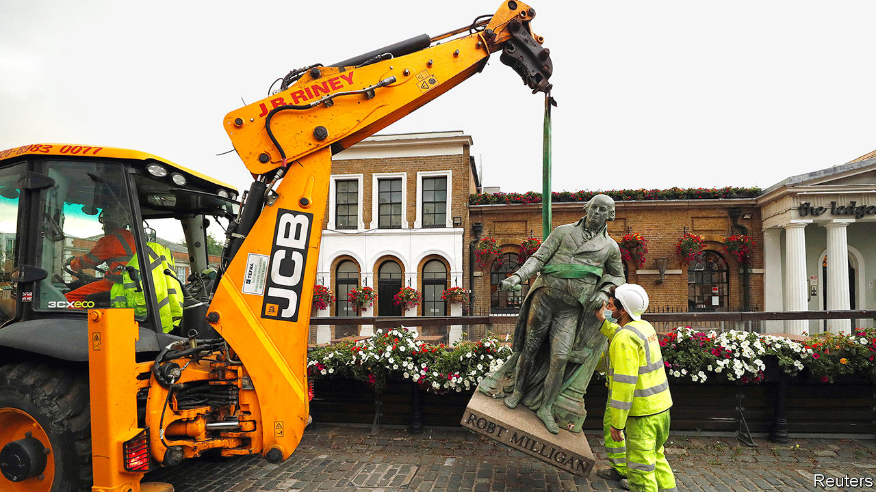

ON DECEMBER 5TH a small group of people carefully removed a sign marking Cassland Road Gardens in London and laid it on the ground. Thus was one corner of the capital purged of its association with an offensive historical figure—John Cass, an early-18th-century slave trader. It was a modest event, noticed by few, which suited the organisers. “It makes more sense to do it this way,” says Toyin Agbetu, a researcher and activist.

The other way is more spectacular. Last June a Bristol crowd inspired by the Black Lives Matter movement pulled down a statue of Edward Colston, another slave trader, and rolled it into the harbour. In the same week activists in Glasgow erected alternative street signs, replacing tobacco barons with black heroes. Elsewhere, statues were daubed with paint. Vigilante groups—some polite and peaceful, others not—mobilised to defend cherished figures.

To cool things down, many local authorities promised to investigate monuments and street names. In theory, all 130 Labour-led councils are doing so, as are some controlled by the Scottish National Party. Hackney, which contains the currently nameless gardens formerly known as Cassland Road, has a rolling process: offensive things are removed when a group of councillors, historians and community leaders reach a consensus. But most councils commissioned reports, which are beginning to come in. This quieter process is likely to topple more statues and names than the crowds did.

Researchers at Lambeth Archives have found that in that London borough four street names, one ward and one tomb commemorate slave owners. Another seven things have some link to slavery or black oppression—for example, a memorial and a block of flats are named after a 17th-century director of the East India Company, which traded slaves at the time. Lambeth Archives uses a traffic-light system: red for definite links, orange for more tenuous ones, green for the blameless.

Some investigations have come up empty-handed. An independent review of statues in Bradford found none that is offensive. In Leeds, investigators found only one “particularly negative” image: an architectural frieze showing an African man in a loincloth. Both cities are far from the coast, and the investigators looked only at statues. Even so, the reports may affect the streetscape. They conclude that the cities should do a better job of reflecting their black, Asian and Jewish populations.

By far the most comprehensive report is the one commissioned by the Welsh government. It finds 68 monuments, places or streets with a definite connection to slavery or racism, and another 213 with a looser connection. One man, Thomas Picton, who governed Trinidad with a brutality that shocked his contemporaries and was later killed at the battle of Waterloo, has 19 roads definitely and 13 possibly named after him. He is also commemorated by a 25-metre obelisk and in the names of a sports centre, a community centre and two pubs.

The local councils that will decide the fate of most street names and monuments must mull tricky questions. If slave traders are anathema, what about people who opposed abolition? And how finicky do they want to be? For example, Swansea has a Grenfell Park Road. That seems to be named after Pascoe St Leger Grenfell, who was part-owner of a copper company that ran Cuban mines with slave labour. But a Grenfell Avenue on the other side of Swansea might have been named after David Grenfell, a Labour MP. It is not clear that many people appreciate the distinction.

The Conservative government is against removing statues, and hints that iconoclasm may lead to funding cuts. But big cities are not Tory territory; statues might become even more tempting targets if they are associated with the government. And the reports will create momentum. Gaynor Legall, who chaired the Welsh investigation, says she used to assume, naively, that slavery was mostly an English phenomenon. She hopes that her review will lead to a national reckoning. “We can’t just drop it now,” she says. ■

This article was downloaded by calibre from <https://www.economist.com/britain/2020/12/10/britains-bureaucrats-prepare-to-tear-down-statues>

|  |  |  |  |
| --- | --- | --- | --- |
| Previous | Articles | Sections | Next |

|  |  |  |  |
| --- | --- | --- | --- |
| Previous | Articles | Sections | Next |

#### New school rules

# Black Lives Matter in Britain’s top public schools

Pupils and teachers drive changes, though some parents need convincing

Dec 12th 2020 |



JOSEPH SPENCE is everything one might expect from the master of Dulwich College. His doctoral thesis delved into 19th-century Irish Toryism, and his CV is a tour of Britain’s most illustrious schools. But he is no traditionalist. Under his leadership, Dulwich offers pupils unconscious bias training and a history curriculum which aims “to amplify the voices of the colonised as much as the coloniser”. The hope, says Dr Spence, is to look beyond the conventional canon, although that “doesn’t mean it has to disappear”, he reassures.

Britain’s public schools were once proud bastions of tradition—now they are trying to move with the times. Marlborough focuses on black history, filling its curriculum with “as many diverse texts, guests and experiences as possible”. Harrow’s summer reading list includes voguish titles like “White Fragility” by Robin DiAngelo. Eton faces criticism for sacking a teacher who made a video arguing against “radical feminism” (the school insists the problem was the refusal to take it off YouTube).

Some of this reflects the schools’ intakes. More than a third of pupils at independent schools now come from ethnic minorities, up from a quarter a decade ago. Many are aware that they could be more welcoming. A survey by the African Caribbean Education Network, a group of black parents whose children attend private and grammar schools, found that 76% of their children have experienced racial bias.

Change is pushed by pupils. Following George Floyd’s death in May, many petitioned for diverse curriculums. At Charterhouse, pupils formed the Unity Society, a safe space where they could discuss current affairs. Most teachers are happy to support these efforts, says Will Orr-Ewing of Keystone Tutors: “These schools are run by liberals, for liberals.”

Opponents think schools are frightened of censure. A recently departed Eton teacher says the Charities Commission, which requires schools to prove they provide a public good to enjoy tax advantages, has had a significant impact on their behaviour, as has growing political opposition to their charitable status. According to the teacher: “Suddenly every leading private school had an outreach officer whose job it was to say, ‘Look how much we care, look how liberal and inclusive we are! Please like us! Please don’t beat us up!’”

Parents are not entirely on board. When pupils at Benenden complained in October that their headmistress used a racial slur in a speech about diversity, parents backed the head. Yet even some sceptics may recognise the appeal. Top public schools offer good grades, and the opportunity to pick up knowledge that helps you get ahead in the world. Is knowing the lingo of much of society’s elite part of that nowadays? “You bet,” affirms one head teacher.

This article was downloaded by calibre from <https://www.economist.com/britain/2020/12/12/black-lives-matter-in-britains-top-public-schools>

|  |  |  |  |
| --- | --- | --- | --- |
| Previous | Articles | Sections | Next |

|  |  |  |  |
| --- | --- | --- | --- |
| Previous | Articles | Sections | Next |

#### Out of sight

# Learning-disabled Britons are the pandemic’s forgotten victims

A lowly position in the vaccine queue is their latest trial

Dec 10th 2020 |



IN A SUPPORTED-LIVING home for people with learning disabilities in Luton, there is no lack of Christmas cheer. One recent evening, staff helped the six women who live there decorate a gingerbread house; another day, they fashioned a collage of hand prints to resemble the outline of a Christmas tree. “We’re trying to make it as fun as we can,” says Carly Somers, one of the workers. Still, it is an uphill battle. Normally, all but one of the women would go to relatives at least for the day itself; this year, they might well all have to stay put. “That’s going to be a big change for them.”

The past year has been trying for everyone. As Edel Harris, boss of Mencap, a charity that supports the six women and 5,000 or so others, puts it: “For those of us without a learning disability, we’re struggling at times to understand what’s happening and to hang on to that hope”. For those who have one it has been even harder, as they struggle to understand change and often require help with everyday life. The latest hurdle is vaccination: most learning-disabled Britons are not in the priority queue for the jabs, the first of which began to be dished out on December 8th.

An official review last month suggested that covid-19 has killed people with learning disabilities at twice the rate of the general population and perhaps six times the rate once sex, age and probable underreporting are accounted for (see chart). That is partly because they are more likely than average to suffer underlying conditions, like diabetes and obesity, that increase risk. But it can also be difficult for them to grasp infection-prevention advice and the need to get tested if symptoms occur.

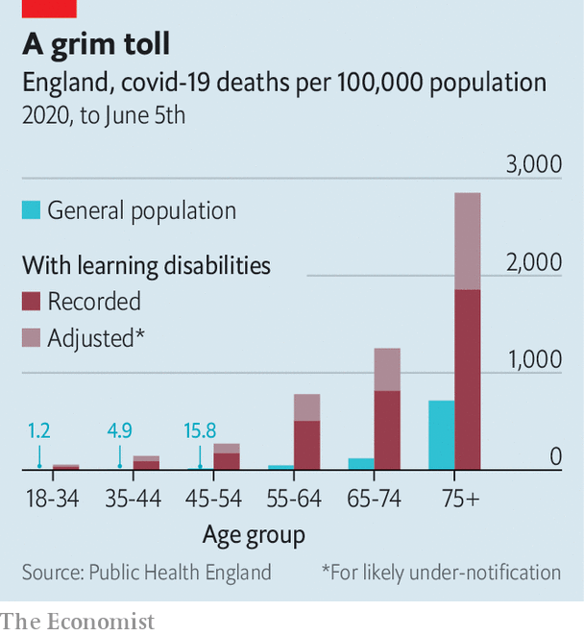

The virus has had a disproportionate impact on their mental health and well-being. Like many of the 1.5m learning-disabled Britons (of whom perhaps 350,000 have a severe disability), Ciara Lawrence has found the government’s official updates on the pandemic hard to follow. “[They] use jargon words like social distancing, shielding and quarantine,” she says. “When they show those graphs on the screen, it is so hard to understand. They show them really quickly.”

It can also be difficult to grasp that social clubs have been suspended rather than canned or understand why relatives have suddenly stopped visiting. Some learning-disabled people have been encouraged by carers to use video calls for the first time to keep in touch with their families. That is a welcome innovation, but no substitute for touch. A group of academics who spoke to learning-disabled Britons, their carers and advocacy groups about the impact of covid-19 reported increased social isolation and loneliness.

Those who look after their learning-disabled relatives themselves have felt the strain as well. Lots of day-care activities and home visits were halted, leaving them without respite. The government has encouraged local authorities to continue such services, while accepting this won’t always be possible. A survey shows a majority of families say the support they receive has fallen by more than half.

The government is belatedly paying more attention to care homes, which bore the brunt of the pandemic’s first wave and whose residents are desperate to be reunited with their families. But whereas care-home residents and staff were prioritised for covid tests, learning-disabled people living in their own homes or with family were not. Official advice on how the rules should apply to them has often been published weeks after similar information for providers of care to elderly adults. And a search of one newspaper database suggests that care-home residents have received about 36 times more coverage in the past year than those with learning disabilities. “A lot of my friends feel they’ve been forgotten,” says Ms Lawrence.

Only those with severe learning disabilities are currently in the priority queue for vaccination; those with moderate or mild ones will receive theirs at the same time as the general population. Jeremy Hunt, the former health secretary, is lobbying public-health officials to change their minds in recognition of the group’s reliance on the support and affection of others as well as its clinical vulnerability. That would be a good start. Ms Lawrence, for one, can’t wait. “I’m not the biggest fan of needles,” she says. Still, she will have the jab as soon as she can, “if it means I can see my family and hug my mum.” ■

Editor’s note: Some of our covid-19 coverage is free for readers of The Economist Today, our daily [newsletter](https://my.economist.com/user#newsletter). For more stories and our pandemic tracker, see our [hub](https://www.economist.com/news/2020/03/11/the-economists-coverage-of-the-coronavirus)

This article was downloaded by calibre from <https://www.economist.com/britain/2020/12/10/learning-disabled-britons-are-the-pandemics-forgotten-victims>

|  |  |  |  |
| --- | --- | --- | --- |
| Previous | Articles | Sections | Next |

|  |  |  |  |
| --- | --- | --- | --- |
| Previous | Articles | Sections | Next |

#### Chasing rainbows?

# Britain excels at announcing climate targets

But it must do more to meet them

Dec 10th 2020 |

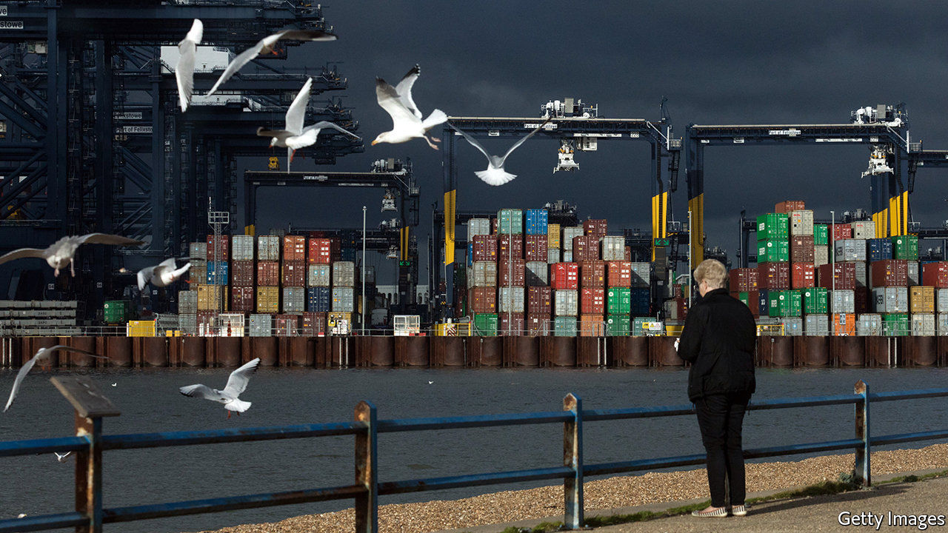

BRITAIN IS IN danger of securing a reputation for too much style and too little substance when it comes to climate change. The government has spent the past few months issuing target after goal after grandiose statement, all intended to portray the birthplace of the Industrial Revolution as a leader on the path to global decarbonisation. But policies and funding to make the targets reality are lacking.

On December 3rd Boris Johnson announced that the country’s greenhouse-gas emissions would, in the coming decade, drop to 68% below where they stood in 1990—a considerable decrease on the previous goal of a 57% drop by 2030. The pledge will form part of Britain’s formal amped-up contribution to the UN Paris agreement. Under the terms of the agreement, all countries are due to submit fresh commitments by the end of 2020. Scores of new pledges are thus expected at a virtual summit on December 12th, held to mark five years since the agreement was made on the outskirts of France’s capital.

On December 9th the Committee on Climate Change (CCC), which advises the government, presented a breakdown of how the economy, landscape and society must change over the coming decades to meet Britain’s long-term goal of cutting emissions to net zero by 2050. It says emissions should decline rapidly between 2025 and 2035, by which date they should be 78% below levels in 1990.

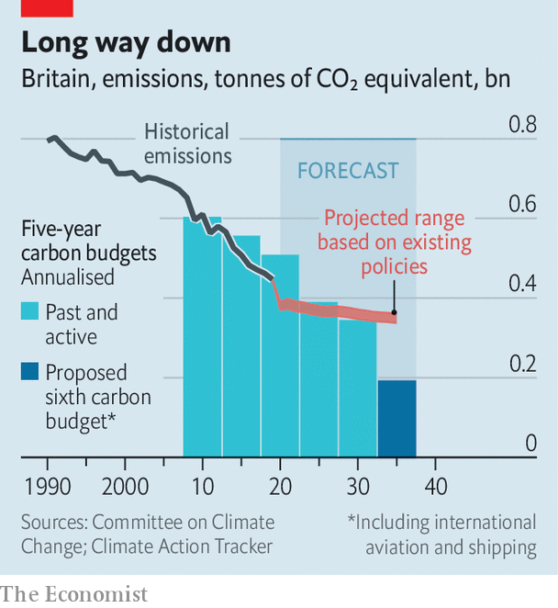

Some of the biggest gains are forecast to come from ditching the combustion engine in favour of electric vehicles, as well as a vast but currently non-existent programme to replace gas boilers in homes with heat pumps. By 2035 every electron coursing through the nation’s power grid would come from a renewable or zero-carbon source. In accordance with the government’s recently announced plan for decarbonisation, a push for wind power would form the bulk of this, growing from 40GW in 2030 to at least 100GW in 2050. The committee also sees a role for hydrogen in heating some buildings as well as in powering ships and industry. Schemes to more than double the area that is planted with trees each year, and to slash cropland and grasslands, would transform large swathes of the landscape. All this would cost £50bn ($70bn) a year by 2030, five times the amount spent now.

Based on the CCC’s recommendations, Britain will now adopt its sixth carbon budget, which will have to be met between 2033 and 2037. By law, it must adopt a new budget every five years, to set the pace for the economy’s decarbonisation. The first two, running from 2008 to 2017, were met. Figures published in October show that British emissions are expected to squeak in just under budget for the third round. But the country is not on track to meet its fourth carbon budget and will miss the fifth by an even greater margin.

According to the CCC, the first and second budgets were probably met thanks to the global financial crisis. “Policy has fallen short of bringing about the measures required to put the UK on course to meet its original long-term ambition of an 80% reduction, let alone the recently agreed net zero ambition,” it noted last year. The covid-19 downturn will aid efforts to meet the third budget. But to be a true leader, Britain must stop relying on mishaps and put money and policy towards real change. ■

This article was downloaded by calibre from <https://www.economist.com/britain/2020/12/10/britain-excels-at-announcing-climate-targets>

|  |  |  |  |
| --- | --- | --- | --- |
| Previous | Articles | Sections | Next |

|  |  |  |  |
| --- | --- | --- | --- |
| Previous | Articles | Sections | Next |

#### Carrion call

# The booming business of tearing apart oil rigs

As North Sea oil dries up, the Shetlands turn to new work

Dec 12th 2020 | LERWICK



ROUNDING THE corner of Dales Voe, a sea loch in the Shetland Islands, Ninian North looms into view like a vast metallic mantis. Out of the water, the oil rig looks long and squat. Streaked with rust, it weighs 14,200 tonnes. For more than three decades the rig sucked oil from under the North Sea, producing 90,000 barrels a day at its peak in the early 1980s, and boosting the local economy in the process.

Now it awaits breakage, propped up against the Shetland sky by eight thick steel legs, lifeboats still dangling from its flanks (people often repurpose them as garden furniture, explains a worker). Men in hard hats and hi-vis vests take a cage lift up to the platform armed with angle grinders, blow torches and Geiger counters. They are stripping harmful substances out of Ninian, from asbestos to radioactive gunk dredged up from the sea floor.

In the late 1990s the North Sea delivered 4.5m barrels of oil a day. Now, it delivers just 1m. As production has tailed off, the Shetland Islands—home to 20,000 or so people, 110 miles north of Scotland—have sought new work. Tearing down the structures that fed the islands’ economy for decades doesn’t take up all the slack, but it helps. Britain is spending about £1.5bn ($2bn) a year on decommissioning, according to Oil and Gas UK, an industry body.

Ninian’s new home at Dales Voe was built for this kind of work. Thanks to the depth of the loch for which the facility is named, it can handle structures that extend hundreds of metres underwater. The facility came into operation in 2017, and has so far decommissioned two rigs. Ninian North is its largest job yet. Veolia, a French waste- and energy-management firm, runs the project, and has said that it expects the North Sea decommissioning market to grow in coming years.

The Shetland Islands are not the only place competing for the these contracts. There are deepwater facilities in Newcastle and Norway, and Aberdeen is said to be mulling one of its own. Although the Shetland facility is a relative newbie, it has the advantage of being closer to the oilfields. Alexander Kemp of the National Decommissioning Centre at the University of Aberdeen reckons oil-rig operators will spend £50bn taking old platforms out of the sea by 2050.

A large chunk of that is due to be spent in the next 15 years, when a number of the biggest, oldest fields are due for decommissioning—and the covid-19 pandemic has further accelerated things. The price of a barrel of crude slumped from $50 in February to $40 today, and was briefly as low as $16 in April, meaning oil-producing assets it might have made sense to keep in operation are no longer viable, and need to be taken out of the water.

Even so, those rig operators who are not making money are having a hard time paying for expensive decommissioning. It helps that they can offset their expenses against taxes that have already been paid. Yet this has caused rows with environmental groups, as the Treasury ends up owing oil companies—like Canadian Natural Resources, which owns Ninian—a refund.

The Shetland Islands will hope the subsidies continue. Sometime in May next year, at midnight, a demolition crew will blow out Ninian’s enormous steel legs, and its body will slump to the ground like a dying beast. Men will swarm the carcass, and begin tearing it apart in Lerwick’s midsummer gloam. Out in the North Sea, another 1.8m tons of oil and gas rig await the same treatment. ■

This article was downloaded by calibre from <https://www.economist.com/britain/2020/12/12/the-booming-business-of-tearing-apart-oil-rigs>

|  |  |  |  |
| --- | --- | --- | --- |
| Previous | Articles | Sections | Next |

|  |  |  |
| --- | --- | --- |
| Britain | Sections | Business |

International

Trans rights: Boys and girls

.

|  |  |  |
| --- | --- | --- |
| Britain | Sections | Business |

|  |  |  |  |
| --- | --- | --- | --- |
|  | Articles | Sections | Next |

#### After the Keira Bell verdict

# An English ruling on transgender teens could have global repercussions

Worries grow over treatments that can leave children sterile

Dec 12th 2020 |



IN 2018 ANDREA DAVIDSON’S 12-year-old daughter, Meghan, announced she was “definitely a boy”. Ms Davidson says her child was never a tomboy but the family doctor congratulated her and asked what pronouns she had chosen, before writing a referral to the British Columbia Children’s Hospital (BCCH). “We thought we were going to see a psychologist, but it was a nurse and a social worker,” says Ms Davidson (both her and her daughter’s names have been changed). “Within ten minutes they had offered our child Lupron”—a puberty-blocking drug. “They brought up the drug directly with our child, in front of us, without discussing it with us privately first.” There was no mention of other mental-health issues, which are known to increase the likelihood of gender dysphoria, the feeling that you are in the wrong body. “There was no therapy on offer and we were just brushed aside when we raised it.”

Meghan belongs to a wave of children across the Western world who have identified as transgender in recent years. America had one gender clinic in 2007; now it has more than 50. Piecemeal evidence around the world suggests that three-quarters of children expressing gender dysphoria at such clinics are adolescent girls, whereas until recently it was roughly evenly split. An increasing number are also de-transitioning, choosing to revert to their previous gender. Unfortunately, if children have already begun a medical transition, including hormone treatment, it can leave them infertile and unable to have a full sex life.

Earlier this month the High Court in London looked at the case of one detransitioner, Keira Bell, who had brought a judicial review against the Tavistock clinic, England’s only specialist youth gender-identity centre. She claimed that the clinic should not have allowed her to take puberty blockers and later undergo testosterone treatment and a double mastectomy. The court ruled that it was “highly unlikely” that a 13-year-old and “doubtful” that 14- and 15-year-olds are mature enough to consent to such a procedure, and that doctors treating 16- and 17-year-olds may also need to consult a judge before starting.

Trans activists argue that a long-marginalised group is now finding its voice in popular culture. Their critics retort that vulnerable teenagers are losing themselves in an online world which adulates anyone who comes out as trans. Both could be right. “Being straight is boring,” says Meghan’s younger sibling.

Society is struggling to strike a balance. Some children who feel they are in the wrong body will always feel that way and might benefit from altering their bodies. Others will change their minds—many of these will simply turn out to be gay. No medical test can tell these two groups apart. Children with mental-health problems or conditions such as autism are more likely to experience gender dysphoria. Untangling all this is extremely hard.

However, there are worries that rich countries have the balance wrong. One of the Dutch scholars on whose work the prescribing of hormones and surgery is based has said that her research is being applied to young people for whom it was not designed. And a growing number of people are dissenting. The Economist spoke to more than four dozen people in rich English-speaking countries, including trans people, parents, doctors, social workers, teachers and people who had identified as trans when they were children. Most of those who were critical wanted to be anonymous for fear of losing their jobs or being branded bigots on Twitter.

“The first duty of medicine is ‘Do no harm’,” says a Canadian paediatrician. “In any other branch of medicine, if you were causing permanent sterility with body-altering surgery and cross-sex hormones, you had better have some pretty strong data...But we’re already going down that road with no strong data at all.”

To find the best approach will require debate. Some activists do not welcome debate, however. “We are liberal people,” says Ms Davidson. “But we are always made to feel like we are right-wing crackpots for raising questions.”

## Crossing a Rubicon

Nobody has global statistics for the rate of trans cases among children. Referrals to the Tavistock in London have surged 30-fold in a decade, with 2,700 children referred there last year. Nearly half those referred will start on puberty blockers. In 2019-20, the BCCH treated 382 patients in its gender clinic, up from 123 in 2016-17. America does not publish statistics. However, in a survey of American high-school students in 2017 by the Centres for Disease Control 1.8% said they were transgender and a further 1.6% said they were unsure.

The case for puberty blockers is that they can help children with severe gender dysphoria, who feel desperate about developing the “wrong” sex characteristics. That is because the drugs could spare them distress and, potentially, traumatic interventions later: a double mastectomy; a hysterectomy or the shaving of the Adam’s apple.

Many who go through full medical transition say they are happy with the result. Tru Wilson, who lives in Vancouver, is one. Tru was a gentle boy, and Tru’s parents thought their child might be gay. They then watched a programme together on trans kids and Tru said, “That’s me!” Tru, now 17, began on blockers at 12, on oestrogen at 14, and is expecting to go through surgery within the next year. “I have zero regrets on how my journey went,” she says. Her father, Garfield, has been impressed by physicians at the BCCH. “There was no pressure pushing us to do anything that we didn’t feel was right for our daughter.” Many other parents also report positive experiences. BCCH says that they take the use of puberty blockers seriously and all their patients “go through rigorous assessments including confirmation that they are capable of considering the benefits and risks”.

But other transitioners come to see such procedures as a mistake. Claire (not her real name), now a 19-year-old student in Florida, started on testosterone aged 14 because of a loathing for her body. (She was also deeply depressed.) “I felt it was the only option, especially with the insistence that having dysphoria meant you are irrevocably trans and thus you will probably kill yourself if you don’t transition.” Obtaining hormones was easy, she says. “They pretty much gold-stamped me through.” Then, aged 17, her dysphoria disappeared. “I felt extremely lost. I had never heard of this happening.” She came off testosterone, embraced her identity as a lesbian, and is furious. “It is the medical industry and the general social attitude towards dysphoric people that failed me.”

Such “desistance” appears to be common. At least half a dozen medical studies show that between 61% and 98% of children presenting with gender-related distress were reconciled to their natal sex before adulthood. However, all these studies looked at children with early-onset dysphoria. One recent study on adolescent dysphoria among girls suggested that in many cases it is brought on by the influence of the internet, by female friends who have transitioned and by the miseries of puberty. “What is needed is quality research into adolescent-onset dysphoria among girls, and the overlap with autism and mental-health diagnoses,” says Will Malone, an endocrinologist and director at the Society for Evidence-Based Gender Medicine, an international group of doctors and researchers.

The decision to desist is hardest for those who have received medical treatment. Lisa Marchiano, a Jungian therapist in Philadelphia, counsels several such people. They all believe they were given access to medical interventions too soon. “It takes enormous strength to admit you have invested so much in a strategy that is a mistake,” she says.

The evidence in favour of medical treatment is being challenged, too. Arguments for providing hormones and surgery to dysphoric teenagers lean heavily on an intervention approach pioneered in the Netherlands, which has come to be known as “the Dutch protocol”. This was tested on 55 young people with early-onset dysphoria. The teenagers were treated with puberty blockers, cross-sex hormones and, after they turned 18, surgery. There was no control group. Instead the results of a study of the approach, published in 2014, concluded that these medical interventions were successful on the basis of psychological functioning at least one year after surgery.

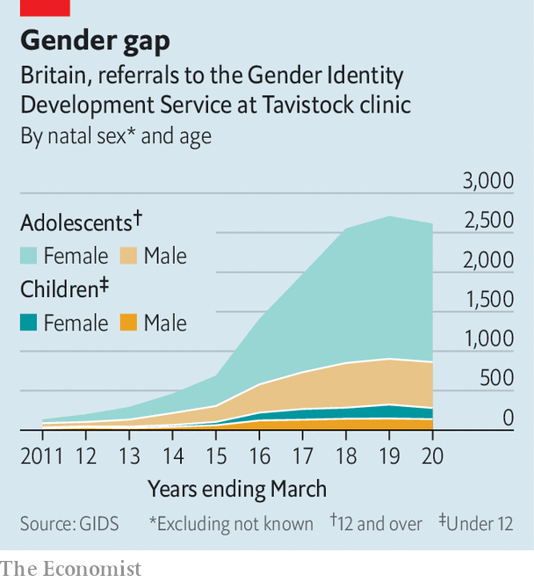

The authors warn that their paper contains a small sample, measures only short-term psychological outcomes and has no evaluation of the implications for physical health. One of its researchers, Annelou de Vries, this year published a commentary in Pediatrics, a medical journal, saying that the approach is being wrongly applied to children (mostly girls) with adolescent-onset dysphoria. She emphasised the need to identify those who need enhanced mental-health support, rather than gender reassignment. Carl Heneghan, a professor at the Centre for Evidence-Based Medicine at Oxford University, wrote last year that use of the Dutch protocol amounts to an “unregulated live experiment on children”. The High Court in England also called such interventions “experimental”. The flood of hormones in puberty help reconcile a child to their sex in a way that doctors do not fully understand. Blockers stop that.

## No turning back

The Tavistock clinic argued that puberty blockers are reversible. That is true up to a point. However, they can affect bone density and so doctors often want to move patients on to cross-sex hormones, which have more permanent effects. The court concluded that blockers almost always lead on to hormones, which carry health risks. Testosterone heightens the chance of heart problems. It leads to vaginal and uterine atrophy which can make a hysterectomy necessary in later life.

Despite the uncertainties, many doctors have embraced medical intervention. The standard approach used to be “watchful waiting”, which advocates counselling before moving on to hormones and surgery. However, Joshua Safer of the Mount Sinai Centre for Transgender Medicine and Surgery in New York says puberty blockers are now “the conservative option” because they allow children time to decide what they want to do. Medical bodies including the World Professional Association for Transgender Health (WPATH) now say that affirming a person’s transgender identity is “international best practice”.

In America intervention was boosted by the Affordable Care Act of 2010, which banned health insurers from discriminating on the basis of sexual orientation and gender identity. In effect, they were thus obliged to cover hormones for people who say they are trans just as they provide contraceptive hormones for women.

In 2018 the American Association of Pediatrics (AAP) said that all medical evidence supports the “affirmative” approach. But according to a detailed rebuttal by James Cantor, a Canadian sexual-behaviour scientist, none of the 11 academic studies of the subject reaches that conclusion.

Plenty of doctors fail to observe even WPATH’s guidelines. Laura Edwards-Leeper, a professor of psychology at Pacific University in Oregon who helped found America’s first transgender clinic for children and teens in Boston, says she gets many emails from parents “desperate to find a therapist who will not just blindly affirm that their child is trans”. Ideally, she said, an adolescent with gender dysphoria would have been regularly seeing a therapist, who encouraged them to explore other possible causes for their feelings and had a comprehensive psychological assessment before being put on blockers or hormones. “It is very rare that even one of these things happens,” she says.

## Schools, the new front line

Affirmation in the clinic often echoes affirmation at school. Canada and some Australian states forbid discrimination against anyone on the basis of their self-declared gender identity. The main school programme, taught in British Columbia and Alberta and due to be rolled out across Canada, is called SOGI-123. Much of the SOGI programme is uncontroversial, about being kind and opposing bullying. But critics worry it makes questioning a child’s decisions difficult.

Pamela Buffone, who runs a website called Canadian Gender Report, says that such programmes attach the concept of “gender identity” (the idea that a biological male can identify as a woman, or a female as a man) to the more familiar concept of “sexual orientation” (being gay or straight). In March last year Ms Buffone launched a legal complaint against a school board in Ottawa over a lesson, under a different programme, in which she says her six-year-old daughter was taught that there is no such thing as boys and girls.

People who support the new curriculum say that it is important to teach trans issues in school just as it is important to teach about race or religion. Glen Hansman, a Canadian teacher who was instrumental in the implementation of SOGI, says that affirming pronouns and names in schools is “not a gateway drug to other things”. Vince, an 18-year-old trans boy in rural Canada, (also not his real name) says that SOGI is a lifeline for many young trans people. He wishes the programme had existed in his school, where he says he was assaulted for being gender non-conforming.

Many legislators, not wanting to look bigoted, are supportive, too. Having seen how the state failed gay people, they are determined that it should not repeat the mistake with trans people. In America Joe Biden has promised to sign the Equality Act into law. That will do a lot to combat widespread discrimination against trans people, such as in housing and the workplace. But it also redefines sex to include gender identity. That could be read to endorse the idea that children should be affirmed in the identity they choose and receive treatment for it—even if that identity may turn out to be temporary.

In Australia the capital, Canberra, and the state of Queensland have outlawed “conversion therapy” in relation to sexual orientation or gender identity. So too have some American states. Canada is considering a similar law. This conflates two separate issues. Many people would say it is wrong to try to convert gay people into being straight. But the implicit definition of trans conversion therapy risks outlawing any counselling that helps children decide whether their dysphoria is permanent or a phase, and what to do about it.

A backlash is beginning. In Sweden, after a 1,500% rise in gender dysphoria diagnoses among 13- to 17-year-old girls in 2008-18, more media coverage has focused on the problems of children transitioning. Aleksa Lundberg, an activist, said that she would probably not undergo surgery if she had the same choice today. Referrals of children to gender clinics have fallen by 65% in a year. Finland recently released stricter guidelines, recommending different treatment for early-onset and adolescent-onset dysphoria, and encouraging patients to seek counselling.

In America trans activists see questions about treatment as political. Chase Strangio, a trans lawyer at the American Civil Liberties Union, tweeted of the English court’s decision: “Please see this for what it is—an attempt to weaponise our happiness, our hopefulness, and our love of our bodies. This is a dangerous attack on trans survival and it is spreading.”



Some politicians in conservative American states have drawn up bills that would make it illegal for doctors to prescribe puberty blockers or hormones to children. This is largely an attempt to inflame the culture wars, but it also reflects the worries of some parents.

Ms Buffone says she raised concerns with her daughter’s school and the local authority. “It was as though I had left Canada and arrived in some kind of authoritarian state. They said this is what we are doing and it was clear I had no recourse.” Some parents in Quebec, which has its own curriculum, are also objecting. When Catherine, a consultant, asked to see the content of her six-year-old’s sex-education class, the school refused, so she made a freedom-of-information request. It turned out teachers are told that “Children can begin to explore their gender identity between the ages of 3 and 7” and that sex is “assigned” at birth rather than observed.

## A legal minefield

The Australian Family Court has in recent years removed itself from decisions about giving blockers and hormones and even surgery for teenagers, unless parents disagree. Instead, it has recently seen the first case of a child being removed from parents who did not support transition. The ruling was hardly reported in the press.

Patrick Parkinson, dean of law at the University of Queensland, says Ms Bell’s judgment in England means that such parents will have a basis to oppose their daughter’s removal. He thinks doctors’ claims that puberty blockers are reversible and do no harm have been debunked. “This is a massive wake-up call for the medical profession in Australia,” he says.

However for many doctors in transgender clinics in America, the idea of restricting the use of puberty blockers in children is anathema. Johanna Olson-Kennedy of the Centre for Transyouth Health and Development at Children’s Hospital Los Angeles says she mourns the loss of “this incredible tool” for English children. “I think there is going to be an avalanche of lawsuits,” says Dianna Kenny, recently retired professor of psychology at the University of Sydney. “But they won’t be in time to save a generation of adolescents who have been wrongly diagnosed as being trans.”

As for Ms Davidson, daughter Meghan still struggles with depression. However she decided, with her parents, not to take the Lupron. In May, by then 14, she announced: “Mum, I’ve decided I’m a girl.” She put on lots of make-up and went to the shopping mall to get her nails painted. But the experience has turned her mother into an activist. She has signed up with CAWSBAR, a women’s group that advocates for rights to be based on biological sex. “I’m mad as hell,” she says.■

This article was downloaded by calibre from <https://www.economist.com/international/2020/12/12/an-english-ruling-on-transgender-teens-could-have-global-repercussions>

|  |  |  |  |
| --- | --- | --- | --- |
|  | Articles | Sections | Next |

|  |  |  |
| --- | --- | --- |
| International | Sections | Finance & economics |

Business

Corporate balance-sheets: A year of raising furiously

.

Big tech and antitrust: Battle commences

.

Bartleby: Fair play

.

Information technology: Hitting the reset button

.

Commercial arbitration: The case of the disappearing cases

.

Self-driving cars: Spinning off

.

Schumpeter: Dirigiste? Moi?

.

|  |  |  |
| --- | --- | --- |
| International | Sections | Finance & economics |

|  |  |  |  |
| --- | --- | --- | --- |
|  | Articles | Sections | Next |

#### A year of raising furiously

# Companies have raised more capital in 2020 than ever before

What now?

Dec 9th 2020 |



IN MARCH THE corporate world found itself staring into the abyss, recalls Susie Scher. From her perch overseeing global capital markets at Goldman Sachs, a bank, she witnessed firms scrambling for money to keep going as the wheels of commerce ground to a halt amid the pandemic. Many investors panicked. Surely, the thinking went, public markets would freeze in the frigid fog of covid-19 uncertainty—and then stay frozen.

Instead, within weeks they began to thaw, then simmer, kindled by trillions of dollars in monetary and fiscal stimulus from governments desperate to avert an economic nuclear winter. In the past few months they have turned boiling hot.

According to Refinitiv, a data provider, this year the world’s non-financial firms have raised an eye-popping $3.6trn in capital from public investors (see chart 1). Issuance of both investment-grade and riskier junk bonds set records, of $2.4trn and $426bn, respectively. So did the $538bn in secondary stock sales by listed stalwarts, which leapt by 70% from last year, reversing a recent trend to buy back shares rather than issue new ones.

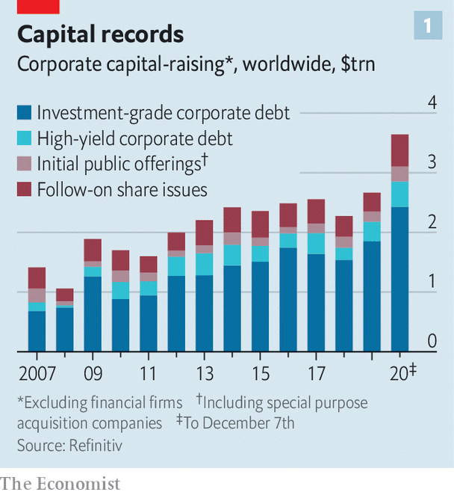

Initial public offerings (IPOs), too, are flirting with all-time highs, as startups hope to cash in on rich valuations lest stockmarkets lose their frothiness, and venture capitalists (VCs) patience with loss-making business models. VCs still plough three times as much into American startup stars as public investors do. But proceeds from listings are now growing faster than private funding rounds (see chart 2). And the boom is global in nature (see chart 3). On December 2nd JD Health, a Chinese online pharmacy, raked in $3.5bn in Hong Kong. A week later DoorDash, an American food-delivery darling, and Airbnb, a home-rental platform, both more or less matched it in New York.

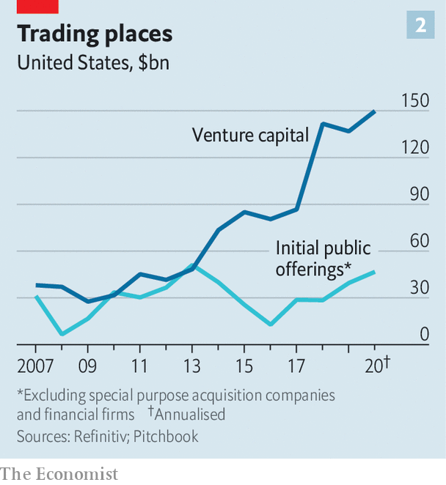

In a world of near-zero interest rates, it appears, investors will bankroll just about anyone with a shot at outliving covid-19. Some of that money will go up in smoke, with or without the corona-crisis. What does not get torched will bolster corporate haves, sharpening the contrast between them and the have-nots.

The original spark that lit capital markets on fire was the $6.25bn in debt and equity that Carnival Cruise Lines secured in April, remembers Carlos Hernandez of JPMorgan Chase, a bank. Investors reasoned that cruises will one day set sail again—by which time some of Carnival’s flimsier rivals will have sunk. Other dominant firms have benefited from this logic. Boeing, part of a planemaking duopoly, sold $25bn in bonds this spring, even as its bestselling 737 MAX jetliner remained on the ground and the near-term future of travel up in the air. Many Chinese companies have taken to issuing perpetual bonds, which are never redeemed but pay interest for ever, to repair their balance-sheets.

By the summer, notes Ms Scher, “rescue capital-raising” had given way to something less defensive. Investors’ ultraloose purse-strings allowed opportunistic firms to lock in historically low coupons. S&P Global, a rating agency, calculates that the average investment-grade bond issued this year paid interest of 2.6% amid the covid recession, down from 2.8% in 2019. Thanks to a boom in online shopping and cloud computing, Amazon, which is a leader in both areas, can now borrow at 1.5% for ten years, more cheaply than any American firm since at least 1980—and than some governments. Indebted giants like AT&T, a telecoms-and-entertainment group, are lengthening debt maturities. In November Saudi Aramco, an oil colossus, sold $2.3bn-worth of 50-year bonds, in spite of looming climate policies that may cripple its business of selling crude long before 2070.

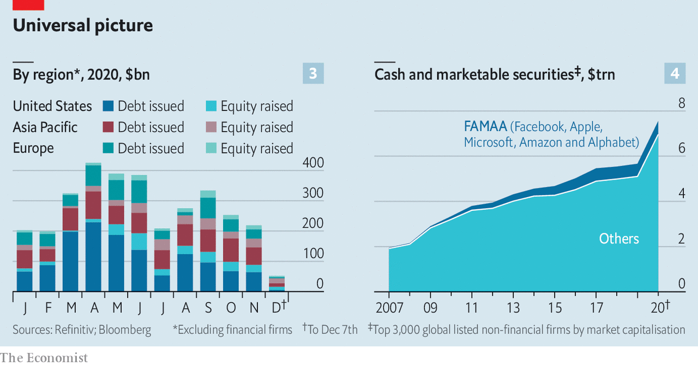

Even cheap debt, of course, must be rolled over and, perpetuities aside, eventually paid back. With stockmarket valuations propped up by loose monetary policy, and only a slim prospect of tightening, many firms opted to shore up their balance-sheets with new share issues. Danaher, a high-rolling industrial conglomerate, raised over $1.5bn by selling new stock just after its share price returned to its pre-pandemic highs in May; it has risen by 39% since. On December 8th Tesla, an electric-car maker whose market value has grown seven-fold this year, to $573bn, said it plans to issue $5bn-worth of shares.

With shareholder payouts trimmed or suspended until the covid fog lifts, the cash held by the world’s 3,000 most valuable listed non-financial firms has exploded to $7.6trn, from $5.7trn last year (see chart 4). Even if you exclude America’s abnormally cash-rich technology giants—Apple, Microsoft, Amazon, Alphabet and Facebook—corporate balance-sheets are brimming with liquidity.

It is still too early to tell what firms will do with all that cash. The merger market is showing signs of life, though mostly as deals put on ice during the pandemic are being revived. Many companies will content themselves with maintaining liquidity, at least until a covid-19 vaccine becomes more widely available.

Startups, for their part, will use IPO proceeds to blitzscale their way to profitability. The pandemic has made business models that might not have matured for years, such as digital health, suddenly viable. Many will fail. But for now giddy investors are pouring money into any firm whose IPO prospectus features the words “digital”, “cloud” or “health”. Headier still, “special purpose acquisition companies”, which go public with nothing but a promise to merge with a sexy startup later on, and which have raised $70bn in 2020, mostly on Wall Street, are shattering previous records.

Markets seem no more discerning in mainland China, where proceeds from listings hit $63bn, the most since 2010. Hong Kong added another $46bn. Shanghai’s STAR Market, a year-old technology board, this week welcomed its 200th member, bringing its IPO haul to $44bn. In September demand for shares to be traded on the Hong Kong Stock Exchange by Nongfu Spring, a water-bottler, outstripped supply by 1,148 times. Even the authorities’ last-minute suspension of Ant Group’s record-breaking $40bn IPO in Hong Kong and Shanghai, after the fintech titan’s co-founder annoyed regulators, may not frighten other listers. And so long as geopolitical tensions between America and China persist, more Chinese firms with an American stock ticker may avail themselves of a Hong Kong one, observes Julien Begasse de Dhaem of Morgan Stanley, a bank.

For now, capital is likely to keep flowing. Mr Hernandez says his bank’s pipeline of IPOs looks “the most robust in years”. The ten-year Treasury yield is below 1% and the spreads between American government and corporate bonds have narrowed to pre-pandemic levels. As a result, even riskier firms’ paper yields less than 5%, according to JPMorgan Chase. Investors expecting meaningful returns are therefore eyeing stocks. For the pandemic’s corporate winners, the choice between cheap debt and cheap equity is a win-win.■

This article was downloaded by calibre from <https://www.economist.com/business/2020/12/09/companies-have-raised-more-capital-in-2020-than-ever-before>

|  |  |  |  |
| --- | --- | --- | --- |
|  | Articles | Sections | Next |

|  |  |  |  |
| --- | --- | --- | --- |
| Previous | Articles | Sections | Next |

#### Battle commences

# A formidable alliance takes on Facebook

Investors don’t seem to care

Dec 12th 2020 |

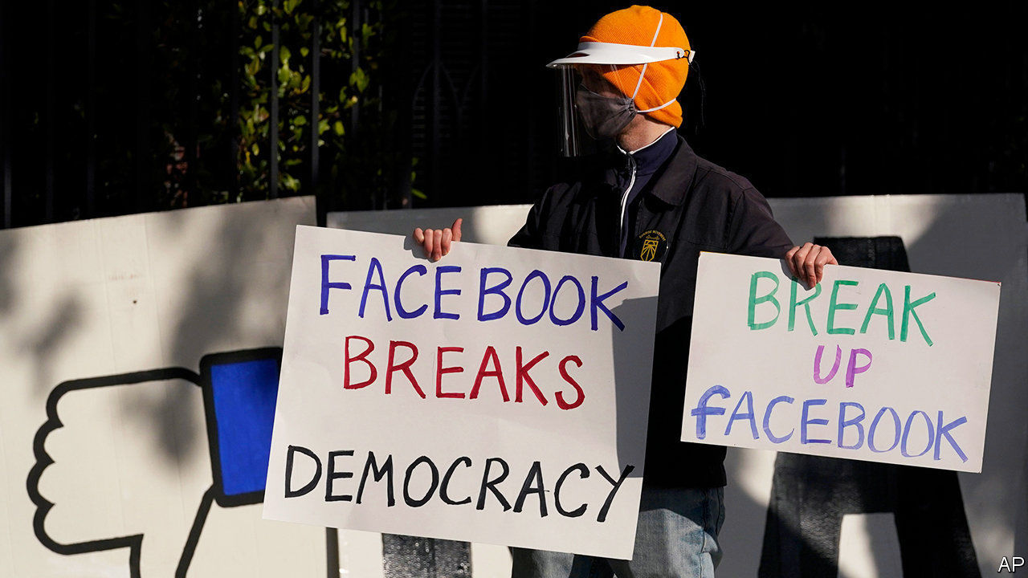

LETITIA JAMES, New York’s attorney-general, couldn’t be blunter in describing the antitrust case lodged on December 9th against the world’s biggest social network. “By using its vast troves of data and money Facebook has squashed or hindered what the company perceived as potential threats. They’ve reduced choices for consumers, they stifled innovation and they degraded privacy protections for millions of Americans,” she declared, summarising the accusations. Forty-five states joined her bipartisan coalition against the giant. Separately, the Federal Trade Commission (FTC) sued Facebook for monopolistic practices in social-networking and demanded remedies including the firm’s break-up.

A few years ago co-ordinated action by 46 states and the FTC that could split Facebook apart was unthinkable, says Lina Khan, an antitrust scholar at Columbia Law School. But the case is about more than narrow competition law. The controversies around Facebook’s privacy practices, the spread of fake news and conspiracy theories on the platform, and its exploitation by authoritarian regimes mean regulators and politicians are set on forcing change.

Will they succeed? The cases look strong. Experts judge Facebook to be the lowest-hanging antitrust fruit, alongside Google (which America’s Justice Department sued over alleged monopoly abuses in October). Amazon and Apple are in the crosshairs, but those cases will take longer, if they come at all, says an antitrust expert.

Listen on: [Apple Podcasts](https://itunes.apple.com/us/podcast/id1449631195?mt=2&ls=1) | [Spotify](https://open.spotify.com/show/12zKAMNyS2GNentUzxq9QN) | [Google](https://www.google.com/podcasts?feed=aHR0cHM6Ly9yc3MuYWNhc3QuY29tL3RoZWludGVsbGlnZW5jZXBvZGNhc3Q) | [Stitcher](https://www.stitcher.com/s?fid=357733&refid=stpr) | [TuneIn](https://tunein.com/podcasts/News--Politics-Podcasts/The-Intelligence-p1186979/)

The Facebook lawsuits centre on its acquisitions. The firm maintained its monopoly in personal social-networking by systematically buying up potential competitors, both contend—notably Instagram in 2012 and WhatsApp in 2014. A smoking gun could be Onavo, an Israeli firm Facebook bought in 2013—to protect user data, the firm said. The suits claim it in fact used Onavo to track rival apps’ popularity and select acquisition targets. Another alleged anti-competitive practice was blocking rival app developers from its platform. As consumer harm is hard to prove against big tech’s mostly free products, the suits try a novel argument: that damage is done to users’ privacy and advertisers’ choice.

Facebook will argue that its market is social media, which is broader and more competitive than social-networking. TikTok, a Chinese-owned short-video app, is now more popular than Instagram among American teenagers. The internal Facebook emails on which the lawsuits hinge hardly paint a picture of a lazy monopolist; Mr Zuckerberg and his lieutenants see competitive threats everywhere. Facebook can also argue that breaking it up is well-nigh impossible. Last year it started integrating Instagram, WhatsApp and Messenger more deeply. And the FTC’s complaint fails to mention it cleared the Instagram and WhatsApp deals. The government “now wants a do-over”, sending a chilling warning to American business that “no sale will ever be final”, Facebook said.

Markets shrugged off the news. Facebook’s shares dipped by 2%, in line with the rest of big tech. Investors either see forced divestitures as unlikely, says Brent Thill of Jefferies, an investment bank—or spy even more money to be made from spin-offs. ■

This article was downloaded by calibre from <https://www.economist.com/business/2020/12/12/a-formidable-alliance-takes-on-facebook>

|  |  |  |  |
| --- | --- | --- | --- |
| Previous | Articles | Sections | Next |

|  |  |  |  |
| --- | --- | --- | --- |
| Previous | Articles | Sections | Next |

#### Bartleby

# Why fair play pays

A new book argues that decency pays off in business as well as in life

Dec 12th 2020 |

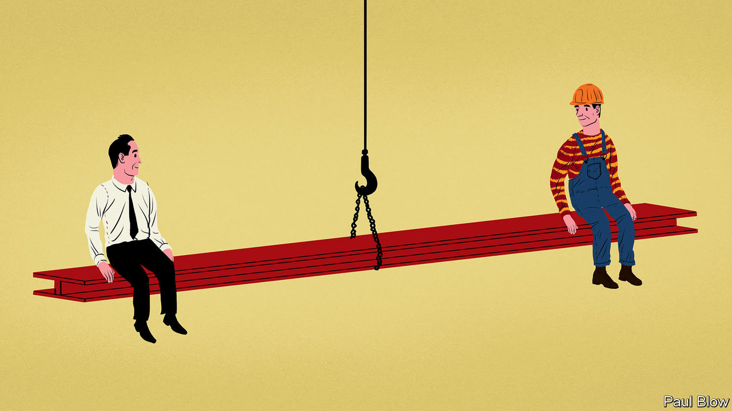

NICE GUYS finish last. That pithy motto was coined by Leo Durocher, a baseball manager noted for exulting at injuring his opponents and for cheating his players at cards. In 1969 his Chicago Cubs had a big lead in the closing weeks of the season, but he so alienated his squad (and the umpires) that the team failed to make it to the World Series. In his case, nasty guys finished behind.

This is one of the tales told by David Bodanis, a writer best known for his science books, who has turned his attention to the issue of how leaders should exercise their authority. The core message in his book, “The Art of Fairness”, can be found in the subtitle: “The power of decency in a world turned mean”.

The Empire State Building was constructed in just 13 months, and that included the dismantling of the Waldorf-Astoria hotel that sat on the site. Paul Starrett, the builder, treated his workers rather well by the standards of the time, paying much attention to safety and paying employees on days when it was too windy to work. Daily wages were more than double the usual rate and hot meals were provided on site.

The concept is known as “efficiency wages”. Companies that compensate workers well and treat them fairly can attract better, more motivated staff. Unlike most construction projects, the Empire State Building had low staff turnover, and workers suggested productivity improvements such as building a miniature railway line to bring bricks to the site. But Starrett was not naively generous; he hired accountants to patrol the works, checking that all materials were accounted for, and staff attendance was recorded four times a day.

The author contrasts Starrett’s story with the tale of Eastern Air Travel, an airline built by Eddie Rickenbacker, a pioneer aviator who had granted mechanics a 40-hour week, profit-related pay and a pension. But when Frank Lorenzo took over the company in the 1980s, he cut wages, alienated the staff and pursued a policy of asset-stripping the company. The workers went on strike in protest and Eastern went bankrupt.

Another contrast cited by the author is that between Steve Ballmer, the hard-charging chief executive of Microsoft notorious for his towering rages, and his more emollient successor, Satya Nadella. Mr Ballmer so disliked Apple that he seized an iPhone from a subordinate in full view of the humiliated employee and pretended to stomp on it. On his watch Microsoft missed out on several promising business opportunities. On the day Mr Ballmer announced his departure the share price jumped by 7.5%. Under Mr Nadella, Microsoft has successfully shifted its attention to cloud-based services and even briefly regained the title of the world’s most valuable listed company.

Public projects also require management skills. When Danny Boyle, a film director, was asked to organise the opening ceremony of the 2012 London Olympics, he faced the tough task of keeping the details secret when the project required thousands of volunteers. The conventional approach would have been to make the volunteers sign a non-disclosure agreement. Instead, he asked them to keep the surprise—and trusted them to do so. They did, thanks to the grown-up way he treated them. He listened to their ideas for improving parts of the ceremony and ensured (by threatening to resign) that the volunteers did not have to pay for their costumes.

Mr Boyle demonstrated one of the most important traits of good leadership, the author argues, which is a willingness to listen. This relates to a concept known as the “power distance”. If a relationship has a high power-distance score, it is assumed that junior staff should not question their superiors’ decisions; a lower score means that senior staff are willing to listen.

Perceptions may differ sharply over whether listening takes place. A study by Johns Hopkins University found that 64% of the medical specialists interviewed felt that their operations had high levels of teamwork, whereas only 28% of their nurses agreed.

Individuals can become fixated on a particular approach to resolving a problem and ignore any advice that suggests a different tack, especially if it comes from a junior colleague. “When your underlings aren’t terrified of you, and you’re modest enough to know you’re fallible, you can set up the channels that will help you avoid fixation,” Mr Bodanis writes. It is a wise lesson. Ruling by fear may work for a while, but it is doomed to fail in the long run. Remember Durocher.

This article was downloaded by calibre from <https://www.economist.com/business/2020/12/12/why-fair-play-pays>

|  |  |  |  |
| --- | --- | --- | --- |
| Previous | Articles | Sections | Next |

|  |  |  |  |
| --- | --- | --- | --- |
| Previous | Articles | Sections | Next |

#### Europe’s biggest tech firm

# Can SAP’s new boss reset its business model?

Christian Klein has the right ideas. Implementing them will not be easy

Dec 12th 2020 | BERLIN

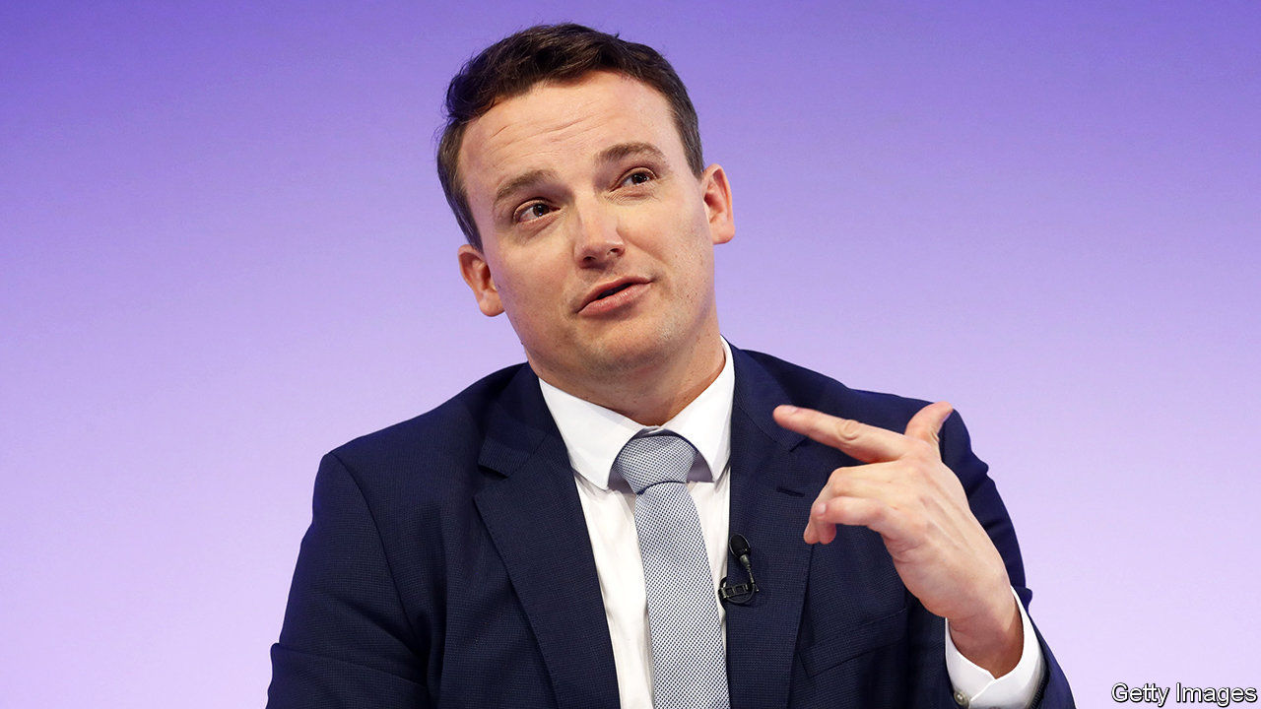

“COUNT ON US, hold us accountable and together we will reinvent the way businesses run.” Thus ends a recent letter of support from 337 senior managers at SAP, a maker of business software, to Christian Klein, their chief executive. In April Mr Klein, then a stripling 39 years old, took over as sole boss of Europe’s biggest technology firm, after running it for a few months in tandem with Jennifer Morgan, an American who used to helm SAP’s business across the Atlantic. He needs all the love he can get, for SAP faces a challenge.

Mr Klein became CEO at the peak of covid-19’s first wave. It had hurt SAP more than other tech firms: many of its biggest clients, such as carmakers and energy companies, were temporarily hit by the pandemic. And it struck as more rivals were vying for swathes of the business-software market that the German giant used to rule.

Then, in October, Mr Klein was humbled when he presented changes to SAP’s business model that would depress margins in the short run and delay earlier revenue and profit targets by two years. Combined with lacklustre results for the third quarter, the news shaved 22% off the firm’s share price, wiping out €35bn ($41bn) in market value, the sharpest drop in 21 years and almost unheard of for a firm of SAP’s size (see top chart). The purchase of almost €250m in SAP shares the following day by Hasso Plattner, chairman of the supervisory board, who co-founded the company 48 years ago, did not reassure investors.

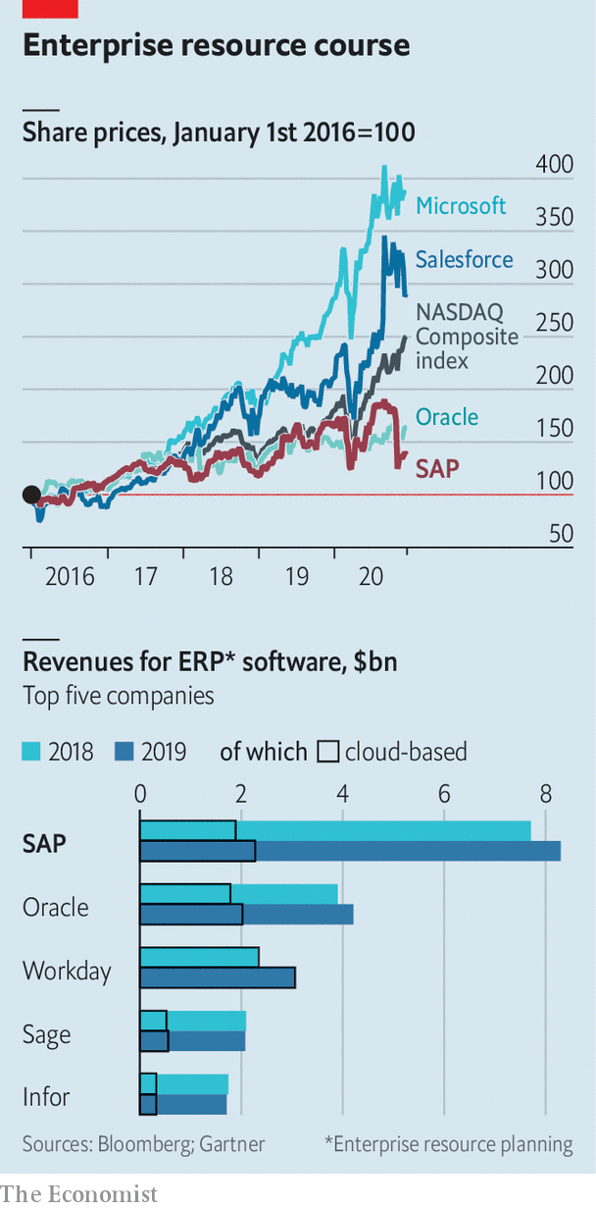

To regain their confidence Mr Klein must improve SAP’s offering in the cloud, and persuade more of its clients to move there. And he needs to do this while fending off competition from firms such as Oracle, Salesforce and Workday in America, SAP’s biggest market.

The pandemic has softened demand for “enterprise resource planning” (ERP) software, which firms use to manage their everyday operations—and which has long been SAP’s forte. It has also prompted SAP’s existing clients, typically large or medium-sized manufacturers, to rethink their ERP processes. “I never had so many calls from CEOs who wanted to talk about supply chains,” says Mr Klein. Retailers and manufacturers asked SAP for tools to get more visibility of their suppliers. Critically, many of them demanded that ERP, which has traditionally resided on firms’ own servers, be moved to the cloud instead.

SAP is very late to the cloud, where companies have been progressively moving for the past 20 years, says Liz Herbert of Forrester Research, a consulting firm. Oracle, which also embarked on the transition belatedly, has done so swiftly. So has Microsoft, the world’s biggest software-maker, with ambitions to expand its enterprise offerings. By contrast, SAP remains more of a hybrid. It has moved a chunk of its business to the cloud but many big customers still use its software on their premises.

Why the dithering? Shifting complex, customised end-to-end ERP processes to the cloud is much harder than uploading human resources, sales or customer-relationship management, Mr Klein explains. And ERP remains SAP’s bread and butter: it controls 21% of the market, according to Gartner, a research firm, compared with 11% for Oracle, its closest competitor (see bottom chart). A whopping 92% of Fortune 500 companies—from carmakers, like BMW, to defence firms, such as Lockheed Martin—use SAP software. It therefore cannot get the transition wrong. SAP listened to its customers and took a methodical approach, says an executive at a rival software firm, whereas the market wants it to move fast and break things.

Even so, says Mr Klein, “covid was clearly an inflection point.” Bosses of big firms who may have waited another five years before switching to the cloud now want to speed up. They are also demanding a closer integration of SAP affiliates acquired by Mr Klein’s predecessor, Bill McDermott. These include Concur, a travel-expenses firm; Ariba, a procurement platform; and SuccessFactors, which makes HR software. This will require additional investments by SAP. So will Mr Klein’s plan to increase spending on research and development.

SAP must now persuade its 35,000-odd ERP clients of the benefits of the cloud. It must convince investors of the same thing. Licences for on-site software bring a big chunk of revenue upfront, whereas customers initially pay much less for rolling cloud subscriptions. But recurring revenues are increasingly coveted by all manner of technology firms, from Amazon and Apple to Netflix, because they are more predictable and build a closer relationship with customers. The shift to the subscription model will eventually mean a big revenue lift for SAP, predicts Mark Moerdler at Bernstein, a broker.

As for the transition to the cloud, it need not be onerous technically. That is a bit of red herring, thinks Paul Sanderson of Gartner. The bigger challenge is changing the culture of SAP, which has become too removed from its clients.

Rivals will try to exploit the transition period to win over some of those customers. Larry Ellison, the colourful co-founder and now chief technology officer of Oracle, declared last year that “SAP’s customer base is up for grabs.” His subsequent claim that a huge client of SAP was about to defect to Oracle proved unfounded. Another such boast might not be. ■

This article was downloaded by calibre from <https://www.economist.com/business/2020/12/12/can-saps-new-boss-reset-its-business-model>

|  |  |  |  |
| --- | --- | --- | --- |
| Previous | Articles | Sections | Next |

|  |  |  |  |
| --- | --- | --- | --- |
| Previous | Articles | Sections | Next |

#### The case of the disappearing cases

# Why more Indian business disputes are settled elsewhere

Companies prefer the speed and impartiality of foreign arbitrators

Dec 12th 2020 |

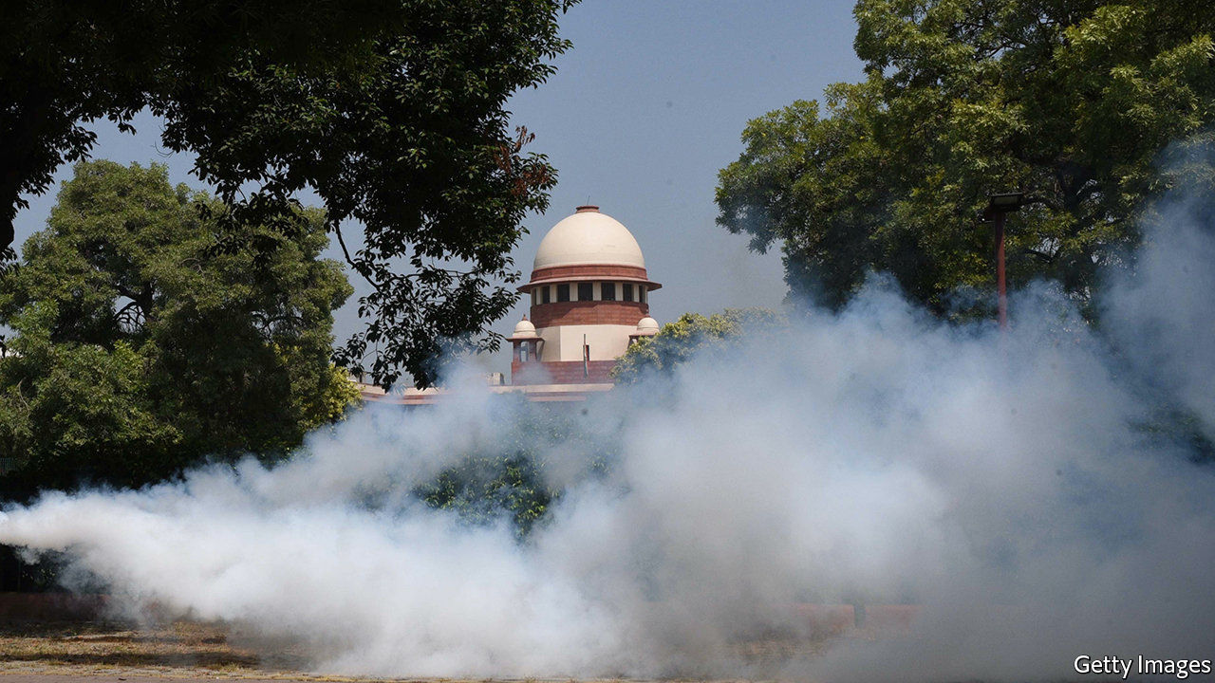

AMAZON, VODAFONE and Cairn Energy operate in different industries: e-commerce, telecoms and oil-and-gas exploration, respectively. But they share a common predicament. All are waging legal battles over their Indian operations—and doing so outside India.

The trio are part of a larger wave. Last year nearly 500 cases filed in the Singapore International Arbitration Centre came from India. No other country came close (see chart). The number of Indian parties involved in arbitration through the Paris-based International Chamber of Commerce tripled last year, to 147. More quietly, London remains a crucial centre for India-related commercial spats, as to a lesser extent does The Hague. Two newish arbitration centres in the United Arab Emirates, in Dubai and Abu Dhabi, want in on the game.

Narendra Modi, the prime minister, is believed to dislike this trend. His administration sees it, with reason, as an infringement of India’s sovereignty—but also as impugning its laws and judicial process. The resistance to outside meddling in the country’s legal affairs is echoed by its bar association, which blocks foreign lawyers and law firms from practising locally.

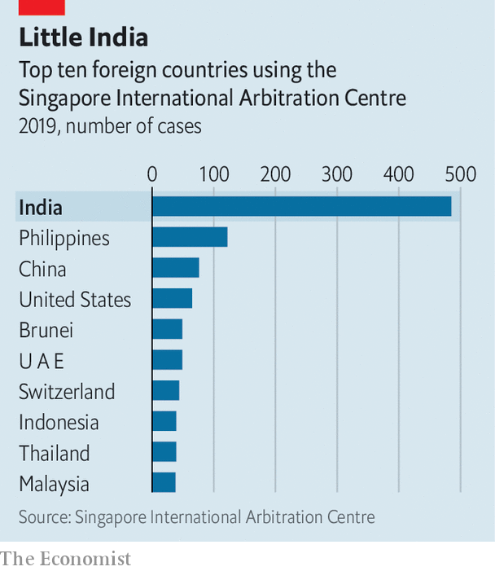

Crucial components of the legal system are nevertheless being outsourced. Companies feel that it is the best way to get a fair shot in India. And for all its grumbling, India’s government understands that attracting investment requires the availability of a judicial recourse that is considered efficient and fair—which Indian courts can at times seem not to be.

The emigrant cases can be divided into two categories. The first kind involve the Indian government. Vyapak Desai of Nishith Desai Associates, an Indian law firm with expertise in the area, has compiled a list of more than a dozen big cases pending. Some were brought by Indian firms. In 2017 Reliance Industries, a conglomerate famous for ably navigating India’s courts and bureaucracy, chose Singapore as the venue to fight a $1.6bn claim by the Indian government, which accused it of improperly extracting gas from fields owned by state-controlled firms. Reliance won and was awarded $8m in compensation.

Foreign arbitration is all the more attractive for firms lacking Reliance’s local nous. Cairn, which is British, filed its case in The Hague, arguing that it should be paid back $1.4bn in taxes involuntarily extracted on the basis of a retroactive law passed in 2012, which was applied to an asset sale six years earlier. Cairn says this violated a bilateral investment treaty between Britain and India; a decision is expected any day now. Vodafone’s case stems from the same law and relies on a similar treaty which India signed with the Netherlands. The firm, which had purchased mobile-telephony assets in 2007, won a bitterly fought case before India’s Supreme Court in 2012 exempting it from a capital-gains tax on the transaction, only to have the levy reimposed by India’s parliament. In September it won a unanimous decision fro

m a three-person arbitration panel in The Hague.

The prime minister’s office is said to be torn over offshore arbitration. On the one hand, it believes that foreigners have no right to contest Indian taxes; partly in response to such cases it has withdrawn from 73 bilateral investment treaties, including the British and Dutch ones, and imposed more onerous terms for challenging tax assessments in new ones it has signed.

On the other hand, it fears that rejecting arbitration would reinforce the sense that India is a toxic place for foreign firms to invest. Appealing against a decision—let alone ignoring it—brings costs, not least by putting off investors at a time when Mr Modi is keen to lure them away from China.

The second category of disputes settled abroad involves only private parties. These often move offshore simply because business moves fast whereas Indian courts do not. It takes more than three years on average to resolve a case before the High Court in Mumbai and nearly three years in Delhi, according to a study by Daksh, a research group. Seven years is not uncommon, Daksh says. Lawyers in Mumbai’s High Court report that is not hard to find cases still pending from the 1960s.

Most of the offshore private cases are resolved quickly and quietly. Some, though, make headlines. The one involving Amazon is an example. In October the e-commerce giant won a favourable decision in Singapore to suspend the acquisition of a tottering retailer, Future Group, by Reliance. Amazon had earlier negotiated with Future a right of first refusal on any sale. Given Future’s troubles, Amazon might reasonably have felt it had no time to wait for a sluggish Indian court to intervene. In appealing against the Singaporean arbitrator’s decision to the Delhi High Court, Future accused Amazon of acting “like the East India Company of the 21st century”. The comments chimed with Mr Modi’s instructions to all Indians to “be vocal for local”. They rhyme less well with his appeals to foreign investors.■

This article was downloaded by calibre from <https://www.economist.com/business/2020/12/12/why-more-indian-business-disputes-are-settled-elsewhere>

|  |  |  |  |
| --- | --- | --- | --- |
| Previous | Articles | Sections | Next |

|  |  |  |  |
| --- | --- | --- | --- |
| Previous | Articles | Sections | Next |

#### Spinning off

# Why is Uber selling its autonomous-vehicle division?

Self-driving cars were meant to be its future

Dec 12th 2020 |

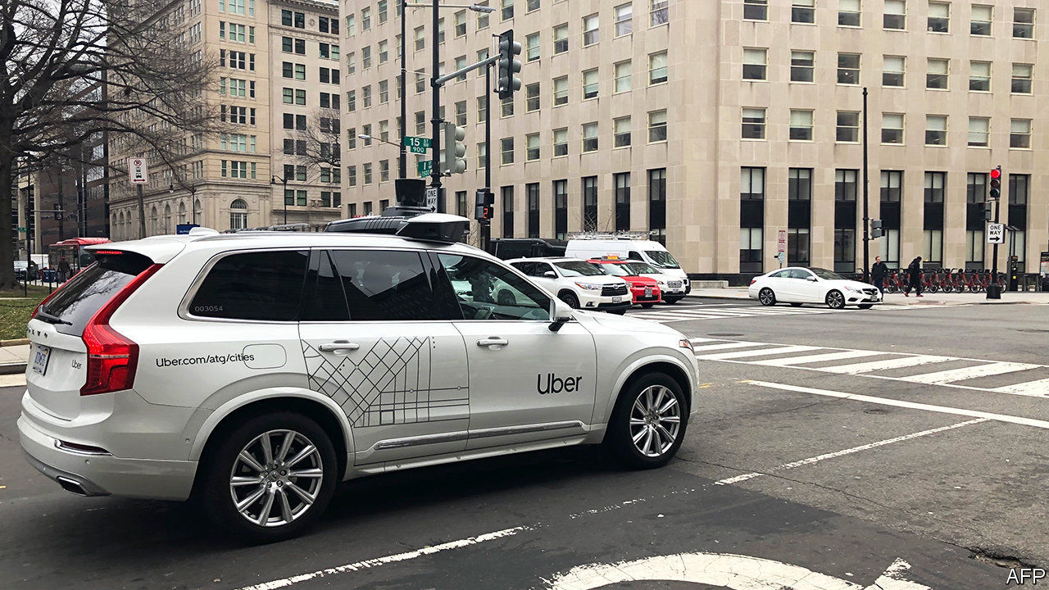

IN 2016 TRAVIS KALANICK, then Uber’s chief executive, described self-driving cars as mission-critical. If somebody managed to beat Uber to making them work, he said, then the rival’s ability to offer taxi trips without paying for human drivers would mean that “Uber is no longer a thing.”

Times change. On December 7th Uber announced the sale of its self-driving arm to a firm called Aurora. No price was given. But Uber said it would put another $400m into the unit; that Dara Khosrowshahi, its current boss, would join Aurora’s board; and that the deal would leave it with a 26% stake in Aurora.

One reason for the spin-off is Uber’s belated effort to return to profit. It lost $8.5bn in 2019, as it fought for market share with rivals such as Lyft. Besides offloading the self-driving unit, the firm has sacked workers and sold its Jump electric-bicycle division to Lime, a scooter firm. On December 8th Uber said it would flog its Elevate flying-car project to a startup called Joby Aviation.

Another explanation is that the reality of self-driving has lagged far behind the excitement, as it had done in the idea’s earlier heydays in the 1960s and the 1990s. The machine-learning software on which the cars rely often struggles to cope with “edge cases”, which are absent from software’s training data but pop up regularly on real roads.

Uber’s self-driving progress has, according to industry rumours, been slow. In 2018 one of its cars ran over and killed a pedestrian in Arizona. It is not alone; Tesla’s “Autopilot” feature has been linked to at least four deaths since it was launched in 2015. But Uber’s Kalanick-era reputation for rule-breaking has made the PR burden heavier.

The bearish interpretation of the sale is that, having given up on self-driving, Uber will remain a fancy taxi-and-delivery firm. But if Aurora can buck expectations and make self-driving work, Uber could license the technology back. And high-tech distractions like self-driving cars—or flying ones—may be the last thing the firm needs. It is under pressure not just from rivals and investors but also from regulatory probes into its other big cost-saving innovation—the assertion that its drivers are not employees, but independent contractors. Joe Biden, America’s president-elect, has called that a “misclassification”. Tighter European rules will come into force by 2022. Those edge cases look urgent.

This article was downloaded by calibre from <https://www.economist.com/business/2020/12/12/why-is-uber-selling-its-autonomous-vehicle-division>

|  |  |  |  |
| --- | --- | --- | --- |
| Previous | Articles | Sections | Next |

|  |  |  |  |
| --- | --- | --- | --- |
| Previous | Articles | Sections | Next |

#### Schumpeter

# Unshackling France SA

The best French firms have shaken off the attention of politicians—and thrived

Dec 12th 2020 |

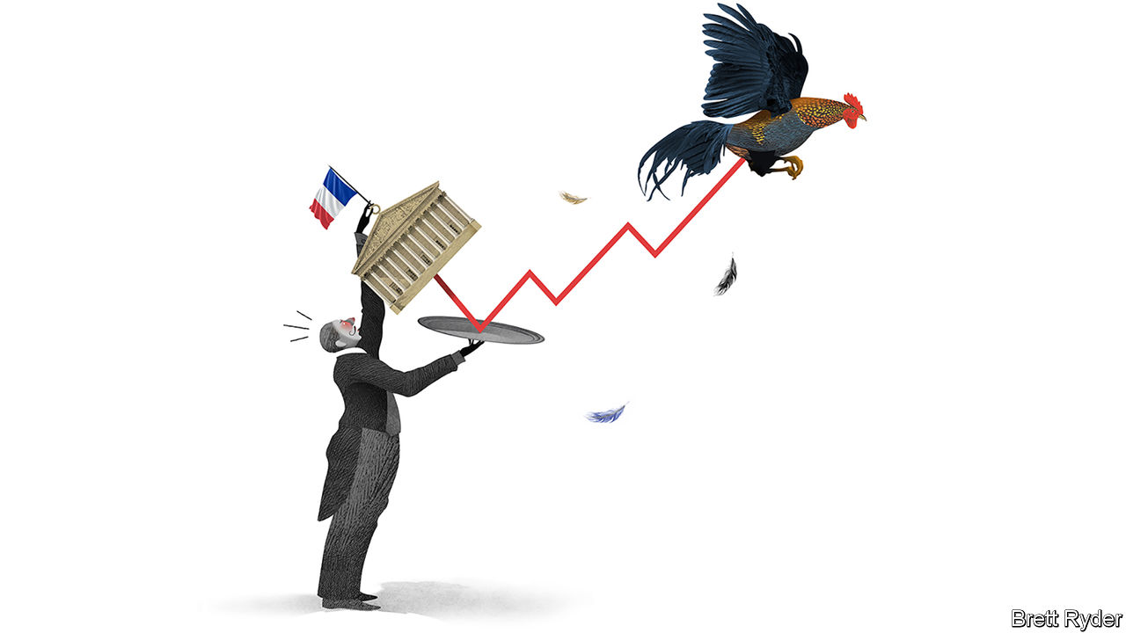

IF DINNER PARTIES were permitted in locked-down France, it is not hard to guess what would set le tout Paris aflutter. For months bankers, politicians and other pre-covid canapé-scoffers have taken sides in a corporate battle royale pitting two century-old firms against each other. Veolia, a water- and waste-management utility, has been struggling to gobble up Suez, a rival which is resisting fiercely. The proposed deal is mired in legal disputes, boardroom recriminations and ministerial intrigue. All grist to the mill for those who see French business as the product of its politicians’ dirigiste tendency to shape the private sector in the mould of the public one. But look at the wider French business landscape and the stereotype is out of date. Away from the clutches of politicians, many French firms have become world-beaters. Is this thanks to the attention of elected officials—or in spite of it?

The ugly spat between Veolia and Suez shows politics still matters in Parisian business circles. Given the two firms offer the same outsourced environmental services to customers dotted across the globe, a tie-up has long been mooted. Veolia having already seized nearly a third of its target’s shares, each side has lined up members of l’establishment to make its case. Their brief is not so much to convince shareholders of the merits of a deal, as might be the case in Britain or America. Rather, politicians whose assent is considered critical are an important audience. Suez and Veolia are each said to have a former speechwriter to President Emmanuel Macron lobbying for them (not the same one). Given that a slew of legal challenges and regulatory clearances is required, the outcome will not be known for months. Few think it will hinge on the transaction’s commercial merits.

Such intrigue used to delight the French business elite. Now it feels old hat. Look at the top of the CAC 40 index of France’s leading companies today, and a new generation of firms has emerged. Two decades ago the corporate league table was dominated by firms in sectors in which relations with government matter, such as telecoms, utilities or banking. The bosses of France Télécom or BNP Paribas, a bank, were inevitably former ministerial advisers. More often than not they had graduated from the École Nationale d’Administration (ENA), a finishing school for public officials.

Fast forward to today and the CAC 40 is led by companies with less use for political connections. The index’s brightest stars today are luxury giants such as LVMH (of Louis Vuitton fame), Kering (Gucci) and Hermès; L’Oréal, a beauty-products firm; Sanofi, a drugmaker; and a host of industrial giants. Selling handbags or skincare products to Chinese yuppies is a global contest in which French firms excel, thanks to competent management. Lesser-known but equally astute companies such as Schneider Electric, a specialist in energy-management kit, have outperformed American rivals such as 3M and General Electric, and European ones like Siemens and ABB. Investors in Air Liquide, a chemicals firm, have enjoyed juicier returns than those of Germany’s BASF or America’s DuPont. Publicis, an advertising group, is worth nearly three times as much as in 2000, while rivals like WPP in Britain and Omnicom in America have lost market value. EssilorLuxottica, a French-Italian firm, is the world’s biggest purveyor of spectacles.

Even more telling, some big firms began to prosper only once unshackled from the government yoke. Total, an oil-and-gas major, used to be worth a fraction of BP or Royal Dutch Shell. As it has gained distance from the corridors of power since privatisation in 1992, it has caught up with its European rivals’ valuations. Safran, an aerospace firm, has seen its market value go up 14-fold in two decades as the state has sold down its stake. Airbus has outpaced its American jetmaking nemesis, Boeing, as political meddling (by the many European governments that founded it) has ebbed.

And today political allies carry less heft than they once did. According to Morgan Stanley, a bank, over 70% of big French firms’ revenues nowadays come from overseas, where French politicians hold little sway. Most regulation critical to French firms used to be done at national level, where regulators were drawn from the same ENA lecture halls as corporate bosses. Now a lot is carried out by European or global watchdogs.

That is not to say that big firms and politicians steer clear of each other. France’s foreign minister recently waded into LVMH’s takeover of Tiffany, an American jeweller, in ways that were eyebrow-raisingly useful for the French luxury champion. But direct patronage is becoming a burden. The French authorities remain a shareholder in Renault and in 2019 clumsily handled a proposed merger with Fiat Chrysler Automobiles, an Italian-American rival (whose big shareholder, Exor, owns a stake in The Economist’s parent company). Peugeot, a nimble competitor with no direct state shareholding, is now in the midst of the merger Renault fluffed.

## French whines

Corporate France has plenty of shortcomings. It has no tech giants to match Google or Amazon. Many large companies with few state ties, such as Accor, a hotel chain, and Carrefour, a retailer, are decidedly ordinary. The CAC 40 was lagging behind its European and American equivalents even before covid-19 hit the French economy particularly hard. Its smaller firms pale in comparison to Germany’s Mittelstand. And French politicians, though no longer the dirigiste master-planners of yore, still pine for national (or European) champions to take on Chinese rivals. They frown on hostile takeovers—the mere prospect of which serves to sharpen managers’ minds—which is one reason the Veolia-Suez deal may fail.

That is a shame. Just ask Danone’s shareholders. In 2005 an unsolicited approach by PepsiCo for Danone was foiled by the French authorities on the grounds yogurt-making was a strategic industry. The American firm went on its way and has since delivered fizzy profits for its shareholders. Those at Danone, meanwhile, have had to stomach far blander returns.■

This article was downloaded by calibre from <https://www.economist.com/business/2020/12/12/unshackling-france-sa>

|  |  |  |  |
| --- | --- | --- | --- |
| Previous | Articles | Sections | Next |

|  |  |  |
| --- | --- | --- |
| Business | Sections | Science & ... |

Finance & economics

Productivity trends: Reasons to be cheerful

.

Buttonwood: C’mon feel the noise

.

Oil production: Opening the taps

.

Mexico’s unbanked: Bringing Mexicans to account

.

Climate finance: Counting the carbs

.

Free exchange: A question of illumination

.

|  |  |  |
| --- | --- | --- |
| Business | Sections | Science & ... |

|  |  |  |  |
| --- | --- | --- | --- |
|  | Articles | Sections | Next |

#### Reasons to be cheerful

# The pandemic could give way to an era of rapid productivity growth

Businesses have adopted new processes and technologies—and there are signs that they may pay off

Dec 8th 2020 |

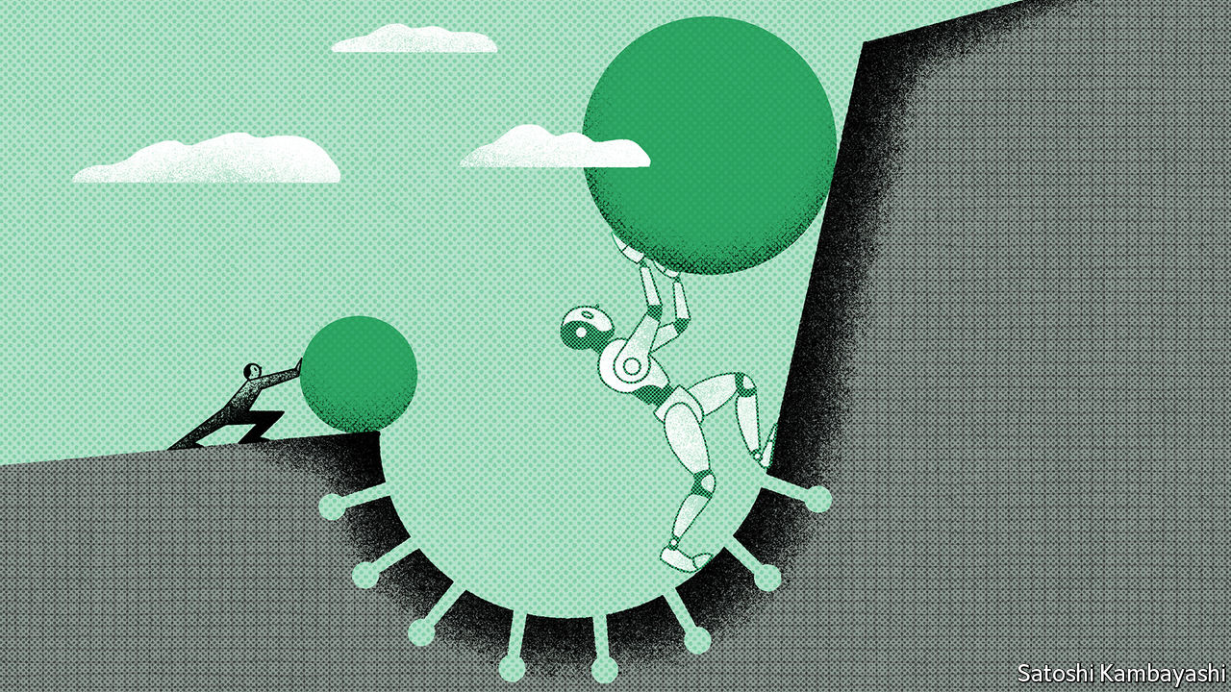

THE PROSPECTS for a productivity resurgence may seem grim. After all, the past decade has featured plenty of technological fatalism: in 2013 Peter Thiel, a venture capitalist, mused of the technological advances of the moment that “we wanted flying cars, instead we got 140 characters”. Robert Gordon of Northwestern University has echoed this sentiment, speculating that humanity might never again invent something so transformative as the flush toilet. Throughout the decade, data largely supported the views of the pessimists.

What is more, some studies of past pandemics and analyses of the economic effects of this one suggest that covid-19 might make the productivity performance worse. According to research by the World Bank, countries struck by pandemic outbreaks in the 21st century (not including covid) experienced a marked decline in labour productivity of 9% after three years relative to unaffected countries.

And yet, stranger things have happened. The brutal years of the 1930s were followed by the most extraordinary economic boom in history. A generation ago economists had nearly abandoned hope of ever matching the post-war performance when a computer-powered productivity explosion took place. And today there are tantalising hints that the economic and social traumas of the first two decades of this century may soon give way to a new period of economic dynamism.

Productivity is the magic elixir of economic growth. Increases in the size of the labour force or the stock of capital can raise output, but the effect of such contributions diminishes unless better ways are found to make use of those resources. Productivity growth—wringing more output from available resources—is the ultimate source of long-run increases in incomes. It’s not everything, as Paul Krugman, a Nobel economics laureate, once noted, but in the long run it’s almost everything.

Economists know less about how to boost productivity than they would like, however. Increases in labour productivity (that is, more output per worker per hour) seem to follow improvements in educational levels, increases in investment (which raise the level of capital per worker), and adoption of new innovations. A rise in total factor productivity—or the efficiency with which an economy uses its productive inputs—may require the discovery of new ways of producing goods and services, or the reallocation of scarce resources from low-productivity firms and places to high-productivity ones.

Globally, productivity growth decelerated sharply in the 1970s from scorchingly high rates in the post-war decades. A burst of higher productivity growth in the rich world, led by America, unfolded from the mid-1990s into the early 2000s. Emerging markets, too, enjoyed rapid productivity growth in the decade prior to the global financial crisis, powered by high levels of investment and an expansion of trade which brought more sophisticated techniques and technologies to the developing-economy participants in global supply chains. Since the crisis, however, a broad-based and stubbornly persistent slowdown in productivity growth has set in (see chart 1). About 70% of the world’s economies have been affected, according to the World Bank.

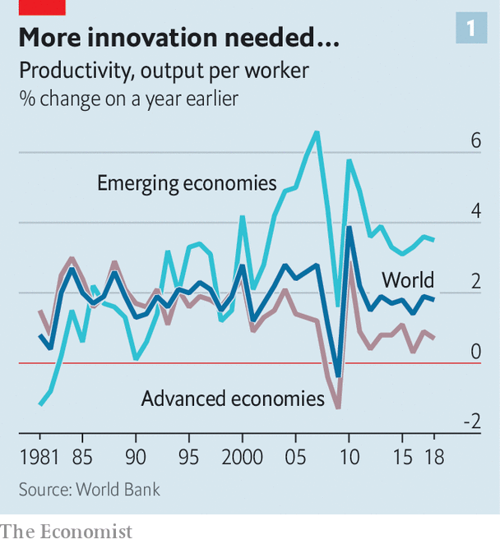

Accounting for the slowdown is a fraught process. The World Bank reckons that slowing trade growth and fewer opportunities to adopt and adapt new technology from richer countries may have helped depress productivity advances in the emerging world. Across all economies, sluggish investment in the aftermath of the global financial crisis looks a culprit: a particular problem in places with ageing and shrinking workforces. Yet while these headwinds surely matter, the bigger question is why new technologies like improved robotics, cloud computing and artificial intelligence have not prompted more investment and higher productivity growth.

Broadly speaking, three hypotheses compete to explain these doldrums. One, voiced by the techno-pessimists, insists that for all the enthusiasm about world-changing technologies, recent innovations are simply not as transformative as the optimists insist. Though it is possible that this will turn out to be correct, continued technological progress makes it look ever less plausible as an explanation for the doldrums. AI may not have transformed the world economy at the dramatically disruptive pace some expected five to ten years ago, but it has become significantly, and in some cases startlingly, more capable. GPT-3, a language-prediction model developed by OpenAI, a research firm, has demonstrated a remarkable ability to carry on conversations, draft long texts and write code in surprisingly human-like fashion.

Though the potential of the web to support an economy in which the constraints of distance do not bind has long underwhelmed, cloud computing and video-conferencing proved their economic worth over the past year, enabling vast amounts of productive activity to continue with scarcely an interruption despite the shuttering of many offices. New technologies are clearly able to do more than has generally been asked of them in recent years.

That strengthens the case for a second explanation for slow productivity growth: chronically weak demand. In this view, expressed most vociferously by Larry Summers of Harvard University, governments’ inability to stoke enough spending constrains investment and growth. More public investment is needed to unlock the economy’s potential. Chronically low rates of interest and inflation, limp private investment and lacklustre wage growth since the turn of the millennium clearly indicate that demand has been inadequate for most of the past two decades. Whether this meaningfully undercuts productivity growth is difficult to say. But in the years before the pandemic, as unemployment fell and wage growth ticked up, American labour productivity growth appeared to be accelerating, from an annual increase of just 0.3% in 2016 to a rise of 1.7% in 2019: the fastest pace of growth since 2010.

But a third explanation provides the strongest case for optimism: it takes time to work out how to use new technologies effectively. AI is an example of what economists call a “general-purpose technology”, like electricity, which has the potential to boost productivity across many industries. But making best use of such technologies takes time and experimentation. This accumulation of know-how is really an investment in “intangible capital”.

Recent work by Erik Brynjolfsson and Daniel Rock, of MIT, and Chad Syverson, of the University of Chicago, argues that this pattern leads to a phenomenon they call the “productivity J-curve”. As new technologies are first adopted, firms shift resources towards investment in intangibles: developing new business processes. This shift in resources means that firm output suffers in a way that cannot be fully explained by shifts in the measured use of labour and tangible capital, and which is thus interpreted as a decline in productivity growth. Later, as intangible investments bear fruit, measured productivity surges because output rockets upward in a manner unexplained by measured inputs of labour and tangible capital.

Back in 2010, the failure to account for intangible investment in software made little difference to the productivity numbers, the authors reckon. But productivity has increasingly been understated; by the end of 2016, productivity growth was probably about 0.9 percentage points higher than official estimates suggested.

This pattern has occurred before. In 1987 Robert Solow, another Nobel prizewinner, remarked that computers could be seen everywhere except the productivity statistics. Nine years later American productivity growth began an acceleration which evoked the golden age of the 1950s and 1960s. These processes are not always sexy. In the late 1990s, the soaring share prices of internet startups hogged the headlines. The fillip to productivity growth had other sources, like improvements in manufacturing techniques, better inventory management and rationalisation of logistics and production processes made possible by the digitisation of firm records and the deployment of clever software.

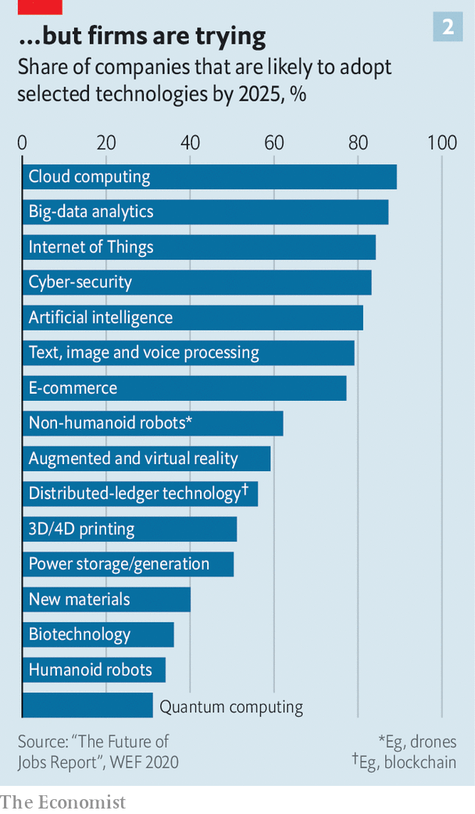

The J-curve provides a way to reconcile tech optimism and adoption of new technologies with lousy productivity statistics. The role of intangible investments in unlocking the potential of new technologies may also mean that the pandemic, despite its economic damage, has made a productivity boom more likely to develop. Office closures have forced firms to invest in digitisation and automation, or to make better use of existing investments. Old analogue habits could no longer be tolerated. Though it will not show up in any economic statistics, in 2020 executives around the world invested in the organisational overhauls needed to make new technologies work effectively (see chart 2). Not all of these efforts will have led to productivity improvements. But as covid-19 recedes, the firms which did transform their activities will retain and build on their new ways of doing things.

## The crisis forced change

Early evidence suggests that some transformations are very likely to stick, and that the pandemic quickened the pace of technology adoption. A survey of global firms conducted by the World Economic Forum this year found that more than 80% of employers intend to accelerate plans to digitise their processes and provide more opportunities for remote work, while 50% plan to accelerate automation of production tasks. About 43% expect changes like these to generate a net reduction in their workforces: a development which could pose labour-market challenges but which almost by definition implies improvements in productivity.

Harder to assess is the possibility that the movement of so much work into the cloud could have productivity-boosting effects for national economies or at the global level. High housing and property costs in rich, productive cities have locked firms and workers out of places where they might have done more with less resources. If tech workers can more easily contribute to top firms while living in affordable cities away from America’s coasts, say, then strict zoning rules in the bay area of California will become less of a bottleneck. Office space in San Francisco or London freed up by increases in remote work could be occupied by firms which really do need their workers to operate in close physical proximity. Beyond that, and politics permitting, the boost to distance education and telemedicine delivered by the pandemic could help drive a period of growth in services trade, and the achievement of economies of scale in sectors which have long proved resistant to productivity-boosting measures.

None of this can be taken for granted. Making the most of new private-sector investments in technology and know-how will require governments to engineer a rapid recovery in demand, to make complementary investments in public goods like broadband, and to focus on tackling the educational shortfalls so many students have suffered as a consequence of school closures. But the raw materials for a new productivity boom appear to be falling into place, in a way not seen for at least two decades. This year’s darkness may in fact mean that dawn is just over the horizon.■

This article was downloaded by calibre from <https://www.economist.com/finance-and-economics/2020/12/08/the-pandemic-could-give-way-to-an-era-of-rapid-productivity-growth>

|  |  |  |  |
| --- | --- | --- | --- |
|  | Articles | Sections | Next |

|  |  |  |  |
| --- | --- | --- | --- |
| Previous | Articles | Sections | Next |

#### Buttonwood

# Retail investors often learn the wrong lessons from success

A study of Indian IPOs suggest investors confuse luck with skill

Dec 10th 2020 |

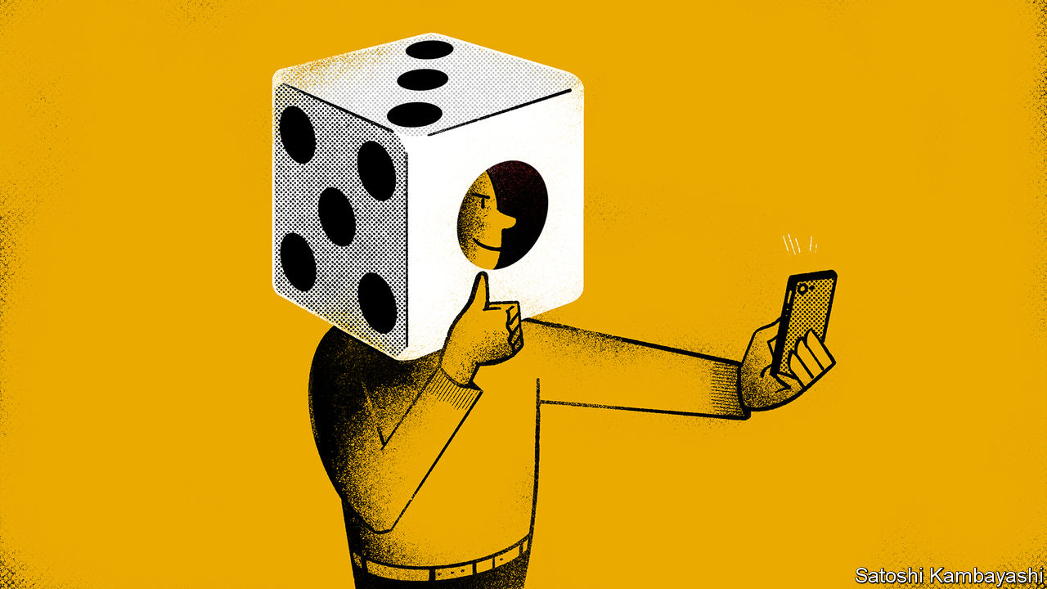

IT IS better to be lucky than good. This is the customary quip of poker players who owe success in a big pot to an improbable draw from the deck. In card games it is usually clear whom fortune has favoured. Not so in investing. The randomness of financial markets makes it hard to distinguish a good investor from a lucky one. It is especially hard for people to assess their own skills.

This long-understood problem has fresh resonance. In the spring no-cost brokerages that cater to small investors reported a surge in new accounts and in trading activity. Many of these newbie investors made money. “Learning from Noise”, a forthcoming paper in the Journal of Financial Economics by Santosh Anagol, Vimal Balasubramaniam and Tarun Ramadorai, sheds light on how these investors might misinterpret their success. Their study’s main finding is that retail investors who were randomly allocated shares in successful Indian IPOs view their good fortune as evidence of skill. There are dangers for new investors in misunderstanding the markets. But the bigger hazard might lie in misunderstanding themselves.

India is fertile ground for the study of retail investing. Its regulators require companies to set aside up to 35% of the shares issued in an IPO to small shareholders. Each IPO has a minimum allotment size. Where there is lots of interest from retail investors, there may not be enough small lots to go round. In such cases shares are allocated randomly by lottery. The “Learning from Noise” paper is based on a sample of 85 of the 240 IPOs that took place in India between March 2007 and March 2012. Of these, 54 were subject to lotteries. The study’s main focus is the randomly allocated IPOs that enjoyed a first-day increase in price—which is most of them.

IPO lotteries create a natural experiment. Some retail investors (the treatment group) get shares and some (the control group) do not. The two groups have similar characteristics. What separates them is sheer luck. Yet they subsequently behave very differently. The treatment group are more active in trading shares other than the allocated stock in the period after an IPO that enjoys a first-day “pop” in its price. Trading volume is 7.4 percentage points higher after two months than for the control group. The difference in trading activity fades over time but is still marked six months after the IPO.

Hyperactive trading by lottery winners cannot be put down to their skill at picking stocks. After all, lottery losers opt for the same IPO stocks, they pick the same winners, but they do not trade as actively. Lottery winners seem to draw something else from their involvement. Perhaps the lived experience of positive returns leads to naive extrapolation—the lesson learned being that stocks go up, so you should buy more of them. But lottery winners respond to good luck by churning their portfolios: they buy more stocks and they also sell more. Having ruled out other explanations the authors plump for the likeliest remaining one—that retail investors “misinterpret random gains and losses as signals about their own ability”. They misconstrue noise as information. They mistake luck for skill.

This seems to confirm much of the prevailing wisdom about retail investors—that they have a habit of over-trading to the detriment of their returns and this tendency is linked to over-confidence. It sits comfortably alongside the psychology literature, which says people often interpret results in ways that are favourable to their self-image. But there is a bit more to this study. Investors, it seems to suggest, might suffer from “under-confidence” as well as overconfidence.

Those in the treatment group who were allocated IPO stocks that went down in value on the first day’s trading subsequently traded less actively than the control group. They took bad luck as a sign of an absence of skill. The paper also casts light on how people learn about themselves. The best investors are often introspective, but many people reflect on themselves as an external observer would—by watching their own actions. You notice that you took part in a successful IPO. You then infer from this that you must be good at trading stocks.

There are stock traders who are genuinely good and not merely lucky. But the number of investors who can trade in and out of shares frequently and profitably is vanishingly small. The “Learning from Noise” study shows how easy it might be for you to convince yourself that you are one of them. But it is probably wise to assume that you are not.

This article was downloaded by calibre from <https://www.economist.com/finance-and-economics/2020/12/10/retail-investors-often-learn-the-wrong-lessons-from-success>

|  |  |  |  |
| --- | --- | --- | --- |
| Previous | Articles | Sections | Next |

|  |  |  |  |
| --- | --- | --- | --- |
| Previous | Articles | Sections | Next |

#### Energy markets

# OPEC loosens up

Amid a cloudy outlook for oil, American frackers can no longer count on OPEC’s price supports

Dec 12th 2020 | NEW YORK

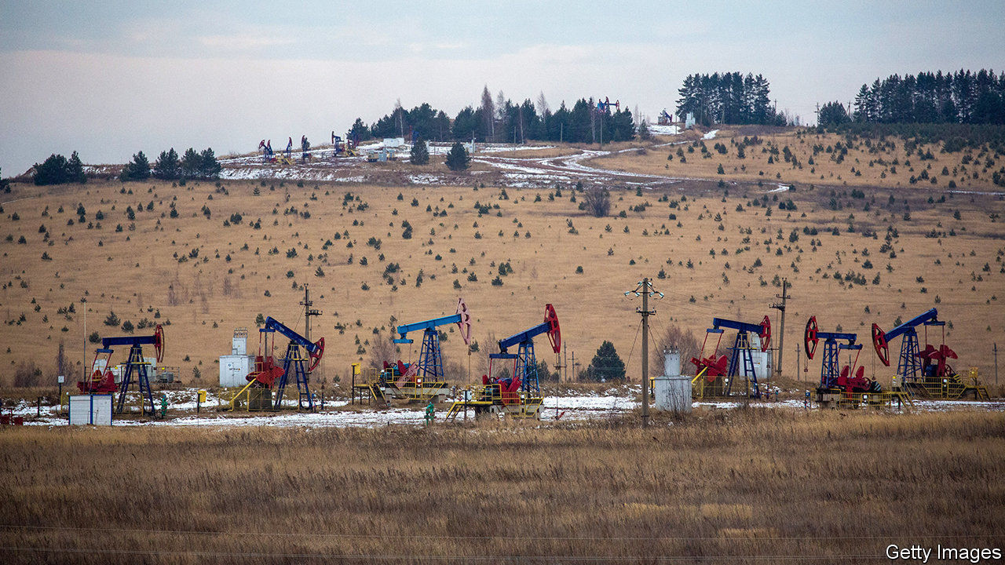

CARTELS EXIST to exert control. This year the Organisation of the Petroleum Exporting Countries (OPEC) and its allies have occasionally seemed to prefer chaos. In March Saudi Arabia and Russia began a price war just as covid-19 crushed demand, akin to staging a fight atop a sinkhole. The group agreed in April to slash output, but at a big meeting in December oil ministers took days longer than expected to decide their next steps. The deal that emerged on December 3rd was a relief to the market, as the group agreed to lift production in January by a modest 500,000 barrels a day.

Beyond January, however, OPEC and its allies planned not to plan. Any changes to production will be decided in monthly meetings. That is in part because it is difficult to predict oil’s recovery. It is also because the new year may mark the beginning of a new strategy.

It is a risky time to test new tactics. The oil market has begun a faltering comeback, with China refining a record 14.1m barrels a day in October and demand picking up in India, too. Promising data on vaccines in November helped buoy prices to their highest levels since March. But storage tanks and ships are still swollen with some 3.8bn barrels of crude, nearly 10% above the level the same time last year, according to Kpler, a data firm. Brent crude, the international benchmark, jumped to almost $50 on December 4th, after the OPEC deal. By December 8th prices had dipped again, as optimism about Britain’s covid vaccine roll-out was doused by uncertainty over further lockdowns.

Yet it is plain that key oil producers are tired of limiting output in ways that support rivals. Capping production to maximise prices makes sense in a world of infinitely growing demand and scarce resources. However oil demand may soon peak, if it hasn’t already, due to energy efficiency, electric cars and rising support for climate regulation. In that context, saving oil riches for later looks increasingly misguided. Furthermore, competitors are happy to free ride on OPEC’s cuts. In 2016 the cartel and its partners agreed to curb production, providing a price support. That boosted American frackers and depressed OPEC’s market share, from 38% in 2016 to 34% last year.

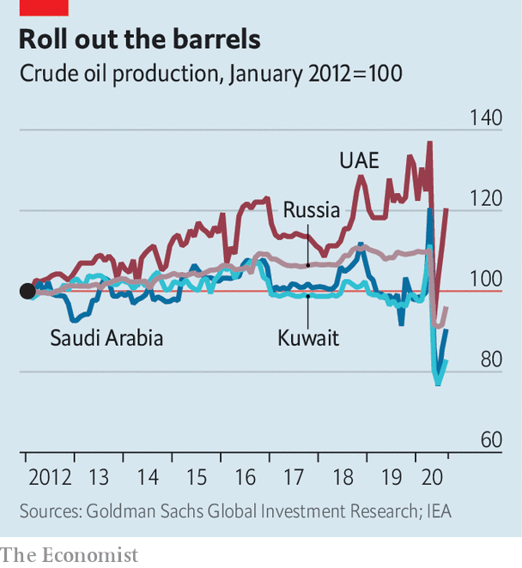

Russia’s reluctance to support American oilmen spurred the price war in March. In recent months the United Arab Emirates (UAE), a core OPEC producer, has aired its own objections. Like Russia, the UAE has worked to raise output (see chart). By 2030 it hopes production capacity will climb by nearly 25%, to 5m barrels a day. To that end, in November it said it had found 24bn barrels-worth of oil tucked beneath Abu Dhabi. OPEC’s new deal reflects an eagerness to ensure such efforts pay off. The cartel and its allies want to provide oil markets with some stability, but not enough to lift output significantly elsewhere and chomp at their own market share. “You can’t assume blindly that OPEC will always be there to support prices,” says Damien Courvalin of Goldman Sachs, a bank.

That uncertainty may continue to weigh on shale production in 2021, further draining investors’ appetite to finance more capital spending. On December 8th America’s Energy Information Administration forecast that the country’s oil output would reach 11.4m barrels a day by the end of 2021. That is up from 11.2m barrels a day in November but still below the 12.2m average for 2019.■

For more coverage of climate change, register for The Climate Issue, our fortnightly [newsletter](https://www.economist.com/theclimateissue/), or visit our [climate-change hub](https://www.economist.com/news/2020/04/24/the-economists-coverage-of-climate-change)

This article was downloaded by calibre from <https://www.economist.com/finance-and-economics/2020/12/12/opec-loosens-up>

|  |  |  |  |
| --- | --- | --- | --- |
| Previous | Articles | Sections | Next |

|  |  |  |  |
| --- | --- | --- | --- |
| Previous | Articles | Sections | Next |

#### Mexico’s unbanked

# Mexicans lack access to credit

Why the country lags other nations

Dec 12th 2020 |

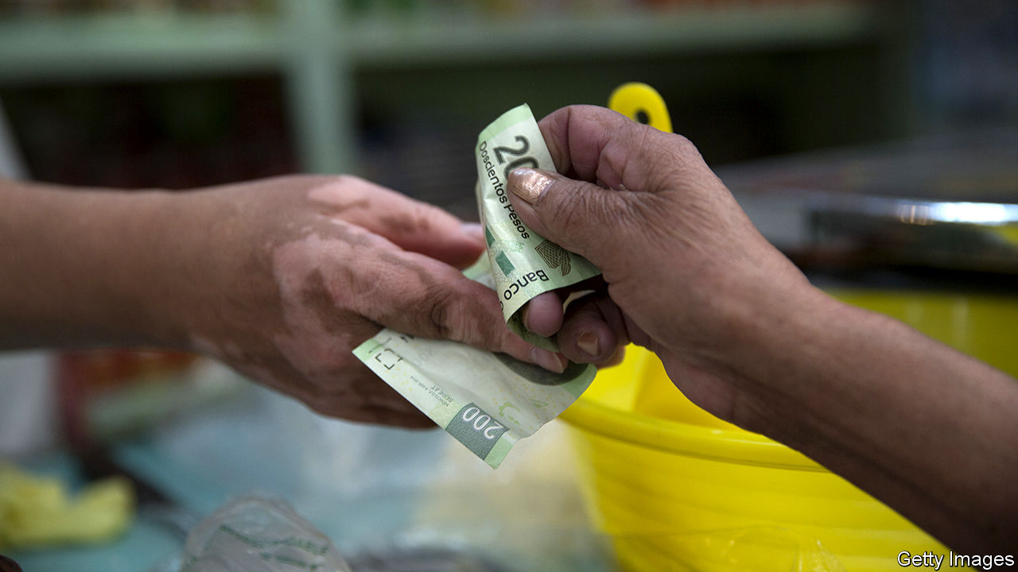

FOR MOST Mexicans online shopping goes like this: people order their goods on Amazon or Mercado Libre, an Argentine ecommerce site that is Latin America’s biggest, but pay in cash at a convenience store. That is no surprise given only 37% of Mexicans over 15 years old have a bank account, according to the World Bank. Some 86% of all payments in Mexico are in cash.

Mexico is an anomaly both in Latin America and among emerging-economy peers such as Kenya and India. In those places 54%, 82% and 80% of people are banked respectively, despite Mexico being richer. Its GDP per person is close to $20,400, around three to four times higher than in Kenya and India.

This shortfall is not just inconvenient. Counting cash adds to business costs, and those without accounts have little access to credit, slowing consumption and investment. The good news is that the country is improving financial inclusion, says Pablo Saavedra, who heads the World Bank’s Mexico programme. Only 27% of Mexicans had an account in 2011, but the pandemic has made the issue “even more urgent”, he says.

There are several reasons why so few Mexicans have access to financial services. Banks are generally conservative. Condusef, the financial watchdog, says bank fees in Mexico are high, with 30% of banks’ income coming from commissions. In rural areas, branches can be hard to reach. Furthermore, banks tend not to be interested in the less well-off: only a fifth of the poorest 20% of Mexicans have accounts. Surveys show many Mexicans do not trust banks. Meanwhile, almost 60% work in the informal sector, where they may receive an inconsistent income, in cash. The lack of access affects some more than others—the poor, rural, women and indigenous people.

Successive Mexican governments have tried to improve access to financial institutions. In 2018, a law was introduced to regulate the fintech industry, which is now booming. Under Andrés Manuel López Obrador (known as AMLO) CoDi, a digital payment system using QR codes and contactless payments was introduced in 2019 while financial literacy was included in the school curriculum in September 2020 (currently schooling is via television during the pandemic). Much still needs to be done to hit the government’s goal of 65% of Mexicans having an account by 2024.

Mexico has also missed a chance provided by the pandemic that other countries have seized. Euromoney, a financial publication, points out that by the end of June 2m people in Colombia had opened bank accounts, compared with 1.4m in all of 2019. Contrast that with Mexico, where the amount of cash in circulation was up by almost 24% in November compared with the year previously, which the Bank of Mexico attributes primarily to the pandemic. One reason for the difference is that Colombia has given handouts to the population, which must be deposited into a bank account, whereas AMLO has been far stingier with support during the crisis.

Newer firms in the private sector are now driving growth, with online-only and challenger banks seeing a rise in demand for their services. Norman Müller, the co-founder of Fondeadora, a challenger bank that received $14m from Alphabet’s venture arm, says of the 250,000 accounts that have been opened since it launched in June 2019, 40% were with people who were previously unbanked (the other 60% were “unhappily banked”, he says). He puts Fondeadora’s success down to an understanding that “our competitor is cash, not other banks” and making the platform as simple and transparent as possible. Since almost everyone owns a mobile phone, mobile money should grow, too.

The current low level of financial inclusion is likely to hamper Mexico’s economic recovery from covid-19, which has been muted by a failure to control the pandemic. For example, small and medium businesses provide 95% of Mexico’s private-sector employment but only 13% have access to formal credit. Under such circumstances “it is very hard to see how you have a strong recovery,” says Mr Saavedra.■

This article was downloaded by calibre from <https://www.economist.com/finance-and-economics/2020/12/12/mexicans-lack-access-to-credit>

|  |  |  |  |
| --- | --- | --- | --- |
| Previous | Articles | Sections | Next |

|  |  |  |  |
| --- | --- | --- | --- |
| Previous | Articles | Sections | Next |

#### Counting the carbs

# Making sense of banks’ climate targets

A lack of data and differing methodologies will make measuring performance fiendishly tricky

Dec 12th 2020 |

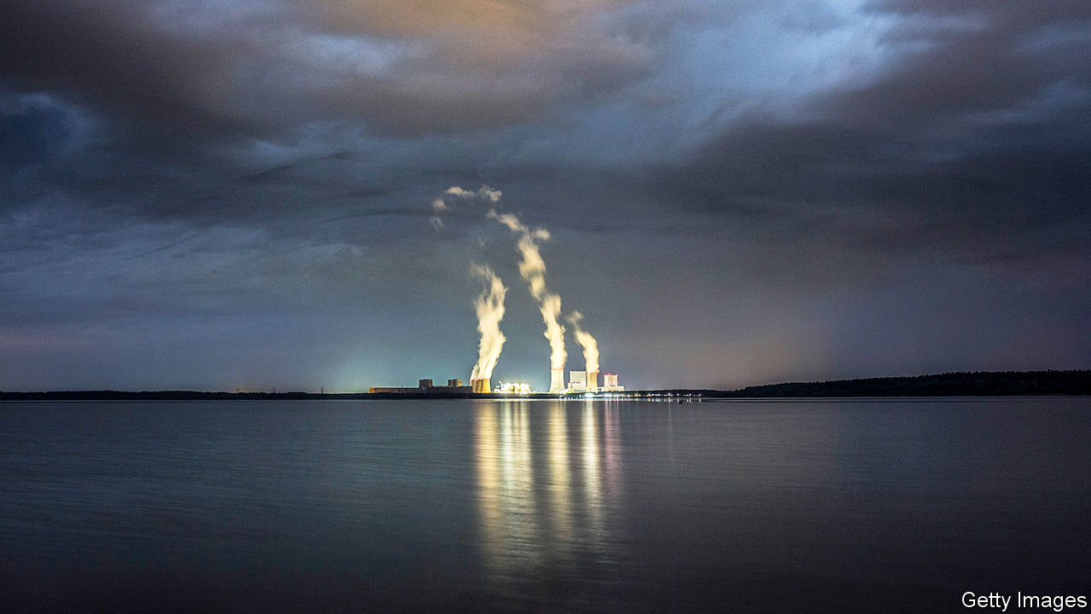

FINANCIAL FIRMS produce very few greenhouse-gas emissions directly, aside from those associated with keeping the lights on and the computers whirring. But the picture changes dramatically when you add “financed emissions”, those associated with a firm’s lending and investing activities. Figures from the few banks and asset managers that disclose them suggest that financed emissions are 100 to 1,000 times bigger than operational ones.

Financed emissions are now coming under more scrutiny from climate-conscious clients and campaigners, and lenders are hoping to manage the associated reputational and regulatory risks. Green regulation, for instance, could damage the viability of an investment. On November 30th Barclays, a British bank, published plans for its net-zero target. Its goal will be to cut emissions from deals it arranges in the capital markets as well as on its loans.

In September Morgan Stanley announced it would reach net-zero financed emissions by 2050. In October similar pledges were made by HSBC and JPMorgan Chase, banks from Britain and America respectively. The Net-Zero Asset Owner Alliance, a group of 30 investors with $5trn of assets under management, recently set targets for its members. Advocates hope the targets will be met either by divesting dirty assets or pressing polluters to clean up their act. But matters will not be so simple.

For a start, assessing the emissions associated with a portfolio is fiendishly complex. Many methodologies have emerged, each with their own drawbacks. One approach tries to capture a portfolio’s carbon footprint. Here, the Partnership for Carbon Accounting Financials (PCAF) is the front-runner. But the lack of data is a problem; small firms rarely disclose emissions. HSBC says climate-related data are provided by only 12% of its loan portfolio.

As a result, PCAF users rely on sector averages to fill in the gaps. Double-counting is endemic. Take the emissions from an office block that has a mortgage and is let out. They could be counted by the mortgage lender, any firm financing the companies using the office or even a firm financing the city where the office is located.

Another complication is divvying up emissions between various investors. PCAF’s approach is to use enterprise value (equity plus debt) as a base. A bank lending $10m to a firm with an enterprise value of $100m would be responsible for a tenth of the firm’s emissions. But the value of an asset changes over time. If a company’s market value increases or if it takes on more debt, a lender’s share of the enterprise value would shrink. The lenders’ carbon footprint would fall through no action of its own. (PCAF says it is working on a fix.)

A second approach to gauging greenness is to see whether the portfolio is aligned with the Paris agreement, which aims to keep warming at less than 2°C above pre-industrial levels. The 2 Degrees Investing Initiative (2DII), a think-tank, looks at the assets and production of portfolio companies to work out if, say, a carmaker is building enough electric vehicles to meet the Paris goals. But many asset classes are not included.

A third approach assigns a temperature score to portfolios. This represents how much the Earth would heat up by 2100, if the carbon intensity of the global economy were the same as a given portfolio. Scientists think the Earth is on course for 3 to 4°C of warming above pre-industrial levels. Financial firms that have totted up their portfolio found a similar result.

The score depends heavily on the approach used, though. A study led by Julie Raynaud of McGill University in Canada looked at 12 different methods. Some of those included the emissions from a firm’s supply chain in their calculations, for instance, but others did not. Another difference was whether companies were assumed to hit their net-zero targets. These kinds of variations led to different results. When the same index of low-carbon companies was analysed by the 12 methods, they produced scores ranging from 1.5°C to 4°C—a huge difference, in climate terms.

One hope is that regulators will force more rigour. They are worried that climate change poses a systemic risk to the financial sector and are demanding more information on financed emissions. Calculating the carbon in a portfolio is part of climate stress-tests, which will soon be conducted in Britain, France and Australia. On November 27th the European Central Bank said it will follow suit. A push towards more climate-risk disclosure could eventually require financed emissions data to be published, too.

Even then, the climate impact of banks hitting their targets will be unclear. A study by 2DII found that the holdings of coal plants by Swiss financial institutions, as measured by generating capacity, fell by 20% between 2017 and 2020. Yet the coal firms found funding elsewhere. By 2020, the original cohort of firms in the 2017 portfolio had increased capacity by 50%. Banks with zero-carbon loan books will attract clients, but may not help the planet. ■

For more coverage of climate change, register for The Climate Issue, our fortnightly [newsletter](https://www.economist.com/theclimateissue/), or visit our [climate-change hub](https://www.economist.com/news/2020/04/24/the-economists-coverage-of-climate-change)

This article was downloaded by calibre from <https://www.economist.com/finance-and-economics/2020/12/12/making-sense-of-banks-climate-targets>

|  |  |  |  |
| --- | --- | --- | --- |
| Previous | Articles | Sections | Next |

|  |  |  |  |
| --- | --- | --- | --- |
| Previous | Articles | Sections | Next |

#### Free exchange

# Where economists focus their research

They don’t always look in the right places

Dec 10th 2020 |

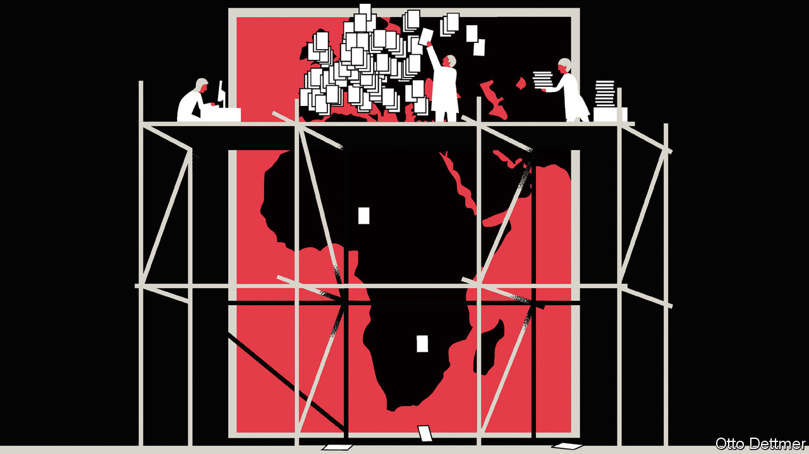

AN OLD joke: a policeman sees an inebriated man searching for his keys under a lamp post and offers to help find them. After a few fruitless minutes, the officer asks the man whether he’s certain he dropped his keys at that particular location. No, says the man, he lost them in the park. Then why search here, asks the officer. The man answers: “Because that’s where the light is.” For years, the story has been used to illustrate the simple point, of great relevance to social scientists, that what you find depends on where you look. And for much of its history, economics has examined a very narrow set of countries. An analysis by The Economist of more than 900,000 papers published in economics journals (see article), finds that as recently as 1990, roughly two-thirds of published papers focused on the rich English-speaking countries: America, Australia, Britain, Canada and New Zealand.

A boom in the emerging world and a greater focus within economics on empirical work have broadened the reach of the lamplight. The share of papers mentioning countries in the Middle East, Africa, Asia or Latin America has risen from 17% in 1990 to 41% today. Yet many parts of the world, such as poor African countries, remain heavily under-studied. Even within regions, some places receive outsized attention. A recent survey of Africa by Obie Porteous of Middlebury College found that 65% of papers about African economies published in the leading five economics journals focus on just five: Kenya, South Africa, Ghana, Uganda, and Malawi. Some overlooked places might count that a blessing; attention from economists has not always been followed by economic success. But the more of the world that economists study, the better their guidance is likely to be. It is thus in everyone’s interest for the profession to continue to broaden its geographic reach.

Patterns of economic research are mostly explained by just a few factors. The size of a country’s economy is the most significant, accounting for nearly 80% of the variation in research attention, according to our analysis. The importance of economic output in shaping research choices has a certain logic. Developed, complex economies provide rich terrain for scholars to explore. If the lessons learned from large economies can be translated into better policy in those places, then such research stands to benefit more people than if scholars focused on minnows. (About half of humanity lives within the world’s ten largest economies.) The quality and availability of data matter too, though less than economic size, as does a country’s use of English. About 90% of the papers in our sample are written in English.

Professional incentives also play a role. An analysis by the World Bank of more than 76,000 empirical papers published between 1985 and 2004 found that top-five economics journals published about 6.5% of all papers written about America over that span, compared with just 1.5% of papers about other nations. Top economists are more likely to write about America. And even if you adjust for the prestige of the authors’ institutions it does not entirely eliminate the gap.

Do countries which receive less attention necessarily suffer as a consequence? The recent increase in developing-world research has not been an unalloyed good. It has been driven, in part, by the rise of the randomised controlled trial—in which scholars randomly assign participants to different groups, only some of which receive a “treatment” (like a microloan or access to education). Well-constructed experiments can provide valuable guidance on how best to alleviate the worst harms of poverty. Yet critics argue that such trials provide little information about how to generate sustained economic development. They also raise ethical questions: regarding whether desperate people and governments can truly give informed consent, for example. As Angus Deaton, a Nobel laureate, noted in 2019, such experiments are nearly always conducted “by better-heeled, better-educated and paler people on lower income, less-educated and darker people”, creating a persistent risk of exploitation.

However, countries dogged by poor policy stand to benefit most from rigorous examinations of how bad policies fail. According to The Economist’s analysis, regional success stories, like Chile or the Czech Republic, receive far more attention than you would expect given their underlying characteristics relative to failing places in the same regions, like Venezuela or Belarus. Reform-minded governments in understudied places, should they come to power, could be hamstrung by a dearth of quality research, outlining how past missteps contributed to present penury. Research biases could also mean that too little light is shone on the failures of interventions by institutions like the IMF which may have exacerbated the problems of struggling countries.

## Attention, please

Indeed, another reason for economists to spend more time on under-examined places is that a broadening of horizons would improve the profession itself, and thus enable economists to serve governments better. There are too many unanswered questions in economics for some corners of humanity to receive so little attention. The 70 least-studied countries account for just 1% of all mentions in economics papers over the past three decades.

And while the profession’s increasing focus on empirical work is welcome, concentrating research within the cone of light that data provide means that some questions are asked much more often than others: in particular, those which can be answered with statistical analysis. An effort to pay more attention to the places least able to provide high-quality data, which often face the toughest roads to development, would force economists to grapple with qualitative matters. If critical contributions to development come from difficult-to-quantify variations in cultural factors, a geographically limited discipline will find it hard to detect them. And both the world and the profession will be poorer for it.■

This article was downloaded by calibre from <https://www.economist.com/finance-and-economics/2020/12/10/where-economists-focus-their-research>

|  |  |  |  |
| --- | --- | --- | --- |
| Previous | Articles | Sections | Next |

|  |  |  |
| --- | --- | --- |
| Finance & economics | Sections | Books & arts |

Science & technology

Hydrogen-powered flight: If at first you don’t succeed...

.

Sonic warfare: A megamegaphone

.

The fiery end of SN8: SpaceX's latest launch

.

Gene therapy: Eyeball to eyeball

.

Bees versus hornets: The uses of dung

.

|  |  |  |
| --- | --- | --- |
| Finance & economics | Sections | Books & arts |

|  |  |  |  |
| --- | --- | --- | --- |
|  | Articles | Sections | Next |

#### Hydrogen-powered flight

# Is the time now ripe for planes to run on hydrogen?

Some planemakers think the answer may be “yes”

Dec 8th 2020 |



IN THE SWAMPS of 1950s Florida, a loud roaring occasionally disturbed the serenity of the local alligators. Under conditions of strictest secrecy, engineers from Pratt & Whitney, an aerospace company, were testing a new type of engine that was powered by a strange substance apparently piped in from a fertiliser plant in the nearby town of Apix. In reality, the town was just a name on a map and the fertiliser plant was a ruse to fool the Russians. The disturbances were the result of Project Suntan, an attempt by America’s air force to build a plane fuelled with hydrogen. It nearly worked. The engines operated successfully, but storing and supplying the hydrogen itself proved too expensive for production to continue.

Suntan was just the first of a string of failed attempts to use hydrogen to power heavier-than-air flight. The allure is great. Hydrogen packs three times as much energy per kilogram as kerosene, the current standard aviation fuel, and lightness is at a premium aloft. Tupolev, in what was then the Soviet Union, tried in the 1980s. Boeing tried in the 2000s. A small demonstrator has flown in Germany. But nothing has, as it were, really taken off. Hydrogen, though light, is bulky, making it awkward to store on board. It must be either pressurised or liquefied, both of which bring complications of their own. On top of that, there is no established infrastructure for making and distributing it.

## This time it’s different

Now, though, things have changed. Aviation is under pressure to curb carbon-dioxide emissions by burning less kerosene. And talk of building hydrogen-manufacturing-and-delivery infrastructure for other purposes, such as heating and ground transport, is getting serious, meaning that hydrogen might become available as a commodity, rather than having to be made specially. The balance of advantage may thus be shifting. So a few brave souls are looking once again at the idea of hydrogen-powered flight.

Project Suntan used the stuff in the way that kerosene is used—to create the heat needed to power a jet engine. That is one way forward. But many planes are driven by propellers, and this permits a second approach, for propellers can be turned by electric motors. Using fuel cells, a 19th-century technology that is now coming into its own, it is possible to generate the electricity needed to do so with hydrogen.

This is the tack taken by ZeroAvia, a firm based in Cranfield, in southern Britain. In September ZeroAvia’s engineers unveiled a six-seater fuel-cell-powered aircraft that could take off, complete two circuits of the airport, and land. The plane in question is a modified Piper M-class—a single-propeller aircraft that is normally driven by a piston engine. The engineers replaced this with an electric motor, and installed a bank of fuel cells to power that motor and a set of tanks to hold the hydrogen which runs the fuel cells.

Val Miftakhov, ZeroAvia’s boss, hopes to see this demonstrator take a 400km trip, tentatively scheduled for the week of December 21st, followed by a longer flight from Orkney, an archipelago off the northern tip of Britain, next spring. (Orkney’s authorities are interested in “hopper” planes that can link the archipelago’s islands.) The firm also plans to have a 20-seat demonstrator ready in 2021. Certification for commercial use might follow in 2023.

Hot on the heels of ZeroAvia is H2Fly, a spin-off from DLR, Germany’s aeronautical research centre. In 2016 this firm added fuel cells to a motorised Pipistrel glider, which then stayed aloft for 15 minutes. The plan is to extend that approach to a production-version propeller-driven plane in tests to be conducted imminently. Meanwhile, in America, an electric-motor manufacturer called magniX has announced a partnership with Universal Hydrogen, a firm in Los Angeles, to convert a 40-seat de Havilland Canada Dash 8-300 to run on fuel cells. This, they hope, will be ready by 2025.

Such approaches seem likely to work in principle. They will, though, have to compete in practice with electric aircraft powered by batteries. In May, an American firm called AeroTEC flew a nine-seater Cessna Caravan that had been converted to battery power through the skies above Washington state. The previous December, magniX collaborated with Harbour Air, a Canadian company, to fly a converted de Havilland seaplane in British Columbia. The two firms are now busy preparing this aircraft for commercial certification. More ambitiously, several companies, such as Eviation, an Israeli outfit, are attempting to build battery-driven aircraft from scratch rather than converting existing airframes.

## Batteries not included

Proponents of fuel cells say, though, that these are better than batteries for powering flight because the cells plus their associated fuel store many times more energy per kilogram than batteries can manage. “Batteries really give you the acceleration. But they won’t give you the range,” says Robert Steinberger-Wilckens, a chemical engineer at the University of Birmingham, in Britain. Battery technology is improving, but big breakthroughs will be needed before longer journeys with passengers and freight on board become possible.

Sticking electric power sources in an existing aircraft, whether in the form of batteries or fuel cells, is a start. But such propulsion could lead to significant redesigns, such as the one Eviation is planning for its putative product, Alice. This has three propellers, all of which face backward. Though once popular, backward-facing propellers have been out of fashion for decades. Electric vertical take-off and landing aircraft—people-carrying drones sometimes touted as the future of personal transport—are also often powered by multiple smaller electric motors, making them a good fit with fuel-cell-based hydrogen power.

Bigger machines have bigger problems. It requires much more power for a plane to take off and land than to cruise, and neither batteries nor fuel cells yet have the oomph to do this for other than small aircraft. If larger ones are to be hydrogen-powered, that will require at least part of the work to be done by returning to the Project Suntan route and employing turbine-driven engines that burn the stuff as a gas.

That approach is now being adopted by Airbus, a European firm which shares with Boeing of America a duopoly on large passenger planes. In September Airbus unveiled ZEROe, a project centred on three hydrogen-powered concept aircraft. Though these are single-aisle short-haul models, they are a step up from anything that might be powered solely by fuels cells.

All three are designed to yoke the two hydrogen-based technologies together, with hydrogen-burning turbine engines boosting take-off and fuel cells powering the cruise. One of the concepts is a turboprop that would carry up to 100 passengers for distances up to 2,000km. A larger turbofan version would take twice that load twice as far. The third approach is more experimental: a “blended wing” model, in which fuselage and aerofoils form part of the same triangular aerodynamic structure. The advantage of this is that it creates extra volume for hydrogen storage.

The challenges of using hydrogen go beyond body shape, though. Redesigning a turbine engine to run on the stuff will be a multi-billion-dollar endeavour. Hydrogen burns faster than kerosene, and also burns hotter. That means materials exposed to its combustion experience greater stresses. It also risks increasing the pollution generated in the form of oxides of nitrogen, which would partially negate the environmental benefits of burning hydrogen. And it would be useful as well to arrange matters so that some of the energy used to compress or liquefy the hydrogen for storage could be recovered and put to work.

For the next few years, Airbus will focus on developing the twin technologies of fuel-cells and hydrogen-powered turbines in parallel with the design of their future aircraft. If ground tests succeed, the firm hopes to have airborne demonstrators—what Glenn Llewellyn, Airbus’s vice-president for zero-emission aircraft, calls flying testbeds—aloft by 2025. A full-scale prototype would follow by the end of the decade, with the first zero-emission commercial airliner entering service by 2035. Who would supply the engines for such a plane is not yet clear. But Safran, a French engine-maker that often works with Airbus, has confirmed it is looking at hydrogen power for commercial aircraft.

So far, Boeing has not followed suit. This geographical split may be no coincidence. EU public policy is firmly green, as is public policy in Britain, no longer a member of the EU but the site of several Airbus facilities. EU policy in particular translates into actual money for relevant research via the union’s Clean Sky 2 programme.

No such support, either moral or financial, has been on offer in America over the past four years. Joe Biden’s incoming administration, however, seems of one mind with Europe on matters environmental. And this new direction is likely, as in Europe, to be accompanied by public money. Boeing, moreover, would be taking a gamble by leaving hydrogen-power to Airbus. If the technology succeeded, it would risk losing an important part of its market—and that is something it certainly cannot afford to do.■

For more coverage of climate change, register for The Climate Issue, our fortnightly [newsletter](https://www.economist.com/theclimateissue/), or visit our [climate-change hub](https://www.economist.com/news/2020/04/24/the-economists-coverage-of-climate-change)

This article was downloaded by calibre from <https://www.economist.com/science-and-technology/2020/12/08/is-the-time-now-ripe-for-planes-to-run-on-hydrogen>

|  |  |  |  |
| --- | --- | --- | --- |
|  | Articles | Sections | Next |

|  |  |  |  |
| --- | --- | --- | --- |
| Previous | Articles | Sections | Next |

#### A megamegaphone

# Super-loudhailers are becoming louder still

That is good for warfare. Perhaps less good for civilians

Dec 12th 2020 |



YOU NEED a pretty powerful bullhorn to broadcast a message to someone who is 2km away. But that is what America’s navy is currently looking for. It wants, among other things, to be able to warn the crews of small vessels, who may or may not be hostile, not to come too close to its ships. And, if the warning is ignored, it would like to be able to hit them with a noise so piercing and horrible that even a determined attacker would have difficulty ignoring it and carrying on regardless.

To some extent, it can do this already. After USS Cole, a guided-missile destroyer, was attacked successfully by boat-borne suicide-bombers in 2000, ripping a huge hole in the vessel’s side (see picture) and killing 17 sailors, America’s admirals have been understandably nervous about the proximity of such craft. One consequence of that nervousness is that they have acquired so-called Long Range Acoustic Devices (LRADs) to hail possible threats. The current top of the range, the 2000RX, generates 160 decibels, while a portable cousin, the 100X, manages 137. But the navy now wants something that combines the former’s power with the latter’s convenience, and with a higher fidelity of transmission.

## Now hear this

The upshot of that desire is a project called Focused Enhanced Acoustic-Driver Technologies (FEAT) for Long Range Non-Lethal Hail and Warn Capabilities. This will build on a previous effort, the Distributed Sound and Light Array (DSLA), that used eight large loudspeakers. FEAT, if the plans work, will be more compact.

Existing LRADs use piezoelectric elements to generate their sound. FEAT, by contrast, will be similar to a conventional loudspeaker—employing a moving magnet to vibrate a diaphragm or cone. This arrangement works better at low frequencies than piezoelectric sound generation, which is important if voices are to be projected, for lower frequencies make speech easier to understand. They are also better at penetrating buildings and vehicles, to deliver messages to those inside.

Louder loudspeakers, though, require stronger magnets and tougher materials. For the magnets, this may mean a better version of the neodymium devices currently favoured by the speaker industry, or possibly some more exotic material. For the diaphragms, the navy’s engineers may be looking at graphene, or possibly synthetic diamond. These allotropes of carbon are both much stronger than conventional speaker materials.

FEAT will combine the outputs of several drivers (the vibrating units that convert an electrical signal into sound), using a technique called beamforming to focus them onto a distant target to create a total volume of more than 156 decibels. Beamforming is widely employed in radio antennae, and the DSLA showed that it is equally effective for sound waves. Lastly, and perhaps most ambitiously, FEAT will include technology intended to cancel atmospheric distortion. This approach improves the focus of laser beams, but has not yet been demonstrated to work for a beam of sound.

The navy is now selecting contractors for a nine-month feasibility study. If that works, the second stage will be to build a prototype for testing by the marine corps. Once deployed, the technology will also be shared with the Departments of Justice, Homeland Security and others. This will not be music to everyone’s ears, though, for LRADs, which are used by some police forces as well as the armed services, are already controversial.

Six people, for example, are suing the New York Police Department for excessive use of force after being exposed to an LRAD in 2014. They allege lasting damage, including tinnitus and migraines. In 2019 a federal appeal court took the plaintiffs’ side and the case continues. And the American Speech-Language-Hearing Association, a group of doctors who work in the area, warns that LRADs could cause permanent hearing loss and balance problems, and advises protesters who might encounter them to wear hearing protection. In June, the mayor of Portland, Oregon, ordered police not to use the “warning tone” function against protesters.

More powerful sonic devices could save lives by conveying warnings to people in small boats or vehicles approaching checkpoints before they behave, possibly mistakenly, in a way that risks their being fired on. They could also warn occupants of buildings about to be cleared by force, giving bystanders a chance to escape before the shooting starts, and enemy combatants the option to surrender. However, smaller, cheaper devices may prove more prone to misuse than LRADs. And if this new technology spills over into the commercial sector, noisy neighbours could wage their own kind of sonic warfare.■

This article was downloaded by calibre from <https://www.economist.com/science-and-technology/2020/12/12/super-loudhailers-are-becoming-louder-still>

|  |  |  |  |
| --- | --- | --- | --- |
| Previous | Articles | Sections | Next |

|  |  |  |  |
| --- | --- | --- | --- |
| Previous | Articles | Sections | Next |

#### SpaceX

# Elon Musk’s latest rocket launch is a successful failure

It crashed. But the data collected will help improve the next attempt

Dec 10th 2020 |

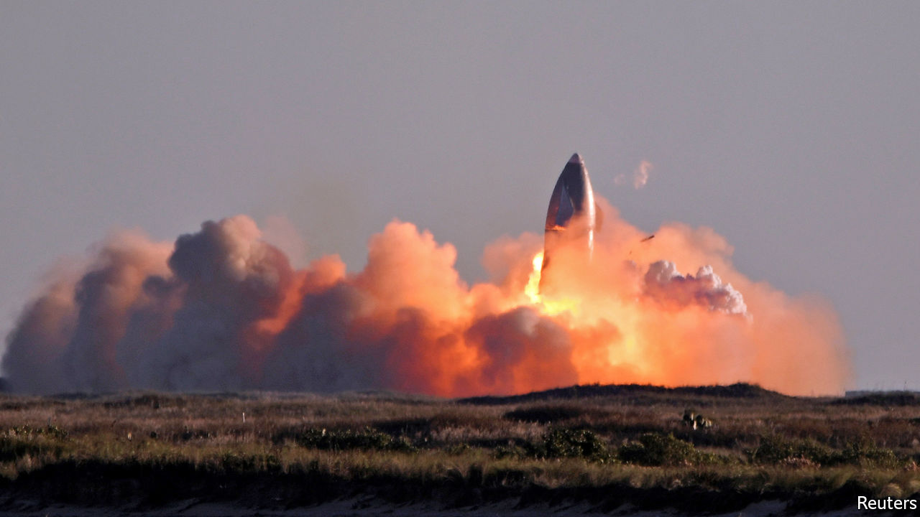

"FAILURE is an option here. If you are not failing, you are not innovating.” So said Elon Musk a few years after he had set up SpaceX, his private rocketry firm. And fail, at the end, his most recent test did. On December 9th SN8, the latest incarnation of SpaceX’s Starship, a craft intended as the second stage of a rocket that will be able to carry 100 tonnes of payload, people included, into orbit, and thence to the Moon and Mars, took off perfectly from its pad in Boca Chica, Texas. It rose to an altitude of 12.5km, cut its three engines and manoeuvred itself parallel with the ground to fall back to Earth. Just before touch down it restarted its engines and lifted itself upright to land. But it came in too fast, and the result can be seen above. Nothing daunted, Mr Musk said that the flight had provided “all the data we needed” before its RUD. For those not in the know, RUD is SpaceX jargon for “Rapid Unscheduled Disassembly”.■

This article was downloaded by calibre from <https://www.economist.com/science-and-technology/2020/12/10/elon-musks-latest-rocket-launch-is-a-successful-failure>

|  |  |  |  |
| --- | --- | --- | --- |
| Previous | Articles | Sections | Next |

|  |  |  |  |
| --- | --- | --- | --- |
| Previous | Articles | Sections | Next |

#### Gene therapy

# A failed study shows a promising treatment for blindness

A story of gene therapy and happy accidents

Dec 12th 2020 |



IN THE TEXTBOOKS, science is simple. You come up with an idea, put it to the test, and then accept it or reject it depending on what your experiments reveal. In the real world, though, things are rarely that straightforward, as a paper just published in Science Translational Medicine shows. In it, a group of researchers led by Patrick Yu-Wai-Man, an ophthalmologist at Cambridge University, investigated a promising new genetic therapy for a hereditary form of blindness. Officially, their study was a failure, for their experiment did not show what the researchers hoped it would. But it was also a smashing success, for 29 of the 37 participants reported big improvements in their vision.

The disease in question is Leber hereditary optic neuropathy (LHON). A defective gene in a sufferer’s mitochondria—the tiny structures that provide a cell’s energy—causes retinal cells to die. That leads to sudden and rapid loss of sight, with many sufferers becoming legally blind within a year. It affects between one in 30,000 and one in 50,000 people. Men in their 20s and 30s are particularly susceptible. Treatment is limited and not particularly effective.

Since most cases are caused by a mutation in a single gene, LHON is a good candidate for gene therapy, a form of genetic engineering which aims to replace the defective gene with a working one. With that in mind, Dr Yu-Wai-Man and his colleagues loaded up a modified virus with a corrected copy of the gene and injected it into their patients’ eyes.

Many viruses can insert their genes into the DNA of their hosts. Ordinarily, that is a bad thing, because cells so subverted churn out more copies of the virus. In this case, the hope was that infection would be a good thing. The defanged virus could not reproduce. But it was capable of replacing the damaged gene with a working copy.

Most medical studies make use of a control group, against which the effectiveness of the treatment can be measured. Here, the researchers controlled the experiment by injecting only one of each patient’s eyes—chosen at random—with the virus. The other eye was given a sham injection, in which a syringe was pressed against the eye, but nothing came out of it. Using two eyes in the same patient makes for a perfect control: their genetic make-up is identical, and any confounding lifestyle factors are removed from the equation.

## Cross-eyes

The surprise came several months into the study. The researchers had hoped to see a big improvement in the treated eyes, compared with the untreated ones. They did not, and for that reason the study failed in its primary objective. Instead, in more than three-quarters of their patients, they saw substantial improvements in both eyes.

On the face of it, that was bizarre. Only one eye had received the treatment, after all. Follow-up studies in monkeys confirmed what the researchers had suspected. The virus, it seems, had found a way to travel from one eye to the other, probably via the optic nerve. Tissue and fluid samples from monkeys given the same treatment as the human patients showed viral DNA in both eyes, not just one.

Although it had a happy outcome in this case, the prospect of a gene-therapy virus travelling to places it is not intended to go might worry regulators. Fortunately, the researchers found no trace of the virus elsewhere in the monkeys’ bodies, including the visual cortices of their brains. And, though the study was technically a flop, its practical success means that an effective treatment for LHON may at last be in reach. GenSight Biologics, the company that has developed the treatment, has already sent its results to Europe’s medical regulator. It hopes to hear back by the end of 2021. ■

This article was downloaded by calibre from <https://www.economist.com/science-and-technology/2020/12/12/a-failed-study-shows-a-promising-treatment-for-blindness>

|  |  |  |  |
| --- | --- | --- | --- |
| Previous | Articles | Sections | Next |

|  |  |  |  |
| --- | --- | --- | --- |
| Previous | Articles | Sections | Next |

#### Bees versus hornets

# Bees defend their hives against hornets with animal dung

They seem to be engaging in a form of chemical warfare

Dec 12th 2020 |



HONEYBEES IN ASIA have it rough. Unlike their cousins in North America, where bee-eating hornets have arrived only recently, Asian bees are relentlessly hunted by these giant wasps. Constant attacks have kicked Asian honeybee evolution into high gear and resulted in the insects developing several defensive tactics besides simply using their stings. First, Asian honeybees build their nests as fortresses, with tiny entrances and tough walls. They also hiss aggressively at predators, to warn them they are being monitored. And, if that doesn’t work, they can swamp attackers in “bee balls”, which generate such heat that hornets inside are cooked alive. Now, a study published in PLOS ONE, by Heather Mattila of Wellesley College, in Massachusetts, shows that these bees have yet another trick up their sleeves: they shield their homes with dung.

Vespa mandarinia and Vespa soror are known as murder hornets for a reason. When scouts from these species find a honeybee hive they land and leave chemical markers near the entrance. The scouts then return with up to 50 of their kin to launch an attack. Armed with powerful jaws and tough body-armour that makes them resistant to bee stings, the hornets besiege the hive’s entrance and try to tear it apart so that they can force their way in. They are attacked by guard bees as they do so, and are sometimes successfully driven away. But not always. Often, they get inside and, once there, each hornet kills thousands of bees. This slaughter paves the way for the hornets to gather the real target of the attack, the brood of larvae developing in the hive. These, they carry away to feed to their own young waiting back at the nest. That obliterates the hive.

Hornet attacks are devastating to apiculture, so there is great interest from bee-keepers in finding ways to help their charges keep these predators at bay. When Dr Mattila’s co-author Gard Otis, of the University of Guelph, in Canada, learned from a beekeeper in Vietnam that bees there stick globs of water-buffalo dung on their hives after being visited by hornets, it therefore piqued his curiosity.

That, in turn, led Dr Otis, Dr Mattila and their colleagues to visit Vietnam, where they monitored 339 honeybee hives. They discovered that many of these hives were indeed covered in globs of what looked like manure, and that most of these globs were clustered around the hive entrance. When they monitored bees’ movements they discovered not only that the bees were collecting buffalo dung, but also that they regularly created globs from faeces collected at a chicken coop and a dung pile in a pig enclosure. Further monitoring of the hives showed that the bees quickly attached hundreds of globs of faeces to their hives after hornet attacks.

## Off the mark

To see whether this was a consequence of the chemical marks, Dr Mattila and her colleagues collected extracts from the glands hornets use to secrete the substances involved. They then soaked some filter papers in these extracts and put bits of this material near hive entrances. As a control, they also soaked some filter papers in ether, and distributed those likewise near the entrances of other hives.

The hornet extract provoked a strong response. Within a day of its arrival hive members created an average of 15 nearby globs. The ether prompted an average of only two. This suggests bees are indeed wise to the marking tactics of hornets, and prepare for a potential attack accordingly.

To make sure the globs actually do help bees defend their hives, the team recorded some attacks. A well-globbed-up hive, they found, reduced the amount of time hornets spent trying to break in by 94%.

Why globs of faeces repel hornets remains a puzzle. Dr Mattila speculates that dung contains compounds which antagonise the hornets in some way. Specifically, these would be defensive substances synthesised by the plants that buffalo, pigs and chickens eat. If that idea does indeed turn out to be correct, then it seems Asian honeybees have invented an effective form of chemical warfare.■

This article was downloaded by calibre from <https://www.economist.com/science-and-technology/2020/12/12/bees-defend-their-hives-against-hornets-with-animal-dung>

|  |  |  |  |
| --- | --- | --- | --- |
| Previous | Articles | Sections | Next |

|  |  |  |
| --- | --- | --- |
| Science & ... | Sections | Economic & ... |

Books & arts

American extremism: Fear and loathing

.

Intellectual history: Pleasure principles

.

Johnson: Eiffel power

.

Contemporary art: The room where it happens

.

|  |  |  |
| --- | --- | --- |
| Science & ... | Sections | Economic & ... |

|  |  |  |  |
| --- | --- | --- | --- |
|  | Articles | Sections | Next |

#### Fear and loathing

# Assessing the threat from America’s far right

The real worry may not be large-scale violence but the “mainstreaming of extremism”

Dec 12th 2020 |



Weaponised Words. By Kurt Braddock.Cambridge University Press; 302 pages; $29.99 and £22.99.

Oath Keepers. By Sam Jackson.Columbia University Press; 240 pages; $35 and £27.

Hate in the Homeland. By Cynthia Miller-Idriss.Princeton University Press; 272 pages; $29.95 and £25.

American Zealots. By Arie Perliger.Columbia University Press; 232 pages; $28 and £22.

HOW SERIOUSLY should anyone take Stewart Rhodes and men like him? Speaking online soon after America’s presidential election, he said phalanxes of his armed comrades were waiting outside Washington. Should Donald Trump be ousted, they were ready for a “bloody fight”.

Mr Rhodes is fond of threatening language. In 2016 his group predicted widespread voter fraud followed by “catastrophic consequences”. It has urged its members, who include ex-soldiers, to help patrol the Mexican border to deter and harass would-be immigrants.

In his study of the Oath Keepers, as this outfit is known, Sam Jackson of the University at Albany estimates that some 5,000 people may have signed up, while many more sympathise. These folk anticipate a second American revolution and claim violence is legitimate to resist what they call tyranny. In the landscape of America’s far right they fit into the category of patriot or militia groups, defined by their hostility to government (other than Mr Trump’s). In the typography used by analysts, the other categories, which usually command more attention, are outright racists and nativists, who oppose foreign influences and religions other than Christianity.

Mr Jackson’s is one of several new books to warn that America’s far right is now more active than at any time since the early 1990s. The Department of Homeland Security agrees, and in testimony to Congress this autumn the FBI’s director, Christopher Wray, called the far right—and white supremacists in particular—America’s gravest domestic-terror threat. Last year, when 48 people were killed in 16 attacks, was their most lethal in a generation. A previous bout of such violence eased only after an anti-government fanatic, Timothy McVeigh, bombed a federal building in Oklahoma City in 1995, killing 168 people.

Fractious politics, anger over lockdowns and Mr Trump’s nudging encouragement of groups such as the Proud Boys have made 2020 worrying, too. The mostly peaceful Black Lives Matter protests provided cover for both armed vigilantes and a few “accelerationists”, who hope assaults on police will spur a civil war. The FBI reports that amid demonstrations in Minneapolis following the death of George Floyd, a member of the Boogaloo Bois, a far-right group, used an AK-47 to shoot up a police station, which he then helped burn down. The “Boog flags are in the air”, he bragged. The same man received money from a fellow Boogalooer who, at roughly the same time, shot dead a policeman in California.

Such co-ordination is relatively—and thankfully—rare. As Arie Perliger of the University of Massachusetts, Lowell, says, a big weakness of right-wing extremists has been that they are fragmented into many organisations, or act entirely alone, in what amounts to a “leaderless resistance”. In “American Zealots”, a history of far-right violence over 150 years, Mr Perliger finds that solitary attackers have usually been less deadly than those who conspire and act in concert. That helps explain why, despite having perhaps 12m adherents or sympathisers in America in total, their overall impact has been limited.

There are grim exceptions, however, such as the white supremacist who murdered 11 people at a synagogue in Pittsburgh in 2018, or the fanatic who killed 23 shoppers in El Paso the following year. Technology, such as ever-more destructive weapons, is altering the calculus. And as in the case of the Oath Keepers—who dislike Muslims and foreigners as well as government—even without formal co-ordination, ideas (and sometimes personnel) are shared across the far-right spectrum.

Among groups whose avowed focus lies elsewhere, for instance, racism still tends to be a factor. Perpetrators typically express unease about social change, often raging against people of a different race or, sometimes, a different religion or sexuality. Almost all are white men, often poor and badly educated. Whereas the South was historically the epicentre of these crimes, they now happen wherever sizeable numbers of African-Americans, Hispanics and Asians live. (Tellingly, the Oath Keepers, the Three Percenters and other anti-government groups were founded as Barack Obama became president.)

## From meat to murder

Like demographic anxieties, other factors are perennial yet especially acute at the moment. Kathleen Belew of the University of Chicago has traced how militia groups grow when soldiers return home. The Ku Klux Klan flourished after previous wars, she notes. Deploying large numbers of troops to Iraq, Afghanistan and elsewhere over two decades has contributed to an uptick in violent activity now. Ms Belew suggests America is “heading to an uphill peak” in far-right ructions.

Rhetoric matters, too, especially as it spreads online. In “Weaponised Words”, Kurt Braddock of American University traces how the language of extremists attracts recruits. But, he says, the words of politicians may be just as dangerous. Mr Braddock warns that Mr Trump and his allies have stirred up talk of resistance to a “deep state”; he was dismayed when Steve Bannon, the president’s former adviser, talked on Twitter about decapitating Mr Wray. Some fantasists act on such words. In October the FBI arrested a group in Michigan who spent months planning to kidnap (and maybe kill) its governor, Gretchen Whitmer, and others. They may have been encouraged by Mr Trump’s disparagements of her and his call to “liberate” the state.

Similarly, in “Hate in the Homeland” Cynthia Miller-Idriss describes how ideas once limited to extremist circles, such as that of a “demographic replacement”—whereby American citizens will be overrun—are now promoted by mainstream figures such as Tucker Carlson and Laura Ingraham of Fox News. She concentrates on the estimated 75,000 active white supremacists who comprise the most threatening strain of the far right. They often have international links, illustrated by some 17,000 Westerners who went to fight in the conflict in Ukraine. Most eagerly share conspiracy theories, especially the anti-Semitic kind that, for example, vilify George Soros, a financier.

Ms Miller-Idriss is most interested in how newcomers are drawn in, including through white-power music or mixed martial arts, notably the “Confederation of Volkisch Fight Clubs”. Some are swayed by a lobby that promotes meat-eating and claims the left “want to take away your hamburgers”. Some teenage boys relish dark humour and internet memes, often involving the Nazis (“baking pizzas” is a preferred euphemism for the Holocaust). The sharing of taboo material is, for many, the start of a path towards extremism.

She is struck by the neatly pressed trousers and white polo shirts of young men who marched in Charlottesville in 2017, chanting “Jews will not replace us”. Others, whom she calls “Nipsters”, or Nazi hipsters, sell and wear expensive clothes embroidered with white-supremacist and other symbols. Such “hate clothing”, Ms Miller-Idriss says, makes the movement more palatable and appealing than did the skinheads and neo-Nazis of the past.

The real threat from the far right, her research suggests, is not that groups such as the Oath Keepers will launch large-scale political violence, let alone a new civil war. The bigger worry is the “mainstreaming of extremism”: the spread of hateful and violent attitudes so that ever-more people share and promote them. ■

This article was downloaded by calibre from <https://www.economist.com/books-and-arts/2020/12/12/assessing-the-threat-from-americas-far-right>

|  |  |  |  |
| --- | --- | --- | --- |
|  | Articles | Sections | Next |

|  |  |  |  |
| --- | --- | --- | --- |
| Previous | Articles | Sections | Next |

#### Pleasure principles

# An inspiring history of the Enlightenment

Today’s arguments are often conducted with weapons and tactics honed three centuries ago

Dec 12th 2020 |

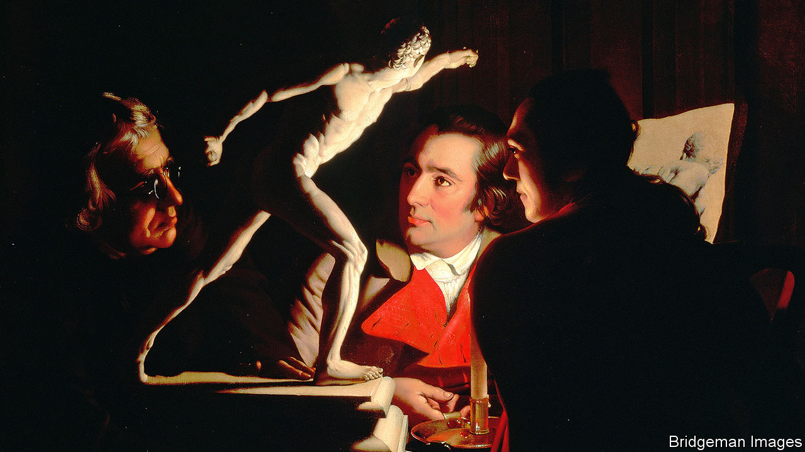

The Enlightenment. By Ritchie Robertson.Allen Lane; 1,008 pages; £40. To be published in America by Harper in February; $45.

IN SEPTEMBER THE University of Edinburgh expunged the name of David Hume from an ugly teaching block. In response to a student petition, the university agreed that the views of the 18th-century thinker on the possible inferiority of non-white races, voiced in a tentative footnote to his essay “Of National Characters”, “rightly cause distress today”. Thomas Jefferson, a slave-owner, used almost identical language. So did Immanuel Kant.

In contrast, many thinkers of the Enlightenment argued forcefully for the “basic unity of humankind”. Johann Gottfried Herder, a German polymath, scorned the notion of race itself, and saw all peoples as related parts of “the same great painting”. In his epic survey of Enlightened minds, ideas and policies across Europe and the Americas, Ritchie Robertson deems Hume-style prejudice “indefensible even in its own time”. At least as typical of the era was the ceramic medallion produced by potter-philanthropist Josiah Wedgwood in 1787 to support the abolition of slavery, on which a chained African figure pleads: “Am I not a man and a brother?” As this masterly book shows, Wedgwood’s brooch better encapsulates the mood of the age: its universal principles, wide-ranging sympathy, social activism—and commercial nous.

The Enlightenment argued fiercely with itself, in terms still in use. When today’s Westerners quarrel over race, empire, gender, religion, science, the state or the market, they often do so with weapons and tactics honed three centuries ago. Or more: in 1673 the maverick pastor François Poulain de la Barre wrote in “On the Equality of the Two Sexes” that “there is no such thing as sex”. Yet revisionists like to frame the heyday of the writers, scholars and progressive rulers presented here as “the apotheosis of hyper-rational calculation”. Supposedly, their influence disenchanted the world and seeded a motley harvest of modern evils from neoliberalism to Stalinism.

Mr Robertson begs to differ. A professor of German at Oxford, he is a champion of the thinkers who promoted “the advance of reason, good sense and empirical enquiry” against superstition and tyranny, from the late 17th century until the French revolution. Isaac Newton’s gravitation, Adam Smith’s political economy, Jean-Jacques Rousseau’s cult of sentiment—indeed, Hume’s outrageous near-atheism—all feature. But Mr Robertson lays special stress on the pursuit of happiness boldly invoked in the American rebels’ Declaration of Independence. That led to the first purpose-built Enlightenment state—“a very British affair” in its intellectual foundations. “The ultimate end of man is happiness,” claimed Rousseau’s fellow-Genevan Jean-Jacques Burlamaqui. By itself reason (which must anyway be “slave of the passions”, insisted Hume) would not ensure felicity.

So Enlightened happiness became a social task, and an art, pursued not just in the study but the laboratory, library, university, printing-house, coffee-shop and Congress. “Man is born to live in society,” affirmed Denis Diderot, tireless instigator of the French “Encyclopédie” (1751-72) and a ubiquitous, uplifting presence in these pages. Meanwhile, no priest or despot should curtail the liberty of thought enjoyed by beings endowed with, in Kant’s words, “the universal religion of reason that dwells in every ordinary person”. Slowly, grudging tolerance gave way to a warmer embrace of cultural diversity, given its theoretical framework in Montesquieu’s pathbreaking “Spirit of the Laws”.

Enlightenment intellectuals not only thought big. They wrote long. The “Encyclopédie”, that “vast panorama of knowledge”, crams 72,000 articles into 17 volumes. The “Histoire des deux Indes” (1770), a monument to cosmopolitan idealism by Diderot and Guillaume Raynal, which documents colonial crimes, runs to 4,353 pages. Mr Robertson’s 1,000-page whopper imbibes something of the spirit of these mammoth compendia. Not every reader will choose to plough straight through, from John Locke advocating “the enjoyment of pleasure” in 1690 to Hanif Kureishi, a modern author, saluting Enlightenment liberation from outmoded orthodoxies in 2019. Those who do will find that Mr Robertson sweetens erudition with humanity, much as his subjects did.

This Enlightenment celebrates what Robert Burns, appalled by the suffering of a shot hare, called “the morality of the heart”. Science and statecraft, which are amply chronicled, yield to compassion, sympathy and a self-critical outlook that welcomes experimentation and changes of mind. Not least among its lessons for today, “The Enlightenment” shows how its sages learned “to manage even Disputes with Civility”. ■

This article was downloaded by calibre from <https://www.economist.com/books-and-arts/2020/12/12/an-inspiring-history-of-the-enlightenment>

|  |  |  |  |
| --- | --- | --- | --- |
| Previous | Articles | Sections | Next |

|  |  |  |  |
| --- | --- | --- | --- |
| Previous | Articles | Sections | Next |

#### Johnson

# Accent discrimination betrays a small mind

Some in France want to make it illegal. But education can help, too

Dec 12th 2020 |



IN THE EARLY 1790s French revolutionaries commissioned a priest, Henri Grégoire, to take a census of the languages spoken in France. His findings were eventually titled a “Report on the necessity and means to annihilate the patois and to universalise the use of the French language”. Grégoire was a pioneering believer in racial equality, a fact that may seem to fit oddly with his passion for eradicating linguistic diversity. But to him, it made sense: French was the language of liberation, and those without it could be kept in ignorance.

How very French, their British cousins might chuckle. The same people who introduced the metric system and (unsuccessfully) tried to replace the Gregorian calendar can seem to have a mania for top-down reform and standardisation. Now some Britons are chuckling to see this approach enlisted in the name of tolerance: on November 26th the National Assembly passed a law forbidding accent discrimination. If it gets through the French Senate, severe cases—say, denying someone a job because of how they speak—could result in three years in prison, or a fine of €45,000 ($55,000). How very French.

The country certainly has biases to amend. In America regional accents can be heard in the highest office in the land (Donald Trump’s New York, George W. Bush’s Texan). In Britain the BBC has expanded the variety of accents heard on its broadcasts. By contrast, regional accents in France are far tougher to find in high places. This makes it harder for the French to associate intelligence and competence with anything but standard Parisian. At best French politicians, like some elsewhere, switch between their local accent when in the areas they represent and the standard Parisian kind when in the capital or on television.

And French leaders face more than just condescension. When Jean Castex, who has a notable south-western accent, became prime minister, reactions were predictably patronising. But such snobbery can have serious consequences, notes Jonathan Kasstan of Westminster University. The political editor of France’s national broadcaster said Mr Castex’s pandemic guidance seemed less credible when delivered in his “patelin”, or village, accent.

In truth, some other countries are more like France than they may think. Beyond the BBC, it remains common in Britain to hear public figures belittled for how they speak. The liberal left indulges these prejudices, too. Alastair Campbell, erstwhile press secretary to Labour’s Tony Blair, mocked the Conservative home secretary, Priti Patel, on Twitter: “I really would prefer it if we had a home secretary who could pronounce the G at the end of a word.” Here snobbery is dressed up as concern for correct enunciation.

But is a ban on such gibes the answer, in France or elsewhere? The case for one is that it would send a powerful signal: there is no rational reason to withhold a job or a loan because of an applicant’s accent. But a specific ban on accent discrimination may not be necessary. Donald Dowling, a lawyer at Littler Mendelson in New York, points out that, in many countries, accent mockery is already used as evidence of other forms of illegal discrimination, such as the racial kind. If you deride a Frenchman for an accent suggesting African origins, you are already breaking the law. In theory that law could be extended to cover (say) Breton origins without specifically adding “accent” to protected categories.

In the end, prejudice against accents betrays bad manners and small minds, and says more about the listener than about the put-upon speaker. But often it is itself a sign of poor education. As it happens, Mr Campbell’s swipe at Ms Patel’s “g-dropping” was badly aimed. There is no actual “g” sound (as in “go”) at the end of words ending in -ing; rather, there is a “velar nasal”, in which the mouth is closed off at the back and air comes from the nose. And the -in’ pronunciation he mocks (as in walkin’) was the “correct” one for centuries, remaining prestigious in the early 1900s.

If more of this were taught in British schools, snobbery would seem irrational. French children might be told that Parisian French was a latecomer, as prestige dialects in France go. Provençal, from France’s south, was the language of poetry when the speech of Paris’s Île-de-France region was a trivial local patois.

Speakers of prestigious accents are lucky that they do not face scorn for their speech. But it is just that—luck, not superior learning or care. A law may modify behaviour, but education is a better way to change attitudes.

This article was downloaded by calibre from <https://www.economist.com/books-and-arts/2020/12/12/accent-discrimination-betrays-a-small-mind>

|  |  |  |  |
| --- | --- | --- | --- |
| Previous | Articles | Sections | Next |

|  |  |  |  |
| --- | --- | --- | --- |
| Previous | Articles | Sections | Next |

#### The room where it happens

# William Kentridge contemplates history and creation

At 65, the South African artist is about to unveil his most mesmerising work

Dec 9th 2020 |

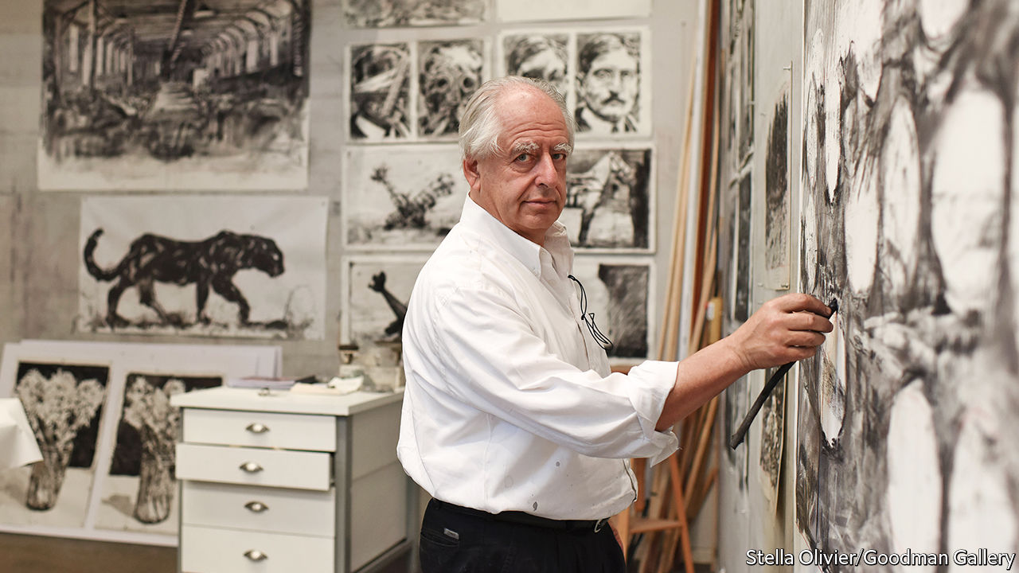

EVEN AS HE first made his name with his charcoal drawings in the 1970s and 1980s, William Kentridge resented the limitations of his craft. To the young artist he was then, working on his own in a studio in South Africa felt stifling. So he branched out, turning his drawings into filmed animations that brought them to life, then into performances with music and movement, and eventually into complex multimedia installations. He produced operas for the Salzburg Festival and the Metropolitan Opera in New York.

What he loved most was collaborating—with film-makers, theatre companies, musicians. In 2016 he took over the building next to his big industrial studio in downtown Johannesburg and created an incubator for performers called the Centre for the Less Good Idea. The name came from a Tswana proverb about the value of working things out together—and how the first, fizziest brainwave may in the end prove less productive than a humbler idea.

Most evenings, when he is in town, Mr Kentridge can be found at the centre, guiding, rehearsing and experimenting with young performers. Six months ago, though, after he, his wife and numerous colleagues caught covid-19, he was forced to retreat into making art on his own.

The role that solitary labour plays in creativity has long fascinated artists and historians. Lucio Fontana, an Italian-Argentine conceptual artist famous for his “slashed” canvases, allowed a photographer to shoot him at work, but only until the knife was poised to touch the canvas; then Fontana insisted on being completely alone. The studio, for him, was a sacred space. Such was the chaos and energy of Francis Bacon’s studio in London—with its smeared floor, gunky paint tubes and matted brushes—that after his death the room was painstakingly reconstructed (in 7,000 pieces) in Dublin City Gallery. It was as if his environs could immerse visitors in Bacon’s thinking.

For his part, Mr Kentridge headed to a building at the bottom of his garden and began a “natural history of the studio”, a long-cherished project about the alchemy of art. “One can think of the studio as a kind of enlarged head,” he says. “Instead of ideas moving a few centimetres from one part of your memory to your active thinking, it’s the walk across the studio that has the same effect of bringing ideas together and allowing something to emerge.”

His art-loving parents were both anti-apartheid lawyers and civil-rights activists; his father defended Nelson Mandela in the “treason trials” of 1956-61. As South Africa moved from pariah state to rainbow nation and beyond, Mr Kentridge sought new ways to depict its contested history, environment, injustices and depredations. From his “Soho Chronicles” (short animated films) to his productions of Alban Berg’s early-20th-century operas, “Wozzeck” and “Lulu”, his themes have been memory, landscape, power, the study of the self and how individuals forge their fates.

The new project will comprise 12 films, each lasting 40 to 45 minutes, far longer and more imaginative than any he has made before. So far, he has completed four. Using an old 16mm Bolex on a tripod, he films himself in conversation with himself, or with two other versions of himself, unpicking the artistic process. He can be the artist-as-maker, clutching a chunk of charcoal and sketching at high speed like a conductor; or the artist-as-critic, assessing his creation from afar. “Suddenly”, he says, “you’re a very different person.”

Combined with snapshots of his own past, and of South Africa’s, this dialogue is mesmerising. The first film, which he shared on his laptop on a flying visit to London, opens with a meditation on a 19th-century painting of hills and a stream that hung in his grandparents’ dining room. Next come memories of a picnic with his parents, involving sardines, boiled eggs and a flask of coffee. The artist argues with himself about small details of the spread, as if he were a pair of squabbling siblings. Then he takes the viewer through a new landscape: the mine dumps that rise out of the flat veldt around Johannesburg, symbols of apartheid’s political economy, and the digs of zama-zamas, freelance miners who scratch out overlooked crumbs of gold. Whose land is this, he seems to ask, and who determines its history?

All this is done with only charcoal and a smudging cloth, a sequence of minutely different drawings on one palimpsestic sheet of paper that, once filmed, have the immediacy of early animation. With editing by Walter Murch, an American who worked on “The Godfather” and “Apocalypse Now”, the effect is layered and theatrical. Mr Kentridge adds performance: improvised music by Kyle Shepherd, a pianist and composer from Cape Town, in which the piano strings are blocked with bits of wood or bound in foil paper to create sounds that echo the axe and the bulldozer. Then he introduces a Zulu chorale by Nhlanhla Mahlangu, a long-time collaborator, about being forced off the land. For Mr Kentridge, sound can convey memory, and the essence of South Africa’s landscape, as much as visual imagery.

In 2022 he will emulate Ai Weiwei and Anselm Kiefer and take over the Royal Academy in London for a retrospective of his career. He hopes all his new films, collectively to be called “Studio Life”, will be shown together. Even now, though, he sees himself as merely the initiator of his art. His collaborators turn it into something new and, with their own memories and connections, so do his audience. ■

This article was downloaded by calibre from <https://www.economist.com/books-and-arts/2020/12/09/william-kentridge-contemplates-history-and-creation>

|  |  |  |  |
| --- | --- | --- | --- |
| Previous | Articles | Sections | Next |

|  |  |  |
| --- | --- | --- |
| Books & arts | Sections | Graphic detail |

Economic & financial indicators

Economic data, markets and commodities

.

|  |  |  |
| --- | --- | --- |
| Books & arts | Sections | Graphic detail |

|  |  |  |  |
| --- | --- | --- | --- |
|  | Articles | Sections | Next |

# Economic data, markets and commodities

Dec 10th 2020 |

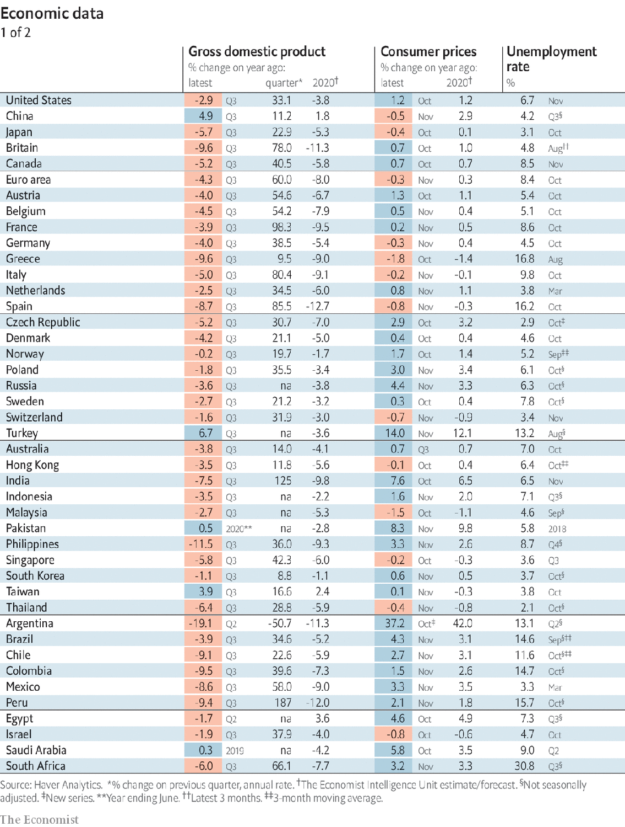

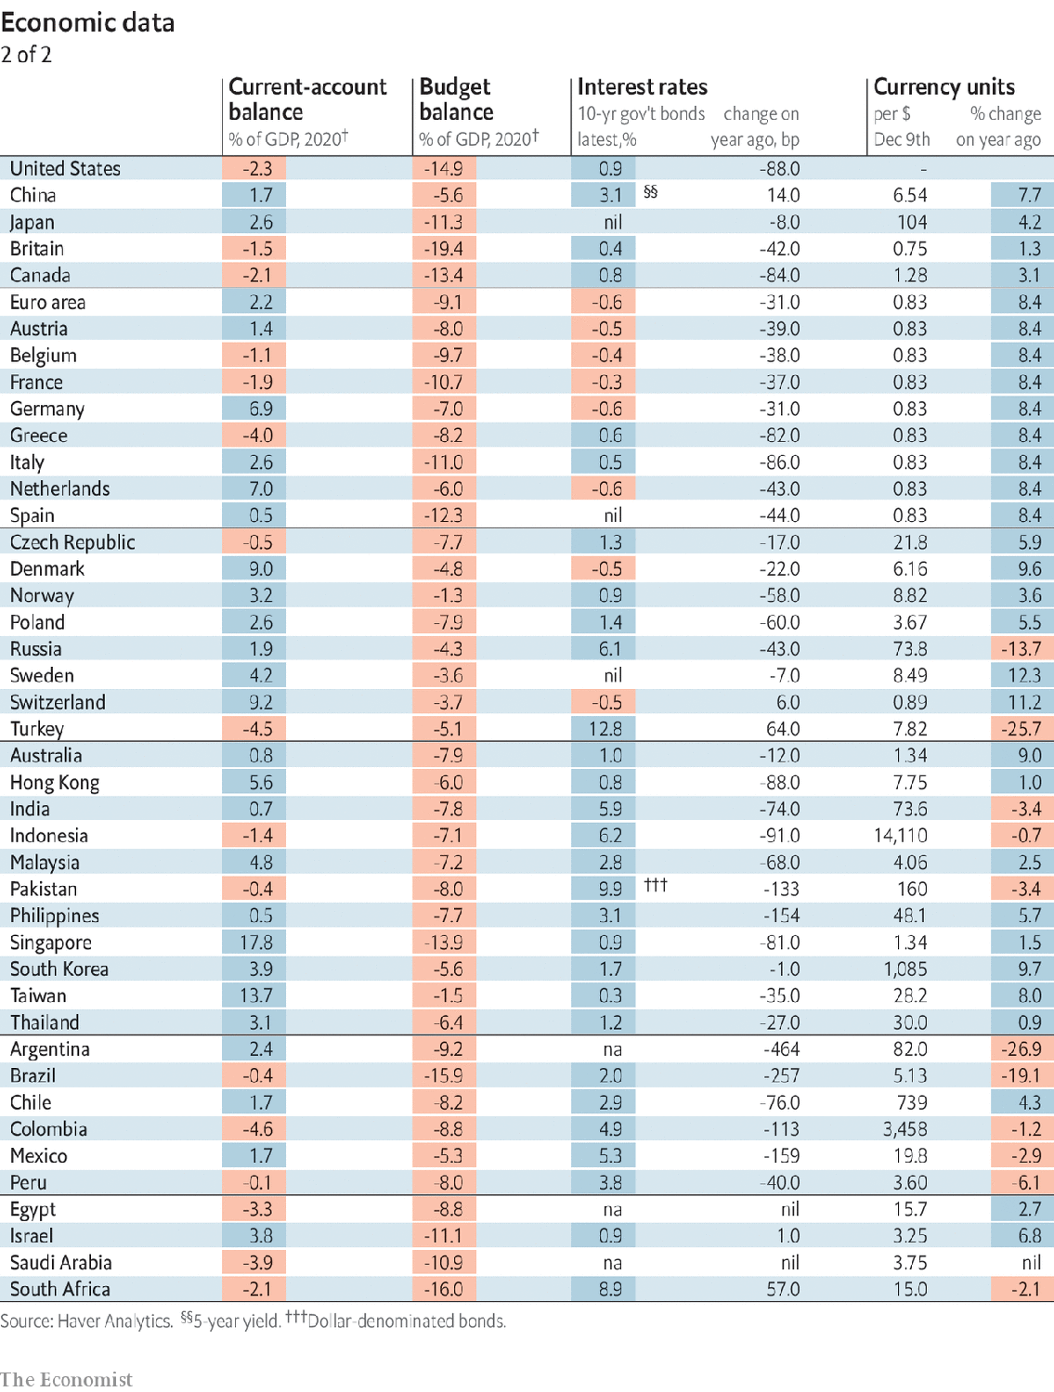

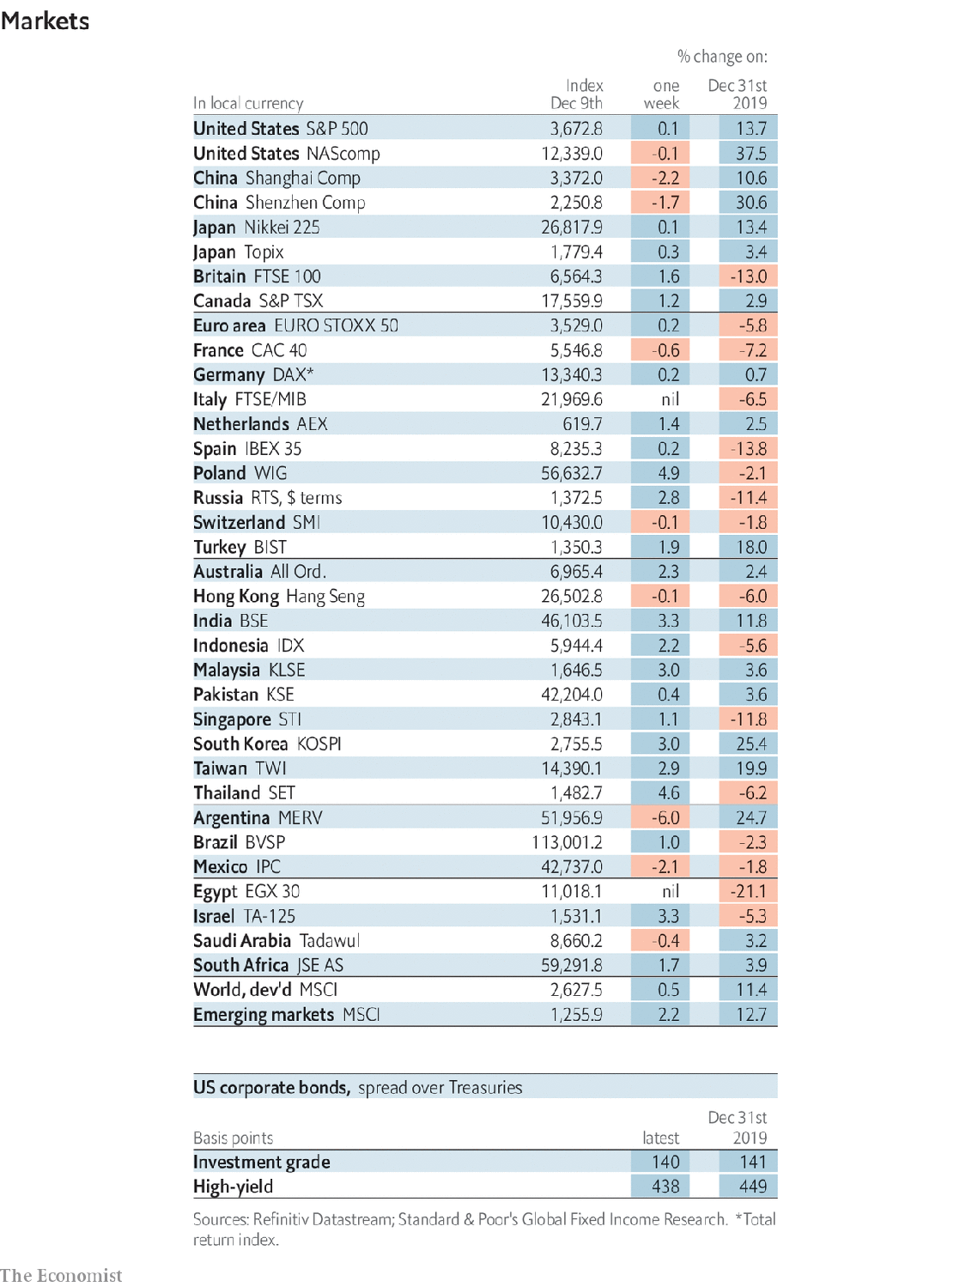

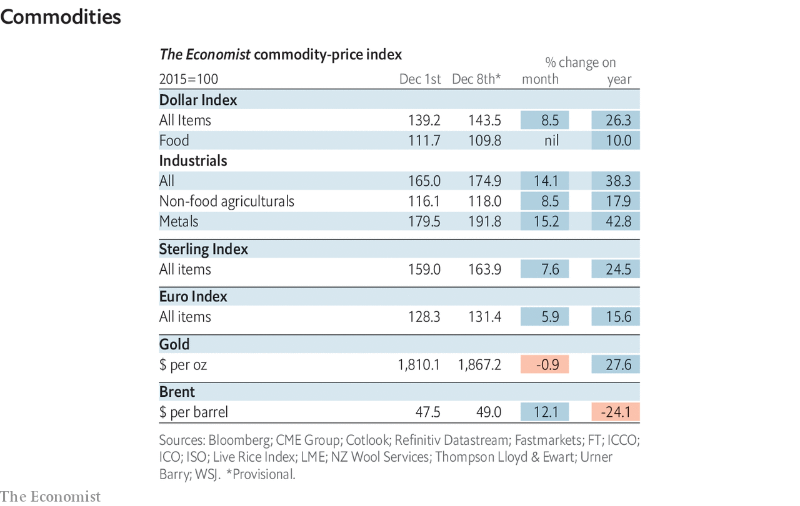

This article was downloaded by calibre from <https://www.economist.com/economic-and-financial-indicators/2020/12/10/economic-data-markets-and-commodities>

|  |  |  |  |
| --- | --- | --- | --- |
|  | Articles | Sections | Next |

|  |  |  |
| --- | --- | --- |
| Economic & ... | Sections | Obituary |

Graphic detail

Economic research: Starving for knowledge

.

|  |  |  |
| --- | --- | --- |
| Economic & ... | Sections | Obituary |

|  |  |  |  |
| --- | --- | --- | --- |
|  | Articles | Sections | Next |

#### Starving for knowledge

# Economists look at more than GDP when choosing countries to study

Speaking English and sending students to study abroad draw researchers’ interest

Dec 12th 2020 |

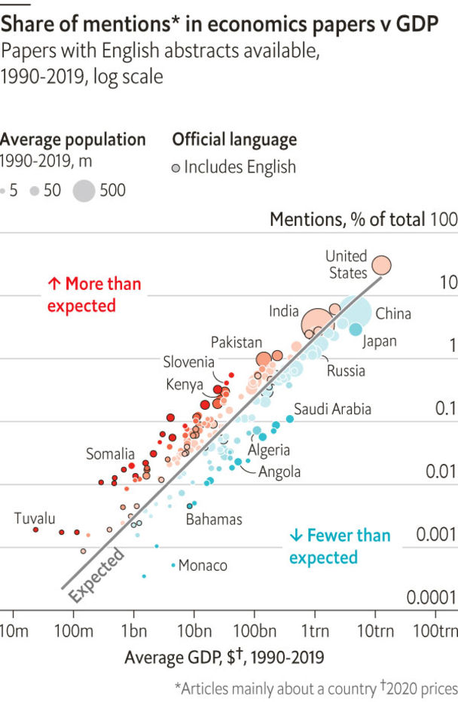

ECONOMIC RESEARCH can reverberate beyond the ivory tower. In 2003 a study of Kenyan schools found that treating intestinal worms improved attendance. After similar work confirmed the policy’s benefits, one author, Michael Kremer, founded an NGO that treats 280m children a year.

Mr Kremer’s work was unusually impactful, but reflects a pattern of research improving policy. One study found that telling Brazilian mayors about the gains from sending reminder letters to taxpayers sharply increased their chances of doing so. Yet many similar countries attract far fewer studies. This can leave policymakers fumbling in the dark (see Free exchange).

To measure this problem, we turned to EconLit, a database curated by the American Economic Association with 910,000 journal articles from 1990-2019. It only tracks papers with abstracts in English, the field’s lingua franca, causing it to under-represent studies intended for non-Anglophone audiences. However, EconLit does include 110,000 papers in other languages with abstracts translated into English.

By far, the best predictor of the amount of research conducted on a country was its GDP. However, economic size leaves many cases unexplained. Kenya gets three times more articles than its GDP suggests; Algeria has one-quarter as many as expected.

Such outliers often cluster in research “oases” or “deserts”. Obie Porteous of Middlebury College notes that studies of Africa are disproportionately concentrated in the continent’s south and east. Expanding this analysis worldwide, we find that the Middle East and parts of Latin America get relatively few papers with English abstracts. China and Russia also seem under-studied.

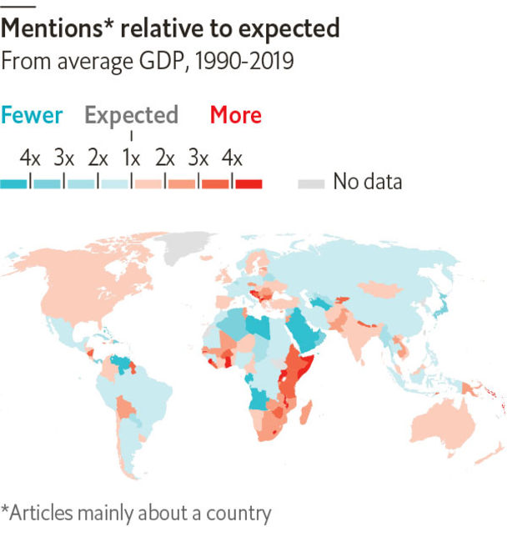

In contrast, South Asia and some regions in eastern Europe were oases. Like much of southern and eastern Africa, India and Pakistan were colonised by Britain. Today, many authors of articles about them work in Britain or America. Meanwhile, European research gluts seem locally driven. Lots of studies on Slovenia, which has one of EconLit’s highest papers-to-GDP ratios, stem from universities in Maribor and Ljubljana that churn out articles in English.

To adjust for such factors, we built a statistical model to predict a country’s share of studies in each year. GDP remained the most important variable, though it mattered less in oil-rich states. The next-best predictors of popularity in the Anglophone database were listing English as an official language and sending lots of students to American universities (boosting places like China). Variables that capture data availability, such as the number of World Development Indicators a country publishes, also had meaningful effects.

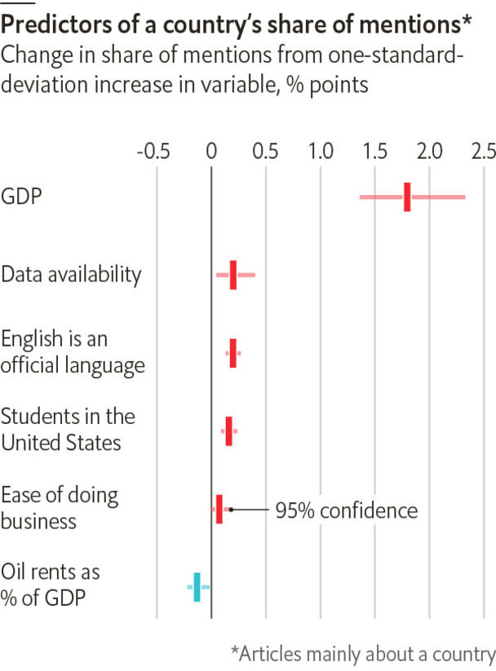

These factors improved the model a lot. They explained most of the difference between Kenya and Algeria, for example. After incorporating them, we found that a country’s spending on universities, form of government and involvement in armed conflicts did not yield additional accuracy.

For policymakers in research deserts who want academic support, that is good news. In the short term, they can do little to boost national GDP significantly. But being more forthcoming with data and fostering links with Western scholars should help. ■

Sources: American Economic Association; World Bank; Encyclopedia Britannica; Institute of International Education; government websites

This article was downloaded by calibre from <https://www.economist.com/graphic-detail/2020/12/12/economists-look-at-more-than-gdp-when-choosing-countries-to-study>

|  |  |  |  |
| --- | --- | --- | --- |
|  | Articles | Sections | Next |

|  |  |  |
| --- | --- | --- |
| Graphic detail | Sections |  |

Obituary

Chuck Yeager: Mechanic to hero

.

|  |  |  |
| --- | --- | --- |
| Graphic detail | Sections |  |

|  |  |  |  |
| --- | --- | --- | --- |
|  | Articles | Sections | Next |

#### Mechanic to hero

# Chuck Yeager died on December 7th

The flying ace and first to break the sound barrier was 97

Dec 12th 2020 |



IF A FLOCK of grouse flew across his path when he was out hunting, Chuck Yeager knew what would happen. He would get his slingshot, pick up some stones, and let fly. With his 20/10 vision in both eyes, he could see to infinity; in five minutes two or three grouse would be dead, hit square in the head. When challenged to target-shoot at a paper plate nailed to a tree, he could aim to hit the nail. He had practised those skills in the woods of West Virginia until they were second nature.

In the second world war, flying over France in P-51s, he once more saw his prey from a long way off and stayed up-sun, so the Germans wouldn’t spot him. Then he shifted to be down-sun, behind them. Once he picked off five Me109s in a day, getting into a big old hairy dogfight, buzzing, diving, shooting, lots of high-gs, becoming an ace right there. He knew how his plane should behave, how all the hardware worked, how the ejector seat and parachute would save him: knew it as a mechanic, which was his training. Armed with that knowledge, nothing much could surprise him. He was in firm control of what was right around him, and what he couldn’t control, such as the enemy, or the outcome, or death, was not worth worrying about. He was too busy.

But when on October 14th 1947 he was dropped in the Bell X-1, a rocket-powered experimental plane, from the bomb bay of a B-29, he had no idea what lay ahead. Fun, probably, as he loved the X-1, and in his post-war test-pilot job he preferred tactical flying that focused on one aircraft, rather than a dozen different planes every week. It was more like combat, and the band of pilots he now belonged to, at Muroc air force base in California, were ex-warriors who felt the same way. “Glamorous Glennis” was painted on the bright orange fuselage in tribute to his wife—the wife with whom he’d had a horseback race two nights before, busting a couple of ribs when his horse flipped him, which still hurt like hell.

The engineers back at base feared that breaching the sound barrier might rip the aircraft apart. The least he expected was something like a bump in the road, to show he’d done it: strong proof for the friendly rivals back at base. Instead, at around 700mph (1,126kph) he felt nothing particular, just a bit of resistance, like poking his finger through Jell-O. He got the Collier trophy for it, a nice statuette on a plinth, and the family went to the White House to collect it (his father, a staunch Republican, refused to shake Harry Truman’s hand). But it was quite a let-down.

He had to go much faster to get the effects he had been half-anticipating. That happened in December 1953, after a few flights approaching Mach 2, twice the speed of sound. He was warned that if he went any faster his X-1A aircraft might “go divergent”. It did. At 74,700 feet (22,800 metres), and at 2.44 Mach speed, it began to roll uncontrollably, then spin upside down. Completely disoriented, battered by plus and minus g-loads, he remembered his helmet cracking the inner canopy, and not a lot else. At last the plane got upright and, at 25,000 feet, he popped it out of the spin. He had dropped 50,000 feet in 70 seconds. Back in radio contact, he gasped out: “Christ!…Boy, I’m not doing that any more.”

It was odd enough that he was in the air anyway. As a boy, running the hills or sitting with his grandfather learning to fish, he never got near a plane, except to see one in the sky. He had no ambitions that way and, with only high school behind him, not enough education. He enlisted in the air force in 1941 as a mechanic, earthbound and easy, because he had already tinkered for years with engines, water-pumps and his father’s cable tools for drilling for natural gas. He took up flight training mostly because pilots had beautiful girls on their arms, and hands that weren’t dirty. But he became the most decorated pilot in America.

In the same strange sort of reversal, he started out with no interest in space and ended up training astronauts. In the 1950s, when space was mentioned, he would dismiss it as a place where he wouldn’t be flying, but sitting in a thing controlled by someone else. No doubt the views were pretty, but he couldn’t have cared less. And anyway, he had no degree. His ideas changed as the government began to press the space programme and America, in his view, fell far behind the Soviets in developing space technology. The USAF Aerospace Research Pilot School at Muroc, now Edwards air force base, which he ran from 1962, offered a state-of-the-art simulator that covered every stage of a space flight, from take-off to landing. Applicants swarmed in, and a bare 1% made it, since even fine grades on paper cut little ice with him. Astronauts, like pilots, had to know the machinery they were riding in, how to fix it and how to get back safely, not rely on some bunch of engineers. Like him, they basically had to be mechanics.

Over the years he became well-known, but it was an intermittent sort of fame. After the war he was celebrated as West Virginia’s leading ace. After breaking Mach in 1947, hardly a month passed without some magazine running an article about him. In the 1960s, when he was running the research-pilot school, he once did 163 talks in a year. He was a draw at any air show and at the Indy 500, where several times he opened proceedings in the pace car, gunning it with joy. Still, people didn’t match the name to the face, he thought, until he did the ACDelco car-parts commercial on TV; and then when, in 1983, his Mach exploits appeared on cinema screens in “The Right Stuff”, the film of Tom Wolfe’s book about the band of pilots. He had helped on the book, going through crash reports, which Wolfe kept getting wrong. As for the film, it was just entertainment, pretty much fiction, from Sam Shepard’s dark handsome face to all those blue skies outside the windows.

So when he was asked, as he was annoyingly often, whether he had the “right stuff”, as a test pilot and generally, he gave a down-to-earth answer. Rather than being “the most righteous”, with “the moxie, the reflexes, the experience, the coolness, to pull it back in the last yawning moment”, as Wolfe wrote, he just knew all about his planes, and had worked his tail off learning it. A mechanic’s answer which, as ever, hit the nail on the head.■

This article was downloaded by calibre from <https://www.economist.com/obituary/2020/12/12/chuck-yeager-died-on-december-7th>

|  |  |  |  |
| --- | --- | --- | --- |
|  | Articles | Sections | Next |